


Deliverable D2.3
Deployment of the MONTEVITIS
Web-based Decision Support Platform

March 31st, 2026

Document Control Sheet
PROJECT INFORMATION
Project Number | 101059461
Project Acronym | MONTEVITIS
Project Full title | Integrating a Comprehensive European Approach for Climate Change Mitigation and Adaptation in Montenegro Viticulture
Project Start Date | January 1st, 2023
Project Duration | 36 months
Funding Instrument | Horizon Europe | Funding Scheme | Coordination and Support Actions (CSA)
Topic | HORIZON-WIDERA-2021-ACCESS-02-01
Coordinator | Univerzitet Donja Gorica Podgorica (UDG)
DELIVERABLE INFORMATION
Deliverable No | D2.3
Deliverable Title | Deployment of the MONTEVITIS Web-based Decision Support Platform
Work-Package No | 2
Work-Package Title | Implementation of Knowledge Transfer
WP-Leader  (Name and Short Org. Name) | Christoph Menz (PIK)
Task No | 2.4
Task Title | Deployment of a Decision Support Platform for Winegrowers and Vineyard Monitoring
Task Leader  (Name and Short Org. Name) | João Carlos Andrade Dos Santos (UTAD)
Main Author  (Name and Short Org. Name) | Marko Simeunović (UDG)
Other Authors  (Name and Short Org. Name) | Christoph Menz (PIK)
Reviewers  (Name and Short Org. Name) | Christoph Menz (PIK)
Status | Draft ☒ Final ☐
Deliverable Type | Report ☒ Data ☐ Demonstration ☐ Other ☐
Dissemination Level | Public (PU) ☒ Sensitive (SEN) ☐ Classified ☐  PU: Public, fully open  SEN: Sensitive, limited under the conditions of the Grant Agreement  Classified R-UE/EU-R – EU RESTRICTED under the Commission Decision No2015/444  Classified C-UE/EU-C – EU CONFIDENTIAL under the Commission Decision No2015/444  Classified S-UE/EU-S – EU SECRET under the Commission Decision No2015/444
Date Approved by Coordinator

DOCUMENT VERSION HISTORY
Version | Date | Author | Description of Change
v1.0 | 16/03/2026 | Christoph Menz (PIK) | initial
V2.0 | 26/03/2026 | Tamara Rackovic | Content update
DOCUMENT REVIEW
Reviewer | Date | Reviewer Name (Short Organisation Name)
1 | 30/03/2026 | Christoph Menz (PIK)

Legal disclaimer
Funded by the European Union under Grant Number 101059461. Views and opinions expressed are however those of the author(s) only and do not necessarily reflect those of the European Union. Neither the European Union nor the European Research Executive Agency (REA) can be held responsible for them. The information in this document is provided “as is”. Neither the European Union institutions and bodies nor any person acting on their behalf may be held responsible for the use which may be made of the information contained therein. The MONTEVITIS Consortium members shall have no liability for damages of any kind including without limitation direct, special, indirect, or consequential damages that may result from the use of these materials subject to any liability which is mandatory due to applicable law.
ABBREVIATIONS
Abbreviation | Definition
CDSE | Copernicus Data Space Ecosystem
DSP | Decision support platform
ESDAC | European Soil Data Center
HPC | High performance computer
IoT | Internet of things
KER | Key exploitable result
R&I | Research & Innovation
R&D | Research & Development
SSP | Shared socioeconomic pathways
S&T | Science & Technology

Partners:
Univerzitet Donja Gorica Podgorica (UDG), Montenegro
Universidade de Trás-os-Montes e Alto Douro (UTAD), Portugal
Potsdam Institut fuer Klimafolgenforschung (PIK), Germany
Università degli studi di Firenze (UNIFI), Italy
Luxembourg Institute of Science and Technology (LIST), Luxembourg
Sociedade Portuguesa de Inovação (SPI), Portugal
Zavod Za Hidrometeorologiju i Seizmologiju Podgorica (IHMS), Montenegro
Vinograd i podrum Rajkovic (RAJ), Montenegro
Buk Doo Za Proizvodnju, Promet Roba i Usluga, Export - Import, Podgorica (BUK), Montenegro
“MNB Kruna” Ulcinj (KRU), Montenegro
Vucinic Dragica (ZNT), Montenegro

Table of contents
1. Introduction 10
2. DSP Overview 14
2.1. General Concept 14
2.2. Platform Architecture 15
2.3. Development Process 16
2.4. Data Sources Overview 17
2.5. Key Functionalities and Metrics 18
3. DSP Data Sources and Integrated Models 21
3.1. Viticulture Data 21
3.2. Climate Data 22
3.3. Integrated Models 23
3.4. Integration of Data and Models into the DSP 28
4. DSP Functionalities 32
4.1. Platform Structure and Navigation 32
4.2. Data Exploration and Visualization 33
4.3. Decision Support Features 36
4.4. Technical Implementation 38
5. Conclusion and Outlook 41
References 42


Chapter 1
Introduction
- Introduction
  - Scope of the document
This document is developed as part of the MONTEVITIS project, which has received funding from the European Union’s Horizon Programme, under the grant agreement number 101059461 and the special Twinning call for Western Balkans HORIZONWIDERA-2021-ACCESS-02. The principal objective of MONTEVITIS is to strengthen and raise UDG (University of Donja Gorica) research and development (R&D) capacity.
The MONTEVITIS web-based Decision Support Platform (DSP) represents a key outcome of the project. It is designed to support winegrowers and decision makers in Montenegro in vineyard management, long-term planning, and decision-making. In addition, the platform serves as a valuable information resource for researchers in the region. By connecting practical vineyard management with scientific research, the platform aims to position UDG as a central hub between practitioners and researchers, facilitating knowledge exchange and generating valuable insights for planning and research on the impacts of climate change on Montenegrin viticulture.
This report accompanies the final publication of the platform and outlines its objectives, structural design and future. It is a part of the Task 2.4 on the ‘Deployment of a Decision Support Platform for Winegrowers and Vineyard Monitoring’.
  - Structure of the document
The report ‘Deployment of the MONTEVITIS web-based Decision Support Platform’ is structured into the following 5 chapters:
Chapter 1 – Introduction provides a motivation to the report and the DSP. It places both within the context of the project and outlines the objectives of the DSP.
Chapter 2 – DSP overview provides general overview of the DSP, including the underlying concepts, its architecture and data basis.
Chapter 3 – DSP Data Sources and Integrated Models describes the datasets and models integrated in the DSP in greater detail.
Chapter 4 – DSP Functionalities describes the functionalities of the DSP, explaining its structure and user navigation. Furthermore, it details the technical implementation and discusses the decision-support features.
Chapter 5 – Conclusion and Outlook summarizes the report and discusses future developments and long-term sustainability of the DSP.
  - Motivation
Viticulture is not only an important component of Montenegro’s economy, but also deeply embedded in its cultural heritage and social identity. Grape cultivation and wine production in the region date back to around 2000 BC. Over millennia, this long tradition has given rise to a remarkable diversity of grapevines, with nearly 500 cultivated and wild varieties recorded [1]. However, climate change is expected to pose a significant threat to this biodiversity and may even challenge the viability of viticulture in Montenegro as a whole [2, 3]. In addition to long-term challenges imposed by climate change, winegrowers are also exposed to immediate threats from pest/disease and extreme weather events, such as late spring frosts or hail.
To mitigate and adapt to these risks, winegrowers need to implement measures that go beyond traditional practices. Effective adaptation requires a combination of long-term strategic planning, continuous vineyard management throughout the growing season, and timely responses to extreme weather events. These actions increasingly depend on the availability of scientific information derived from climate projections and short-term forecasts. However, such data are usually not readily accessible, and their interpretation typically requires expert knowledge. Within the MONTEVITIS project, researchers at UDG were trained to access, process, and analyses climate and impact data, with the aim of establishing UDG as a knowledge hub at the interface between science and practice. A central outcome of this effort is the DSP. Developed and maintained by UDG, the DSP enables winegrowers to assess the potential impacts of climate change at the field scale. In addition, it provides early warnings of adverse conditions requiring immediate attention. Beyond the vineyard level, the DSP can also support stakeholders and policymakers in both short-term decision-making and long-term strategic planning. By facilitating the exchange of information between UDG, winegrowers, stakeholders, and the scientific community, the DSP contributes to improved understanding and management of regional climate change impacts, while also supporting day-to-day vineyard management.
  - Objectives
As a core product of the MONTEVITIS project, the DSP serves several different objectives. We aim to fulfil the following primary objectives:
- Provide winegrowers with scientific evidence-based analysis on the impact of climate change on Montenegrin viticulture.
- Aid winegrowers, vineyard managers, stakeholders and decision makers to base their decision making on robust scientific results.
- Help in day-to-day and seasonal management of the vineyard by providing timely warnings on near-term vineyard conditions.
- Provide researchers, practitioners and the interested public with robust and unified data on climate change and its impacts on Montenegrin viticulture.
Furthermore, we have defined additional secondary objectives:
- Improve visibility of UDG as an important research center for climate change impacts on Montenegrin viticulture.
- Increasing the network of UDG by additional users of the DSP.
- Increase the resilience of Montenegrin viticulture sector to the impacts of climate change via vineyard-specific adaptation measures.
Chapter 2
DSP Overview
- DSP Overview

General Concept
The MONTEVITIS Decision Support Platform (DSP) was developed as a web-based digital infrastructure designed to support science-informed decision-making in Montenegrin viticulture under conditions of increasing climate variability and environmental uncertainty. The conceptual framework of the DSP was introduced in an earlier study, presenting the conceptual preview of the system architecture and integration logic of the proposed decision-support environment [4]. Building on this initial concept, the present deliverable documents the operational deployment of the platform and its implementation within Task 2.4 of the MONTEVITIS project.
Viticulture in Montenegro is characterized by strong spatial heterogeneity, complex topography and limited availability of high-resolution environmental observations at vineyards. These conditions create challenges for both short-term operational vineyard management and long-term climate adaptation planning. In response to these constraints, the MONTEVITIS DSP was designed as an integrated system combining heterogeneous climate, environmental and vineyard datasets into a unified analytical framework accessible through a user-friendly web interface.
The platform enables the integration of multiple categories of information relevant for decision support, including local in-field IoT observations, national meteorological station measurements, gridded historical climate datasets and high-resolution climate projections derived from global climate model ensembles. By combining these data streams, the system provides both real-time monitoring capabilities and long-term scenario-based climate risk assessments tailored to vineyard applications.
The DSP is designed to support several stakeholder groups with different analytical requirements. Winegrowers represent the primary end users of the platform and benefit from parcel-level monitoring, alert-based recommendations and visualization tools supporting irrigation planning, disease prevention and phenological timing. Researchers use the platform as a structured repository of harmonized environmental and phenological datasets enabling climate-impact assessment and model development. Stakeholders and policy makers benefit from aggregated regional indicators supporting strategic planning and the development of climate adaptation measures within the agricultural sector. By engaging a diverse range of users, the DSP enhances knowledge exchange between research and vineyard practice. In this context, the platform represents an operational interface linking climate observations, modelling outputs and management-relevant indicators, thereby supporting the broader MONTEVITIS objective of enhancing climate resilience and digital capacity in Montenegrin viticulture.

Platform Architecture
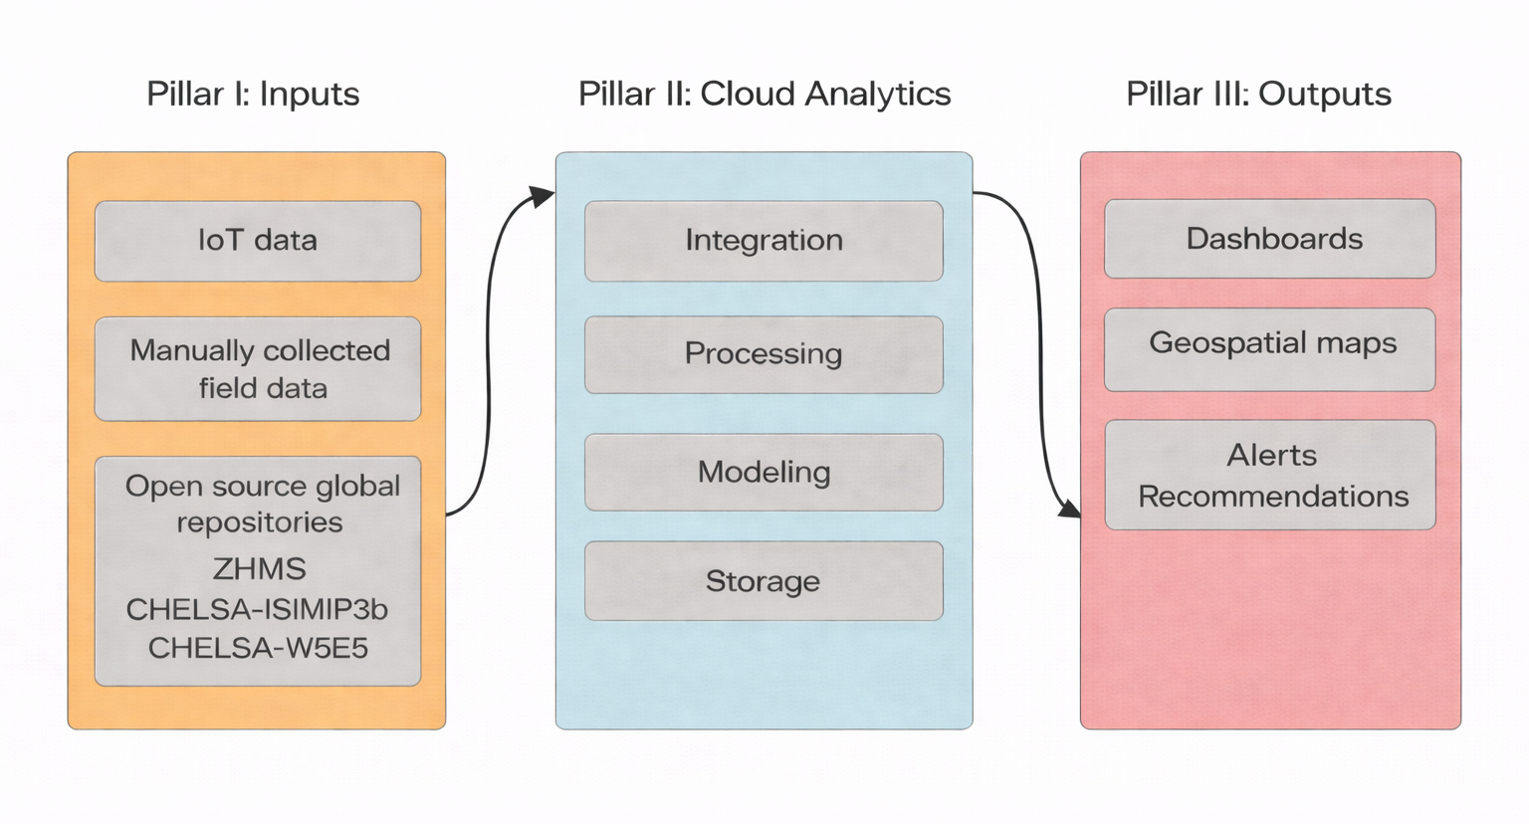
The MONTEVITIS DSP follows a modular three-layer system architecture designed to enable the efficient integration, processing and delivery of heterogeneous environmental datasets within a unified operational decision-support environment (Figure 1). The architecture consists of (i) a data acquisition layer, (ii) a cloud-based analytics and modelling layer, and (iii) a decision-support delivery layer translating analytical outputs into user-oriented information products.
Figure 1: Data Flow Diagram
The data acquisition layer integrates observations originating from multiple sources operating at different spatial and temporal resolutions. These include in-field IoT monitoring stations installed at pilot vineyard sites, national meteorological observations provided by the Montenegrin Institute for Hydrology and Seismology (ZHMS) [5], and high-resolution gridded climate datasets derived from international repositories such as CHELSA Climate Data [6] and Copernicus Climate Change Service [7]. Together, these sources establish a comprehensive monitoring framework supporting both site-specific and regional-scale analysis of climate variability and environmental conditions relevant for viticulture.
The cloud-based analytics layer performs data ingestion, validation and aggregation procedures required to ensure interoperability across heterogeneous datasets. Observational and model-derived data streams are processed through a standardized workflow including temporal aggregation, spatial alignment and derivation of decision-relevant indicators such as climate indices, phenological thresholds and drought-related risk metrics. The use of cloud-based infrastructure ensures scalability of the system and supports the continuous integration of additional datasets and modelling components as they become available.
The decision-support delivery layer represents the user-facing component of the platform and provides access to processed datasets through dashboards, geospatial visualization tools and alert-based notification systems. Rather than functioning solely as a visualization interface, this layer enables the operational interpretation of climate indicators and modelling outputs across different stakeholder groups. By translating complex analytical results into accessible graphical and map-based representations, the platform supports both short-term vineyard management decisions and longer-term climate adaptation planning.
The core system architecture consists of several interacting components, including the environmental data acquisition layer integrating IoT monitoring stations and national meteorological observations, the cloud-based processing and harmonization environment responsible for data aggregation and modelling workflows, and the user-facing visualization interface supporting parcel-level exploration, scenario analysis and decision-support indicators. Through this layered architecture, the MONTEVITIS DSP establishes a structured workflow connecting raw environmental observations with actionable decision-support outputs within a single integrated digital environment. A detailed description of the technical implementation of the frontend and backend components, including deployment infrastructure, server environment and hardware accessibility, is provided in Section 4.4.

Development Process
The development of the DSP was initiated during the early implementation phase of the MONTEVITIS project within the framework of Task 2.4 of Work Package 2, which focuses on strengthening knowledge transfer capacities and supporting climate-informed vineyard management in Montenegro. The platform builds upon a previously established conceptual framework describing the architecture and integration logic of a digital decision-support environment adapted to viticulture under conditions of increasing climate variability [4].
An important preparatory step in the development of the DSP was the deployment of vineyard-level IoT monitoring stations at partner vineyard locations at the beginning of the project. These monitoring stations established the first distributed microclimatic observation network supporting parcel-level environmental monitoring in Montenegrin viticulture and provided the empirical basis for the integration of real-time observational datasets into the platform environment.
The technical development of the DSP advances through the integration of observational monitoring infrastructure and downscaled climate datasets into a unified analytical workflow tailored to vineyard-scale applications. Particular emphasis was placed on ensuring interoperability between locally acquired sensor observations, national reference measurements and externally derived climate information to support the development of parcel-level monitoring and modelling functionalities within the platform environment.
The development process involved close collaboration between MONTEVITIS project partners representing academic institutions, climate research centers and operational vineyard stakeholders. Academic partners contributed expertise in climate data processing, modelling workflows and system architecture design, while pilot vineyard partners supported the deployment of monitoring infrastructure and provided field-level observations and management data required for the calibration and validation of platform components. In parallel, the integration of national meteorological datasets provided by ZHMS ensured the availability of spatially distributed reference observations supporting regional-scale climate analysis and strengthening the reliability of the monitoring framework.
The DSP is connected to the institutional data infrastructure of the University of Donja Gorica (UDG). This connection further strengthens the role of UDG as a regional hub for climate-informed viticulture research and facilitates the long-term sustainability and further development of the platform beyond the duration of the MONTEVITIS project.
Through the combination of conceptual system architecture, monitoring infrastructure deployment and cloud-supported data processing workflows, the MONTEVITIS DSP evolved from an initial design concept into an operational decision-support platform supporting both scientific analysis and practical vineyard management applications.

Data Sources Overview
The DSP integrates multiple categories of environmental, climatic and vineyard-specific datasets that together support parcel-level monitoring and climate-informed decision-making in Montenegrin viticulture. These datasets differ in spatial coverage and temporal resolution and include both locally collected observations and externally derived climate information.
At the vineyard scale, the platform incorporates observations obtained from IoT monitoring stations installed at selected pilot vineyard locations. These datasets provide high-frequency measurements (30 min) of local meteorological conditions relevant for site-specific environmental monitoring.
In addition to local sensor observations, the platform integrates meteorological measurements from the national observation network operated by the Montenegrin Institute for Hydrology and Seismology [5]. These datasets provide spatially distributed reference information covering the territory of Montenegro and support regional-scale climate assessment and data harmonization procedures.
To complement national observations, the platform further incorporates high-resolution gridded climate datasets. The observational climate baseline integrated into the DSP is derived from the CHELSA-W5E5 dataset [8]. Scenario-based projections are derived from the CHELSA-ISIMIP3b dataset, which downscales CMIP6 global climate model ensemble simulations to approximately 1 km spatial resolution under multiple SSP pathways [9, 10].
In addition to institutional datasets, the platform incorporates vineyard-specific observations provided directly by winegrowers through the user interface. These include phenological records reported according to the BBCH [11] scale, annual yield data by grape variety, and management-related information such as pruning dates, plant protection treatments and harvest timing. The systematic collection of these observations represents the first structured dataset on the phenological development of the autochthonous grapevine variety Vranac at vineyard scale in Montenegro. At the same time, the integration of yield and management records establishes a valuable empirical basis for analyzing relationships between climatic conditions, vineyard practices and production outcomes. Together, these user-generated datasets support the calibration of phenology estimation procedures and contribute to improving the reliability of decision-support indicators at local scale.
A detailed description of the datasets integrated into the MONTEVITIS DSP and their role within the platform architecture is provided in Chapter 3.

Key Functionalities and Metrics
The MONTEVITIS Decision Support Platform provides a set of integrated functionalities supporting both operational vineyard management and long-term climate adaptation planning through the visualization of environmental observations, model-based indicators and scenario-based projections.
The platform includes multiple types of visualization tools enabling users to explore climate and vineyard-related datasets across spatial and temporal scales. These visualizations include interactive geospatial representations of vineyard parcels derived from the national cadastral vineyard atlas, monitoring station locations, parcel-level environmental indicators, time-series analysis of meteorological variables, and phenological observations, as well as graphical representations of bioclimatic indices and climate suitability indicators relevant for grapevine development.
With respect to temporal coverage, the DSP integrates datasets supporting both near real-time environmental monitoring and long-term climate projections. High-frequency observations obtained from vineyard-level monitoring stations enable tracking of current meteorological conditions during the growing season, while historical climate datasets provide baseline information for trend analysis. In addition, scenario-based projections derived from global climate datasets under different Shared Socioeconomic Pathways (SSP scenarios) enable the assessment of long-term changes in temperature conditions and phenological development relevant for vineyard suitability under future climate conditions.
Decision-support functionalities are further supported through the implementation of model-based phenology estimation tools providing predictions of key developmental stages of grapevine growth at parcel level. In addition, alert-based indicators supporting vineyard management are being progressively implemented and evaluated, with operational monitoring of alert performance initiated at the beginning of 2026.
At the current stage of deployment, the platform integrates environmental observations collected from four pilot vineyard locations representing different production environments in Montenegro. In parallel, the DSP provides access to a national digital vineyard atlas derived from cadastral records, enabling spatial analysis of vineyard distribution across the country.
The platform further supports the collection of vineyard-level phenological observations reported by winegrowers, together with yield and management-related information. The systematic expansion of these user-contributed datasets represents an important component of the ongoing development of the DSP as a national knowledge-transfer infrastructure for climate-informed viticulture.

Chapter 3
DSP Data Sources and Integrated Models
- DSP Data Sources and Integrated Models
The DSP is fundamentally built upon data. In order to support its development already from the beginning of the MONTEVITIS project, an extensive assessment was conducted to identify available datasets and existing data gaps, in order to fulfill user needs. Where gaps were identified, efforts were made to address them in collaboration with vine growers within MONTEVITIS, either by incorporating their existing data collections or by conducting additional measurement campaigns. All data integrated into the DSP were evaluated and unified. This initial acquisition constitutes the primary dataset. Based on the primary dataset, climate indices relevant to grapevine development were derived and model simulations were performed, resulting in secondary data products. This chapter describes both the primary and secondary data underpinning the DSP, as well as their implementation within the platform.

Viticulture Data
The MONTEVITIS DSP focuses on Montenegrin viticulture. In order to attract as much Montenegrin winegrowers as possible, we collected basic information (owner, address, etc.) and vineyard plot location for 469 different vineyards throughout the country, representing almost all Montenegrin vineyards. These vineyards are already implemented in the DSP and we encourage the winegrowers to provide additional vineyard data to get the most benefit from the platform.
Within the MONTEVITIS project we collaborated with 4 different Montenegrin winegrowers (Vinarija Vučinić, Vinarija i podrum Rajkovića, MNB Kruna and BUK) to acquire additional data and implement them as the first users of the DSP. These vineyards provide additionally yield, phenology and management data. To simplify the acquisition and implementation of these datasets in the DSP, we directly implemented the integration option within the platform for registered users. Phenology measurements comprise the years 2023 to 2025 for up to 31 different BBCH stages each year. Depending on the vineyard observations cover the autochthonous and commercial varieties Cabernet-Sauvignon, Chardonnay, Cubrica, Kratosija, Malvazija, Marselan, Muscat Ottonel, Smederevka, and Vranac.
To acquire local weather observation we installed IoT measurement devices at each of the 4 vineyards. These IoT devices gather various environmental parameters at a 30 minute interval, capturing weather conditions directly within the vineyard. The weather observations from IoT devices as well as the phenology and yield observations and the management data for each of the 4 vineyards are implemented in the DSP. Furthermore, we were able to acquire and implement these data also from Montenegro’s larges wine producer 13. Jul Plantaze. Further details on the vineyard data implemented in the DSP are available in the MONTEVITIS deliverable reports:
- D2.1 - Report on the implementation of IoT devices,
- D2.2 - Report on the implementation of a database,
- D5.2 Final Sustainability and Exploitation Plan, and
- D1.2 - White Paper on precision viticulture research.
Vineyard data can be used in the DSP to track past conditions and analyze future changes in the respective vineyards. Furthermore, these data can also used to train models for yield and phenology simulations as well as models for risk assessments. Therefore, we encourage all Montenegrin winegrowers to register and provide these data, to allow detailed analysis and projections for these locations as well.

Climate Data
Climate data constitute the largest data component implemented in the DSP, providing a comprehensive representation of historical and future climate conditions in Montenegro. These data serve as the primary input for the grapevine models and are further used to define baseline conditions and threshold ranges for the warning systems. In the DSP we employ two types of climate data: in-situ observations and gridded climate data.
In-situ observations consist of direct measurements. To ensure the use of the most accurate climate data for each vineyard, we primarily rely on IoT data (see Section 3.1). For vineyards without installed IoT devices, we use daily weather observations from the nearest station within the IHMS network [5]. Currently, data from the stations in Bar, Cetinje, Podgorica, Ulcinj, and Virpazar are used, covering daily temperature (minimum, mean, and maximum), precipitation, relative humidity, surface pressure, sunshine duration, cloudiness, solar radiation, and wind speed from 1961 onwards.
For gridded climate data, we used observational datasets as well as historical and future climate model simulations derived using the Climatologies at High Resolution for the Earth’s Land Surface Areas (CHELSA) methodology [12, 13, 14]:
- Observation-based data from CHELSA-W5E5 [8] and
- Historical simulations and future projections from CHELSA-ISIMIP3b, based on climate model outputs.
The CHELSA-W5E5 dataset is publicly available via the CHELSA website (https://www.chelsa-climate.org). The CHELSA-ISIMIP3b dataset was generated within the MONTEVITIS project. Both datasets cover the Montenegrin domain at a spatial resolution of 1 km and include daily minimum, mean, and maximum temperature, as well as precipitation.
CHELSA-W5E5 [8] spans the period 1981-2010 and is based on the W5E5 gridded observation product [15, 16]. W5E5 itself is derived from ERA5 reanalysis data [17], which has been bias-adjusted and interpolated to a ~50 km global grid. These data are subsequently downscaled to 1 km resolution using the CHELSA methodology, resulting in a high-resolution gridded daily observational dataset covering whole Montenegro.
The CHELSA-ISIMIP3b dataset comprises historical simulations (1961-2014) and future projections (2015-2100) under three Shared Socioeconomic Pathways (SSPs) [9, 10]: SSP1-2.6, SSP3-7.0, and SSP5-8.5. The underlying climate simulations originate from the Inter-Sectoral Impact Model Intercomparison Project (ISIMIP3) [18], which provides bias-adjusted and downscaled outputs from CMIP6 models [19, 20] using the ISIMIP3BASD method [21]. These data are available at ~50 km resolution and were further downscaled to 1 km using the CHELSA method within the MONTEVITIS project.
To further improve regional accuracy, an additional bias adjustment of the CHELSA-ISIMIP3b ensemble was performed using the E-OBS v31.0e gridded observational dataset for Europe [22]. The final ensemble includes nine CMIP6 models: CanESM5, CNRM-CM6-1, CNRM-ESM2-1, EC-Earth3, IPSL-CM6A-LR, MIROC6, MPI-ESM1-2-HR, MRI-ESM2-0, and UKESM1-0-LL. By combining a multi-model ensemble with multiple SSP scenarios at high spatial resolution, the dataset captures a broad range of uncertainties, including natural variability, model structural differences, and scenario uncertainty.
All gridded datasets were harmonized and provided in CF-compliant NetCDF format [23]. In addition, we derived annual, seasonal, and growing-season averages based on 10-year periods to support efficient visualization within the DSP. We further computed 88 bioclimatic indicators, a dryness index, and a disease index relevant for grapevine modelling. Additional details on the climate data implemented in the DSP are provided, for example, in Deliverable D5.2 (Final Sustainability and Exploitation Plan).

Integrated Models
The DSP integrates a set of indicator-based and process-oriented modelling components designed to support climate-informed vineyard management at vineyard or parcel level. These models transform environmental and vineyard data into operational indicators supporting irrigation planning, disease or pest control, phenological and yield estimation under present and projected climate conditions. The modelling framework implemented within the platform comprises a phenology model for temperature-based phenological stage estimation, a water-balance model for the calculation of a drought-related indicator, a disease risk model for deriving disease risk indices, and a yield model for simulating productivity for the selected vineyard or parcel. All model simulations, except for the yield model, are implemented as in-season forecasts to support timely interventions by vine growers and short-term vineyard planning. The yield model provides estimates under current conditions and long-term future projections.
3.4.1. Water-balance model
Drought-related conditions affecting grapevine development are assessed using a dryness index [24] calculated from temperature and precipitation data integrated within the platform environment. The indicator provides an estimate of moisture availability conditions and supports the interpretation of water balance dynamics at vineyard scale.
The dryness index is derived from daily minimum and maximum air temperature together with daily precipitation observations obtained from vineyard-level monitoring stations and reference climate datasets available within the DSP. By combining temperature conditions with accumulated precipitation, the indicator enables the identification of periods characterized by increased drought stress risk relevant for grapevine development.
Within the operational workflow of the platform, the dryness index is continuously updated throughout the growing season and used as an input for irrigation-related decision-support functionalities (Figure 2). A rule-based decision threshold is applied to translate dryness index values into operational irrigation recommendations. When the index falls below a predefined threshold (DI = 50), an alert-based irrigation recommendation is automatically generated and delivered to end users through the platform interface. This threshold value (DI = 50) is implemented as an operational decision criterion supporting timely irrigation planning under conditions of increased drought stress risk and seasonal variability in water availability.
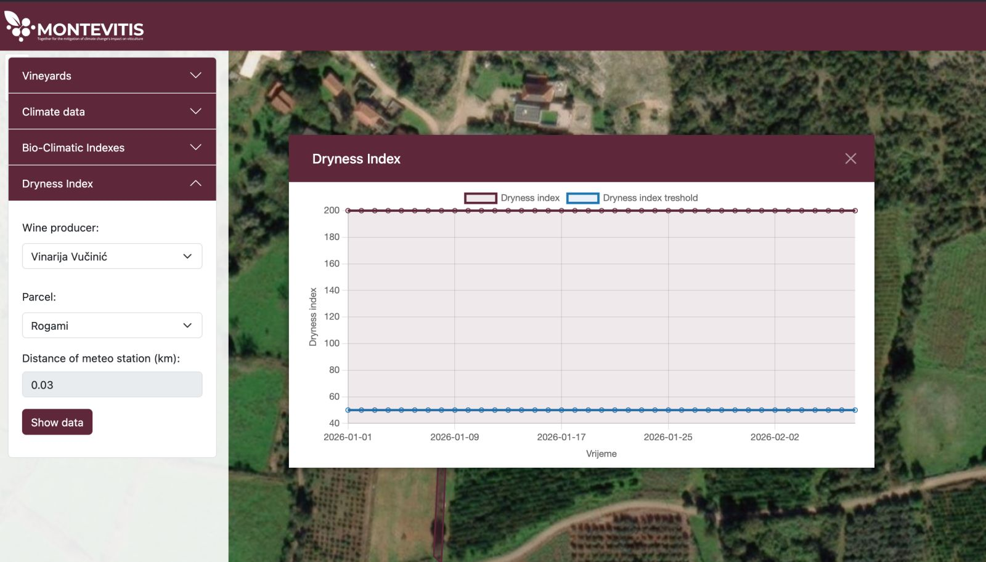
Figure 2: Annual profile of the Daily Dryness Index.
3.4.2. Disease risk model
Disease risk assessment within the DSP is supported through the implementation of a temperature- and precipitation-based infection risk indicator for downy mildew (Figure 3). The model integrates the widely applied 3–10 rule for the identification of primary infection conditions together with the Goidanich infection risk index [25] for the assessment of secondary infection dynamics during the vegetation period.
The modelling workflow operates in two sequential phases. The initial phase represents the onset of primary infection and is triggered when the so-called 3–10 rule is satisfied, i.e., when cumulative precipitation exceeds 10 mm within a 24-hour period, mean air temperature is above 10 °C, and vine shoot length exceeds 10 mm. Once these conditions are met, the model transitions to a daily risk accumulation phase in which infection risk is computed as a function of relative humidity and air temperature using the Goidanich index scale.
Meteorological observations obtained from vineyard-level monitoring stations and the weather observation network are continuously integrated into the risk accumulation procedure. When the cumulative infection risk exceeds a predefined threshold of 50%, the platform automatically generates an alert within the decision-support interface, accompanied by a recommendation for timely treatment application.
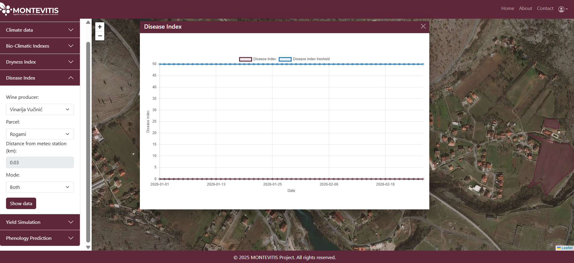
In addition to environmental thresholds, the interpretation of infection risk conditions is further supported through the integration of vineyard management records describing plant protection treatments entered by winegrowers within the platform environment. Recorded spraying events are explicitly incorporated into the modelling workflow and result in a reset of the simulated disease risk index to zero, enabling adaptive updating of infection risk estimates throughout the growing season. In the absence of recorded management data, a rule-based assumption is applied whereby treatment is considered to occur once the predefined infection risk threshold is exceeded.
Figure 3: Annual profile of the daily Disease Index.
3.4.3. Phenology estimation model
The phenology forecasting module is designed to support climate-informed vineyard management through the prediction of key developmental stages of grapevine growth at parcel level. The phenology model provides time-relevant information supporting the planning of vineyard operations under variable environmental conditions and represents one of the primary analytical decision-support tools implemented within the platform environment.
The phenology forecasting approach implemented in the DSP is based on the accumulation of Growing Degree Days (GDD) [26], a temperature-driven indicator widely used for estimating the timing of phenological transitions in grapevine development. The model uses cumulative active temperature values above a predefined threshold to estimate the progression of seasonal development stages throughout the vegetation period (Figure 4).
Within the MONTEVITIS platform, the model was parameterized for the autochthonous Montenegrin grapevine variety Vranac using phenological observations collected from pilot vineyard locations. These observations enabled the definition of temperature accumulation thresholds corresponding to major developmental stages, including budburst, flowering, veraison and ripening. The integration of locally observed phenological records improves the reliability of model outputs under heterogeneous microclimatic conditions characteristic of Montenegrin viticultural regions.
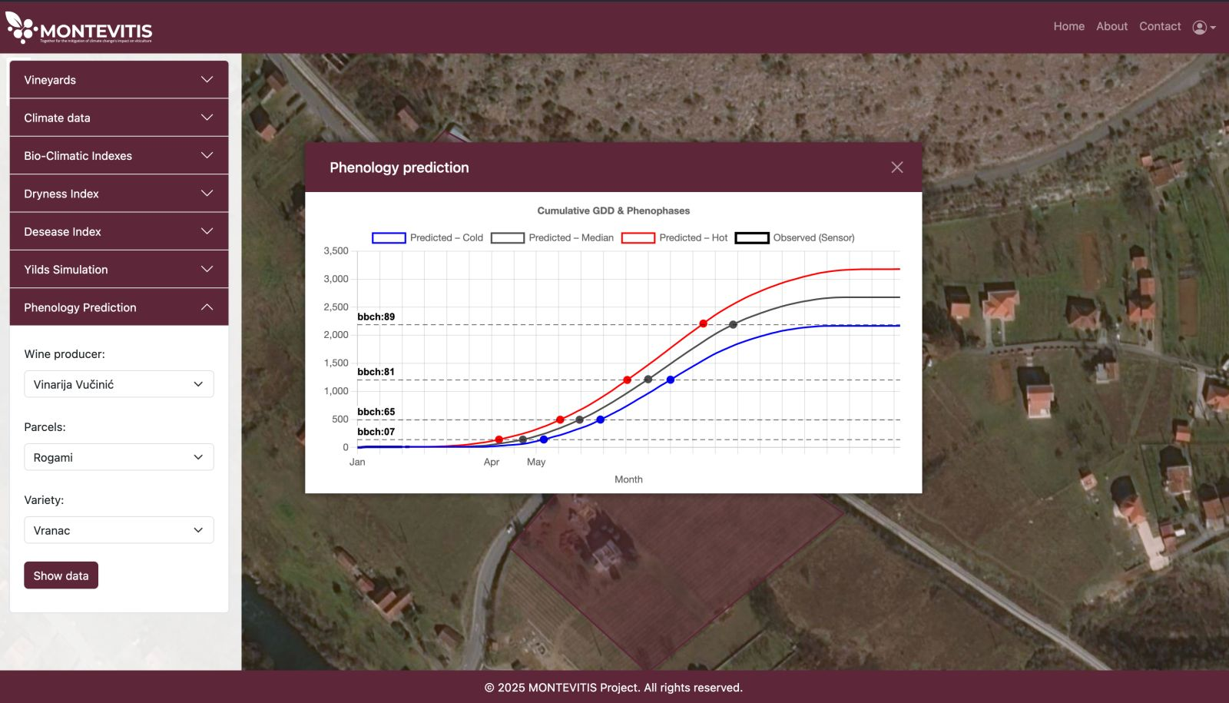
Figure 4: GDD estimates for Vranac variety, derived from historical data from E-OBS v 32, using daily percentile distributions.
The phenology forecasting module operates through the integration of temperature observations obtained from vineyard-level monitoring stations together with station observations available within the DSP environment. Based on observations up to the current date, near-term conditions are projected using historical median, upper, and lower daily temperature trajectories to estimate the range of seasonal phenological development. As new observations become available during the growing season, cumulative temperature indices are continuously updated, allowing the platform to generate dynamically refined estimates of expected phenological transitions. Through its integration within the operational workflow of the MONTEVITIS DSP, the phenology model enables parcel-level estimation of development timing and supports the optimization of management practices such as pruning operations, plant protection scheduling and harvest planning.
3.4.4. Yield Simulation Model
The DSP further integrates a process-based yield simulation module supporting the assessment of potential grapevine productivity under present and projected climate conditions (Figure 5). The model estimates biomass accumulation and yield variability for the autochthonous grapevine variety Vranac using environmental observations and climate scenario datasets available within the platform environment.
This modelling component enables the exploration of potential production responses of Vranac vineyards to changing temperature regimes and seasonal variability in environmental conditions. By combining observational datasets with scenario-based projections, the yield simulation module supports longer-term planning decisions related to vineyard management strategies and climate adaptation measures.
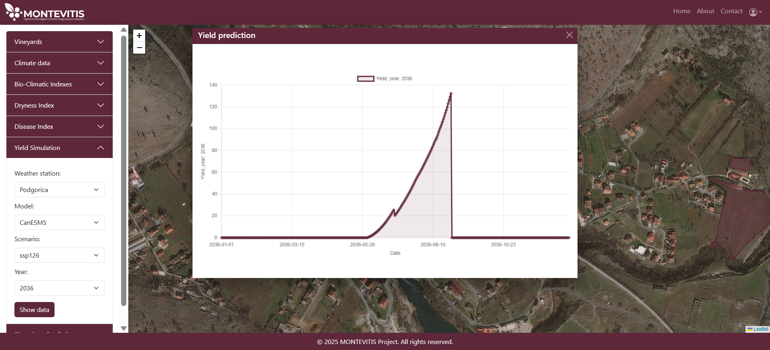
The integration of yield estimation tools within the DSP extends the functionality of the platform beyond operational monitoring and contributes to the evaluation of climate change impacts on the productivity of Vranac vineyards at parcel and regional scales.
Figure 5: Yield simulation under CanESM5 model SSP1 scenario for 2036.

Integration of Data and Models into the DSP
The integration of heterogeneous datasets and modelling components within the MONTEVITIS DSP follows a structured processing workflow designed to ensure interoperability between data sources and implemented models operating at different spatial and temporal resolutions. This workflow enables the transformation of raw environmental data into harmonized analytical inputs supporting parcel-level monitoring and model-based decision-support functionalities.
Prior to integration into the platform environment, observational datasets originating from vineyard-level monitoring stations, national meteorological networks and externally derived climate projections undergo a preprocessing procedure aimed at ensuring consistency across temporal structure, spatial reference systems and data completeness. This preprocessing stage includes validation of sensor observations, identification of missing values and correction of temporal inconsistencies that may arise from heterogeneous monitoring systems.
Following validation, datasets are transformed into a unified format suitable for storage and processing within the DSP data infrastructure. Environmental time series are standardized, enabling their use within modelling workflows and visualization modules. Spatial datasets describing vineyard parcel boundaries and monitoring station locations are harmonized within a common geospatial reference framework supporting map-based exploration and parcel-level indicator generation.
Temporal harmonization procedures are applied in order to enable consistent integration of datasets with different observation frequencies. High-frequency sensor measurements can be aggregated into daily, monthly and yearly time steps, while historical climate datasets are aligned with seasonal and annual analytical intervals required for phenology estimation and climate suitability assessment. This temporal structuring enables the dynamic updating of cumulative temperature indices used within the phenology forecasting module throughout the vegetation period.
In addition to temporal harmonization, spatial alignment procedures are implemented to ensure compatibility between parcel-level vineyard observations and gridded climate datasets. Location matching procedures allow the association of environmental indicators with individual vineyard parcels included within the national cadastral vineyard atlas integrated into the platform environment.
The harmonized datasets serve as input for the modelling implemented within the DSP. Temperature observations derived from monitoring stations and reference climate datasets are combined to generate cumulative Growing Degree Day (GDD) indices supporting the estimation of key grapevine developmental stages during the growing season. In addition, temperature, precipitation and relative humidity observations are integrated into disease risk assessment procedures supporting the generation of downy mildew alerts, while temperature and precipitation datasets are further used for the calculation of drought-related indicators contributing to irrigation planning support. These model outputs are continuously updated as new observational data become available and are delivered to end users through parcel-level visualization interfaces and alert-based decision-support modules.
Through the implementation of standardized preprocessing procedures, temporal aggregation workflows and spatial alignment mechanisms, the MONTEVITIS DSP establishes a scalable integration framework linking heterogeneous environmental datasets with operational modelling components within a unified decision-support environment.

DSP Functionalities
Chapter 4

- DSP Functionalities

Platform Structure and Navigation
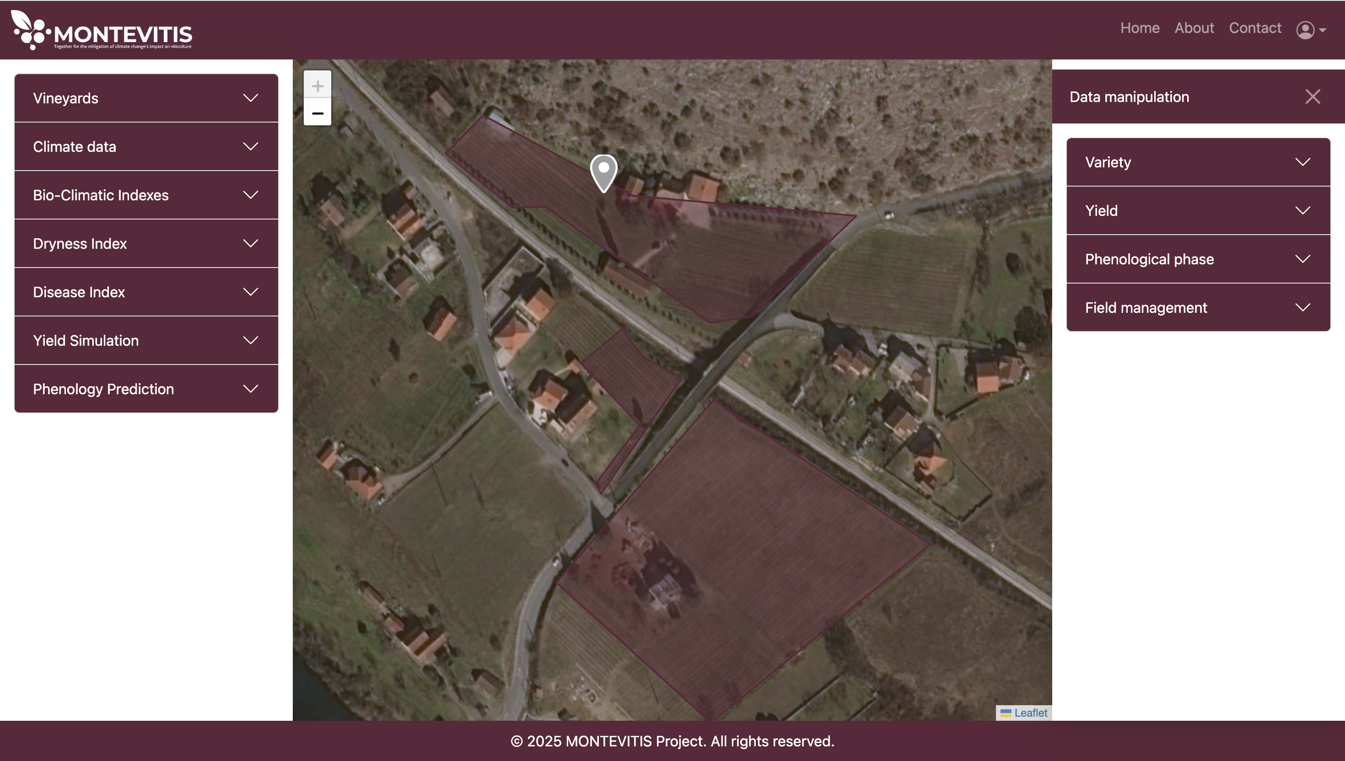
The MONTEVITIS Decision Support Platform is structured as a web-based interactive environment consisting of two main navigation layers designed to support both vineyard-level data entry by winegrowers and analytical exploration of environmental datasets and model outputs (Figure 6). This structure enables the integration of user-provided observations with monitoring infrastructure and climate datasets within a unified decision-support interface.
Figure 6: Initial Dashboard
The first navigation layer is dedicated to vineyard data entry and is accessible to registered winegrowers contributing parcel-level observations to the platform. This interface is organized through four thematic dropdown menus: Variety, Yield, Phenological phase and Field management. Within the Variety menu, users provide information on vineyard establishment year, grape variety, parcel location and planting geometry, including plant spacing and row spacing. The Yield menu enables the entry of annual production data by variety and parcel. The Phenological phase module allows users to upload BBCH observations together with observation dates and supporting field photographs. The Field management module enables the documentation of vineyard operations such as pruning, plant protection treatments and harvest timing through time-referenced activity records. Together, these inputs establish a structured vineyard-level observational dataset supporting model calibration and parcel-level monitoring workflows within the platform environment.
The second navigation layer enables analytical exploration of vineyard parcels, environmental monitoring data, climate indicators, and model simulations through an interactive map-based interface. Within the first vineyard module, users can select individual producers and access general information describing their vineyard parcels, cultivated varieties and archived phenological observations for user-defined time periods. The same interface provides access to recorded vineyard management activities, supporting the interpretation of environmental conditions in relation to operational practices. Furthermore, IoT sensor observations collected at pilot vineyard locations can be accessed in this module. Users can select individual environmental parameters and visualize sensor readings using different temporal aggregation levels, enabling the exploration of short-term variability and seasonal monitoring conditions relevant for vineyard management.
The platform further includes a climate data module supporting the visualization of historical observations and scenario-based projections. Within this module, users can select the type of graphical representation, including spatial map visualizations and temporal series plots, together with the environmental variable of interest. Climate information can be explored either as observational datasets or as ensemble-based projections derived from climate model outputs. For future climate analysis, users can select between three available emission scenarios representing alternative socio-economic development pathways (see Section 3.2).
In addition to primary climate data based on scenario projections, the platform provides access to bioclimatic indices and long-term climate normals calculated over 20-year and 30-year reference periods. These indicators support the assessment of climate suitability conditions for grapevine development across different vineyard regions.
The navigation structure further includes specialized decision-support modules providing access to irrigation alerts, disease risk alerts for downy mildew, yield simulation tools and phenology prediction outputs. These modules translate environmental observations and model-based indicators into operational information supporting vineyard management planning under current and projected climate conditions.

Data Exploration and Visualization
The MONTEVITIS Decision Support Platform provides multiple visualization environments enabling users to explore environmental observations, climate indicators and model-based outputs across different spatial and temporal scales. The platform supports both parcel-level monitoring and regional-scale climate analysis through interactive graphical and map-based representations.
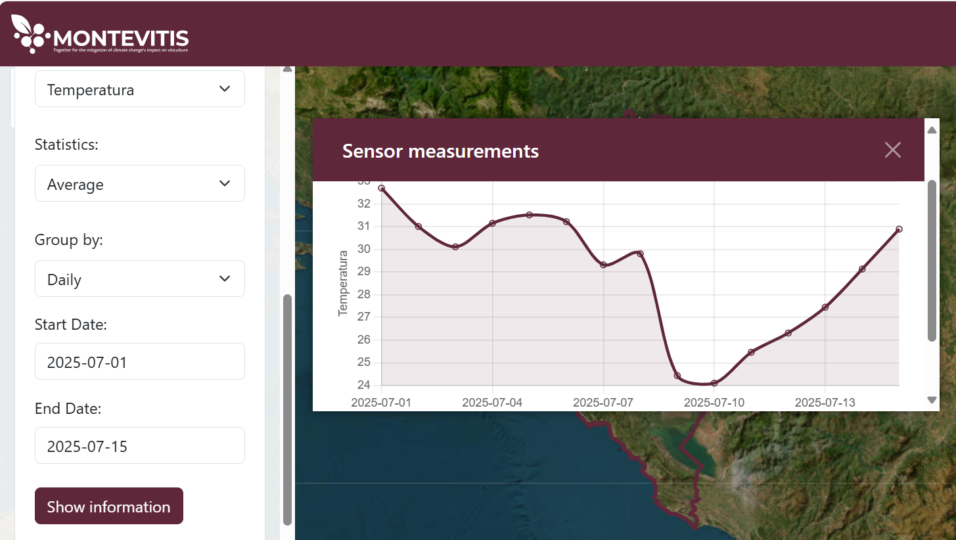
For vineyard-level monitoring data obtained from IoT sensors, environmental variables are visualized through time-series plots allowing flexible temporal aggregation. Users can select individual parameters and display minimum, maximum or average values with aggregation intervals defined as daily, weekly or monthly summaries, or alternatively explore raw measurements recorded at 30-minute resolution. This functionality supports detailed analysis of short-term variability and seasonal environmental dynamics relevant for vineyard management (Figure 7).
Figure 7: Average monthly temperature for the period 01.01.2024–10.08.2025.
Climate datasets derived from observational records and model ensemble projections under different scenarios can be visualized using either time-series plots for each parcel or spatial map representations. Users can select key meteorological variables, including daily precipitation and minimum, maximum or average air temperature, and explore their variability across user-defined time periods. Scenario-based projections derived from climate model ensembles enable the comparison of historical observations with future climate conditions under alternative socio-economic pathways.
Bioclimatic indices and long-term climate normals are additionally available through both graphical time-series visualizations and spatial map-based representations. These indicators summarize climate conditions over 20-year and 30-year reference periods and support the assessment of long-term suitability conditions for grapevine development across different viticultural regions, under different future scenarios (Figure 8).

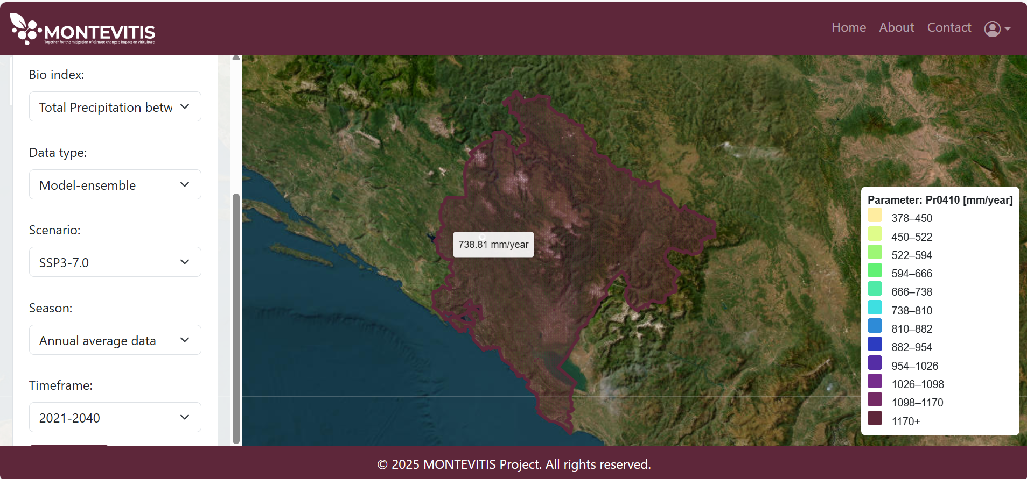
Additional graphical outputs are provided for derived decision-support indicators including dryness index, disease risk index for downy mildew, phenological stage estimation, and yield simulation results. These indicators are presented through dedicated graphical interfaces enabling users to interpret model-based outputs in relation to environmental monitoring conditions for each parcel, as presented in Section 3.4. User interaction with the platform is designed to be intuitive and flexible, allowing the selection of specific vineyard parcels, climate variables, temporal ranges and scenario configurations through the graphical interface. Additional functionality enables the export of selected datasets and visualization outputs in structured formats for further offline analysis. Through the integration of spatial, temporal and scenario-based visualization tools, the MONTEVITIS DSP supports comprehensive exploration of climate-related indicators and strengthens the capacity of stakeholders to interpret complex environmental datasets relevant for vineyard management and adaptation planning.
Figure 8: Geospatial visualization of CHELSA-based climate normal (2021–2040) for total precipitation (April–October) under the SSP3 scenario.

Decision Support Features
Decision-support functionalities are based on the integration of vineyard-level monitoring data, user-provided vineyard data and climate datasets that together enable both short-term operational decision-making and long-term strategic planning for individual vineyards.
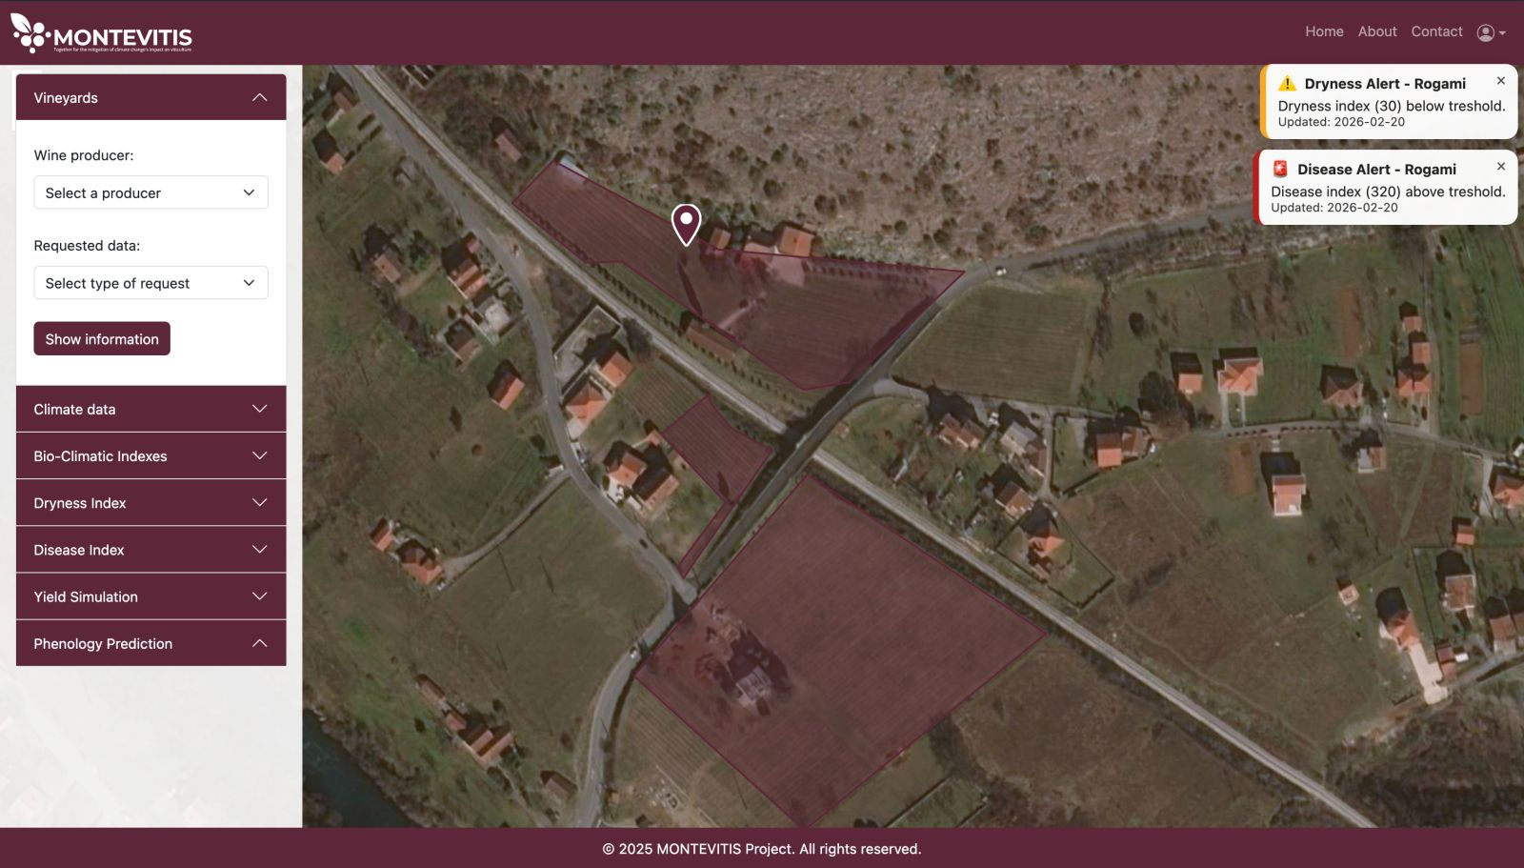
A central component of the decision-support framework is the integration of environmental observations obtained from IoT monitoring stations installed at pilot vineyard locations. These observations are continuously used to generate indicators supporting for example irrigation planning and disease risk assessment. The alert-based decision-support functionalities implemented within the MONTEVITIS DSP are directly derived from the modelling components described in Section 3.4. Environmental indicators generated through the phenology forecasting module, dryness index estimation and disease risk assessment are translated into operational notifications delivered to end users through the platform interface. These alerts provide timely information supporting irrigation planning, plant protection measures and scheduling of vineyard management activities during the growing season. Selected decision-support indicators are communicated directly to end users through alert notifications displayed on the main platform interface. (Figure 9). These alerts provide immediate access to irrigation recommendations and disease risk warnings without requiring navigation through individual visualization modules, thereby supporting rapid interpretation of management-relevant information during the growing season.
Figure 9: Example of dryness and downy mildew alerts generated within the MONTEVITIS DSP interface for a pilot vineyard location.
In addition to sensor-based monitoring, phenological observations provided directly by winegrowers through BBCH-scale reporting represent an important input for decision-support workflows. These observations are used for the calibration of phenology estimation procedures developed for the autochthonous grapevine variety Vranac and support the generation of parcel-level predictions of key developmental stages. The availability of dynamically updated phenology forecasts enables improved timing of vineyard management activities throughout the growing season. The possibility of integration of user-provided phenology data incentivizes data sharing and encourages continued interaction with the platform, supporting its long-term sustainability.
User-provided vineyard management information further contributes to the refinement of decision-support indicators. Records describing plant protection treatments are integrated into the disease risk assessment workflow, allowing the dynamic interpretation of infection risk conditions in relation to actual vineyard protection practices. This interaction between monitoring data and management records improves the operational relevance of alert-based recommendations delivered through the platform interface.
In addition to parcel-level monitoring indicators, the platform provides access to climate projections and bioclimatic normals supporting long-term planning. These datasets enable institutional users and advisory services to assess regional climate suitability conditions and identify potential adaptation strategies under changing environmental conditions.
The MONTEVITIS DSP further enables the download of selected vineyard-level datasets entered by winegrowers, including information on vineyard establishment, phenological observations and management activities. These datasets can be exported in structured formats such as spreadsheet tables and PDF reports, supporting their use in external analytical workflows, advisory activities and documentation of vineyard management practices.
The platform integrates parcel-level datasets describing vineyard characteristics, phenological observations and management practices provided directly by winegrowers. These user-generated inputs improve the reliability of local decision-support indicators and enable the refinement of platform outputs through continuous interaction between monitoring infrastructure and field-level observations.
The platform further supports decision-making through the visualization of bioclimatic indices derived from historical observations and climate projections. These indices enable users to evaluate vineyard suitability conditions and assess climate-driven risks affecting grapevine development across different regions and time horizons. By combining observational datasets with model-derived indicators and scenario-based projections, the DSP provides a comprehensive analytical framework supporting both operational and strategic decision-making processes.
In addition to interactive visualization tools, the platform provides functionality for downloading selected datasets and derived indicators in structured formats suitable for further analysis. Users can export parcel-level phenological observations, environmental time series and climate indicator datasets for user-defined time periods, enabling integration with external analytical workflows and supporting research, advisory and policy-related applications. This export functionality further enhances the usability of the platform as a knowledge-transfer instrument within the MONTEVITIS project framework.

Technical Implementation
The DSP is implemented as a web-based digital system combining a browser-accessible frontend interface with a centralized backend data-processing environment supporting the integration, storage and analysis of environmental observations and model outputs. This architecture enables the delivery of parcel-level decision-support indicators to multiple stakeholder groups through a unified online platform.
The frontend component provides the main user interface through which environmental datasets, phenological observations, climate indicators and decision-support outputs are accessed and visualized. The interface supports interactive navigation across vineyard parcels included in the national cadastral vineyard atlas, exploration of monitoring station observations and access to model-based indicators through graphical and map-based visualization modules. In addition, the frontend enables registered winegrowers to upload parcel-level information including vineyard characteristics, phenological observations and management records through structured data-entry forms integrated within the platform environment.
The backend component supports the ingestion, harmonization and storage of heterogeneous datasets originating from IoT monitoring stations, national meteorological observation networks and externally derived climate datasets. These data streams are processed through standardized workflows enabling temporal aggregation, spatial alignment and the calculation of derived indicators such as phenological development estimates and environmental risk indices. The backend infrastructure further enables the continuous updating of monitoring observations and model outputs throughout the growing season.
The platform is connected to the institutional data infrastructure of the University of Donja Gorica (UDG), where the DSP supports the integration of observational datasets, modelling components and vineyard-level information within a centralized research and knowledge-transfer environment. The use of a centrally managed hosting environment ensures stable platform availability and supports the long-term sustainability of the system beyond the duration of the MONTEVITIS project.
The MONTEVITIS DSP is accessible through standard web browsers and does not require specialized software installation on the user side. The platform supports operation on commonly used desktop and laptop systems and is accessible through mobile devices with internet connectivity, enabling flexible use by researchers, institutional stakeholders and winegrowers in both office and field conditions.

Conclusion and Outlook
Chapter 5

- Conclusion and Outlook
This deliverable presented the deployment of the MONTEVITIS web-based Decision Support Platform (DSP), developed within Task 2.4 of the MONTEVITIS project as part of Work Package 2 dedicated to strengthening knowledge transfer and supporting climate-informed vineyard management in Montenegro. The platform represents a central digital infrastructure component of the project and provides an operational environment for winegrowers and decision makers, linking environmental monitoring, vineyard observations and model-based indicators within a unified decision-support system.
The DSP integrates multiple categories of datasets, including IoT-based environmental observations, national meteorological measurements, climate projection datasets and vineyard-level records provided directly by winegrowers. Through this integration framework, the platform enables both short-term operational decision-making and longer-term climate suitability assessment at parcel and regional scales. In particular, the inclusion of BBCH observations collected from pilot vineyard locations represents the first structured dataset supporting phenological modelling of the autochthonous grapevine variety Vranac at vineyard scale in Montenegro.
The deployment of monitoring infrastructure at pilot vineyard sites and the integration of parcel-level management information demonstrated the feasibility of combining observational data, modelling workflows and user-provided inputs within a single operational platform environment. These functionalities support improved timing of vineyard management, disease risk awareness and irrigation planning, while also providing institutional users with access to climate indicators relevant for adaptation planning and policy development.
Beyond its operational role for vineyard monitoring, the DSP contributes to strengthening the institutional capacity of the University of Donja Gorica as a national knowledge-transfer hub for climate-informed viticulture. The connection of the platform to national observational datasets and cadastral vineyard information further supports its role as a foundation for the future development of integrated digital services for the agricultural sector.
The MONTEVITIS DSP provides a structured framework for the continued integration of vineyard-level observational datasets, phenology monitoring records and climate-based indicators supporting climate risk assessment in viticulture. The platform establishes a basis for the incorporation of additional monitoring components and weather-based information products, further strengthening its role as an operational tool supporting evidence-based vineyard management during the growing season. Furthermore, we incentivize Montenegrin winegrowers to register and provide parcel-level information, enabling vineyard-specific decision-making across Montenegro and fostering knowledge exchange between UDG, winegrowers, stakeholders, and policymakers.

References

[1] | A. R. Balingit, C. Dibari, L. Leonini, N. Bartoloni, K. Ratković, M. Simeunović, S. Radonjić, N. Kovač, H. Fraga, C. Menz, A. C. P. Fernandes, J. C. A. dos Santos, K. Heilemann e D. Molitor, “White Paper on Precision Viticulture Research to Optimize Vineyard Management,” 2026.
[2] | J. A. Santos, H. Fraga, A. C. Malheiro, J. Moutinho-Pereira, L.-T. Dinis, C. Correia, M. Moriondo, L. Leolini, C. Dibari, S. Costafreda-Aumedes, T. Kartschall, C. Menz, D. Molitor, J. Junk, M. Beyer e H. R. Schultz, “A Review of the Potential Climate Change Impacts and Adaptation Options for European Viticulture,” Applied Sciences, vol. 10, 2020.
[3] | C. van Leeuwen, G. Sgubin, B. Bois, N. Ollat, D. Swingedouw, S. Zito e G. A. Gambetta, “Climate change impacts and adaptations of wine production,” Nature Reviews Earth & Environment, vol. 5, p. 258–275, 2024.
[4] | M. Simeunović, K. Ratković, N. Kovač, T. Racković e A. Fernandes, “A Knowledge-Driven Framework for a Decision Support Platform in Sustainable Viticulture: Integrating Climate Data and Supporting Stakeholder Collaboration,” Sustainability, vol. 17, 2025.
[5] | Montenegrin Institute for Hydrology and Seismology (ZHMS), National meteorological observation network of Montenegro, n.d..
[6] | CHELSA Climate Data, Climatologies at High Resolution for the Earth’s Land Surface Areas, n.d..
[7] | Copernicus Climate Change Service (C3S), In-situ gridded observations for Europe (E-OBS), 2024.
[8] | D. N. Karger, S. Lange, C. Hari, C. P. O. Reyer, O. Conrad, N. E. Zimmermann e K. Frieler, “CHELSA-W5E5: daily 1 km meteorological forcing data for climate impact studies,” Earth System Science Data, vol. 15, p. 2445–2464, 2023.
[9] | M. Meinshausen, Z. R. J. Nicholls, J. Lewis, M. J. Gidden, E. Vogel, M. Freund, U. Beyerle, C. Gessner, A. Nauels, N. Bauer, J. G. Canadell, J. S. Daniel, A. John, P. B. Krummel, G. Luderer, N. Meinshausen, S. A. Montzka, P. J. Rayner, S. Reimann, S. J. Smith, M. van den Berg, G. J. M. Velders, M. K. Vollmer e R. H. J. Wang, “The shared socio-economic pathway (SSP) greenhouse gas concentrations and their extensions to 2500,” Geoscientific Model Development, vol. 13, p. 3571–3605, 2020.
[10] | K. Riahi, D. P. van Vuuren, E. Kriegler, J. Edmonds, B. C. O’Neill, S. Fujimori, N. Bauer, K. Calvin, R. Dellink, O. Fricko, W. Lutz, A. Popp, J. C. Cuaresma, K. C. Samir, M. Leimbach, L. Jiang, T. Kram, S. Rao, J. Emmerling, K. Ebi, T. Hasegawa, P. Havlik, F. Humpenöder, L. A. D. Silva, S. Smith, E. Stehfest, V. Bosetti, J. Eom, D. Gernaat, T. Masui, J. Rogelj, J. Strefler, L. Drouet, V. Krey, G. Luderer, M. Harmsen, K. Takahashi, L. Baumstark, J. C. Doelman, M. Kainuma, Z. Klimont, G. Marangoni, H. Lotze-Campen, M. Obersteiner, A. Tabeau e M. Tavoni, “The Shared Socioeconomic Pathways and their energy, land use, and greenhouse gas emissions implications: An overview,” Global Environmental Change, vol. 42, pp. 153-168, 2017.
[11] | D. H. Lorenz, K. W. Eichhorn, H. Bleiholder, R. Klose, U. Meier e E. Weber, “Growth Stages of the Grapevine: Phenological growth stages of the grapevine (Vitis vinifera L. ssp. vinifera)—Codes and descriptions according to the extended BBCH scale,” Australian Journal of Grape and Wine Research, vol. 1, pp. 100-103, 1995.
[12] | D. N. Karger, O. Conrad, J. Böhner, T. Kawohl, H. Kreft, R. W. Soria-Auza, N. E. Zimmermann, H. P. Linder e M. Kessler, “Climatologies at high resolution for the earth’s land surface areas,” Scientific Data, vol. 4, p. 170122, 2017.
[13] | D. N. Karger, D. R. Schmatz, G. Dettling e N. E. Zimmermann, “High-resolution monthly precipitation and temperature time series from 2006 to 2100,” Scientific Data, vol. 7, p. 248, 2020.
[14] | D. N. Karger, A. M. Wilson, C. Mahony, N. E. Zimmermann e W. Jetz, “Global daily 1 km land surface precipitation based on cloud cover-informed downscaling,” Scientific Data, vol. 8, p. 307, 2021.
[15] | S. Lange, WFDE5 over land merged with ERA5 over the ocean (W5E5 v1.0), Potsdam: ISIMIP Repository, 2019.
[16] | M. Cucchi, G. P. Weedon, A. Amici, N. Bellouin, S. Lange, H. Müller Schmied, H. Hersbach e C. Buontempo, “WFDE5: bias-adjusted ERA5 reanalysis data for impact studies,” Earth System Science Data, vol. 12, p. 2097–2120, 2020.
[17] | B. Bell, H. Hersbach, A. Simmons, P. Berrisford, P. Dahlgren, A. Horányi, J. Muñoz-Sabater, J. Nicolas, R. Radu, D. Schepers, C. Soci, S. Villaume, J.-R. Bidlot, L. Haimberger, J. Woollen, C. Buontempo e J.-N. Thépaut, “The ERA5 global reanalysis: Preliminary extension to 1950,” Quarterly Journal of the Royal Meteorological Society, vol. 147, pp. 4186-4227, 2021.
[18] | K. Frieler, J. Volkholz, S. Lange, J. Schewe, M. Mengel, M. del Rocı́o Rivas López, C. Otto, C. P. O. Reyer, D. N. Karger, J. T. Malle, S. Treu, C. Menz, J. L. Blanchard, C. S. Harrison, C. M. Petrik, T. D. Eddy, K. Ortega-Cisneros, C. Novaglio, Y. Rousseau, R. A. Watson, C. Stock, X. Liu, R. Heneghan, D. Tittensor, O. Maury, M. Büchner, T. Vogt, T. Wang, F. Sun, I. J. Sauer, J. Koch, I. Vanderkelen, J. Jägermeyr, C. Müller, S. Rabin, J. Klar, I. D. Vega del Valle, G. Lasslop, S. Chadburn, E. Burke, A. Gallego-Sala, N. Smith, J. Chang, S. Hantson, C. Burton, A. Gädeke, F. Li, S. N. Gosling, H. Müller Schmied, F. Hattermann, J. Wang, F. Yao, T. Hickler, R. Marcé, D. Pierson, W. Thiery, D. Mercado-Bettı́n, R. Ladwig, A. I. Ayala-Zamora, M. Forrest e M. Bechtold, “Scenario setup and forcing data for impact model evaluation and impact attribution within the third round of the Inter-Sectoral Model Intercomparison Project (ISIMIP3a),” Geoscientific Model Development, vol. 17, p. 1–51, 2024.
[19] | V. Eyring, S. Bony, G. A. Meehl, C. A. Senior, B. Stevens, R. J. Stouffer e K. E. Taylor, “Overview of the Coupled Model Intercomparison Project Phase 6 (CMIP6) experimental design and organization,” Geoscientific Model Development, vol. 9, p. 1937–1958, 2016.
[20] | B. C. O'Neill, C. Tebaldi, D. P. van Vuuren, V. Eyring, P. Friedlingstein, G. Hurtt, R. Knutti, E. Kriegler, J.-F. Lamarque, J. Lowe, G. A. Meehl, R. Moss, K. Riahi e B. M. Sanderson, “The Scenario Model Intercomparison Project (ScenarioMIP) for CMIP6,” Geoscientific Model Development, vol. 9, p. 3461–3482, 2016.
[21] | S. Lange, “Trend-preserving bias adjustment and statistical downscaling with ISIMIP3BASD (v1.0),” Geoscientific Model Development, vol. 12, p. 3055–3070, 2019.
[22] | R. C. Cornes, G. van der Schrier, E. J. M. van den Besselaar e P. D. Jones, “An Ensemble Version of the E-OBS Temperature and Precipitation Data Sets,” Journal of Geophysical Research: Atmospheres, vol. 123, p. 9391–9409, 2018.
[23] | B. Eaton, J. Gregory, B. Drach, K. Taylor, S. Hankin, J. Caron, R. Signell, P. Bentley, G. Rappa, H. Höck, A. Pamment e M. Juckes, NetCDF Climate and Forecast (CF) Metadata Conventions, 2023.
[24] | A. Fonseca, J. Cruz, H. Fraga, C. Andrade, J. Valente, F. Alves, A. C. Neto, R. Flores e J. A. Santos, “Vineyard Microclimatic Zoning as a Tool to Promote Sustainable Viticulture under Climate Change,” Sustainability, vol. 16, 2024.
[25] | V. Rossi, T. Caffi, S. Giosuè e R. Bugiani, “A mechanistic model simulating primary infections of downy mildew in grapevine,” Ecological Modelling, vol. 212, pp. 480-491, 2008.
[26] | N. Verdugo-Vásquez, C. Pañitrur-De la Fuente e S. Ortega-Farías, “Model Development to Predict Phenological scale of Table Grapes (cvs. Thompson, Crimson and Superior Seedless and Red Globe) using Growing Degree Days,” OENO One, vol. 51, September 2017.

