Manual: Initialization of stands

Content
1. Content 1
2. Introduction 2
3. Several stands with averaged stand data (number > 1) 2
3.1. Dialogue 2
3.2. Structure of the input file 2
3.3. Output 4
4. Single stand with averaged stand data 7
4.1. Dialogue 7
4.2. Input file 7
4.3. Output file 8
5. Initialization by planting using stand data 8
5.1. Dialogue 9
5.2. Input file 9
5.3. Output file 9
6. Initialization with single tree data 11
6.1. Simulation file 11
6.2. File with tree data 12
6.3. Initialisation dialog 13
6.4. Result 13
7. Initialization with dbh class data 14
7.1. Simulation file 14
7.2. File with dbh class data 14
7.3. Initialisation dialog 14
7.4. Result 15

Introduction
Initialization is separated from simulation. If it is necessary to initialize one stand or several stands then:
- Simulate the model with an explicit initialization sim-file (flag_stand=2 or flag_stand=0).
A file <name>.ini and <name>.initctrl (only for information) is generated.
- Use the generated ini-file in a new sim-file as input for a simulation with flag_stand=1.
- If an initialization file with several ini-data sets is used and flag_multi = 1, the number of the used initialization is required in the sim-file (row 7 below the row ! ** input).

Several stands with averaged stand data (number > 1)
It requires flag_stand = 2 in the simulation control file.

Dialogue

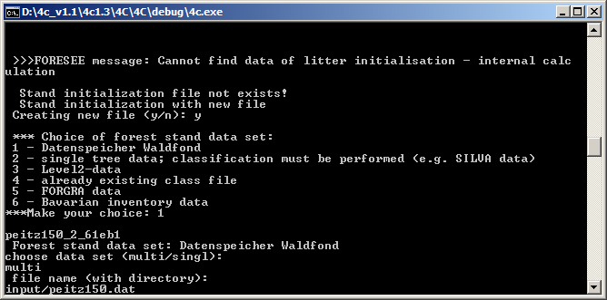

Structure of the input file
Example for three stands (txt-file, numbers separated by space):
1 0 0 0 0 0 1 11 62 1.0 9.2 10.4 29.5 0 0
2 0 0 0 0 0 1 11 67 1.0 9.9 11.4 31.01 0 0
3 0 0 0 0 0 1 11 62 1.0 9.0 10.8 21.3 0 0

Column 1: number of the stand
Columns 2 – 6: zero (not used)
Column 7: number of rows per stand, in the case of mono-species stand 1, for a mixed stand >1; the mixed stand is described by one row per species
Column 8: species type (see Table 1)
Column 9: age
Column 10: patch size (ha)
Column 11: mean height (m)
Column 12: mean DBH [cm]
Column 13: basal area (m²)
Columns 14-15: 0
Table 1 Species type code in column 8
Species type number | species | Taxid in 4C  (species.par) | species
1 | Abies alba | 2 | spruce
2 | Acer platanoides | 1 | beech
3 | Acer | 1 | beech
4 | Alnus glutinosa | 5 | birch
5 | birch | 5 | birch
6 | Carpinus betulus | 1 | beech
7 | Castanea sativa | 4 | oak
8 | Beech | 1 | beech
9 | Frax. excelsior | 4 | oak
10 | Spruce | 2 | spruce
11 | pine | 3 | pine
12 | Populus tremula | 8 | aspen
13 | Quercus petrea | 4 | oak
14 | Quercus pub. | 4 | oak
15 | oak | 4 | oak
16 | Tilia cordata | 1 | beech
17 | Ulmus glabra | 4 | oak
21 | Douglasie | 10 | Douglas fir
23 | Pinus strobus | 7 | Pinus ponderosa
24 | larix | 10 | Douglas fir
30 | Eucalyptus glob. | 12 | Eucalyptus glob.
31 | Eucalyptus grandis | 13 | Eucalyptus grandis

Output
In the input directory the resulting ini-file is stored, in the case of the example it contains three initializations:

1 -99. ! = volume function, patch size
! data source= D source file= input/peitz150.dat
! sapwood fraction and form factor now dynamic per cohort
! 4C Tree Initialization File (Stand)
!
! contains the following data (single tree values):
!
! x_Ahb: cross sectional area of heartwood at stem base (cm**2)
! height: tree height (cm)
! x_hbole: bole height (cm)
! x_age: tree age (years)
! n: number of trees
! sp: species (integer number)
! DC: diameter at crown base
! DBH: diameter at breast height
!
! x_fol x_frt x_sap x_hrt x_Ahb height x_hbole age n sp DC DBH
1 10000.00 stand identifier, stand area
0.70841 0.70841 5.24632 2.82494 40.14457 860. 662. 62 602 3 4.29339 7.48289
0.90351 0.90351 7.54647 4.06348 48.97933 989. 763. 62 623 3 4.84511 8.45072
1.12823 1.12823 10.47202 5.63878 59.20908 1118. 865. 62 561 3 5.40435 9.44331
1.37929 1.37929 14.03830 7.55908 70.64241 1245. 964. 62 419 3 5.96350 10.44129
1.64671 1.64671 18.12082 9.75737 82.81343 1364. 1056. 62 312 3 6.50443 11.40866
1.94359 1.94359 22.93710 12.35074 96.31477 1480. 1146. 62 271 3 7.05613 12.39447
2.27304 2.27304 28.58420 15.39149 111.26393 1595. 1234. 62 208 3 7.62122 13.40385
2.62625 2.62625 34.95127 18.81991 127.26677 1704. 1317. 62 143 3 8.18532 14.40769
3.01102 3.01102 42.18682 22.71598 144.67072 1811. 1398. 62 85 3 8.75958 15.42706
3.41182 3.41182 49.98800 26.91661 162.78668 1909. 1471. 62 46 3 9.32173 16.42174
3.81805 3.81805 58.22078 31.34965 181.11896 1998. 1538. 62 32 3 9.86036 17.37187
4.25874 4.25874 67.59649 36.39811 200.97351 2085. 1605. 62 17 3 10.41388 18.34706
4.71262 4.71262 77.52253 41.74290 221.42387 2170. 1665. 62 2 3 10.95478 19.30000
5.16239 5.16239 87.64429 47.19308 241.66017 2250. 1720. 62 1 3 11.46559 20.20000
5.57939 5.57939 97.09858 52.28385 260.43759 2310. 1765. 62 2 3 11.91967 21.00000
6.31979 6.31979 114.74910 61.78798 293.61395 2415. 1845. 62 2 3 12.68594 22.35000
7.10632 7.10632 133.50533 71.88748 328.99533 2510. 1910. 62 1 3 13.45220 23.70000
7.40932 7.40932 141.30211 76.08575 342.49506 2550. 1940. 62 1 3 13.73600 24.20000
-99.9
2 10000.00 stand identifier, stand area
0.67687 0.67687 5.24507 2.82427 40.99206 860. 662. 67 654 3 4.22645 7.48226
0.86314 0.86314 7.54202 4.06109 50.00311 989. 763. 67 674 3 4.77069 8.44926
1.07978 1.07978 10.49826 5.65291 60.53798 1119. 865. 67 588 3 5.32513 9.45034
1.31929 1.31929 14.05975 7.57063 72.20179 1246. 964. 67 459 3 5.87192 10.44597
1.58098 1.58098 18.24033 9.82172 84.94003 1367. 1058. 67 330 3 6.41174 11.43515
1.86308 1.86308 23.03374 12.40278 98.65436 1482. 1148. 67 296 3 6.94448 12.41351
2.17683 2.17683 28.67710 15.44151 113.88295 1597. 1235. 67 210 3 7.49293 13.41810
2.50081 2.50081 34.77378 18.72434 129.58844 1701. 1315. 67 139 3 8.01875 14.38201
2.85424 2.85424 41.70235 22.45511 146.69318 1803. 1393. 67 85 3 8.55520 15.36471
3.25111 3.25111 49.77486 26.80185 165.87625 1906. 1470. 67 54 3 9.12054 16.39815
3.68089 3.68089 58.89715 31.71385 186.61624 2007. 1545. 67 31 3 9.69815 17.44839
4.05919 4.05919 67.07206 36.11573 204.88364 2085. 1602. 67 13 3 10.17947 18.32308
4.62100 4.62100 79.73067 42.93190 231.93358 2195. 1680. 67 2 3 10.85624 19.55000
5.15564 5.15564 91.83128 49.44761 257.67346 2280. 1745. 67 2 3 11.46149 20.65000
5.79870 5.79870 107.07757 57.65715 288.50201 2380. 1820. 67 1 3 12.15216 21.90000
5.90509 5.90509 109.40089 58.90817 293.62674 2390. 1830. 67 1 3 12.26268 22.10000
6.64856 6.64856 127.80443 68.81777 329.31650 2495. 1900. 67 2 3 13.01173 23.45000
-99.9
3 10000.00 stand identifier, stand area
0.70968 0.70968 5.25960 2.83209 40.20183 860. 662. 62 451 3 4.29688 7.48958
0.90324 0.90324 7.54253 4.06136 48.96976 989. 763. 62 449 3 4.84466 8.44944
1.13088 1.13088 10.50996 5.65921 59.32653 1120. 866. 62 395 3 5.41045 9.45443
1.37846 1.37846 14.02761 7.55333 70.60268 1245. 963. 62 299 3 5.96177 10.43812
1.65127 1.65127 18.19434 9.79695 83.02018 1366. 1057. 62 225 3 6.51336 11.42445
1.93902 1.93902 22.86356 12.31115 96.10162 1479. 1145. 62 209 3 7.04762 12.37990
2.26848 2.26848 28.52081 15.35736 111.04946 1594. 1233. 62 146 3 7.61392 13.39041
2.63195 2.63195 35.04168 18.86860 127.53353 1705. 1318. 62 103 3 8.19414 14.42330
2.99481 2.99481 41.85144 22.53539 143.93817 1805. 1395. 62 62 3 8.73573 15.38548
3.43399 3.43399 50.43755 27.15868 163.76839 1914. 1476. 62 40 3 9.35170 16.47500
3.86293 3.86293 59.12800 31.83815 183.15358 2006. 1545. 62 19 3 9.91815 17.47368
4.26010 4.26010 67.60942 36.40507 201.04858 2087. 1604. 62 10 3 10.41555 18.35000
4.66391 4.66391 76.51435 41.20004 219.21188 2165. 1660. 62 2 3 10.89802 19.20000
5.11140 5.11140 86.68941 46.67892 239.27341 2240. 1720. 62 1 3 11.40883 20.10000
6.17920 6.17920 111.26530 59.91208 287.32614 2390. 1830. 62 1 3 12.54404 22.10000
6.98688 6.98688 130.64087 70.34509 323.63596 2500. 1900. 62 1 3 13.33868 23.50000

Single stand with averaged stand data
Flag_stand = 2 in the simulation control file

Dialogue

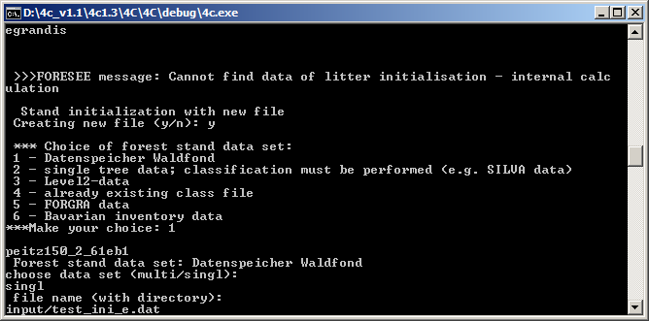

Input file
Example, similar to the structure of multi stand file, but only one row, and 14 columns (txt-file, numbers separated by space):
1 0 0 0 0 0 1 8 30 11.2 11.6 7.0 0 0
Column 1: number of the stand
Columns 2 – 6: zero (not used)
Column 7: number of rows per stand, in the case of mono-species stand 1, for a mixed stand >1; the mixed stand is described by one row per species
Column 8: species type (see Table 1)
Column 9: age
Column 10: mean height (m)
Column 11: mean DBH [cm]
Column 12: basal area (m²)
Columns 14-15: 0

Without explicit information on patch size, patch size is assumed 1 ha.
In the case of two species:
1 0 0 0 0 0 2 5 17 8.60 7.50 2.05 0.00 0.00 11 17 8.60 7.50 2.05 0.00 0.00
Column 7: 2 (means 2 species)
Column 8: 5 (first species birch)
Column 15: 11 (second species pine)
…..

Output file
Similar to the multi stand ini-file with only one initialization data set.

Initialization by planting using stand data
This method should be applied for stands with low DBH and age. The method of generating tree with Weibull distributions, used for initialization from averaged stand data, does not work very well in this case. Therefore an easier approach is recommended, which assumed planting of tree cohorts with fixed DBH but varying height.
Flags: flag_reg=20; flag_stand = 0

Dialogue

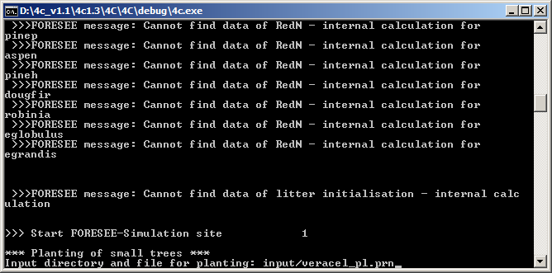

Input file
Example for a single stand (texfile, numbers separated by space):
1 1111 13 16.6 7 13.3 -99.9
Column 1: number of stand
Column 2: number of plants per ha
Column 3: species type – corresponds to the taxid number in 4C
Column 4: mean sapling height (m)
Column 5: age
Column 6: mean DBH (cm)
Column 7: bole height, if not available -99.9

It is also possible to plant several stands by a number of rows > 1

Output file
10 cohorts are intialised with varying height and equal DBH. In the case of a single stand initialization the first row ( 1 10000) should be removed.
Example:
1 10000. ! = volume function, patch size
! data source= source file= input/veracel_pl.prn
! sapwood fraction and form factor now dynamic per cohort
! 4C Tree Initialization File (Stand)
!
! contains the following data (single tree values):
!
! x_fol: foliage biomass (kg)
! x_frt: fine root biomass (kg)
! x_sap: sapwood biomass (kg)
! x_hrt: heartwood biomass (kg)
! x_Ahb: cross sectional area of heartwood at stem base (cm**2)
! height: tree height (cm)
! x_hbole: bole height (cm)
! x_age: tree age (years)
! n: number of trees
! sp: species (integer number)
! DC: diameter at crown base
! DBH: diameter at breast height
!
! x_fol x_frt x_sap x_hrt x_Ahb height x_hbole x_age n sp DC DBH
1 10000.00
4.96394 4.96394 32.95486 7.02160 79.13116 1328. 531. 7 111 13 10.26346 13.30000
4.96394 4.96394 34.89244 7.41983 76.48411 1370. 581. 7 111 13 10.26346 13.30000
4.96394 4.96394 36.83001 7.83187 74.38439 1411. 630. 7 111 13 10.26346 13.30000
4.96394 4.96394 38.76759 8.25384 72.67826 1452. 680. 7 111 13 10.26346 13.30000
4.96394 4.96394 40.70516 8.68320 71.26458 1494. 729. 7 111 13 10.26346 13.30000
4.96394 4.96394 42.64274 9.11819 70.07415 1536. 779. 7 111 13 10.26346 13.30000
4.96394 4.96394 44.58032 9.55760 69.05796 1577. 828. 7 111 13 10.26346 13.30000
4.96394 4.96394 46.51789 10.00051 68.18037 1619. 878. 7 111 13 10.26346 13.30000
4.96394 4.96394 48.45547 10.44625 67.41488 1660. 927. 7 111 13 10.26346 13.30000
4.96394 4.96394 50.39305 10.89434 66.74127 1702. 977. 7 111 13 10.26346 13.30000

Initialization with single tree data

Simulation file
The initialisation flag is set flag_stand = 2.
Example:
1 ! Run option 0 = single run, 1-6 multi run
1 !
! *** simulation specifications **************************************
1 ! number of simulation years
1990 ! start year for simulation
2500.0 ! patch size [m²]
50.0 ! thickness of foliage layers [cm]
7 ! time step photosynthesis calculations [d]
! *** choice of model options *****************************************
1 ! mortality flag (flag_mort)
0 ! regeneration flag (flag_reg)
0 ! use FORSKA environmental factors and regeneration (flag_forska)
2 ! initialization flag (flag_stand)
0 ! soil vegetation flag (flag_sveg) !!! new !!!
0 ! management flag (flag_mg)
0 ! disturbance flag (flag_dis)
4 ! light algorithm number (flag_light)
1 ! foliage-height relationship (flag_folhei)
1 ! volume function (flag_volfunc)
0 ! respiration flag (flag_resp)
15 ! limitation flag (flag_limi)
1 ! decomposition model (flag_decomp)
0 ! root activity function flag (flag_sign)
1 ! soil water uptake flag (flag_wred)
1 ! root distribution flag (flag_wurz)
0 ! heat conductance flag (flag_cond)
0 ! interception flag (flag_int)
0 ! evapotranspiration flag (flag_eva)
0 ! CO2 flag (flag_CO2)
0 ! dummy flag (flag_dum1)
0 ! dummy flag (flag_dum2)
0 ! dummy flag (flag_dum3)
! *** output specifications *******************************************
1 ! Yearly output flag
end
0 ! Daily output flag
end
0 ! cohort output flag
end
2 ! summation output flag
!******
input/species_neu.par
Zvirgzde11
input/Liep.cli
input/Zvir.sop
input/Ebw1617.soi
input/zvirgzde11.ini ! name of the new generated initialization file
9999
input/ebw03_h95.man
input/dummy.dep
input/dummy.red
input/dummy.lit

File with tree data
Example of an initialization file (txt-file with space separated numbers). If the bole height is not available (-99.9) it is estimated by a function in 4C.
Liepaja
26880 m² ! plot size
NR BA BHD H KA AL ! tree number, species type, BHD (mm), H (m), bole
height (m), age
1 3 27 2.3 -99.9 10
2 3 8 1.62 -99.9 10
5 3 22 1.7 -99.9 10
7 3 5 1.35 -99.9 10
9 3 6 1.4 -99.9 10
.
.
.
The species number in this file corresponds to the species number in species_neu.par.
If the stand consists of several species, the tree must be sorted according to the species type and the trees must be separated by a line starting with -9999.
Example:
Patchsize [m²]
3200
nr BA BHD H KA Al
.
229 3 301 24.3 -99.9 77
230 3 220 21.2 -99.9 77
-9999 3 0 0 0 77
7 5 253 23.4 -99.9 77
19 5 324 24.2 -99.9 77
…..

Initialisation dialog
Answers are necessary to the following questions:
1.question: Y
2. question: 2
3.question: 2
4. question: 2
Input directory and file: input/<name>.prn
See
The prn-file is placed in the input directory

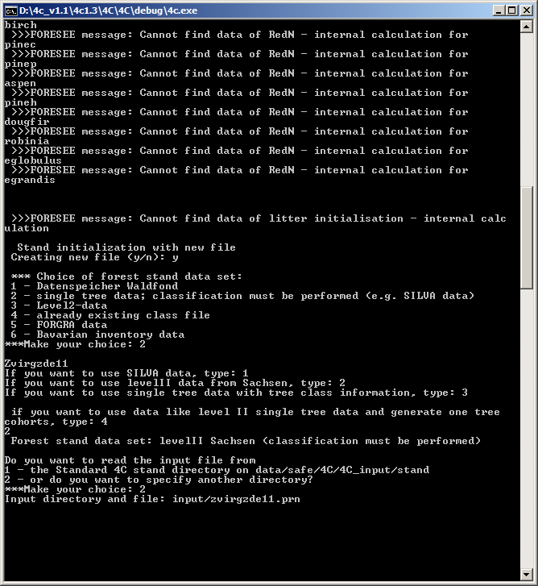

Result
A file <name>.ini file is produced in the input directory.
In the case of the example the file zvirgzde11.ini is produced.

Initialization with dbh class data

Simulation file
The initialisation flag is set flag_stand = 2.
The sim-file has the same structure as described in 6.1.

File with dbh class data
Example of an initialisation file (Brasschaat, Cermak 1998)

S 3 0.300 ! code S species type (pine), rsap (estimate)
10000 ! patch size (m²)
542 17 66 !number of trees, number of classes, age
166 17.5 0.004 15.4 ! dbh (mm), Height (m), share, bole height
186 18.3 0.026 15.7
203 19.3 0.081 16.5
222 19.6 0.116 16.5
242 20.1 0.170 16.7
261 20.5 0.173 16.8
280 20.8 0.153 17
300 21.1 0.118 17
315 22.3 0.037 17.5
339 22.3 0.052 17.4
361 22 0.035 17
381 22.8 0.020 17.2
394 21.9 0.006 17.1
420 23.2 0.004 15.9
438 22.2 0.002 17.6
460 20.9 0.002 16.8
484 23.3 0.002 15.4

Share: 0. < value <1 share of dbh class on the whole stem number

Initialisation dialog
- Question: y
- Question: 4
- Question: S
- Question: filename
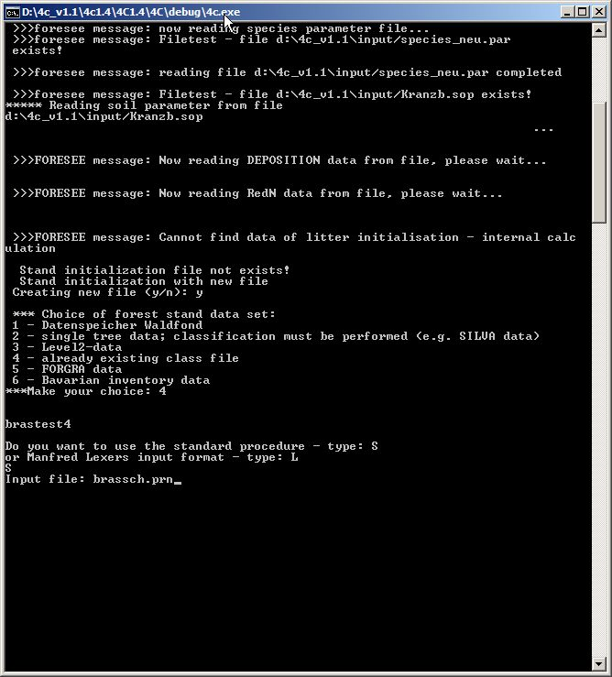

Result
A file <name>.ini file is produced in the input directory.

