**Climate change in the upstream parts of the Amazon and the Río de la Plata: Impacts and adaptation in the Water – Energy – Food Nexus of Bolivia**

Fred Fokko Hattermann, Anne Gädeke, Andrea Salinas, Stephanie Gleixner, Carlos Fernandez Palomino, Carlos Pedro Saavedra, Stefan Liersch, Genesis Nava, Hagen Koch

**Abstract**

The effects of climate change in Bolivia are already visible, and challenge the management of water and land with the retreat of glaciers, increased occurrence of extreme events such as floods and droughts and, as a result, increased variability in agricultural yields. Strategies are necessary and currently sought to avoid or reduce negative impacts through adapted management of natural resources, while enabling sustainable development.

Here, we firstly quantify the potential impacts of climate change on natural and managed water resources, crop yields and hydropower production in two regions of Bolivia (sub-basins of the Amazon and the Río de la Plata). The simulated climate impacts form the boundary conditions within which a series of adaptation measures, developed in a regional context, were defined in cooperation with the regional actors. Afterwards, their effectiveness under climate change conditions was estimated. The model used in the study to quantify the climate impacts and the effectiveness of possible adaptation measures integrates the relevant hydrological and vegetation processes, the management of arable crops, dams and hydropower generation in a process-based way.

The climate projections show a regionally varying pattern for Bolivia: The windward slopes of the Andes facing the Amazon basin receive in general more rainfall, while the Amazon lowlands and the Altiplano receive less. As a consequence, natural water supply and agricultural yields decrease in the Bolivian lowlands, whereas no changes or a possible increase in annual water availability and yields is simulated in the headwaters of the Amazon and Río de la Plata sub-catchments. At the same time, extreme events such as prolonged droughts will increase in both basins under scenario conditions. The results further illustrate that adapted management considering the Nexus Water – Food – Energy has the potential to compensate for the increase in flow variability to some extent, but the applied management has to balance the demand for irrigation water, electricity generation and flood protection. Moreover, the results showcase the importance of climate change mitigation, with the impacts on land, water and extremes being less severe under moderate warming.

**Introduction**

Many countries around the world, including Bolivia, will be severely affected by climate change with strong impacts on the water resources and related sectors within the Water – Energy – Food (WEF) Nexus (Gaetani et al. 2023, de Roo et al. 2021), and possibly serious effects for the livelihood and welfare of the local people and societies. The water cycle and vegetation processes are inextricably linked to the climate system, and for every additional increment of global warming, impacts become larger and related losses and damages likely escalate (IPCC 2022). Also, the effectiveness of available adaptation options decreases with every increment of warming (IPCC 2023). At the same time, the world is not advancing fast enough in its emission reductions nor in its adaptation efforts (UN 2022, IPCC 2023).

Earth observations such as the GRACE-FO satellite data show unusual low soil water and groundwater storage in larger parts of Central and Eastern South America, including the lowlands of the Amazon basin (Rodell et al. 2022). This is not only a threat for the local environment, for example the pristine rain forest, but also relevant for human water supply, because aquifers are the main source of water for human consumption in the Amazon and La Plata sub-basins in Bolivia (Guzman Rojo et al. 2024). Water-related impacts are often exacerbated by political decisions and the (mis-) management of water and land.

When the Paris Agreement entered into force in 2020, one focus was on ensuring that global pledges adequately consider adaptation and mitigation measures, which will be implemented and updated in the Nationally Determined Contributions (NDC, UN 2015). Almost all the NDCs identify water as a central component of their adaptation work and some also link water to the provision of sustainable energy, food security and forest restoration (UN Water 2010, Sadoff et al. 2020).

Bolivia is currently developing implementation and investment plans for climate change adaptation, and the Bolivian NDCs cover adaptation in the water, energy, forest and agriculture sectors including livestock. However, Bolivia lacked comprehensive analyses projecting climate risks in these sectors. To address this prevalent bottleneck, projections of climate impacts are needed. The projections are the input to further cost-benefit-analyses in order to select adaptation measures with focus on the water sector for the relevant economic sectors and the society.

The objective of this study is to provide a climate risk assessment to support the science informed design of robust water policies and adaptation strategies. Climate change adaptation measures are currently being planned all over the world, and the results of this study show how important it is to consider the feedback loops in the WEF Nexus.

**The study areas**

Bolivia has a very diverse landscape ranging from the Amazon rain forest in the northeast to the Andes Cordillera in the west. The latter acts as a topographic barrier for the warm and moist flux from the Amazonian region leading to strong local and regional differences in climate. As a result, the country has three clearly distinct regions: the lowlands with elevations up to 500 m above sea level (asl), which is about 60 % of the country; the Altiplano and the Andean mountains with elevations above 3500 m asl (around 16 % of Bolivia); and the valleys and the slopes of the Andean mountains which encompass the remaining 24 % of the Bolivian territory (Abadi et al., 2020). The climate varies from tropical in the northeast, semiarid in the southeast, mountainous tropical forests along the eastern slopes of the Andes, and arid highlands to the west (Velpuri et al., 2016). The mean annual precipitation (temperature) is about 1285 mm (22 °C), with 1300 mm (25 °C) in the state of Santa Cruz region and 745 mm (19 °C) in the state of Tarija.

To capture the physiographic diversity of Bolivia, two regions with three river basins have been selected for this study: The San Martín and Paraguá basins (Santa Cruz State) and the Guadalquivir basin (Tarija State) (Figure 1).

The Guadalquivir basin is located in the upper part of the Bermejo catchment in the state of Tarija with heights ranging between 1,595 and 4,750 m asl. The Bermejo is a tributary of the Río de la Plata flowing into Argentina and has a total basin area of 3,334 km². It is characterized by a large central valley surrounded by a chain of mountains and hills to the west and southeast, and mountains to the north (Moya et al., 2021).

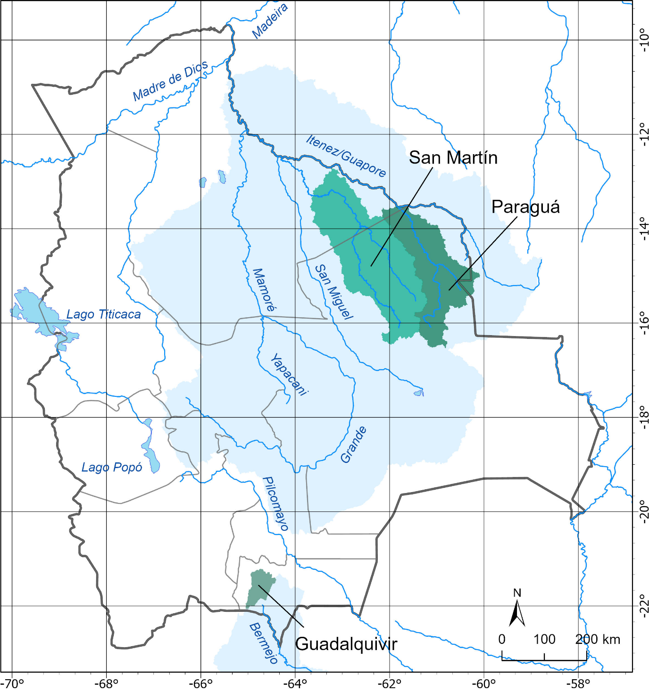 **Figure1: The study areas.**

The San Martín basin and the Paraguá basin are located within the Itenez catchment in the Chiquitanía Norte region of the state of Santa Cruz. Hydrographically, these two basins are part of the great Amazon basin. The San Martín River Basin is located in the north of the state, covering an area of 33,155 km². The Paraguá basin covers an area of 27,170 km² (Figure 1). The region's forests are considered one of the most productive in Bolivia (GAD Santa Cruz 2020). Their ecological value has also been recognized through the establishment of the largest protected area of Bolivia (Noel Kempff National Park).

**Data and Methods**

**Climate data**

The latest IPCC report (IPCC, 2021) considers several scenarios as possible projections into the future, the so-called shared socioeconomic pathways (SSPs). They span a range of additional radiative forcing levels from 2.6 to 8.5 W/m2 until 2100. SSP1-2.6 represents a future world with strong mitigation efforts, while SSP3-7.0 and SSP5-8.5 represent a future world with little to no mitigation. SSP1-2.6, SSP3-7.0 and SSP5-8.5 were chosen in this study to cover the widest possible range of the newest generation of climate scenario data. They are taken from the project ISIMIP (Inter-Sectoral Impact Model Intercomparison Project) phase 3 (Frieler et al. 2024), in which an ensemble of ten global climate models of the Coupled Model Intercomparison Project (CMIP6) has been downscaled to a 0.5° resolution and bias-adjusted, applying the methodology described in Lange et al. (2021). The calibration of the eco-hydrological model and the bias adjustment has been done using W5E5 reanalysis data, a merged dataset combining WFDE5 data over land with ERA5 data over the ocean (Lange et al. 2021). The W5E5 data were chosen, because they are the ones with which also the bias-adjustment of the ISIMIP climate data was done. The comparison of W5E5 and ISIMIP data for the historical period is presented in the Supplementary Material (A1).

**The eco-hydrological model**

The eco-hydrological and water management model SWIM (Soil and Water Integrated Model) was developed to investigate the impacts of climate and land use change at the regional scale (Krysanova et al. 2015, Hattermann et al. 2011). The model integrates all the relevant and interconnected hydrological, plant and management processes, such as runoff generation, plant growth, nutrient and carbon cycling, and erosion. In addition, water management measures and agricultural cropping patterns and yields can also be simulated. The water management module allows the simulation of different reservoir operations, e.g. focusing on flood protection, hydropower generation, water supply and low-flow control (Koch et al. 2013; Liersch et al. 2019). Irrigation and transmission losses are also implemented (Liersch et al. 2023). The agricultural module includes the simulation of cropping sequences, fertilisation and harvesting and the associated nutrient cycles. The vegetation module simulates the dynamic growth of crops, different forest types as well as grassland and shrubland. The approach thus allows the simulation of all interrelated processes and feedbacks of the WEF Nexus in a single model framework using a daily modeling time step.

SWIM uses a three-level disaggregation scheme from catchment (basin) to sub-basin to hydrotope (elements having the same properties in terms of land use, soil, and other features defined in the model set-up) that operates on a daily time step.

The results of the model calibration for both regions using observed river discharge, where data is available, are provided in the Supplementary Material (A2). The observed discharge data were provided by the local authorities. Figure 2 shows exemplarily a comparison of observed and modelled water levels and volumes of the San Jacinto Dam, the main reservoir located in the Guadalquivir basin. Because of the lack of regional data, simulated crop yields were compared and adjusted using national statistics (FAO 2024).

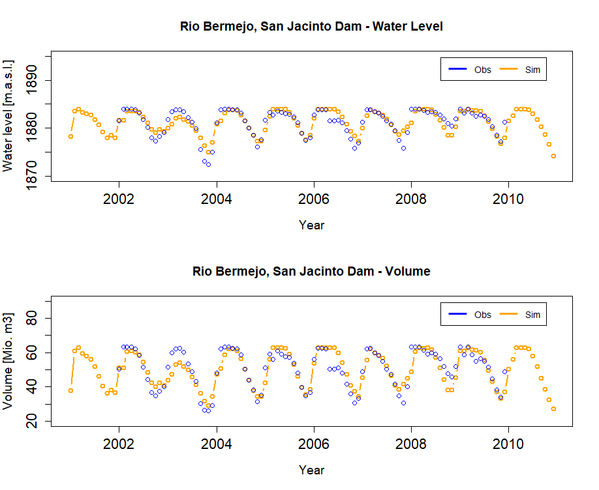

**Figure 2. Observed and simulated monthly water level and volume of the San Jacinto Dam (Guadalquivir basin, Tarija), modelled by SWIM.**

**Management scenarios and adaptation measures**

A series of workshops and discussions were held with the local actors of each target region to find out what adaptation measures are being discussed and planned. As a result, five adaptation options, applying to the geographical context of the two regions, were selected by the local experts: For the San Martín and Paraguá basins in Santa Cruz, the adaptation measures are i) restoration of areas affected by fires and ii) improvement of the current livestock practices including fodder production. For the Guadalquivir basin in Tarija, the adaptation options are improved dam operation with focus on water availability for irrigation with the second aim to produce more highly valuable crops such as iii) grapes and vi) strawberries. An additional focus was v) flood protection under climate change conditions.

The Tarija case study illustrates the dependencies within the WEF Nexus, where the various trade-offs and synergies can be quantified by adjusting reservoir operation in the model set-up.

Table 1: Definition of adaptation measures and scenarios for the Tarija region.

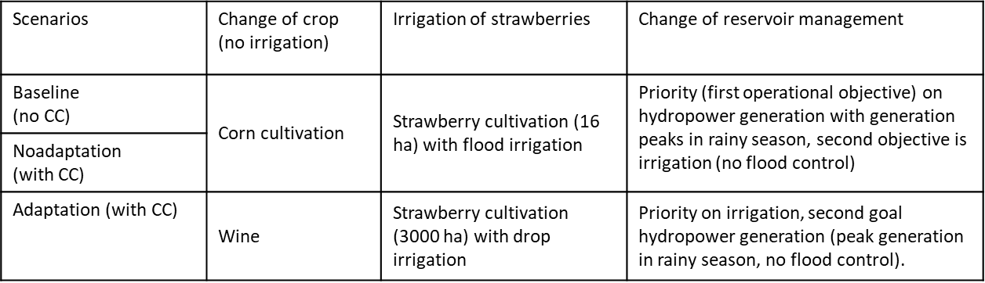

The implementation of the adaptation measures is embedded in the storylines of three main management scenarios (see Table 1):

* Baseline scenario: serves as a reference and describes the current status quo. The first objective of the reservoir operation is to generate hydroelectricity, and the second is supply of water for irrigation. There are no investments in the infrastructure. In this scenario, no climate change is considered.
* Adaptation scenario: the priority of reservoir management is shifted to irrigation water supply, while hydropower generation becomes the second objective. By 2050, successive parts of the irrigation pipeline will be renewed, increasing the water flow capacity and decrease transmission losses. The changing climate conditions additionally influence the water inflow to the dam.
* Non-adaptation scenario: the dam remains in an obsolete state so that agricultural land cannot be expanded. The allocation of water for hydropower and irrigation purposes remains the same as today (baseline). However, hydropower generation needs to be adjusted to the new flow conditions. As in the adaptation scenario, the change in climate affects the volume of water in the reservoir.

**Results**

**Climate change impacts on air temperature**

Air temperature projections show an increase in annual mean temperature under the three SSP scenarios over the 21st century compared to the reference period 1985-2015 (Figure 3a). The climate projections start to diverge after the 2030s. The SSP3-7.0 and SSP5-8.5 scenarios exhibit a steady increase in air temperature during the 21st century, whereas the warming trend of the SSP1-2.6 scenario stabilizes after the 2050s.

Compared to the reference period, projected far-future (2065-2095) changes show that annual mean temperature is very likely to be higher between 2°C-3.4°C in SSP1-2.6, 3.8°C-6.9°C in SSP3-7.0, and 4.4°C-8.2°C in SSP5-8.5, with a multi-model median of +2.5°C (SSP1-2.6), +4.7°C (SSP3-7.0), and +5.8°C (SSP5-8.5). Spatially, the largest increase in air temperature is projected for the southern Altiplano and northern lowlands (Figure A4 in the Supplementary Material). Projections of warming trends will contribute to more very hot days (Figure 3b), while fewer frost days are expected (Figure 3c) in all scenarios.

|  |  |  |
| --- | --- | --- |
| a) | b) c) |  |
|  |  | |

**Figure 3: Projected changes compared to the 1985-2015 average in annual mean air temperature (a), very hot days (b), and frost days (c) over the 21st century differentiated by the SSP scenario pathway for Bolivia.** **Lines and shaded areas show multi-model percentiles of 31-year running mean values. Lines represent the best estimate defined by the median of the ensemble and shaded areas the uncertainty bands defined by the confidence intervals of 66% (likely range) and 90% (very likely range).**

Maps of projected changes in mean annual temperature and changes in very hot are provided in the Supplementary Material (A3).

**Climate change impacts on precipitation**

The multi-model median indicates a negative trend in projected precipitation amounts over Bolivia under all scenarios with an average decrease of minus 30 mm (SSP1-2.6), minus 68 mm (SSP3-7.0), and minus 67 mm (SSP5-8.5) for the far future (2065-2095) relative to the reference period (Figure4). The large ensemble spread suggests high uncertainties in precipitation projections across the model ensemble. Precipitation is projected to decrease during wetter months, especially during September through November under SSP3-7.0 and SSP5-8.5 scenarios. During December to February, precipitation tends to decrease in the second half of the century for all scenarios.

Important is that the projected changes in precipitation differ largely across regions (Figure 4). Focus is made on areas with high confidence (more than 75 % of CMIP6 models agree on the sign of the change in the precipitation projections, see dots in Figure 4). Less precipitation is projected in the northern lowlands, where concurrently the largest increase in temperature is projected. More precipitation is simulated for the northern part of the Bolivian Altiplano and the Andes' south-eastern slopes, where the Tarija department is located. A robust and alarming result is that all areas show an increase of extreme drought events (Figure 5).

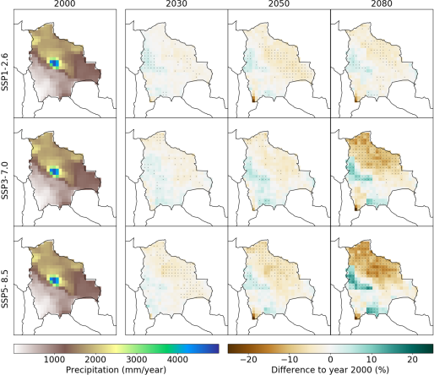

**Figure 4: Projected changes in mean annual precipitation in the near-future (the 2030s; 2015-2045), mid-century (2050s; 2035-2065), and far-future (2080s; 2065-2095) relative to the reference period (2000s; 1985-2015) for the three different SSP scenarios.**

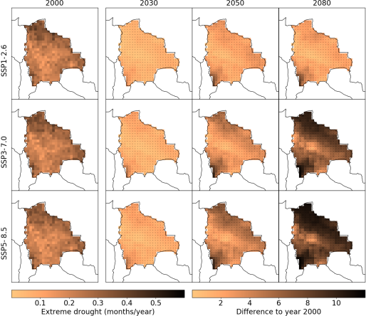

**Figure 5: Projected changes in the frequency of months with extreme drought conditions (standardized precipitation evapotranspiration index [SPEI] <= -2) in the near-future (the 2030s; 2015-2045), mid-century (2050s; 2035-2065), and far-future (2080s; 2065-2095) compared to reference period (2000s; 1985-2015) for the three different SSP scenarios.**

Maps of projected changes in mean annual frequency of heavy precipitation days and frequency of extreme drought events are provided in the Supplementary Material (A3).

**Impacts on hydrology and crop yields**

The model SWIM was used to translate the changes in climate into impacts on water resources, extreme river flow and crop yields. As a result of the regionally different climate trends and the uncertainty therein, impacts on water resources and vegetation differ between the two regions of Tarija and Santa Cruz and come with a considerable range of uncertainty. However, some robust pattern is visible.

a) b)

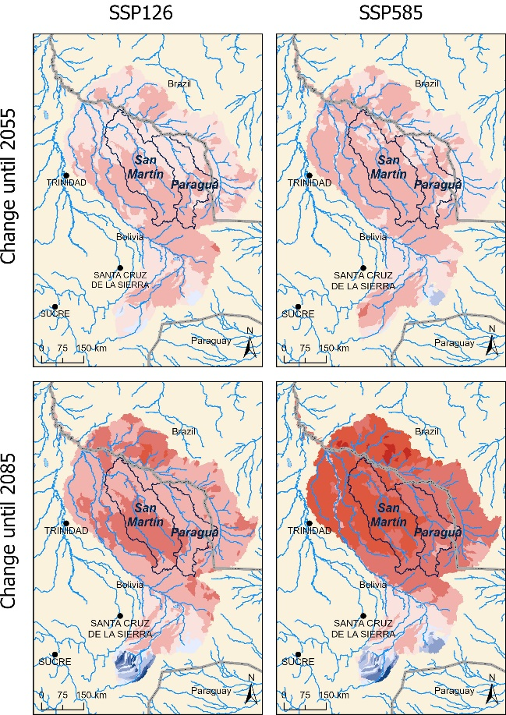 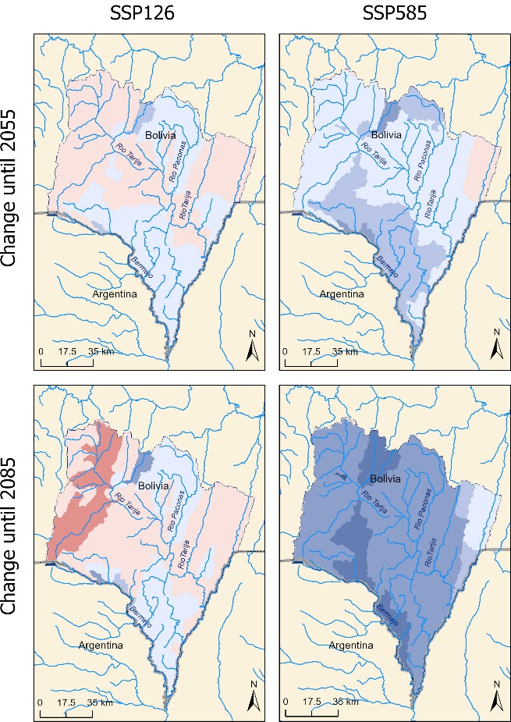

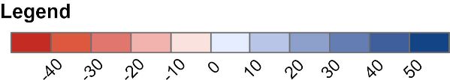

**Figure 6a: Change in discharge under climate change until mid of the century (top) and end of the century (bottom) and for the low warming scenario (left) and the high warming scenario (right) for the Itenez/Rio Grande basins relative to the reference period (2000s; 1985-2015). Figure 6b: The same for the Bermejo basin.**

Figure 6 illustrates the spatial distribution of mean changes in river flow in the Itenez basin (with the basins San Martin and Paraguá located within) and in the Bermejo basin (with the Guadalquivir basin located within). In the Itenez basin, almost only decreases in discharge are visible with down to -15 % until around 2055 and down to -25 % until the end of the century under the moderate climate scenario SSP1-2.6 conditions (with low increase in temperature and possible decrease in precipitation). The impacts are more extreme under the SSP5-8.5 scenario, with some increases in river flow in the upstream parts of the basin, but uniformly strong decreases in the San Martin and Paraguá basins down to around -25 % until mid of the century and down to -40 % until the end of the century.

In the Bermejo basin, there are only slight changes with decreases and increases in river flow visible in the headwaters of the basin, ranging from a decrease of -5 % to an increase of +10 % under the conditions of the moderate climate scenario SSP1-2.6 and until the mid of the century (Figure 6b). The changes aggravate with values between -10 % and +20 % in some subbasins until the end of the century under moderate climate warming. In contrast, the changes are in almost all cases positive under the warmer scenario SSP5-8.5, with up to +20 % until mid of this century and +40 % until the end of the century.

With the overall increase in meteorological drought frequency (Figure 5), also low flow conditions increase in number and intensity in both basins. Figure 7 provides boxplots with the ranges of change per scenario and period. All low flow indicators (Q90, Q95 and Q99, with 90 %, 95 % and 99 % of the daily values above) show strong decreases in discharge, the strongest in the far future and for the high-end scenario SSP5-8.5 with up to -50 % less discharge for Q95 and Q99.

While high flows generally increase in the Bermejo basin, moderate high flow indicators (Q10 and Q5, with 10 % and 5 % of the daily values above) show no changes or even decrease in the Itenez basin, with the strongest decreases for the scenarios SSP3-7.0 and SSP5-8.5. Only the extreme high flow indicator (Q1 with 1 % of the flows above) has an increase up to the mid of the century and for scenarios SSP1-2.6 and SSP3-7.0.

a)

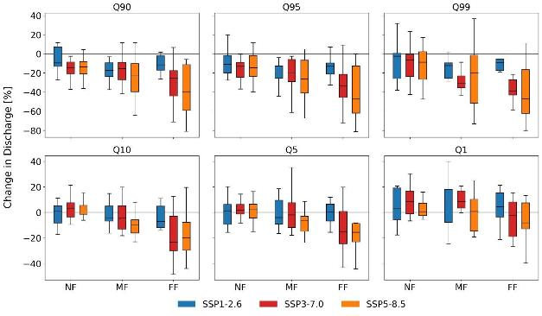

b)

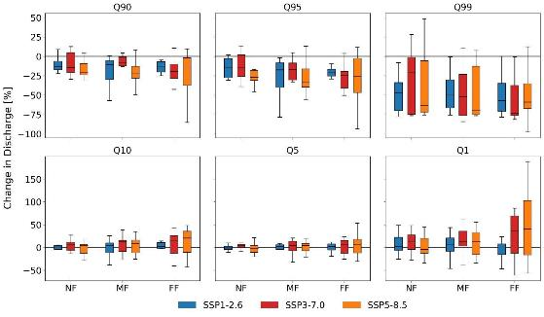

**Figure 7: Change in low flow (Q90, Q95, Q99) and high flow (Q10, Q5, Q1) indicators at (a) Principe da Beira gauging station (downstream San Martin and Paraguá) and (b) San Jacinto (Bermejo) for the near (NF) to far (FF) future relative to the reference period (1985-2015). SWIM simulations forced by 10 bias-adjusted CMIP6 models and three different SSPs.**

Especially in the Bolivian lowlands, the decrease in precipitation and increase in drought conditions could negatively impact crop yields (soybean as an example) and pasture (Figure 8). While the moderate scenario SSP1-2.6 gives only small decreases, severe changes are visible, especially in the high-end scenario SSP5-8.5. The crop yields modelled by SWIM show the strongest decrease at the end of the century (SSP5-8.5) with more than 25 % for pasture and around 45 % for soybean on average when considering the pure climate effects without change in management. Because of the possible slight increase in precipitation and the overall increase in temperature, crop yields in the Bermejo basin may have a small positive trend.

Additional information about the impacts on impacts on seasonal flows and inflow into two reservoirs in the Santa Cruz region are provided in Supplementary Material (A4).

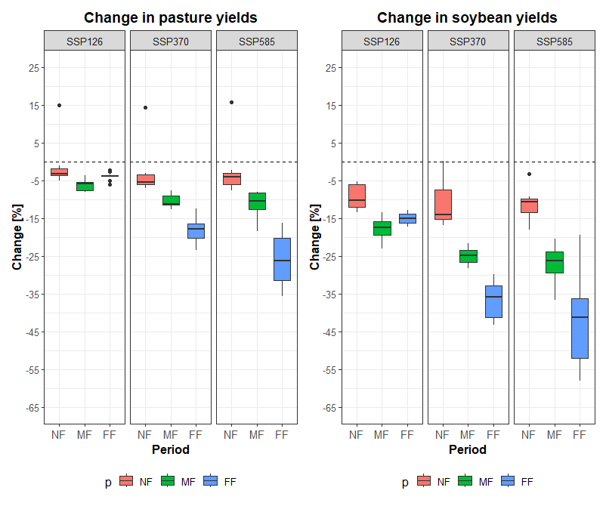

**Figure 8: Scenario yields of soybeans (during austral summer, wet season) and pasture (two harvest/ grazing periods) in the Santa Cruz region in the near (NF) to far future (FF) relative to the reference period (1985-2015).**

**Adaptation measures integrating water and land management**

Of the set of measures discussed with the local actors and experts in the Guadalquivir basin (Tarija), adapted reservoir management considering the integration of irrigation, flood protection and hydropower generation has been selected as the example to illustrate the impacts and feedbacks within the WEF Nexus. Priority on flood protection was considered as an additional adaptation measure because of the possible increase in flood risk under climate change conditions (see Figure 7). In the flood protection mode (“Flood protection”), a larger part of the reservoir volume is consequently used for flood prevention, thus reducing the volume available for irrigation water supply and hydropower generation. In the management strategy with priority on hydropower (“Constant electricity”), as much water as possible is stored in the rainy season for hydropower generation in the dry season. The active storage capacity of the reservoir is approximately 45 million m3 and is thus the volume which can be managed with different priorities.

The combined impacts of climate change and reservoir management on the water stored in the dam and hydropower generation is shown in Figure 9. One result is that without larger changes in annual inflow into the reservoir under scenario conditions, the reservoir is able to buffer the increase in variability, and management scenarios have a larger impact than the climate scenarios in the near, middle, and far future. The greatest difference is simulated between the adaptation measure “Constant electricity” with as much water stored in the rainy season as possible and the “Flood protection” measure with as much water released in the rainy season as possible to have free storage in case of a flood.

In the “adaptation” scenario, where the goal is to optimize and expand irrigation, more water is stored in the reservoir for irrigation than in the “no adaptation” scenario, to enable irrigation of 3000 ha of strawberries in the dry season. In the no adaptation scenario, less water is stored than in the “adaptation” scenario and the released water is used for hydropower production.

a) b)

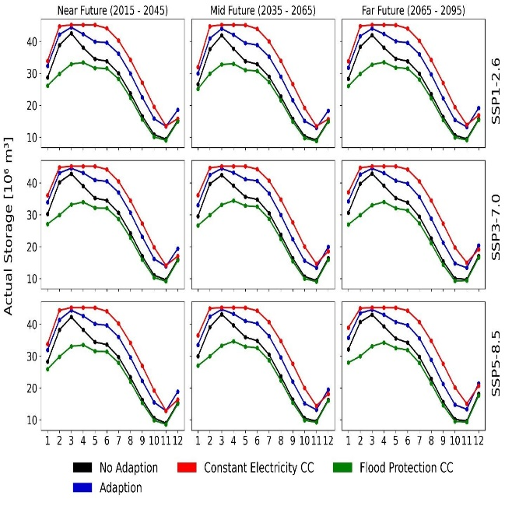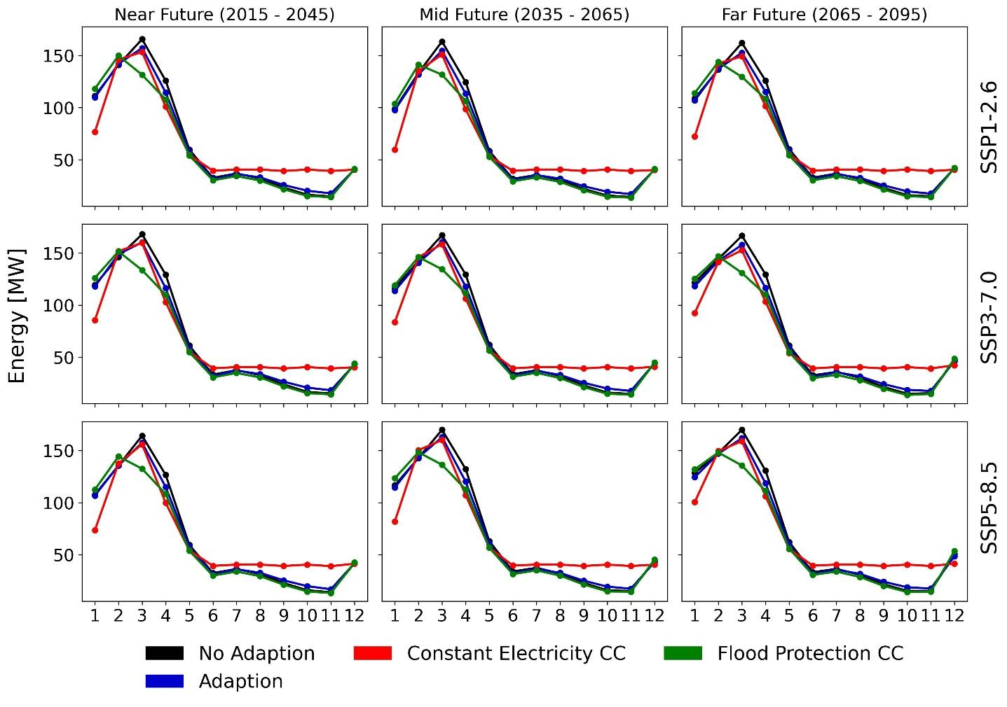**Figure 9: Storage (a) and hydropower generation (b) in the San Jacinto dam based on the three climate and four management strategies. Simulations are based on SWIM forced by 10 bias-adjusted CMIP6 climate models (ensemble median) for three different SSPs (SSP1-2.6, SSP3-7.0).**

Not surprisingly, the highest electricity production, especially in the dry season, is under “Constant electricity” scenario conditions (Figure 9b), because the water stored in winter is released in summer. Visa versa, the lowest electricity production is under “Flood protection” scenario conditions, because less water is stored to have a buffer volume in case of a flood event.

In order to estimate the needed volume for additional irrigation from the reservoir and to estimate the potential area of additional irrigation, SWIM was applied to stepwise increase the amount of irrigated areas for strawberry cultivation in the Bermejo basin from 3000 ha to 7000 ha, with the water taken from the reservoir. We further investigated the impact considering different irrigation measures with i) irrigation is managed as flood irrigation (as it is done currently in the basin) and ii) the irrigation infrastructure has been improved to drip irrigation.

The results shown in Figure 10 and Figure 11 quantify how often thresholds of water storage in the reservoir would be exceeded, in Figure 10 considering flood and in Figure 11 considering drip irrigation with stepwise increase of irrigated area from 3000 ha over 5000 ha to 7000 ha. The future climate projections are displayed for the near-future (NF, 2015-2045), mid-future (2035-2065, MF), and far-future (2065-2095, FF) based on 10 bias-adjusted CMIP6 climate models and three SSPs (SSP1-2.6, SSP3-7.0, SSP5-8.5).

The additional irrigation demand can be covered in almost all cases when the demand rises to irrigation of 3000 ha. The demand is considerably lower when applying drip irrigation. When increasing the irrigated area to 7000 ha, not enough water might be in the reservoir in the dry season when flood irrigation is applied, however, the situation improves with drip irrigation.

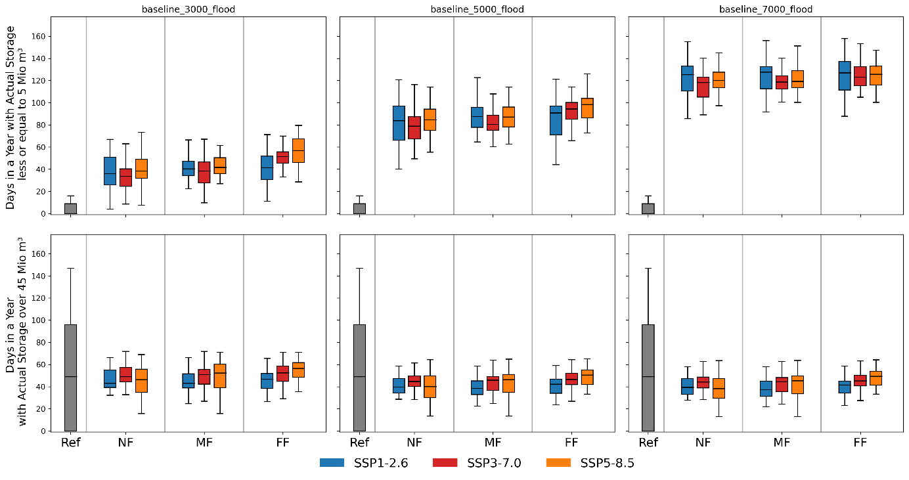

**Figure 10: Number of days when the actual storage of the reservoir is larger than 45 million m3 or lower than 5 million m3, considering application of flood irrigation of 3000 ha (left), 5000 ha (middle) and 7000 ha (right) of land from the reservoir.**

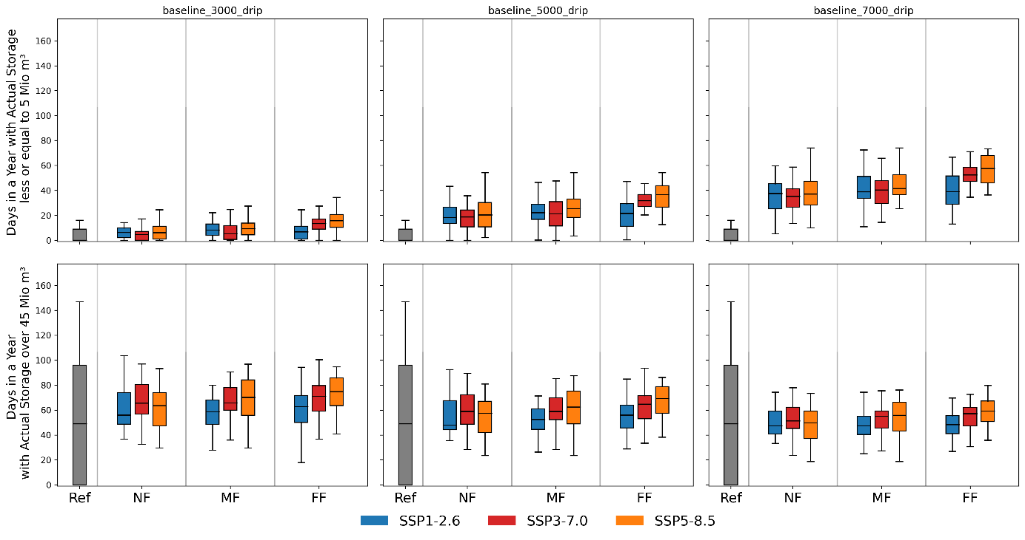

**Figure 11: Number of days when the actual storage of the reservoir is larger than 45 million m3 or lower the 5 million m3, considering application of drip irrigation of 3000 ha (left), 5000 ha (middle) and 7000 ha (right) of land from the reservoir.**

It is obvious that drip irrigation leads to more storage in the reservoir and is as such more sustainable, for example when looking at electricity generation in the dry season. The number of days, when the active storage is less than 5 Mio m3, increases to on average more than 100 days per year under flood irrigation and until the end of the century (Figure 10, flood irrigation), while it is on average less than 50 days per year until the end of the century under drip irrigation (Figure 11).

Additional information about the impacts of irrigation treatment on reservoir storage are provided in the Supplementary Material (A5).

**Discussion**

Climate warming in Bolivia is projected to be higher than mean global warming. Similar results for Bolivia have also been found in the future warming projections based on the CMIP5 scenario generation (Seiler et al., 2013). The projected changes show less precipitation over the lowlands, and an increase at the eastern slopes of the Andes. The projected decrease of precipitation over the lowlands is in line with the currently observed negative trend (-5.1 mm/year) reported for the Madeira River basin by Da Motta-Paca et al. (2020), and with the increase over the Andes such as the south-eastern slopes and northern part of the Altiplano where positive precipitation trends were reported by Torres-Batlló and Martí-Cardona (2020), Segura et al. (2020) and Seiler et al. (2013). Uncertainties in precipitation projection are probably due to uncertainties in climate models in the simulation of precipitation over this region where precipitation patterns are modulated by the interplay among large-scale (e.g., latitudinal migration of Atlantic Intertropical Convergence Zone, South American Monsoon Systems, Bolivian Highlands) and local circulation patterns (e.g., upslope and downslope moisture transport) and the complex Andean orography (Espinoza et al., 2020; Segura et al., 2020; Garreaud 2009). These climatic patterns are also strongly affected by the El Niño-Southern Oscillation (ENSO) (Poveda et al., 2020), and due to the interactions among such a variety of phenomena, there can be large biases in simulating precipitation in CMIP6 models (Arias et al. 2021).

As a result, impacts on water resources and crop yields differ in the lowlands and the slopes of the Andes, and the adaptation measures of the NDC and other national policies should be flexible to different developments of climate in the regions. While in Tarija there is a tendency to no changes or more water availability (SSPs 3-7.0 and 5-8.5), but with huge uncertainty and even a tendency to less availability under moderate climate change (SSP1-2.6) and overall more droughts, all scenarios show less water availability in the lowlands of Santa Cruz, the stronger, the higher the temperature increase is. It is important to notice that the yet uncertain projection of more water availability in Tarija diverge from the results of Álvarez, et al. 2021, where scarcity of water resources in Tarija was pointed out, yet, based on only two GCM outputs of CMIP5.

The results show that reservoirs have the potential to alleviate hydrological extremes, but this comes with trade-offs for specific water users within the WEF Nexus. Thus, it has to be robust enough to be adaptable to changing conditions over time (Loucks and van Beek, 2017).

**Conclusions**

Climate change is a global phenomenon, but the impacts manifest at the regional scale. It is therefore important to consider the variety of landscapes and manifestations of climate change in local impact and adaptation studies. One example is the upstream part of the Amazon and La Plata rivers, where precipitation may increase in the headwaters located at the upper slopes of the Andes, but may decrease downstream in the lowlands. As a result, water availability within the WEF Nexus changes and the management of water and land has to be adapted. Adaptive management has the potential to mitigate the worst effects of climate change, as long as climate change does not progress too far.

Furthermore, the decline in rainfall at the foot of the Andes and in the lowland areas of the Amazon and La Plata rivers does not bode well for the valuable environment in these areas, and further research is needed to assess the impact e.g. on the vulnerable pristine rainforest which is already under pressure by human activities such as deforestation and expansion of agriculture.

The results also illustrate how important climate change mitigation is: the impacts on water resources and hydrological extremes (droughts and floods) increase in both areas in number and intensity with the increase in temperature (from the moderate warming scenario SSP1-2.6 to the strong warming scenario SSP5-8.5).

**Acknowledgements**

Several institutions, colleagues and experts have contributed to the development of this study by providing data, collaborating in mapping, conducting reviews and providing valuable criteria for the interpretation of the results. The authors are particularly grateful to the Directorate of Planning, Vice Ministry of Water Resources and Irrigation (Dirección de Planificación, Viceministerio de Recusos Hídricos y Riego), the National Meteorological and Hydrological Service (Servicio Nacional de Meteorología e Hidrología), the Departmental Autonomous Government of Santa Cruz (Gobierno Autónomo Departamental de Santa Cruz) and the Departmental Autonomous Government of Tarija (Gobierno Autónomo Departamental de Tarija).

This study is part of the “Climate risk assessment to identify robust adaptation strategies in the water sector in Bolivia” ([download here](https://www.bivica.org/file/view/id/6432)), which was funded by the German Cooperation through the Deutsche Gesellschaft für Internationale Zusammenarbeit (GIZ) GmbH.

**References**

Abadi A M, Rowe CM and Andrade M (2020) Climate regionalization in Bolivia: A combination of non-hierarchical and consensus clustering analyses based on precipitation and temperature. International Journal of Climatology, 40(10), p. 4408-4421. https://doi.org/10.1002/joc.6464

Álvarez C, Rojo J, Sampedro N, Cacho E, Garcia E, Ayala R, Aguilar R, Oller C, Pereira D and Peres JA (2021) Índice de vulnerabilidad y adaptación al cambio climático en la ciudad de Tarija, Bolivia. Resumen Ejecutivo. (CAF, Ed.). ISBN:978-980-422-245-0

Arias PA, Ortega G, Villegas LD and Martinez JA (2021) Colombian climatology in CMIP5/CMIP6 models: Persistent biases and improvements. Facultad de Ingeniería, 100, p. 75-96. https://doi.org/10.17533/udea.redin.20210525

Da Motta-Paca VH, Espinoza-Dávalos GE, Moreira DM and Comair G (2020) Variability of Trends in Precipitation across the Amazon River Basin Determined from the CHIRPS Precipitation Product and from Station Records. Water Journal, 12, p. 1244. <https://doi.org/10.3390/w12051244>

De Roo A, Trichakis I, Bisselink B, Gelati E, Pistocchi A and Gawlik B (2021) The Water-Energy-Food-Ecosystem Nexus in the Mediterranean: Current Issues and Future Challenges. *Front. Clim.* 3:782553. doi: 10.3389/fclim.2021.782553

Espinoza JC, Garreaud R, Poveda G, Arias PA, Molina-Carpio J, Masiokas M, Viale M and Scaff L (2020) Hydroclimate of the Andes Part I: Main Climatic Features. Frontiers in Earth Science, 8(64). <https://doi.org/10.3389/feart.2020.00064>

FAO (2024) Food and Agriculture Organization of the United Nations - Production: Crops and livestock products (<http://www.fao.org/faostat/en/#data/QCL>, retrieved April 2024).

Frieler, K., …Hattermann, et al. (2024) Scenario setup and forcing data for impact model evaluation and impact attribution within the third round of the Inter-Sectoral Model Intercomparison Project (ISIMIP3a). - Geoscientific Model Development, 17, 1, 1-51.

GAD Santa Cruz y AMDECRUZ. (2020) Plan de recuperación de zonas afectadas por incendios en el departamento de Santa Cruz. (FAO, Ed.)

Gaetani M, Ceglar A, Diedhiou A, Jerez S, Rodriguez-Fonseca B and Sultan B (2023) Editorial: (10 years) Water-energy-food nexus: Impact of climate variability and change on the water-energy-food nexus. Front. Clim. 5:1137710. doi: 10.3389/fclim.2023.1137710

Garreaud RD (2009) The Andes climate and weather. Advances in Geosciences, 22, p. 3-11. <https://doi.org/10.5194/adgeo-22-3-2009>

Guzmán Rojo MX, Hurtado CP y Vargas ZG (2024) Un viaje hacia la sostenibilidad hídrica y la visibilización del agua subterránea. SDSN Bolivia, 23, 2024

Hattermann FF, Weiland M, Huang S, Krysanova V and Kundzewicz ZW (2011) Model-Supported Impact Assessment for the Water Sector in Central Germany Under Climate Change—A Case Study. Water Resources Management, 25(13), p. 3113-3134. https://doi.org/10.1007/s11269-011-9848-4

IPCC. (2021). Climate Change 2021: The Physical Science Basis. Contribution of Working Group I to the Sixth Assessment Report of the Intergovernmental Panel on Climate Change. Cambridge University Press, Reyno Unido and New York, NY, USA. doi:10.1017/9781009157896

IPCC. (2022). Climate Change 2022: Impacts, Adaptation and Vulnerability. Contribution of Working Group II to the Sixth Assessment Report of the Intergovernmental Panel on Climate Change. Cambridge University Press. Cambridge University Press, Cambridge, Reyno Unido and New York, NY, USA. doi:10.1017/9781009325844

IPCC (2023) Summary for Policymakers. In: Climate Change 2023: Synthesis Report. Contribution of Working Groups I, II and III to the Sixth Assessment Report of the Intergovernmental Panel on Climate Change [Core Writing Team, H. Lee and J. Romero (eds.)]. IPCC, Geneva, Switzerland, pp. 1-34, doi: 10.59327/IPCC/AR6-9789291691647.001

Koch H, Liersch S and Hattermann FF (2013) Integrating water resources management in eco-hydrological modelling. Water Science and Technology 67(7), 1525-1533. doi: 10.2166/wst.2013.022.

Krysanova V, Hattermann F, Huang S, Hesse C, Vetter T, Liersch S, Koch H and Kundzewicz ZW (2015) Modelling climate and land-use change impacts with SWIM: lessons learnt from multiple applications. Hydrological Sciences Journal, 60(4), p. 606-635. https://doi.org/10.1080/026266 67.2014.925560

Lange S, Menz C, Gleixner S, Cucchi M, Weedon GP, Amici A, Bellouin N, Schmied HM, Hersbach H, Buontempo, C and Cagnazzo C (2021) WFDE5 over land merged with ERA5 over the ocean (W5E5 v2.0). Repositorio de ISI-MIP. <https://doi.org/10.48364/ISIMIP.342217>

Liersch S, Fournet S, Koch H, Djibo AG, Reinhardt J, Kortlandt J, Van Weert F, Seidou O, Klop E, Baker C and Hattermann FF (2019) Water resources planning in the Upper Niger River basin: Are there gaps between water demand and supply? Journal of Hydrology: Regional Studies 21, 176-194.

Liersch, S., Koch, H., Abungba, J. A., Salack, S., Hattermann, F. F. (2023) Attributing synergies and trade-offs in water resources planning and management in the Volta River basin under climate change. - Environmental Research Letters, 18, 1, 014032.

Loucks DP and van Beek E (2017) Water Resource Systems Planning and Management. An Introduction to Methods, Models, and Applications (Vol. 1). Switzerland: Deltares and UNESCO-IHE. doi:10.1007/978-3-319-44234-1

Moya MI, Meneses RI, Gonzales A, Palabral A, Loayza E, Urrelo V, Loza S and Cuba E (2021) La biodiversidad de la cuenca del río Guadalquivir: implicancias de su conservación para la seguridad hídrica de la region

Poveda G, Espinoza JC, Zuluaga MD, Solman SA, Garreaud R and van Oevelen PJ (2020) High Impact Weather Events in the Andes. Frontiers in Earth Science, 8(162). doi:https://doi.org/10.3389/feart.2020.00162

Rodell M, Li B, Getirana A, and Beaudoing HK (2022) NASA/GSFC/HSL (2022), Groundwater and Soil Moisture Conditions from GRACE and GRACE-FO Data Assimilation L4 7-days 0.25 x 0.25 degree Global V3.0, Greenbelt, MD, USA, Goddard Earth Sciences Data and Information Services Center (GES DISC), Accessed: [Data Access Date], 10.5067/SZYMDFZ7TJ4H

Sadoff C, Grey D and Borgomeo E  (2020, May 29) Water Security. Oxford Research Encyclopedia of Environmental Science. Retrieved 9 Aug. 2023.

Segura H, Espinoza JC, Junquas C, Lebel T, Vuille M and Garreaud R (2020) Recent changes in the precipitation-driving processes over the southern tropical Andes/western Amazon. Climate Dynamics, 54, p. 2613-2631. https://doi.org/10.1007/S00382-020-05132-6

Seiler C, Hutjes RA and Kabat P (2013) Likely Ranges of Climate Change in Bolivia. Journal of Applied Meteorology and Climatology, 52(6), p. 1303-1317. https://doi.org/10.1175/JAMC-D-12-0224.1

Torres-Batlló J and Martí-Cardona B (2020) Precipitation trends over the southern Andean Altiplano from 1981 to 2018. Journal of Hydrology, 590(125485). [https://doi.org/10.1016/j. jhydrol.2020.125485](https://doi.org/10.1016/j.%20jhydrol.2020.125485)

UN (2022) UN Climate Change. "Nationally determined contributions under the Paris Agreement: Synthesis report by the Secretariat." 2022

UN (2015) Paris Agreement to the United Nations Framework Convention on Climate Change, Dec. 12, 2015, T.I.A.S. No. 16-1104.

UN Water (2010) Climate Change Adaptation: The Pivotal Role of Water. https://www.unwater.org/sites/default/files/app/uploads/2017/05/unw_ccpol_web.pdf

Velpuri NM, Pervez S, Cushing, W M (2016) Hydropower assessment of Bolivia—A multisource satellite data and hydrologic modeling approach. Open-File Report 2016-1156, U.S. Geological Survey, U.S. Department of Interior. https://doi.org/10.3133/OFR20161156