Supporting Online Material for “Global Fossil Energy Markets and Climate Change Mitigation – an analysis with ReMIND”
Nico Bauer, Ioanna Mouratiadou, Gunnar Luderer, Lavinia Baumstark, Robert Brecha, Ottmar Edenhofer, Elmar Kriegler

Additional assumptions for the fossil fuel sector of the ReMIND model
Table S1 presents the assumptions of the decline rates of oil and gas for different regions. Fossil fuels are differentiated into various economic grades that are defined by a maximum cumulative extraction, lower costs and upper costs as well as annual decline rates. Grades are sorted by marginal extraction costs, see also Figure S1. The decline rates are lower bounds on extraction from each grade. Hence, the production profile from each grade is constrained by the decline rate. The default value is 15% p.a. Table S1 lists exceptions for oil and gas.
Table S1: Decline rates in percent per year of oil and gas per grade and region; source IEA (2008, 2009).
 | Oil |  |  |  | Gas
Grade | 1 | 2 | 3 |  | 1 | 2
MEA | 3.4 | 3.4 | 8 |  | 4.1 | 4.1
RUS | 5.8 | 5.8 | 8 |  | 4.1 | 4.1
LAM | 6.6 | 6.6 | 8 |  | 11.1 | 11.1
USA | 9.7 | 9.7 | 9.7 |  | 11.1 | 11.1
EUR | 11.9 | 11.9 | 11.9 |  | 11.1 | 11.1
AFR | 6.8 | 6.8 | 8 |  | 8.2 | 8.2
CHN | 6.7 | 6.7 | 9 |  | 8.2 | 8.2
IND | 6.7 | 6.7 | 8 |  | 8.2 | 8.2
JPN | 12.6 | 12.6 | 12.6 |  | 11.1 | 11.1
OAS | 6.7 | 6.7 | 8 |  | 8.2 | 8.2
ROW | 6.7 | 6.7 | 9 |  | 11.1 | 11.1

Table S2 presents the assumptions for the techno-economic assumptions for fossil fuel trade costs as implemented in REMIND. The 12% energy loss that comes from LNG trade and that is independent of distance is due to liquefaction.
Table S2: Parameters of trading costs. See Lüken (2011, Ch.5) and references therein.
 | Financial costs |  | Energy losses
 | Depending  on distance | Independent  of distance | Depending  on distance | Independent  of distance
 | US$/GJ*1000km | US$/GJ | % per 1000km | %
Natural gas (pipeline) | 0.4 |  | 2
Natural gas (LNG) | 0.08 | 1 | 0.2 | 12
Oil tanker | 0.023
Coal tanker | 0.014 | 0.4

Scenarios
The following Table S3 gives the overview of all scenarios that have been performed and used in this study.
Table S3: Overview of scenarios.
 | Climate Change Stabilization
Baseline  assumption | No Policy | 550 ppm-e | 450 ppm-e
Default | X | X | X
Fast Growth | X | X | X
Slow Growth | X | X | X
High Fossil | X | X | X
Low Fossil | X | X | X
Low Oil | X
High Coal | X
High Gas | X
Mod. Policy | X

Variation of baseline assumptions
This Section provides further details on the variation of baseline assumptions and the scenario design of the study.

Fossil fuel supply curves
Figure S1 shows the long-term fossil fuel supply cost functions that are assumed in the study. The crosses in the graphs mark the different fuel grades. If there were no dynamic constraints on extraction from different grades, the low cost strategy would be to extract from each grade until it is fully exhausted. Since the ReMIND model considers dynamic constraints, several grades will be exploited at the same point in time. The methodology to derive the fossil fuel supply curves, and the underlying quantitative assumptions, are described in the Supplementary Online Material to the Synthesis paper of the RoSE study (Kriegler et al.).
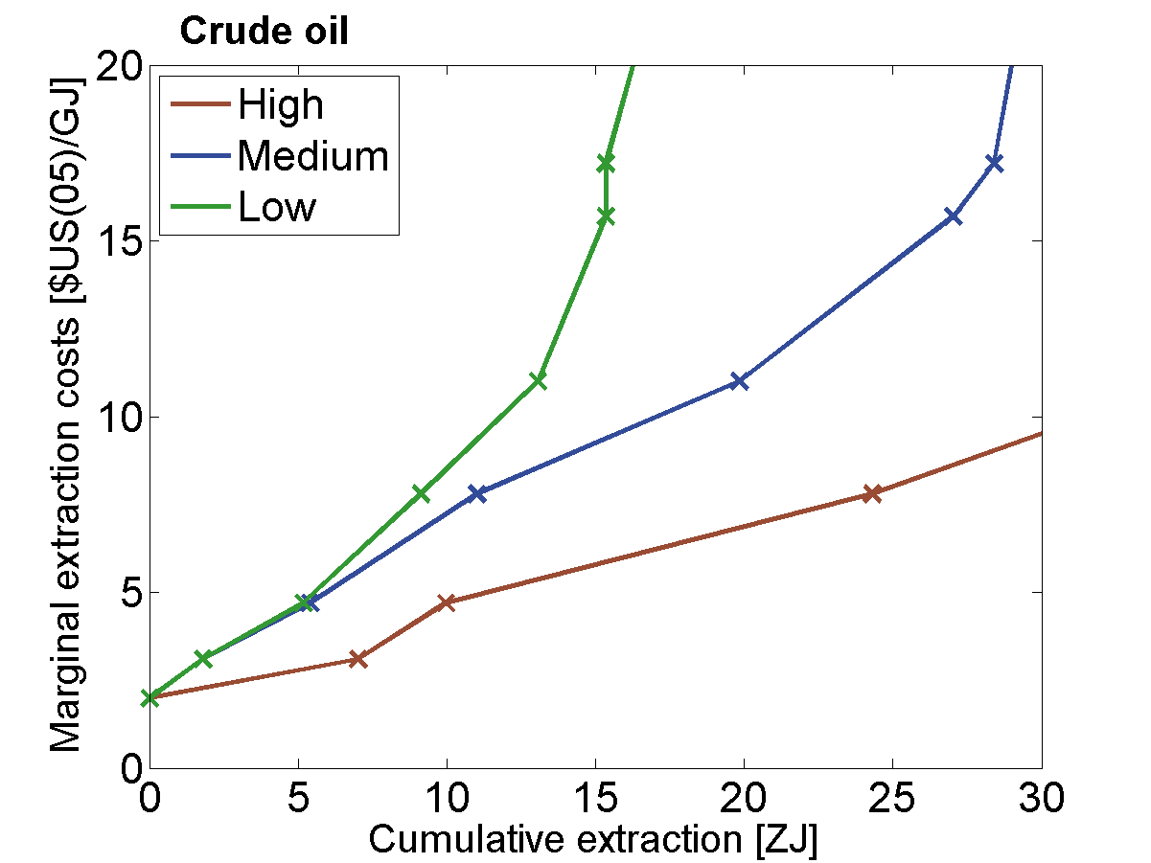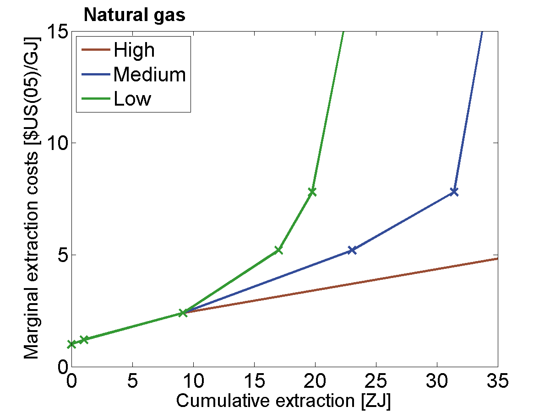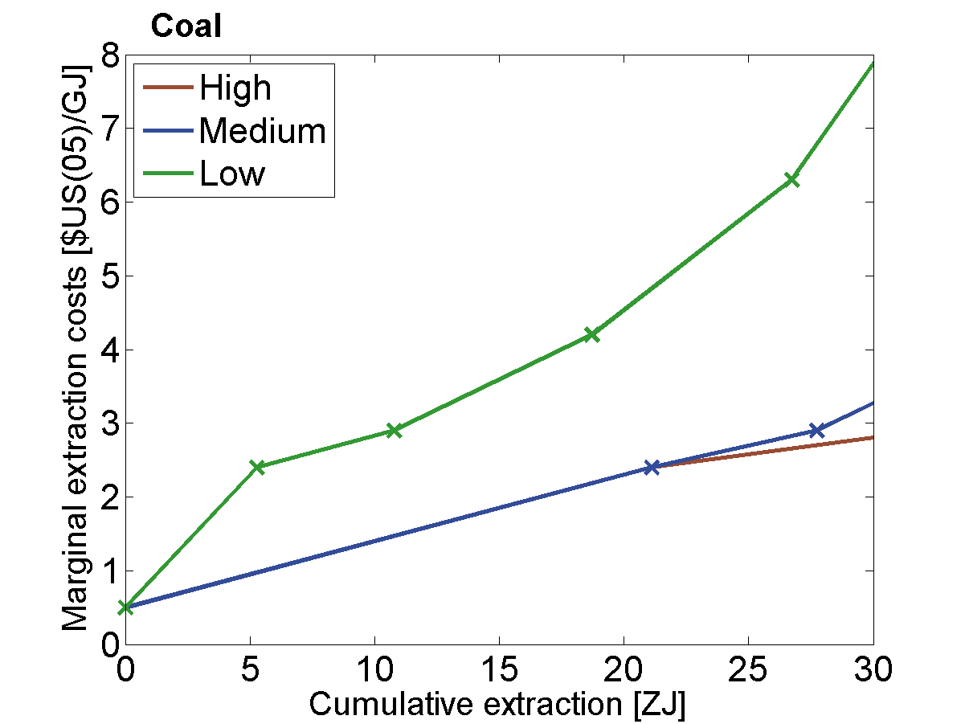
Figure S1: Assumptions for long-term fossil fuel supply curves. The crosses mark the borders of different grades modeled. From left to right the figures show crude oil, natural gas, and coal. In each graph the assumptions for low, medium and high fossil fuel availability are shown. The default case is based on the medium cases for each of the three fossil fuels. Note the different scaling. The figures report the relevant range covered by the scenarios until 2100, but the assumptions extend beyond.

Note that extraction cost differences between low, medium, and high availability vary between the different fossil fuels. For instance, the extraction costs for gas are the same for the first two grades. Only at higher cumulative extractions do the low, medium and high cases differ. For oil and coal, the extraction costs follow different paths. However, due to the inter-temporal structure of the ReMIND model and perfect foresight, the extraction paths are sensitive to the higher gas extraction costs even in the near term to the extent that is economically reasonable to conserve gas in the near term.

Economic growth assumptions
The demand for energy and consequently fossil fuels will depend, among other things, on future economic growth. Figure S2 shows economic output across world regions for the three cases of slow, medium and fast growth considered in this study. The derivation of the scenarios and the underlying assumptions are described in the Supplementary Online Material to the Synthesis paper of the ROSE study (Kriegler et al.).
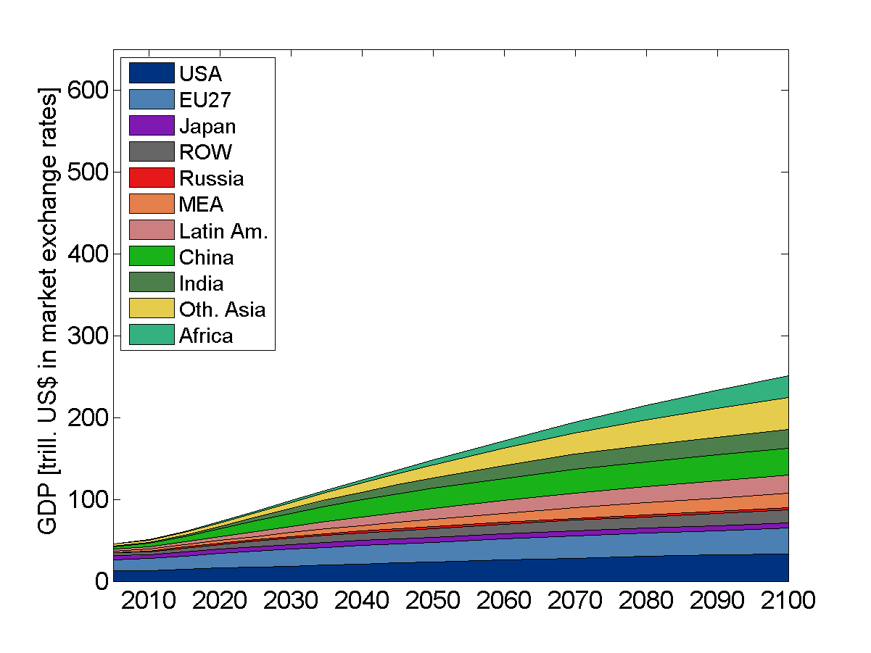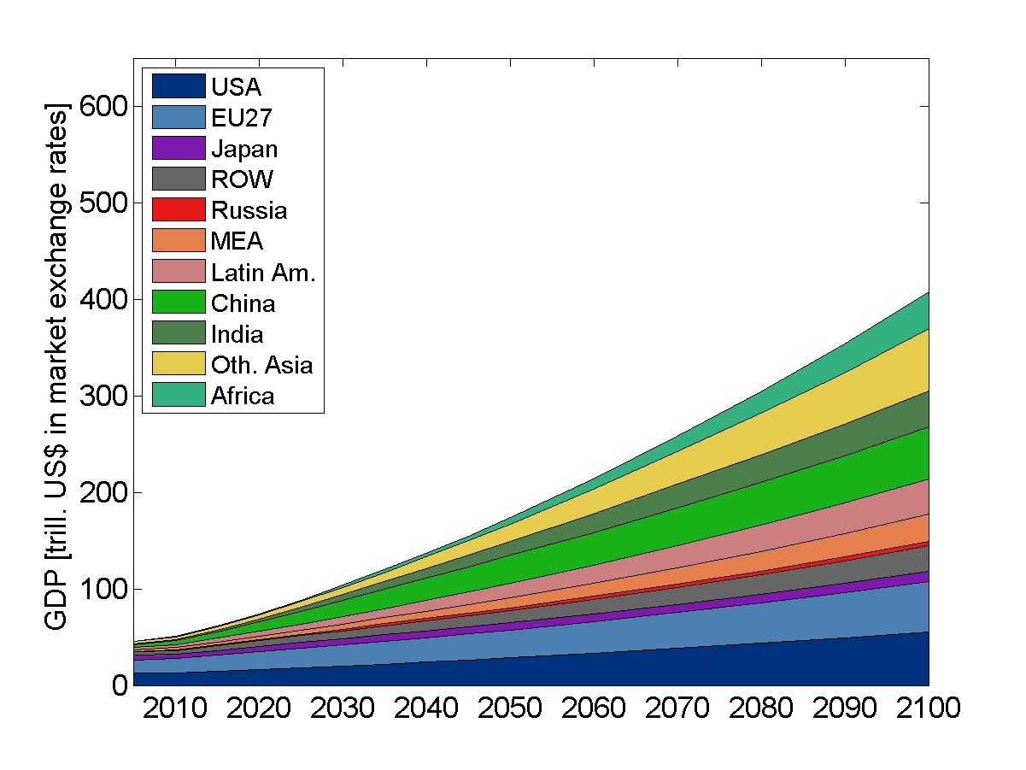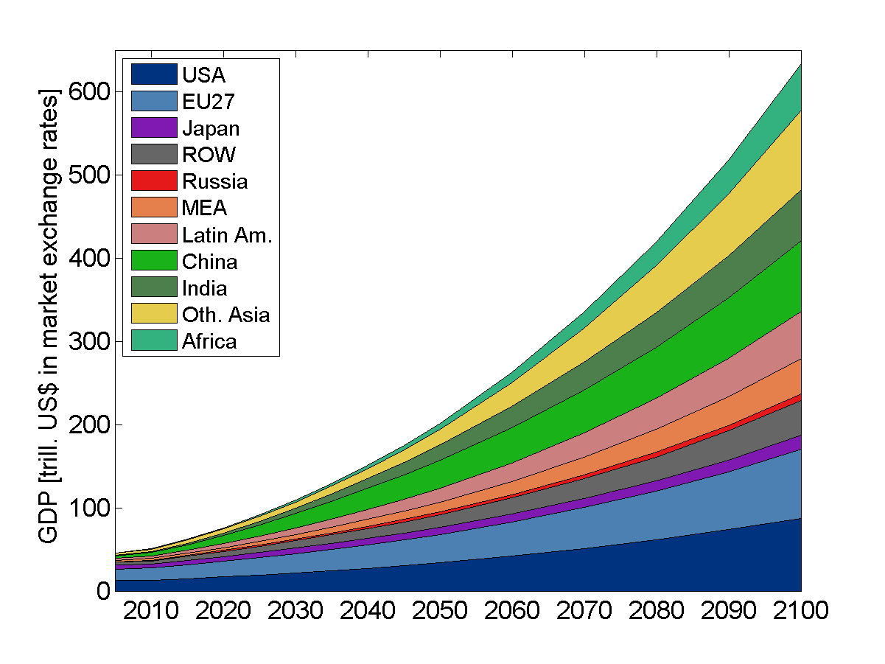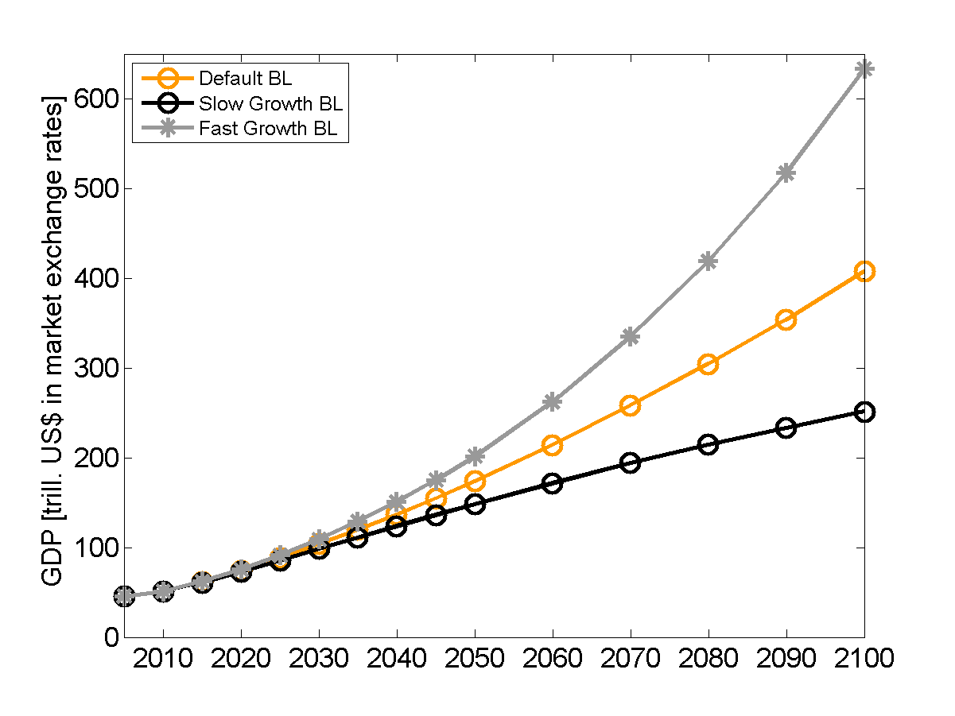
Figure S2: GDP scenarios with regional differentiation for slow (top left), medium (top right) and fast (bottom left) growth and comparison of global total (bottom right). The reference scenario is based on the medium growth assumptions.
It is worth mentioning that global GDP in the three scenarios only differ significantly after 2030 and continue diverging in the longer term.

Results
In this section various arguments of the main text are supported by detailed analysis of the scenarios.

The Default Baseline

General Baseline Characteristics
Figures S3 and S4 support the argument made in the main text that the baseline scenario is characterized by (i) growing total final energy demand and (ii) a shift in regional and structural use of final energy. Biomass (mainly traditional use), coal in solid form and non-transport liquids grow only slightly, whereas the use of transportation fuels, gases and electricity grow strongly. Hydrogen use is only of minor importance.
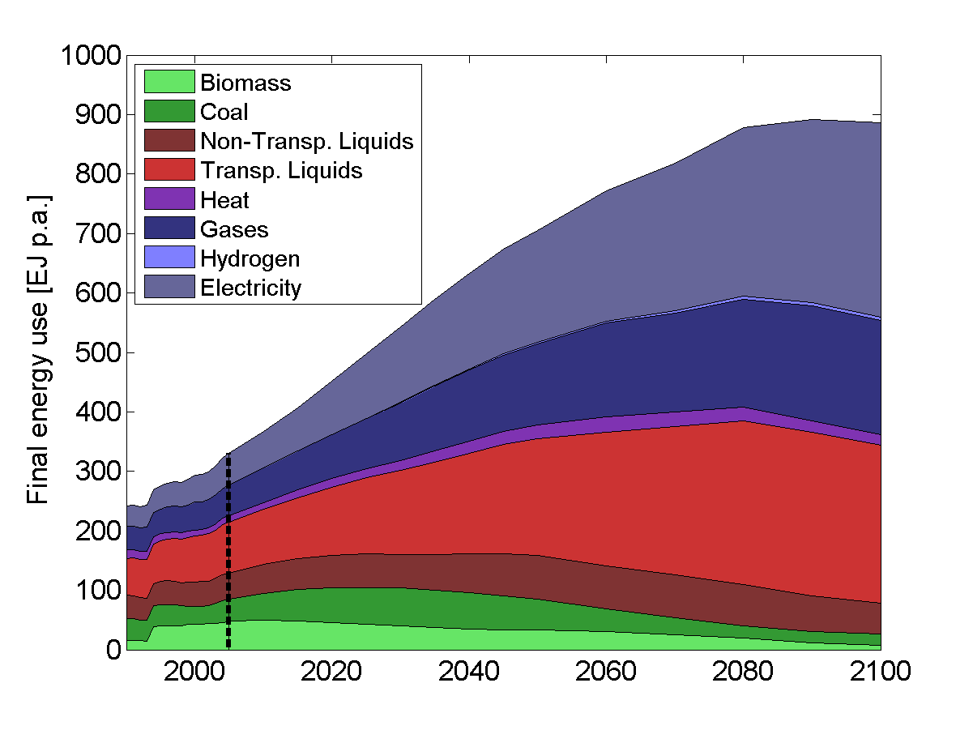
Figure S3: Global final energy consumption differentiated by final energy type. The vertical dashed line separates historical data and the scenario pathway. Historical data is taken from IEA (2007).

Figure S4 highlights the shift in regional allocation of final energy use. Most of the growth in final energy use is driven by strong economic growth in Latin America, Africa, China, India, Other Asia and the Middle East. Sectoral and regional shifts are interrelated as the growing economies are also modernizing their final energy supply.
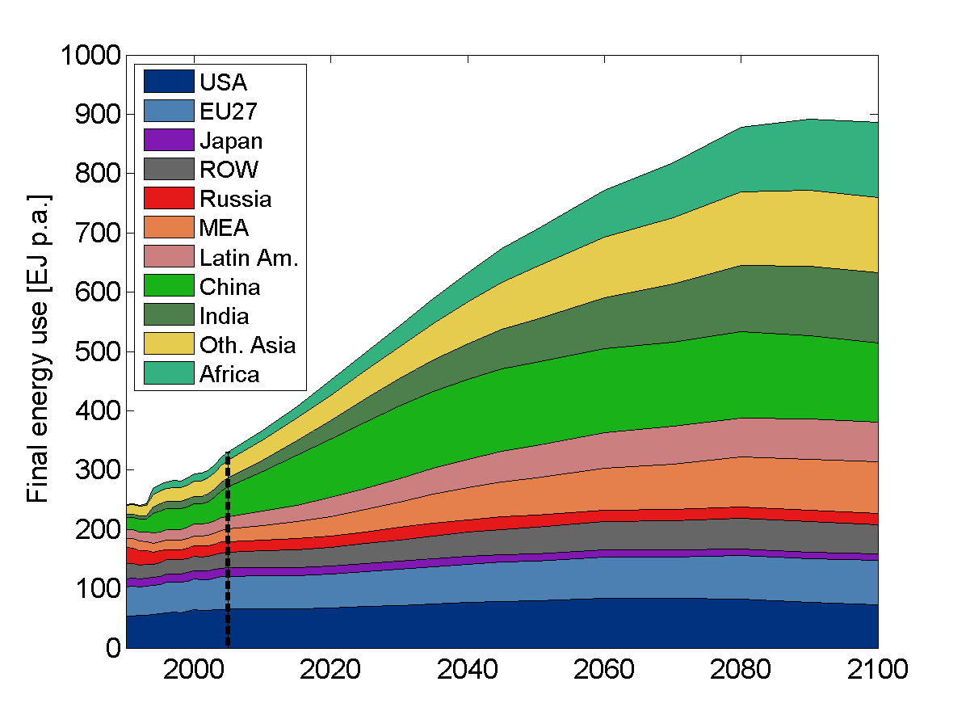
Figure S4: Global final energy consumption differentiated by consuming region. The vertical dashed line separates historical data and the scenario pathway. Historical data is taken from IEA (2007).
Figure S5 shows the CO₂ emissions by region from 2005 to 2100. The absolute amount and the regional shift mirror the changes in the energy system. The continued use of coal and the regional shift of economic activity towards developing countries drives emissions in the absence of targeted climate policies, and combines with roughly stagnant emissions from industrialized countries.
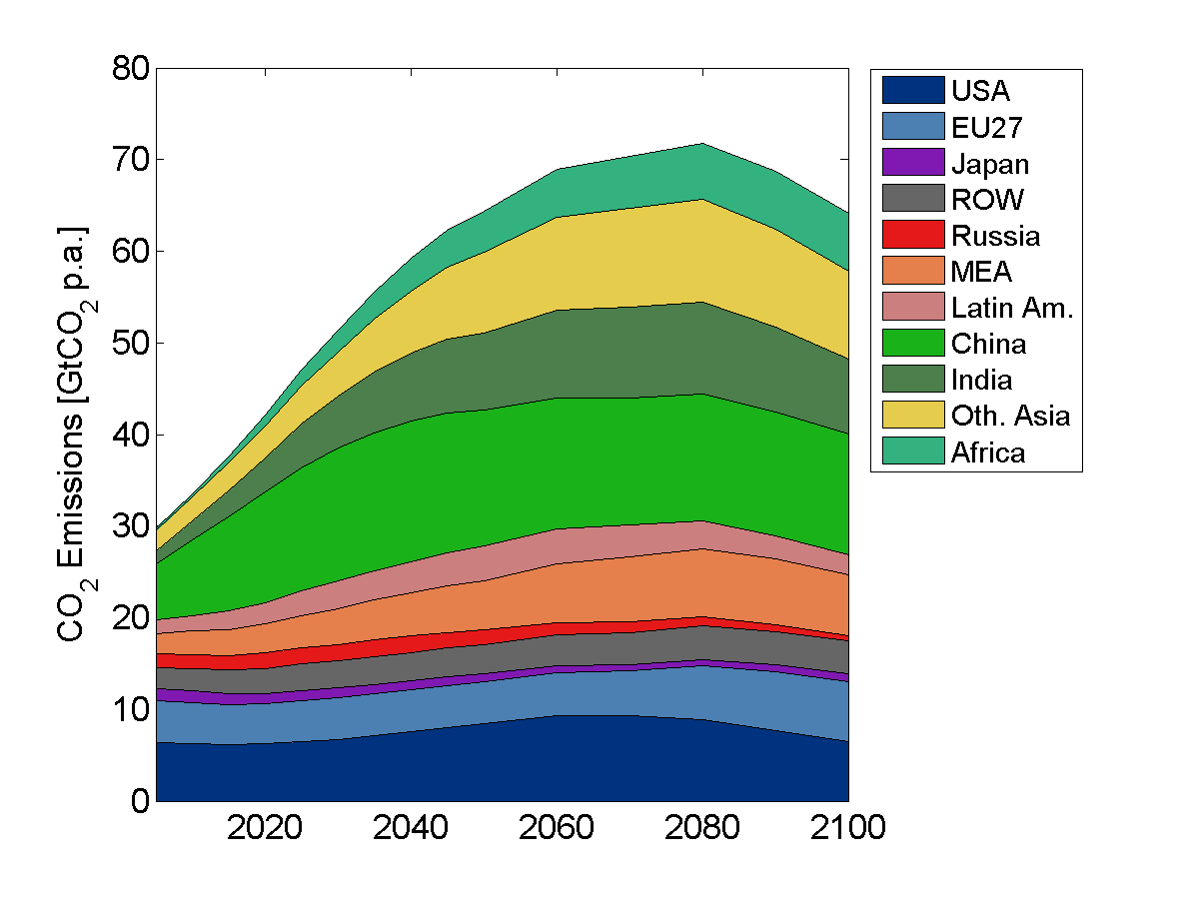
Figure S5: Global CO₂ emissions from fossil fuels and industry differentiated by region 2005-2100.

Fossil Fuel Extraction Paths
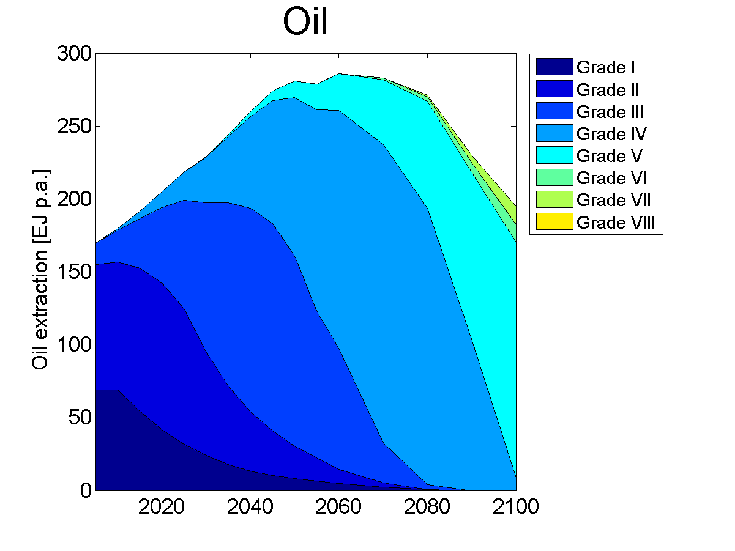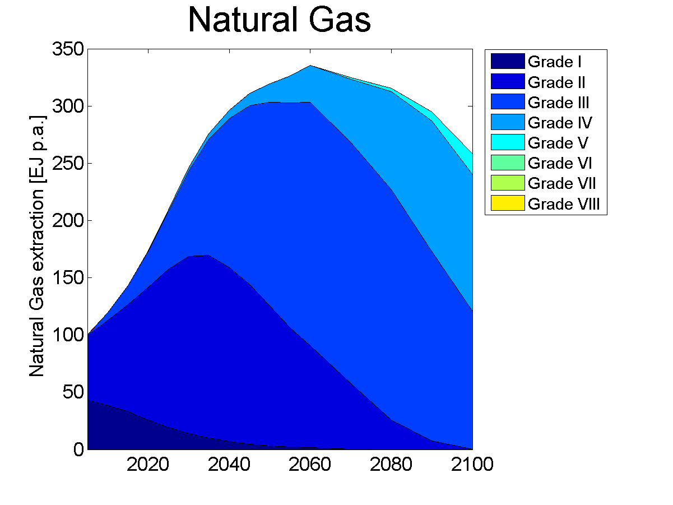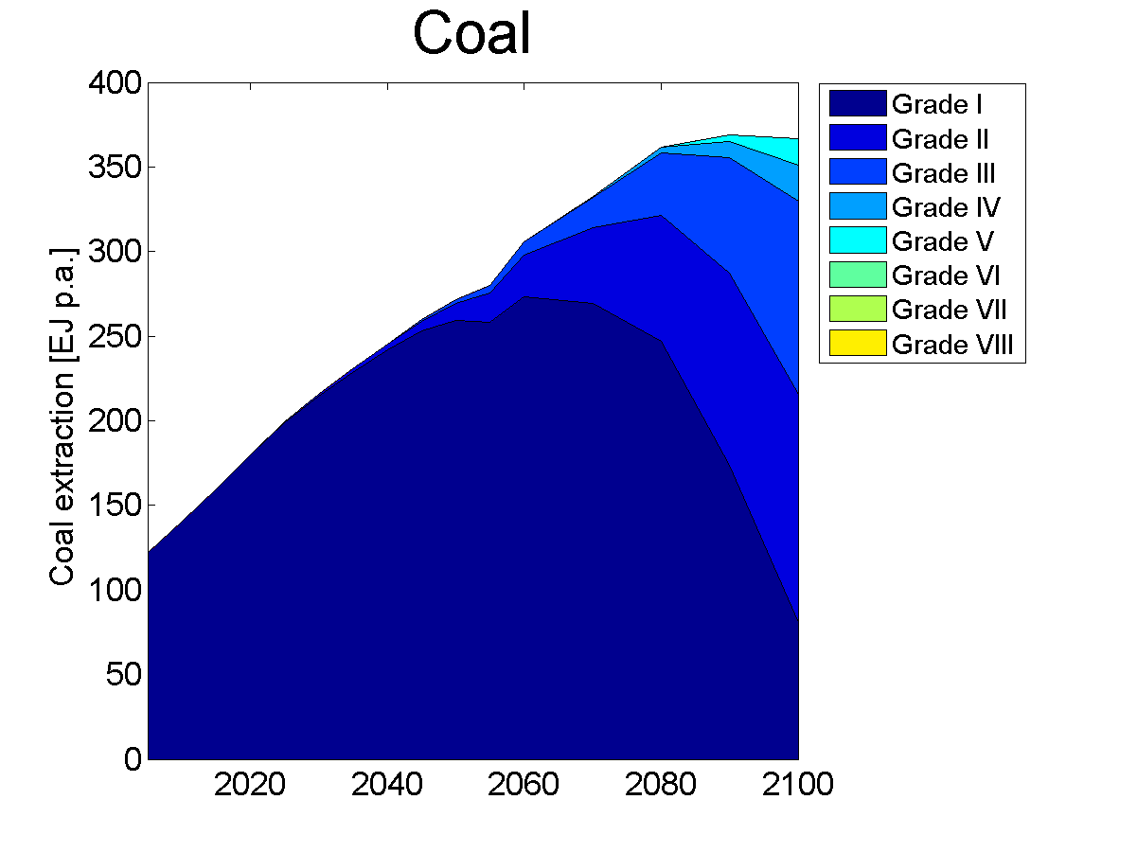
Figure S6: Global extraction of oil, gas and coal 2010 – 2100 differentiated by cost grades.
The fossil fuel extraction paths shown in Figure S6 describe the extraction dynamics underlying the price formation. The colored patches represent the extraction from different grades that are characterized by increasing marginal costs. Various grades are exploited at any given point in time. Grades with higher costs are entering the market as grades with lower marginal costs phase out production in accordance with the decline rates.
As has been pointed out in the main part of the paper, the flow constraints drive prices higher than would be suggested by the long term extraction cost curves. . This mechanism can be exemplified with the fifth grade of oil production that starts at marginal costs of 11US$/GJ. Production from this grade enters the market in 2030. Although the contribution is very small at that time, the oil price is set by this grade (see Figure 2 of the main paper).

Fossil Fuel Prices, Extraction Costs, Transportation Costs and Rents
This Sub-Section provides further information on the relationship between prices, extraction costs, transportation costs and rents, all of which are only briefly discussed in the main paper. Also we present the calculation of the net present values of fossil fuel rents shown in Figures 3 and 7. Figure S7 shows prices, extraction costs and rents for oil, gas and coal in prototypical export (upper row) and import (bottom row) regions.
For the case of oil it can be seen that the prices are nearly the same in MENA and the US. The production costs are different though, and therefore the rents per unit of energy are different, with producers of oil in the MEA region able to obtain a higher rent than US producers. As might be expected, rents per unit of energy are higher in exporting than in importing region.
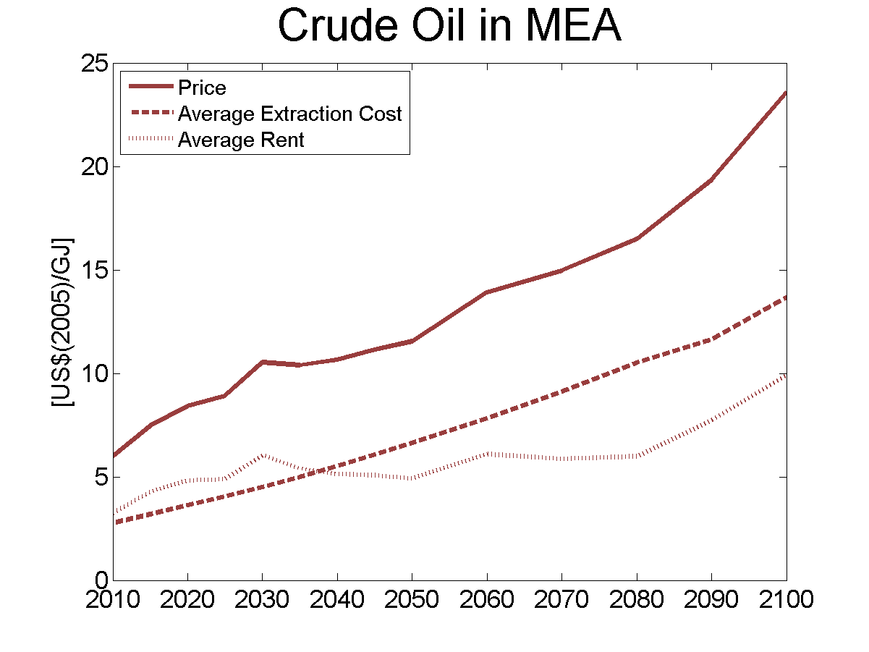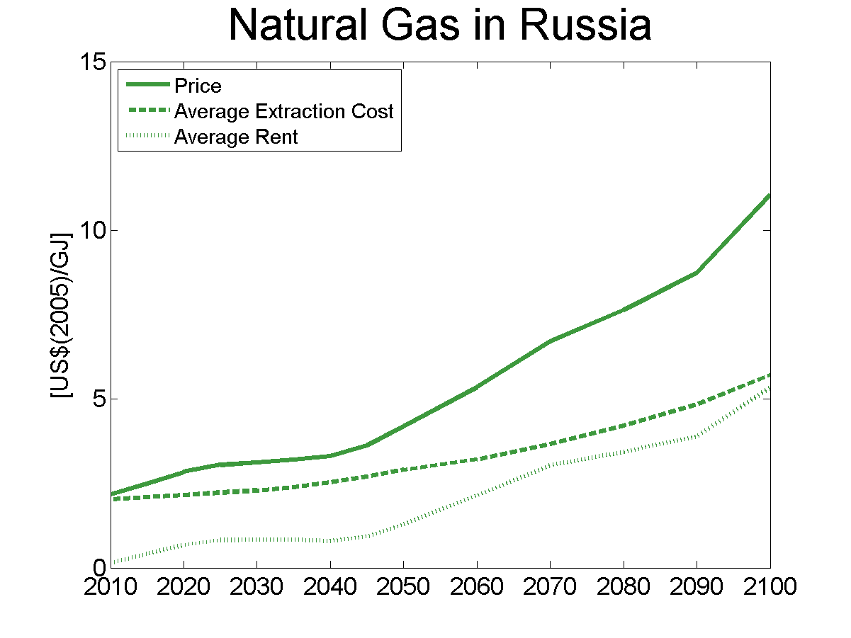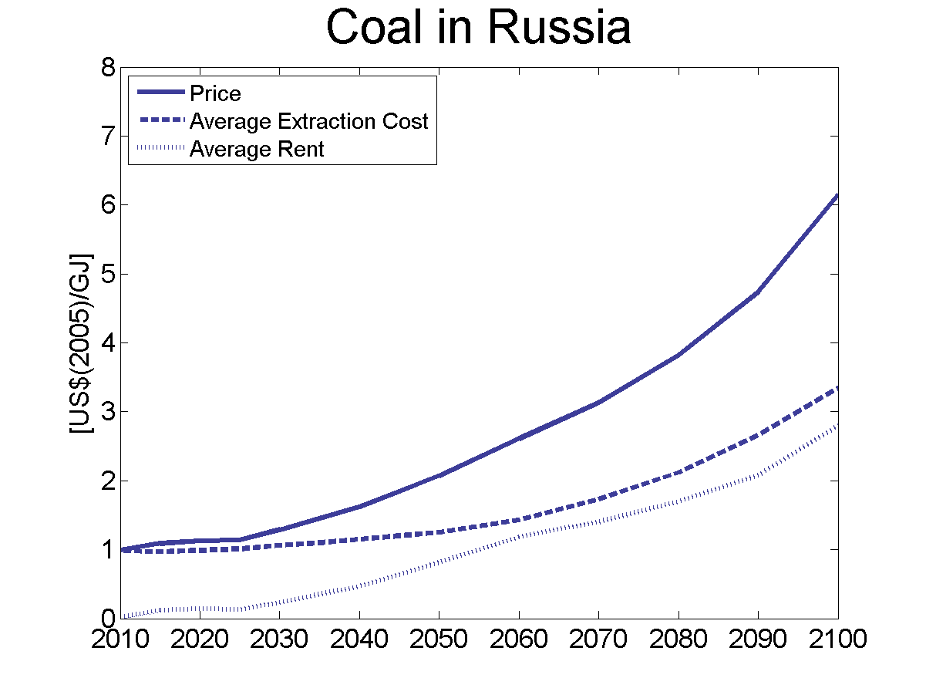
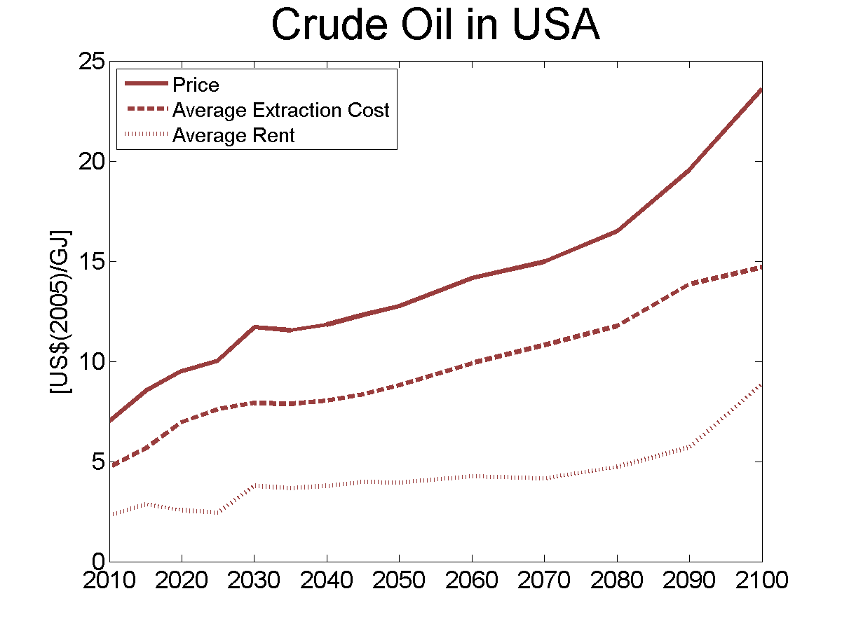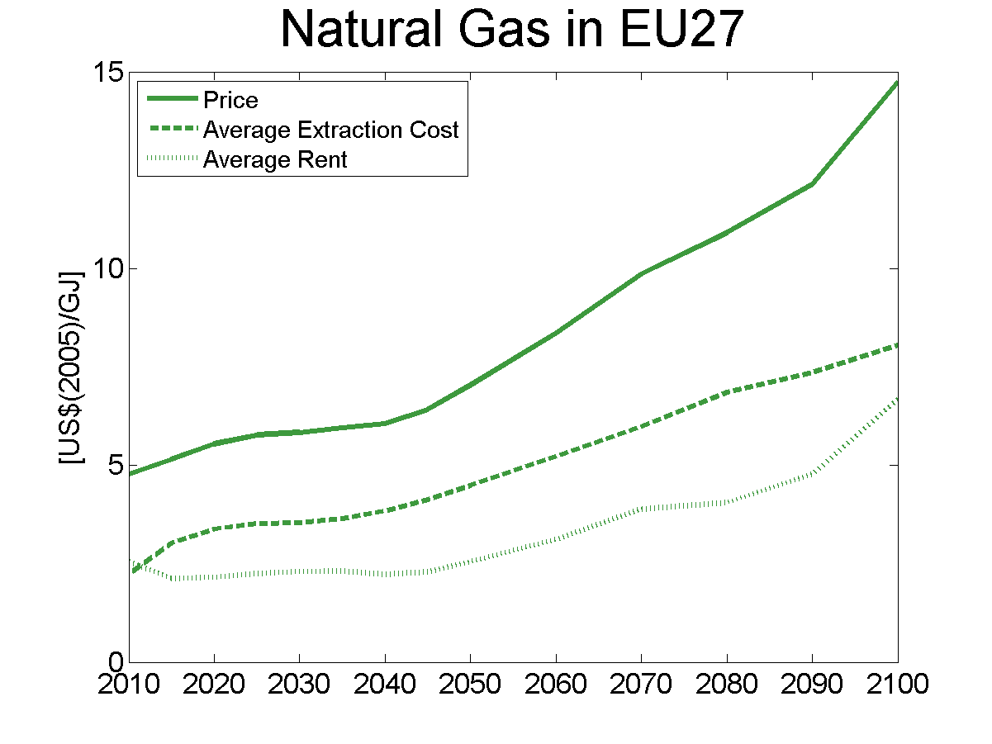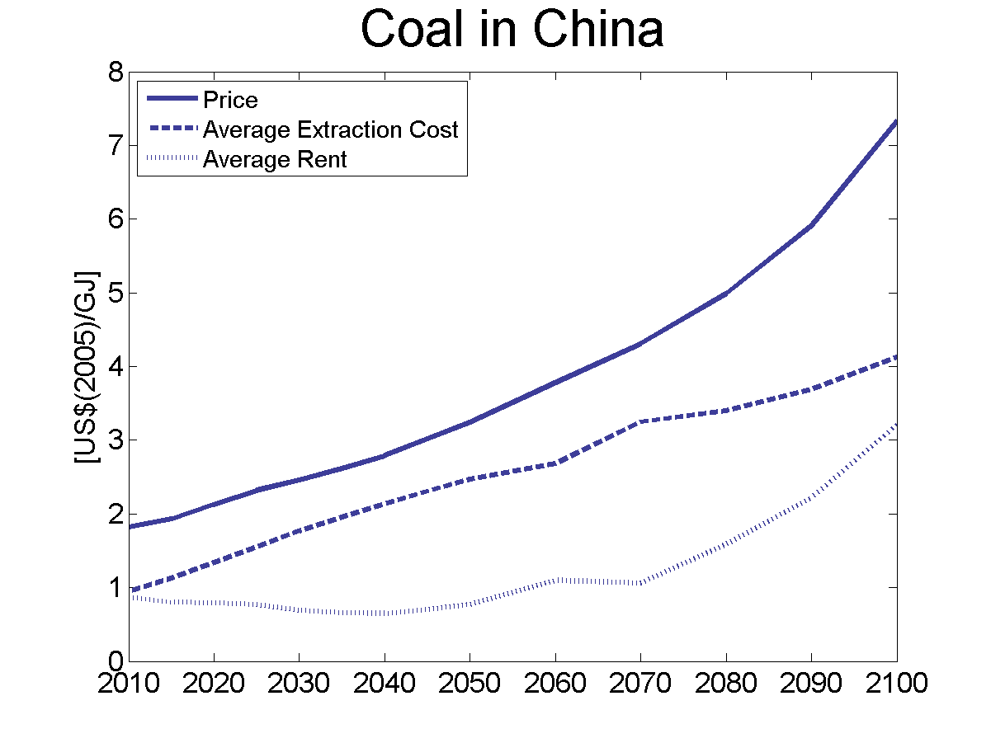
Figure SI7: Prices, average domestic supply costs and rents of fossil fuels in selected export and import regions 2010 – 2100.
The case is different for gas and coal, where transportation costs are more important and, thus, regional price differences are more pronounced than in the case of oil. Hence, the gas price in Russia is lower than in EU-27. In Russia the rent per energy unit is smaller than in EU-27 because the production costs are closer to the price than in EU-27. Hence, gas producers in the importing region receive a higher average rent than producers in the exporting region. The same observation holds for coal. Hence, regional distribution of rents per unit of oil follows different rules than rents per unit of gas and coal, because of the regional price differences induced by the transportation costs.
The net present values of rents discussed in the main paper are computed as follows. The annual profits in each region consider the total extraction valued with the difference between the domestic price and the extraction costs plus the domestic transportation costs. The exporters receive the domestic price at the border and they have to cover the extraction costs and the domestic transportation costs. The transport costs for international trade equal the price mark-up that importers have to pay. Hence, exports and domestic consumption in exporting regions are treated equally. This simple approach is valid because there are no exogenous limits on trade that would drive a wedge between domestic prices and prices for fossil fuels that are exported.

Fossil Fuel Trade
The trade in fossil fuels is of paramount importance for the development of future energy system. The issue of energy security and the effects of climate policies will be analyzed in a separate paper as part of this Special Issue (Cherp et al.). Here we provide details on fossil energy trade. The pathways for imports and exports of oil, gas and coal are shown in Figure S8.
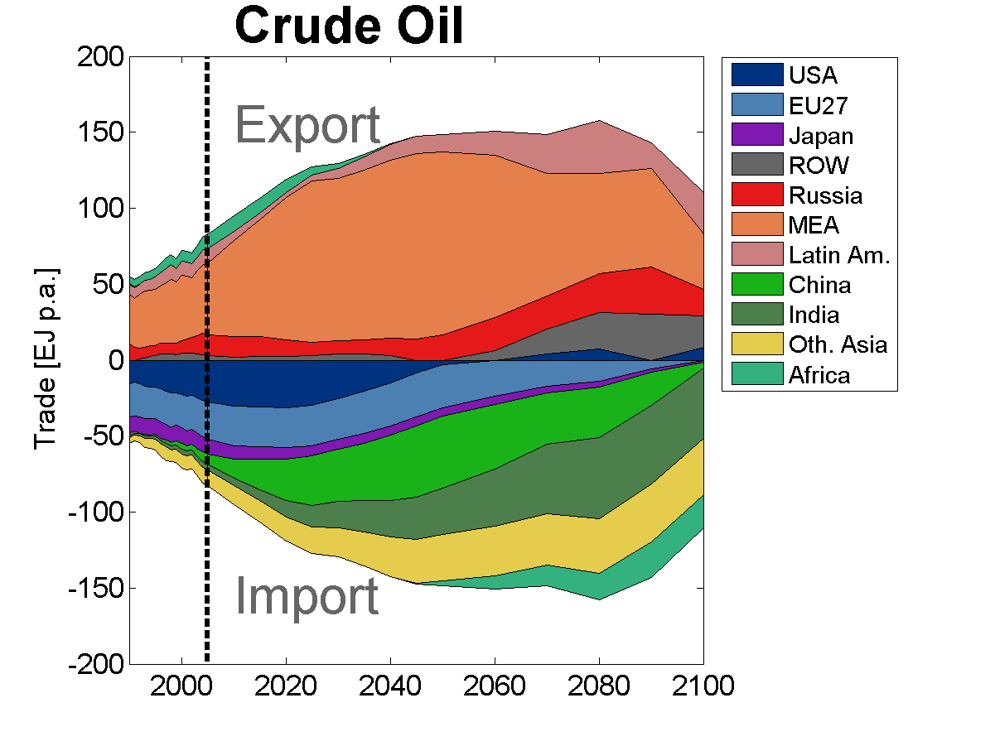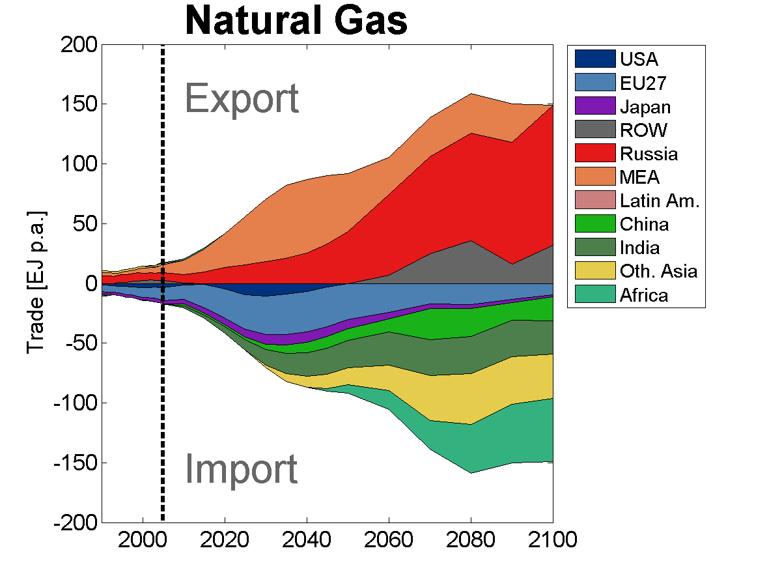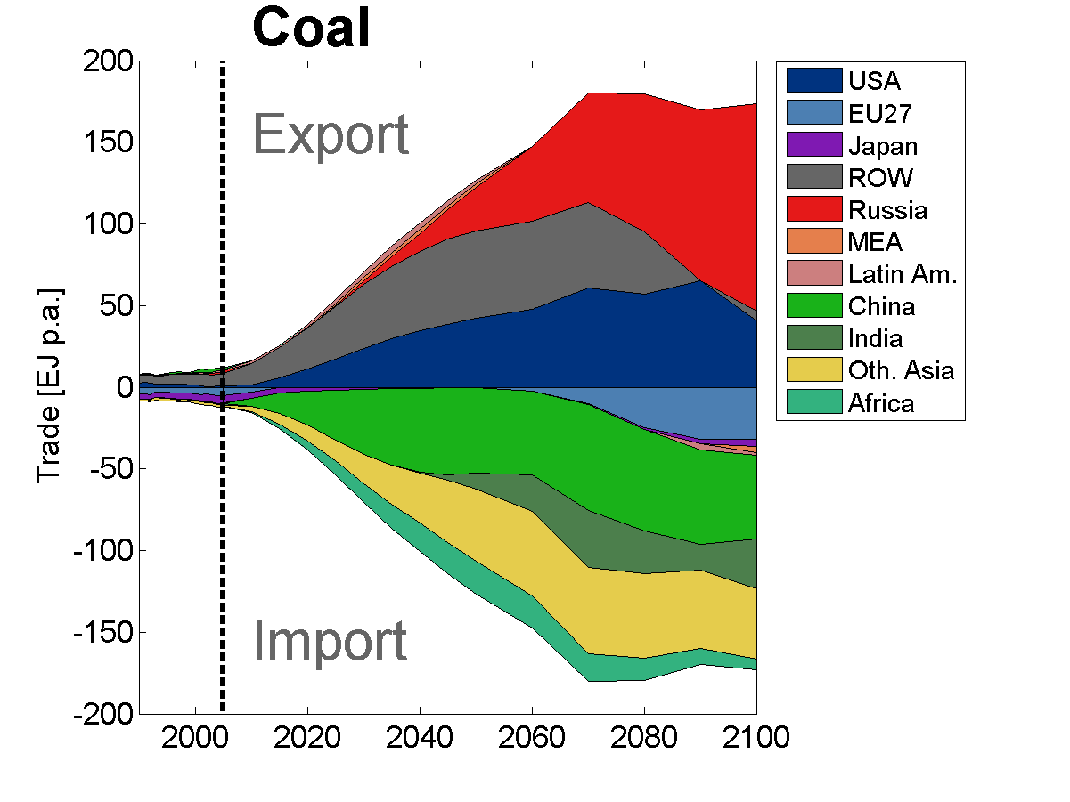
Figure S8: Global trade of oil, gas and coal. The vertical dashed line separates historical data and the scenario pathway. Historical data is taken from IEA (2007).
On the import side, growing demand from developing countries is the major driver, whereas the demand from developed regions is reduced; this represents a major shift in global fossil fuel markets. The main exporters of oil and gas are the MEA region and Russia. Growth in natural gas markets is strong compared with historical experience and will require large investments in infrastructure and political willingness to integrate the markets. The international coal market in the reference pathway grows enormously thanks to the supplies from Russia, the US and Rest of the World including Canada, Australia and South Africa.

Baseline Variations

Fossil Fuel Use and CO₂ Emissions
We have analyzed the sensitivity of cumulative fossil fuel use and CO₂ emissions with respect to baseline assumptions in the main text. Here we present the pathways of these key variables at the global level. Figure S9 shows the time path of global oil, gas and coal use as well as the resulting CO₂ emissions.
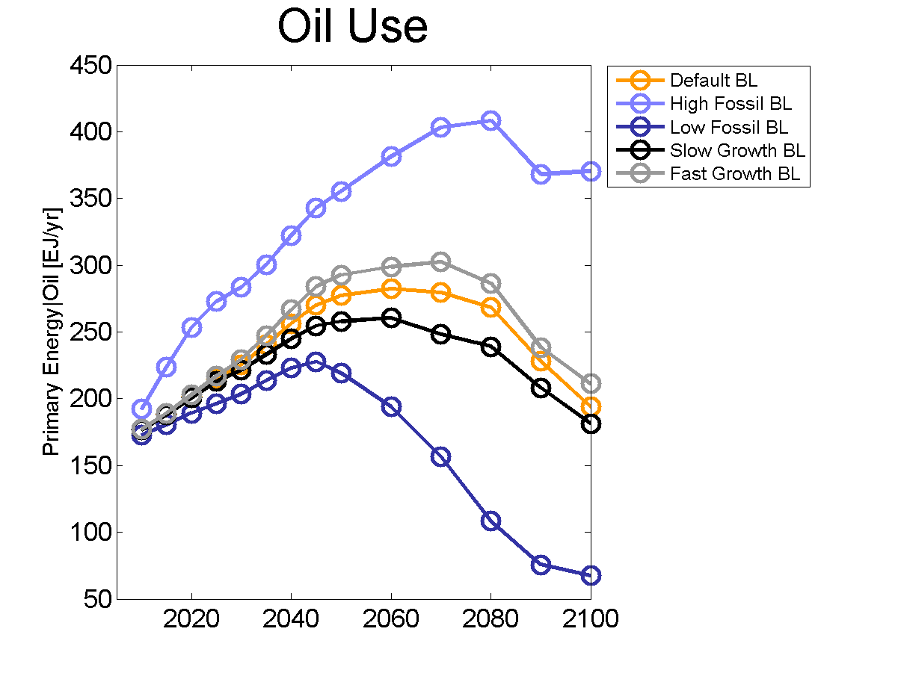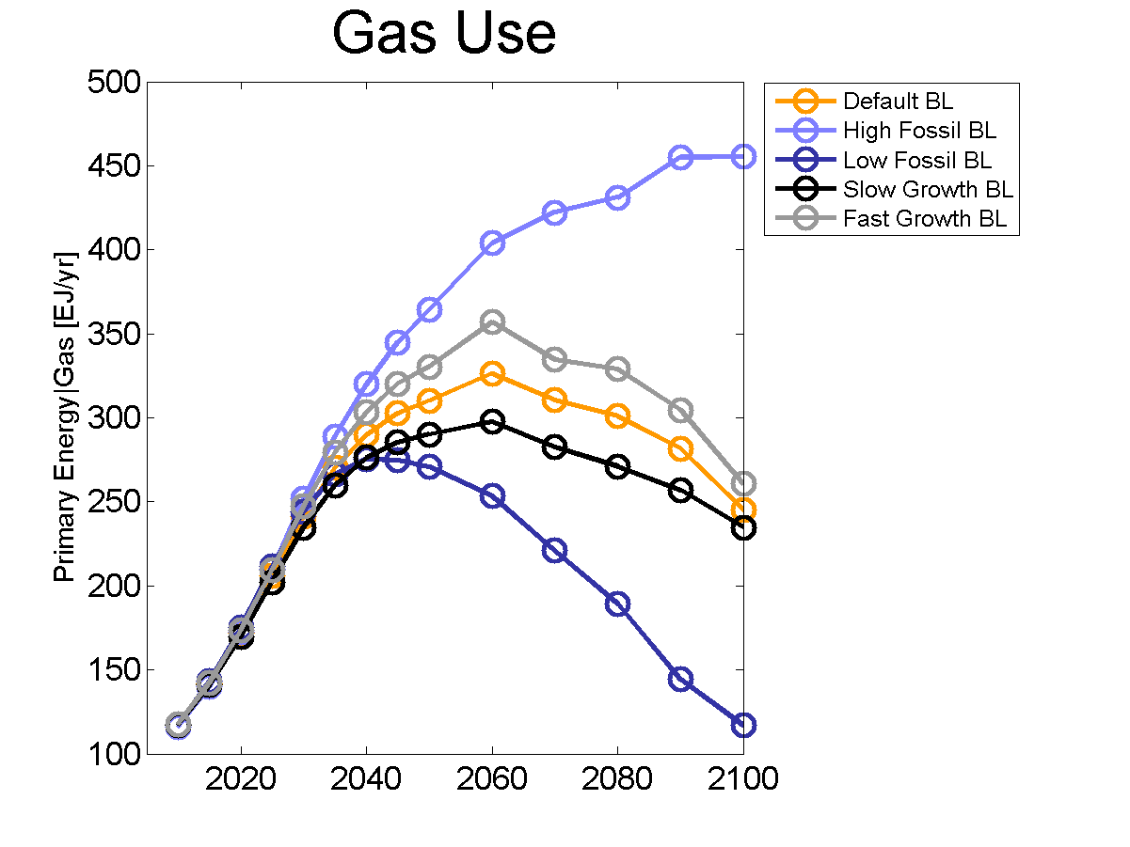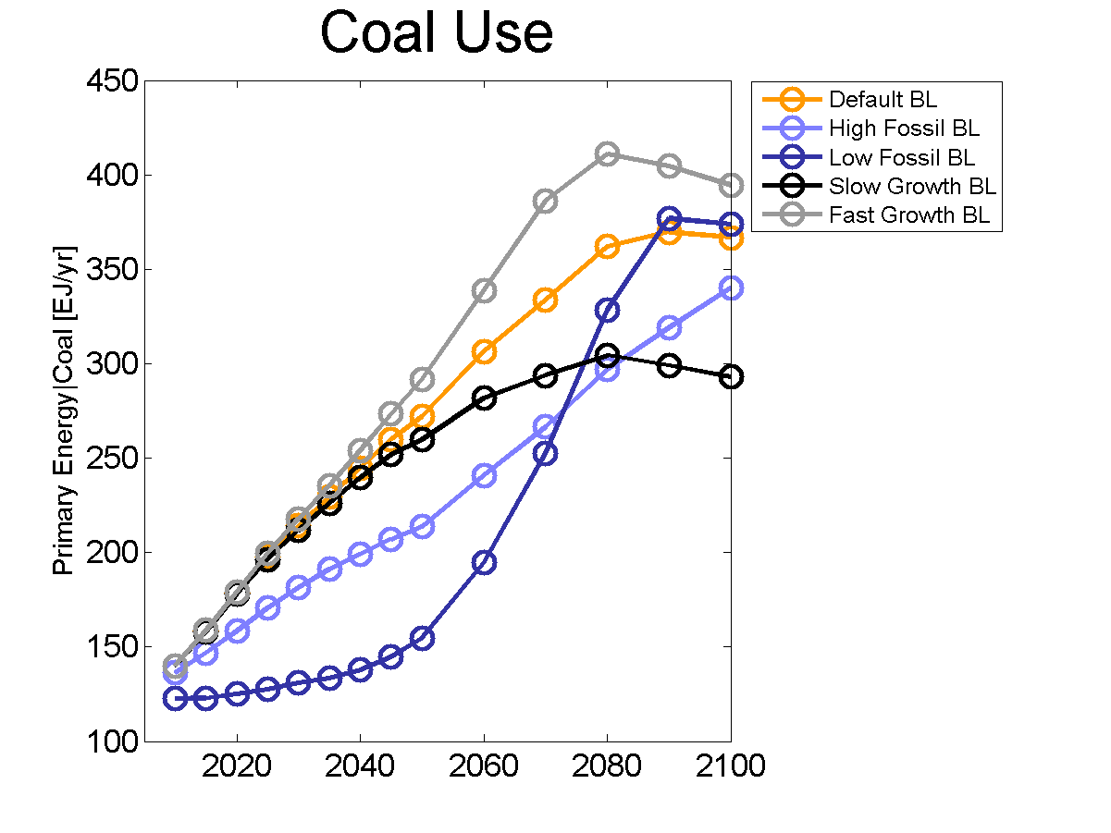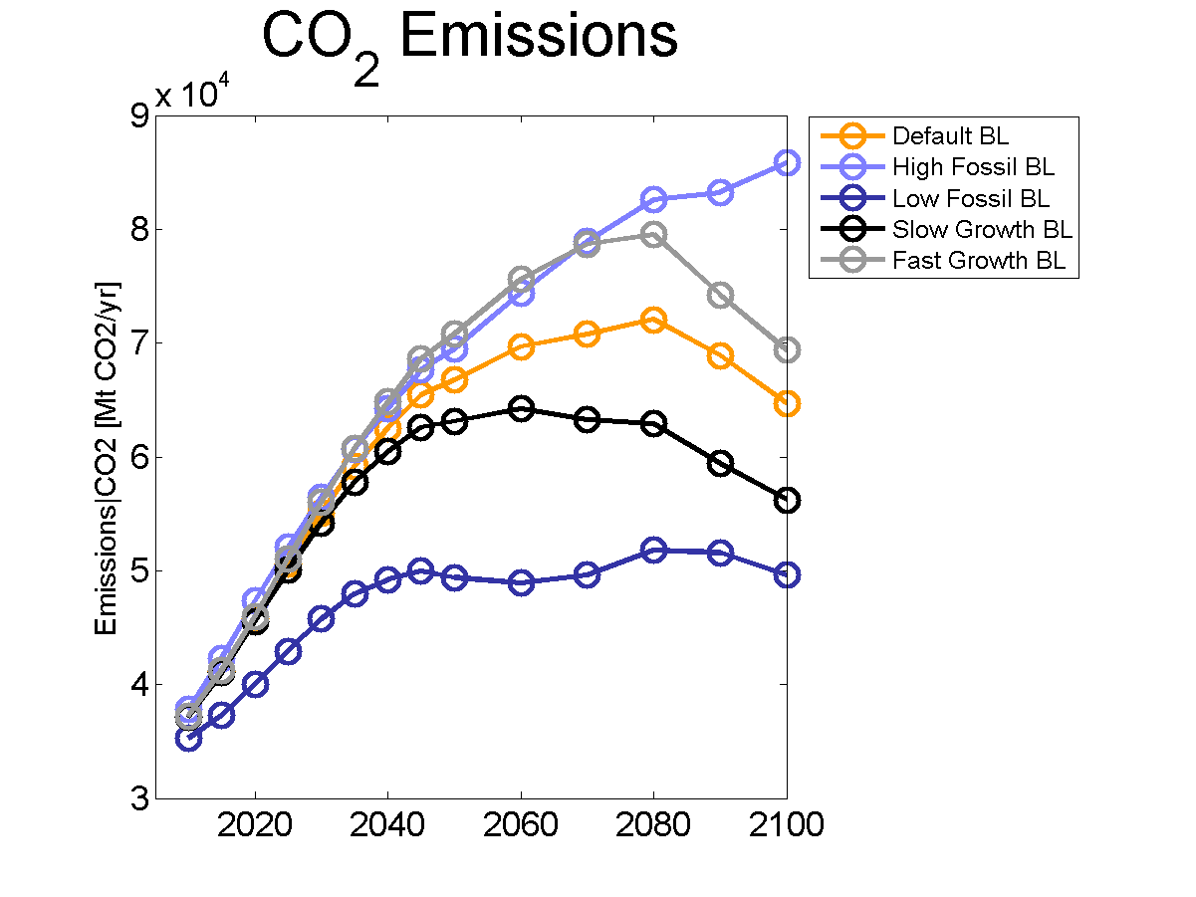
Figure S9: Global use of oil, gas and coal and global CO₂ emissions from industry and fossil fuel combustion 2005-2100.
Three main findings follow from the analysis. The assumptions of economic growth change the time path of fossil fuel utilization only after 2030. Second, the assumptions of fossil fuel availability have an impact on the near term use of oil and coal, but not for gas. The main reason is that assumptions of the gas supply curve only start to deviate for cumulative use larger than 10ZJ. The assumptions in the case of oil start to deviate at significantly smaller cumulative amounts. Since Figure S9 depicts only cases in which the availability of all fossil fuels is simultaneously varied, the following should be added: if only gas availability is changed, as in the High Gas scenario, the use of gas also increases in the near term and is substituted for coal. Finally, in case of low fossil fuel availability, coal consumption stagnates until 2040 and increases significantly thereafter to substitute oil for liquid fuel production.

Fossil fuel prices
In the main text only the sensitivity of the oil price was shown (Figure 5). Figure S10 also shows the prices of gas and coal.
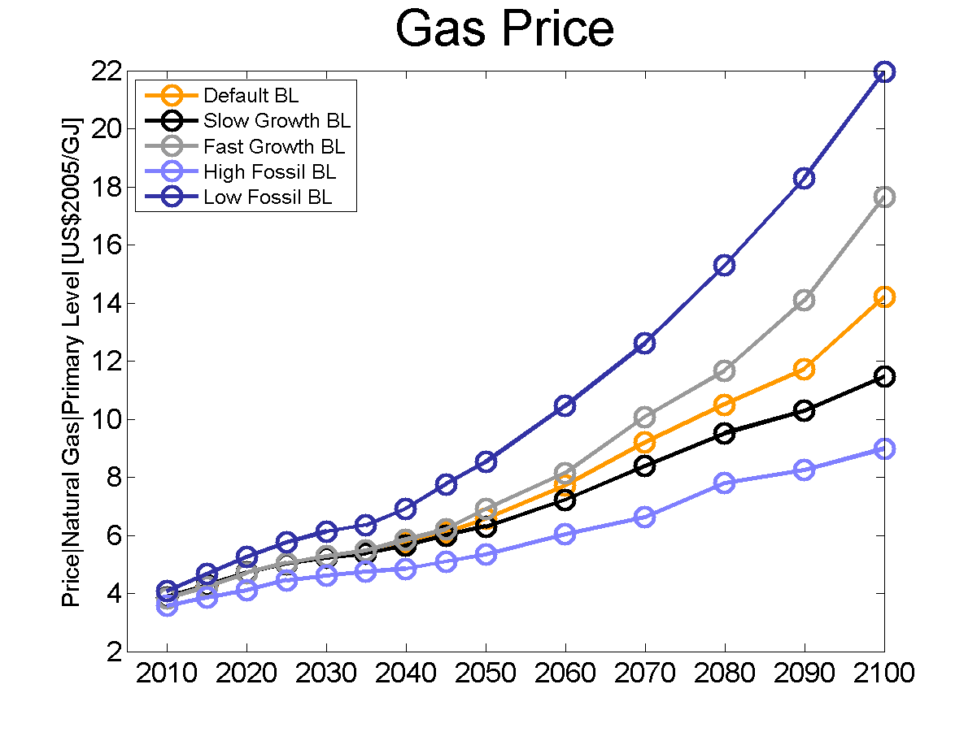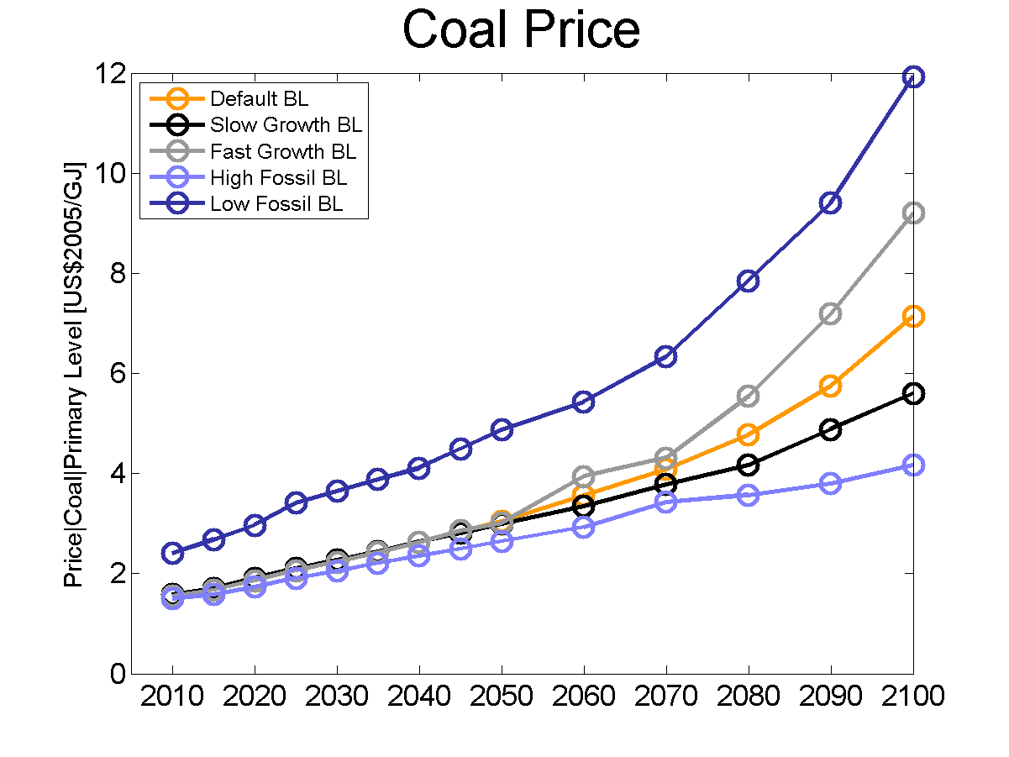
Figure S10: Global average gas and coal price for the baseline scenarios (2010-2100).
The sensitivity with respect to economic growth assumptions of gas and coal prices is generally the same as for oil prices. Also, the variations of fossil fuel availability have a larger impact. The increase of coal prices in the case of low fossil fuel availability is most notable.

The analysis of the cumulative extraction and price
Figure S11 shows the global average market prices as a function of global cumulative extraction. The graph also implicitly shows the time dimension, since all curves start in the lower left corner and show the development as cumulative extraction changes over time.
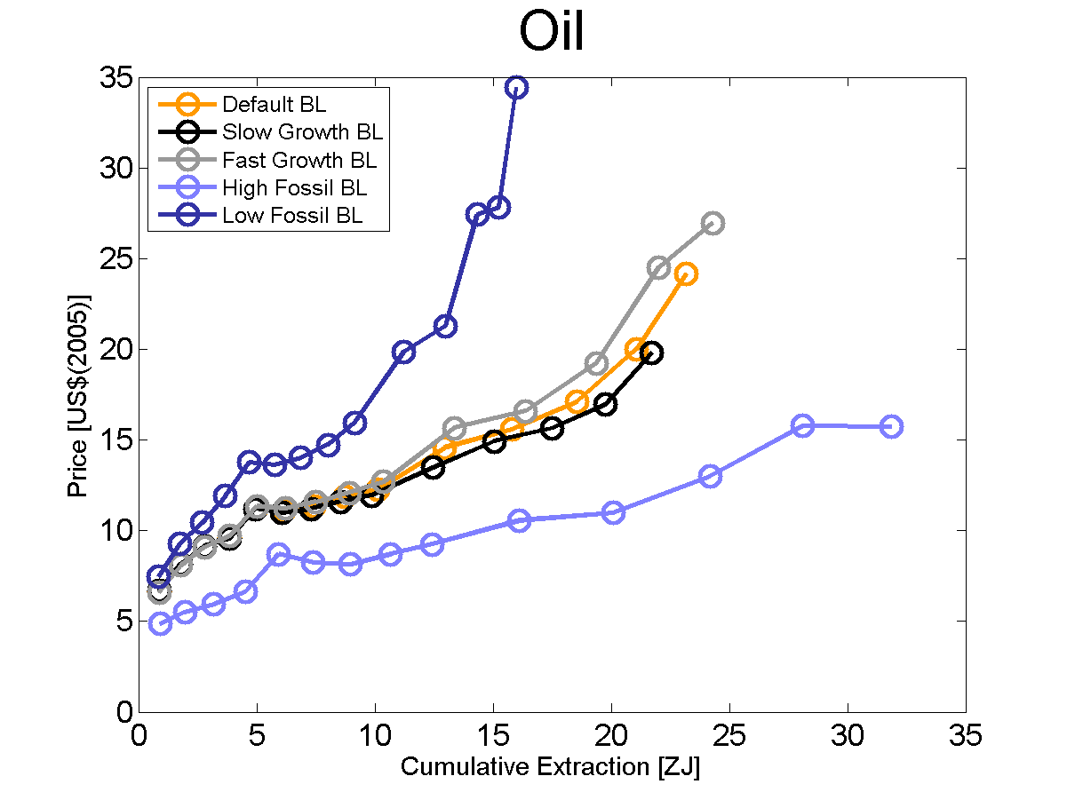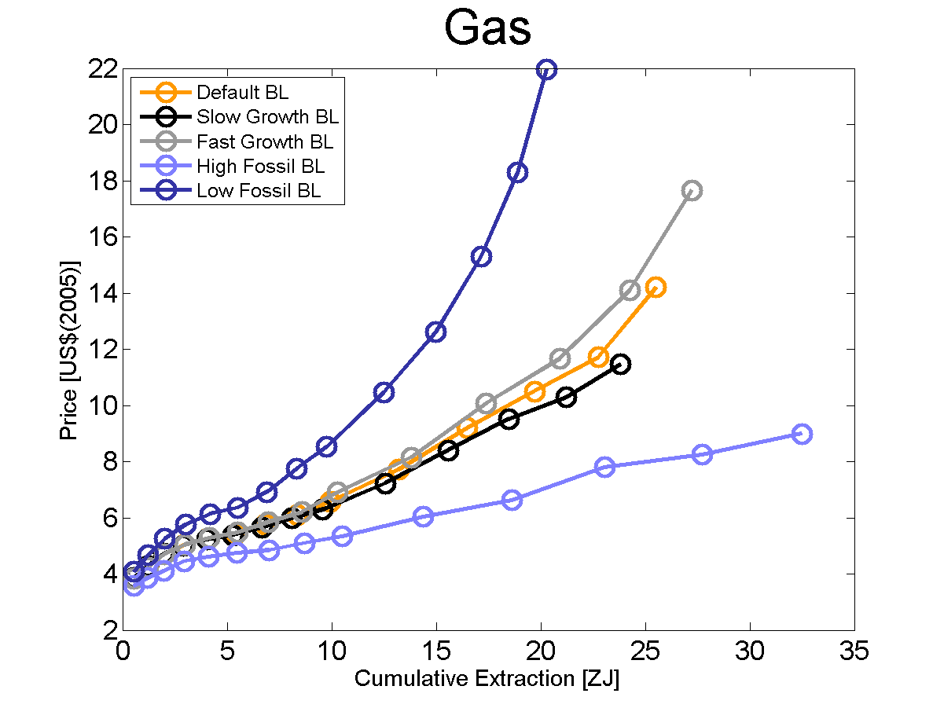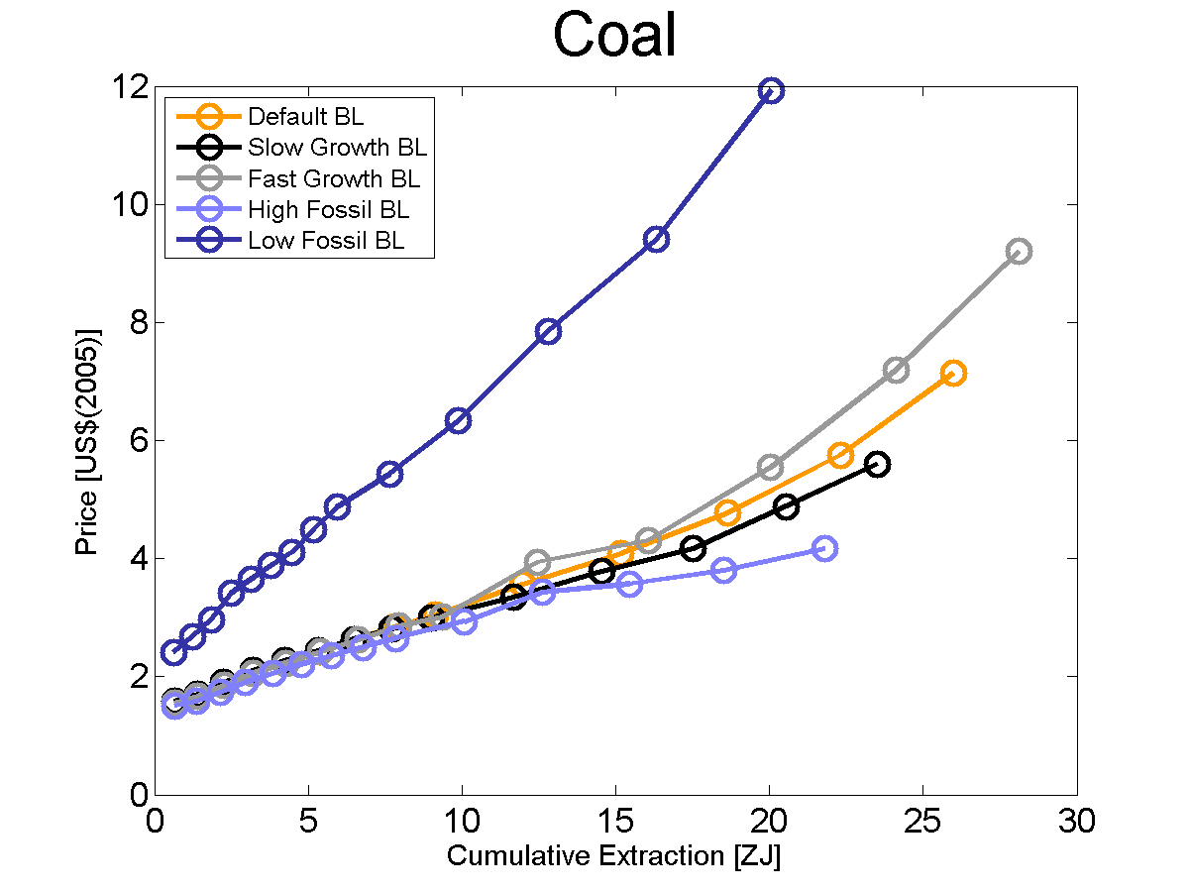
Figure S11: Global average fossil fuel prices depending on cumulative extraction for different baselines. Note that in the cases with High and Slow growth the assumptions on extraction cost are the same like in the default case.
Two findings are noteworthy. First, the variation of GDP growth assumptions has only a small impact on the slope of the curve. For the same cumulative extraction the price differences are only small. Nevertheless, there is a price effect despite the assumption of identical long term extraction cost curves. Second, the impact of varying fossil fuel availability is larger. For the same cumulative extraction the prices vary significantly reflecting the differences in the long term extraction cost curves.

Policy Scenarios

Carbon prices to achieve climate change stabilization
Figure S12 shows the carbon prices under the two long-term climate change stabilization policies. All price trajectories increase. For the initial decades the increase is roughly exponential. For the 450 scenarios the prices start at significantly higher levels. Also in the near term fossil fuel availability has a stronger effect on carbon prices. In the longer term the energy demand growth becomes more important.
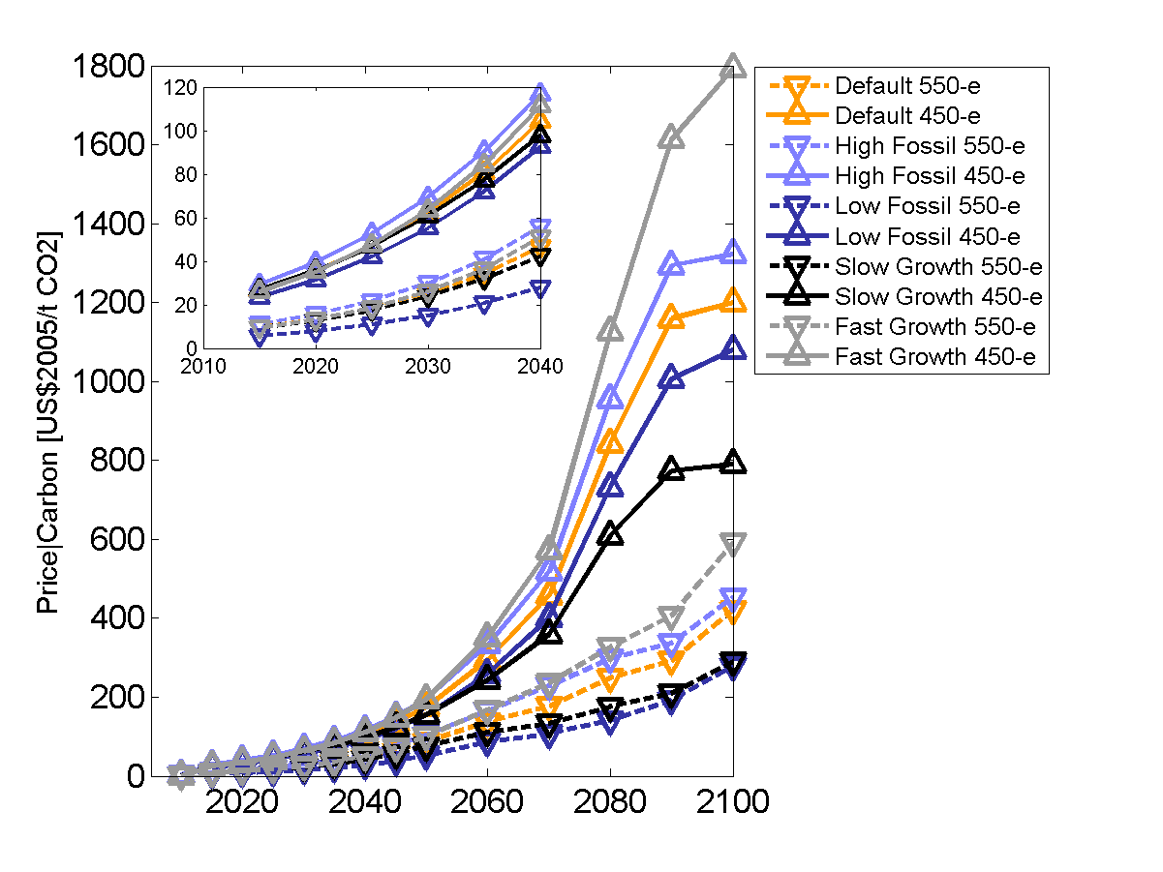
Figure S12: Carbon prices for various stabilization scenarios. The inset shows the carbon price for the period 2015-2040.

The impact of climate policies on fossil fuel use and prices
Figure S13 shows the impact of climate change mitigation on the cumulative extraction of fossil fuels and on prices. The graph is of the same type as Figure S12, now showing dynamics for the no-policy baseline (BL) and the 550-e scenarios with variations of fossil fuel availability.
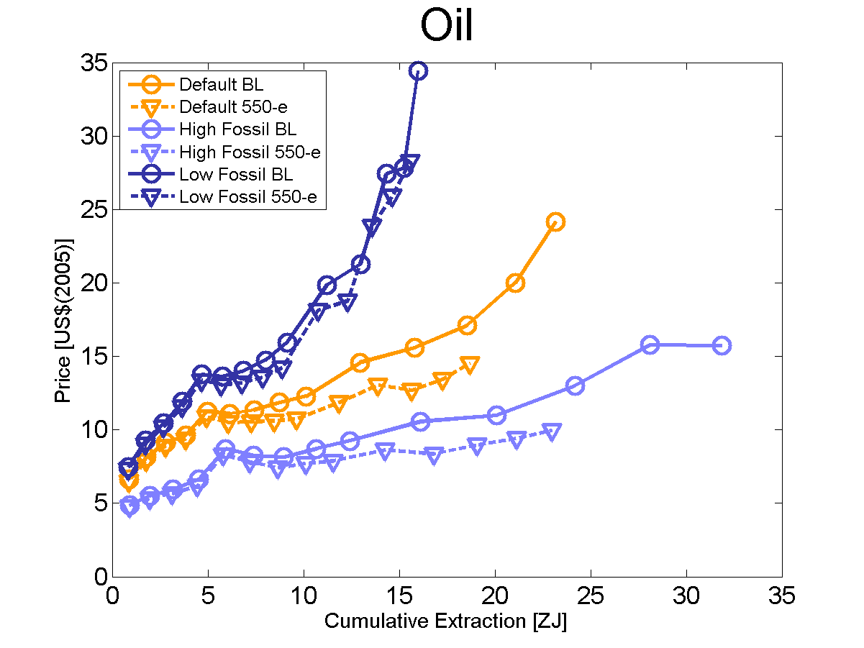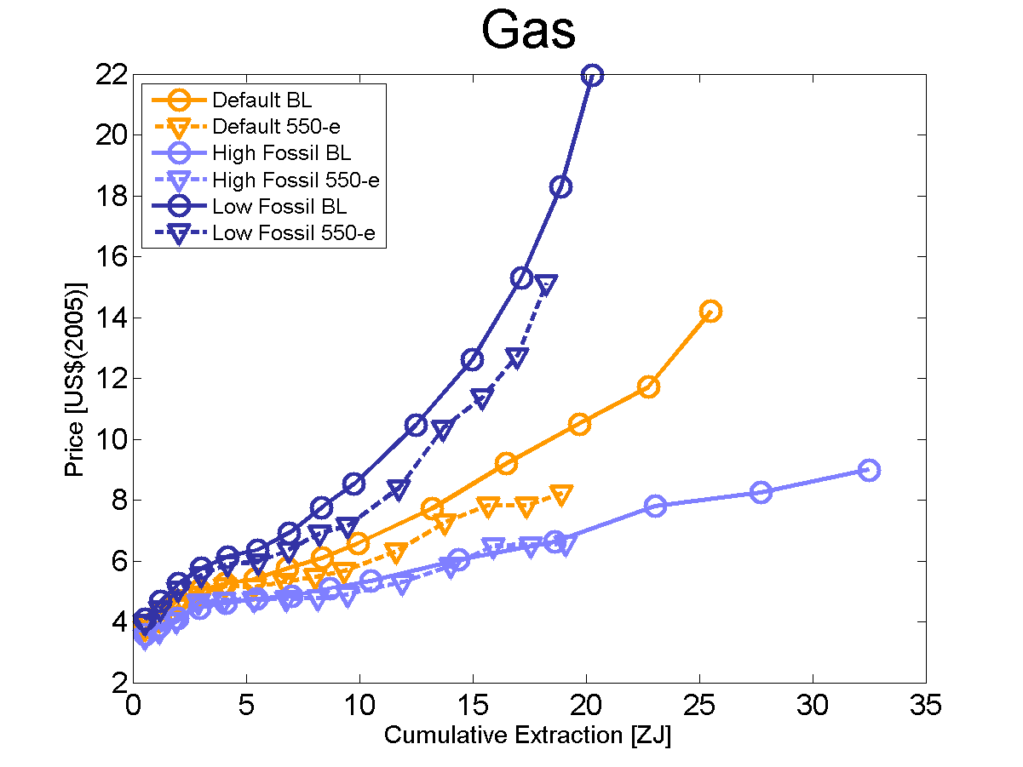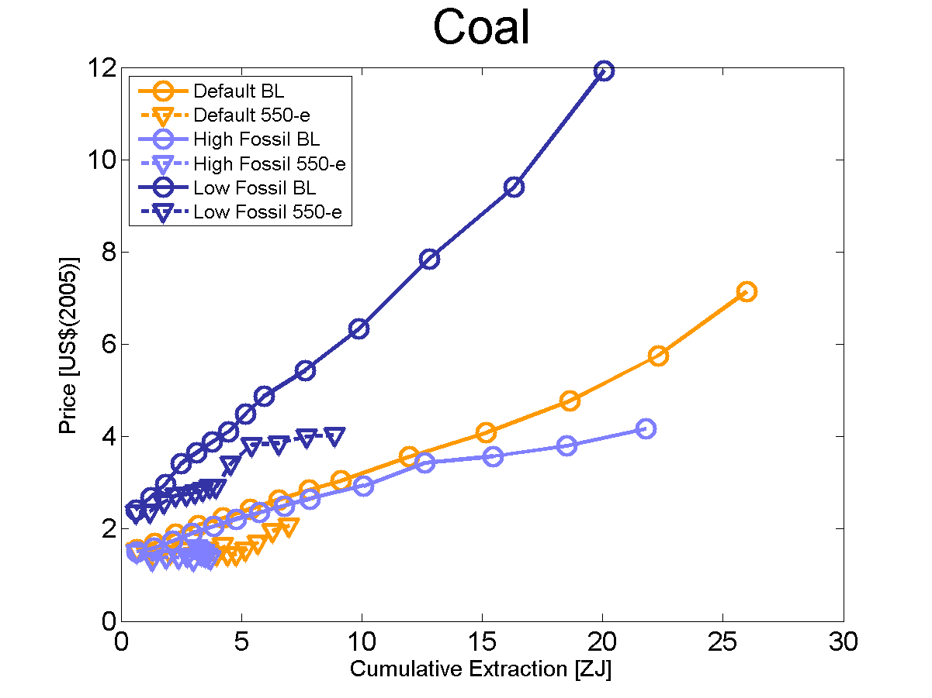
Figure S13: Global average fossil fuel prices as a function of cumulative extraction for different Fossil fuel baselines and the no-policy cases. Note that in the cases with high and slow growth the assumptions on extraction cost are the same as in the default case.
The different extents of cumulative extraction for pairs of the same colors show the effect of climate policies on fossil fuel use. The vertical differences along the y-axis show the effect on prices for equal cumulative extraction. The comparison between the no-policy and the 550-e stabilization cases therefore shows by how much prices (along y-axis) and fossil fuel consumption (along x-axis) decrease.

The impact of climate policies on fossil fuel and carbon rent
Figure S14 shows the redistributive impact of climate policies consistent with the two stabilization scenarios for the default baseline. The figure depicts the changes of fossil fuel and carbon rents at the regional level. It must be taken into account here that the carbon rent results from an initial allocation of carbon emission permits that fully matches the market allocation and thus, no international redistribution is considered. If those emissions permits were auctioned, or an equivalent carbon tax were to be imposed, the carbon rent would accrue to the governments in the respective regions.
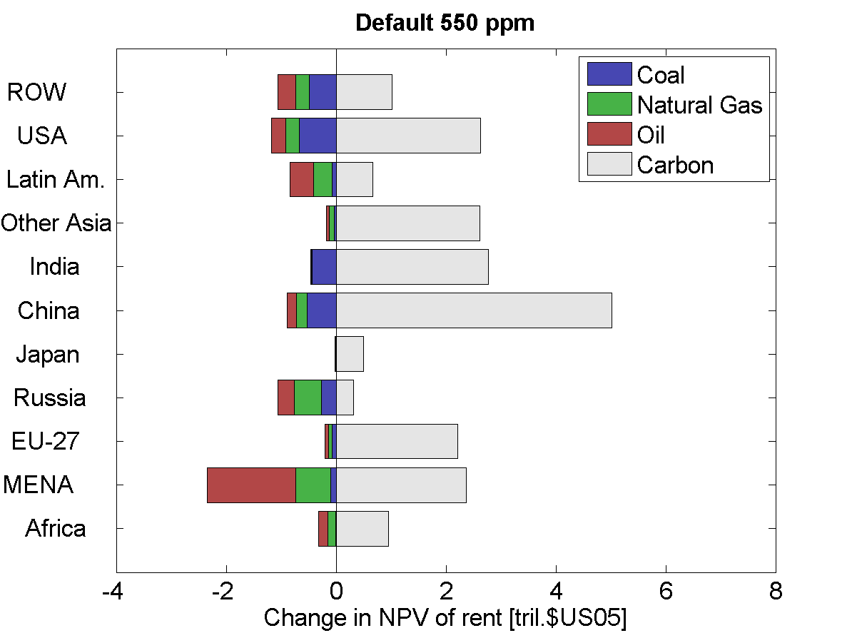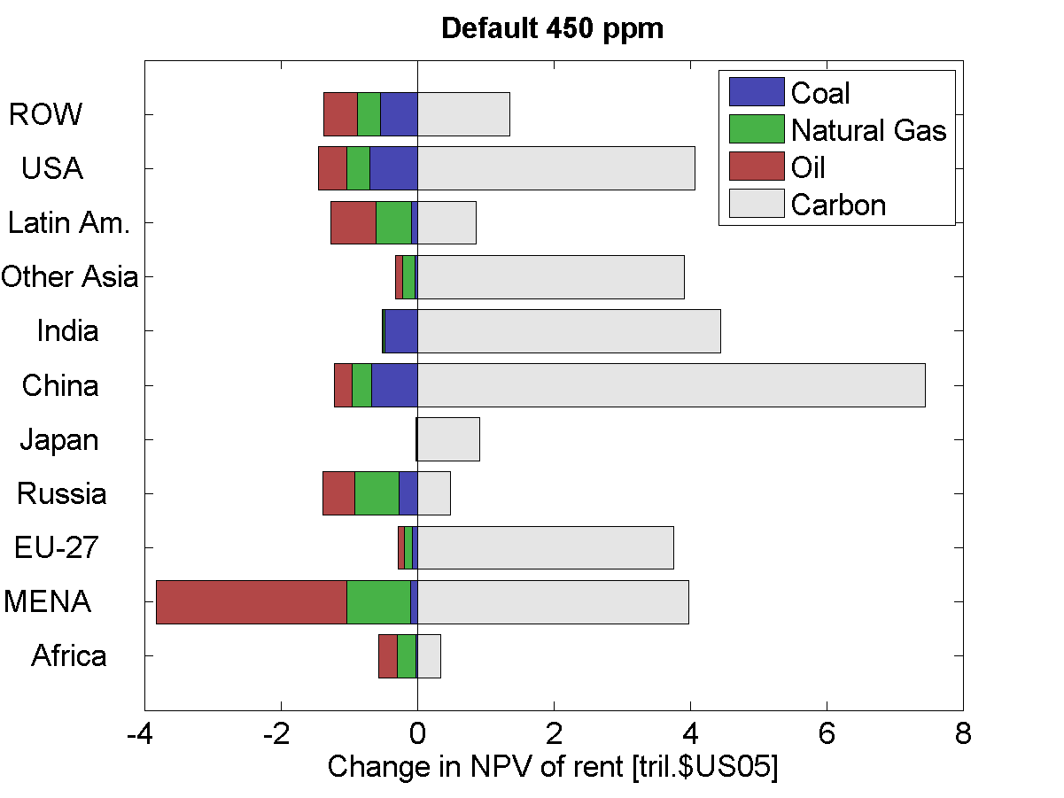
Figure S14: Regional changes in NPVs of fossil fuel and carbon rents for stabilization scenarios compared with the BAU scenario. No international redistribution is considered. The regional carbon rents are fully generated by domestic carbon emissions. The discount rate is 5%.
The figures show that for the two stabilization scenarios in most regions the carbon rent over-compensates the loss of fossil fuel rent. This also includes the MENA region, but a prominent exception is Russia. The main structural difference of these two resource exporting countries is that MENA’s population is expected to grow, whereas Russia’s population is expected to decrease. This leads to very different patterns of energy demand. Also Russia is rich in renewable energy supplies and can reduce its greenhouse gas emissions more strongly. This means that a greater abatement effort is assigned to Russia when distributing emissions allowances so that initial allocation and market allocation match (such that no international transfers would occur in a global carbon market). Thus, the result that the carbon rent may compensate for missing fossil fuel rent under climate policy at the regional level must be interpreted with great care. In addition, the carbon rent cannot compensate for reductions in GDP – and consequently macro-economic consumption – as these are ultimate reductions of the grand total of economic value generated.
References
Lüken M (2011) Distributive impacts of global climate change mitigation. PhD thesis, TU Berlin, Faculty VI.

Corresponding author. Potsdam Institute for Climate Impact Research, PO Box 601203, 14412 Potsdam, Germany. Tel. ++49+331 288 2540, email: nico.bauer@pik-potsdam.de
More information on ReMIND 1.5 can be found here: http://www.pik-potsdam.de/research/sustainable-solutions/models/remind/description-of-remind-v1.5

