Worksheet 5: KlimafolgenOnline-Bildung.de
Snow depth [cm]
Total snow depth at 07:00 MEZ on the day of the measurement

1. In your group find out how the snow depth has changed over the years and will probably change. Take key notes and discuss your findings.
The picture on the right side shows the RCP 8.5 scenario with medium temperature increase.

1900-2000 2000-2100
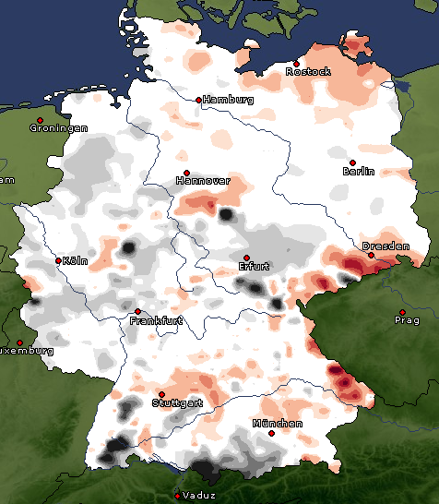 | 