Worksheet 2: KlimafolgenOnline-Bildung.de
Precipitation [mm]
Daily accumulated precipitation

1. In your group find out how the precipitation has changed over the years and will probably change. Take key notes and discuss your findings.
The picture on the right side shows the RCP 8.5 scenario with medium temperature increase.

1900–2000 2000–2100
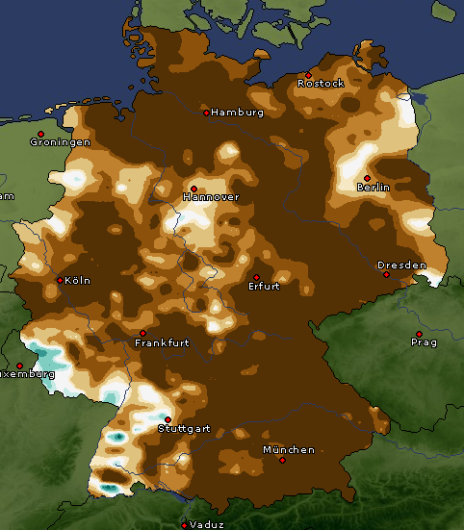 | 