Research workshop: Viticulture
Dieser Research Workshop für den englisch-bilingualen Unterricht beschäftigt sich mit dem Einfluss des Klimawandels auf den Weinanbau in Deutschland.

Beschreibung der Unterrichtseinheit
Der Klimawandel führt dazu, dass der Weinanbau auch in Deutschland zunehmend attraktiv wird, weil die Qualität des Weins aufgrund der günstigeren klimatischen Verhältnisse steigt. Mithilfe des Unterrichtsmaterials „Research Workshop: Viticulture“ recherchieren die Schülerinnen und Schüler die Wirtschaftlichkeit des Weinanbaus in den kommenden 50 Jahren für eine bestimmte Region.

Linkliste
PDF-Datei mit Statistiken www.deutscheweine.de/fileadmin/user_upload/Website/Service/Downloads/Statistik_2015-2016.pdf
In diesem Dokument finden Sie Statistiken zu verschiedenen Themen wie Rebflächen, Weinerzeugung, Weinimport und -export, etc., [Stand: 28.02.2018].

Risiken im Weinbau
www.klima-warnsignale.uni-hamburg.de/wp-content/uploads/2014/06/maixner.pdf
Hier werden klimabedingte neue Risiken durch Schadorganismen im Weinbau thematisiert, [Stand: 28.02.2018].

Unterrichtsmaterial Research Workshop Viticulture
Arbeitsblatt Research Workshop 4
Research Workshop 4 (Viticulture)
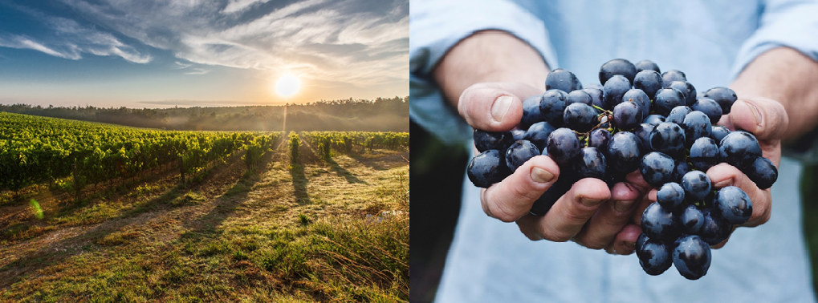
Pictures: pixabay free images

Because of climate change vine cultivation is becoming increasingly attractive in Germany. One important factor is the rising quality of wine due to favorable climate conditions. This development results in a higher demand for German wine. Therefore, wine-growers search for new areas of cultivation and some wine connoisseurs think about entering this economic sector. So does your uncle. He asks you to research how the climatic conditions for viticulture in Germany will develop within the next 50 years.

Tasks:
Focus your research on the following tasks and guiding questions:
- Research the ideal climatic conditions for viticulture. How do the possibilities for wine cultivation in Germany change due to climate change? What is the situation like in your region?
- Has there been an expansion of vineyards in Germany since the year of 1990? Research online using the document: http://www.deutscheweine.de/fileadmin/user_upload/Website/Service/Downloads/Statistik_2015-2016.pdf
- Can an expansion of vineyards be expected due to the changing climate conditions in the future? What might this potential development look like? Research for the development and the parameters using the platform “KlimafolgenOnline-Bildung.de” (http://www.klimafolgenonline-bildung.de/).
- Take a look at the German city of Delmenhorst on “KlimafolgenOnline-Bildung.de”. What development can you see for viticulture in this region over the next 30 to 50 years? Does the shift of the vine blossom improve the preconditions for wine cultivation?
Divide the work between the members of your group.
Review your research findings critically and present each other’s findings within the group.

You can proceed as follows:  - Create an outline.  - Summarize your results in short texts.  - Visualize your findings/ information in graphs, maps and pictures (if possible).  - Use the platform “KlimafolgenOnline-Bildung.de” to visualize developments. | Present your group’s research findings in class, for example as a/an …  - presentation (with Prezi or PowerPoint)  - newspaper article  - interview with an expert  - video (documentary)  - blog or website
Further resources for the research workshop “viticulture”:
- PDF-Datei mit Statistiken In this document you will find statistics on various topics like vineyards, wine production, wine import and export, etc.
- Risiken im Weinbau This article discusses new climate-induced risks due to pests in viniculture.
- 3sat: Beitrag mit Video zum Weinanbau This article includes a video that deals with the advantages and disadvantages of climate change for wine cultivation in Germany.

