Research workshop: Health
Dieser Research Workshop für den englisch-bilingualen Unterricht beschäftigt sich mit den möglichen Auswirkungen des Klimawandels auf die Gesundheit.

Beschreibung der Unterrichtseinheit
Ein Anstieg von schwülen und heißen Tagen als Folge des Klimawandels hat auch Konsequenzen für die Gesundheit. In dem Unterrichtsmaterial „Research Workshop: Health“ geht es um die Frage, wie ein Anstieg von schwülen und heißen Tagen den schulischen Sportunterricht beeinflusst. Aus der Rolle eines Schülersprechers diskutieren die Schülerinnen und Schüler bei einer Fachkonferenz Sport über erforderliche Anpassungsmaßnahmen im Sportunterricht.
Linkliste
www.umweltbundesamt.de/
Das Umweltbundesamt informiert über die Auswirkungen der klimabedingten Hitzewellen auf die Gesundheit, [Stand: 28.02.2018].

www.bildungsserver.de/
Der Hamburger Bildungsserver veranschaulicht die direkten und indirekten Folgen des Klimawandels auf die Gesundheit, [Stand: 28.02.2018].

3sat: Video zum Hitzestress
www.3sat.de/mediathek/?mode=play&obj=60127
Dieses Video beschäftigt sich mit der Thematik Hitzestress am Beispiel von Stuttgart, [Stand: 28.02.2018].

Broschüre zu Klimafolgen
www.climate-service-center.de/imperia/md/content/csc/csc_broschueren/broschure_gesundheit_und_klimawandel.pdf
Diese Broschüre beschäftigt sich mit den gesundheitlichen Folgen des Klimawandels für vulnerable Gruppen, [Stand: 28.02.2018].

Unterrichtsmaterial Research Workshop Health
Arbeitsblatt Research Workshop 6
Research Workshop 6 (Health)
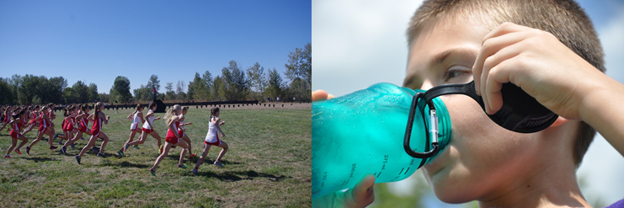
Pictures: pixabay free images

It has been shown that climate change has negative impacts on people’s health as well. An increasing number of hot and humid days can cause cardiovascular problems, for example. Children, elderly and sick people and those in need of care are particularly at risk. This aspect needs to be considered in planning processes of schools, hospitals and nursing homes.
At your school’s physical education teachers’ conference, the teachers discuss potential adaptations for sports classes. As the elected students’ representative of your school you are invited to the conference and asked to contribute ideas.

Tasks:
Focus your research on the following tasks and guiding questions:
- Research the development of hot and humid days in Germany up to the year 2030 using the platform KlimafolgenOnline-Bildung.de. Find the number of hot days for your federal state in the current decade (2010-2020) and for the following decade. Calculate the percentage change. Additionally, search for further resources (e.g. newspaper articles, online sources) that deal with the topic.
- Name the regions that are particularly affected by hot and humid days. Conversely, what is the situation respectively in your own region?
- Research the health risks from heat and humidity and discuss them in your group.
- What are potential adaptation strategies for physical education classes at your school?
- Summarize your findings briefly (keywords).
Divide the work between the members of your group.
Review your research findings critically and present each other’s findings within the group.

You can proceed as follows:  - Create an outline.  - Summarize your results in short texts.  - Visualize your findings/ information in graphs, maps and pictures (if possible).  - Use the platform KlimafolgenOnline-Bildung.de to visualize developments. | Present your group’s research findings in class, for example as a/an …  - presentation (with Prezi or PowerPoint)  - newspaper article  - interview with an expert  - video (documentary)  - blog or website

Further resources for the research workshop “health”:
- www.umweltbundesamt.de The Federal Environmental Agency in Germany provides information about the impacts of climate-induced heat waves on health conditions.
- www.bildungsserver.de “Der Hamburger Bildungsserver“ visualizes the direct and indirect consequences of climate change for people’s health.
- 3sat: Video zum Hitzestress This video deals with the topic of heat stress using the example of Stuttgart.
- Broschüre zu Klimafolgen This brochure focuses on health consequences of climate change for vulnerable groups.

