Climate Risk Assessment to identify robust adaptation strategies for the water sector in Bolivia
Disclaimer
Copyright
Authors
Date
Graphic design and photo credits

Acknowledgements

No | Name | Institution
Public institutions
1 | Oscar Meave  Neftalí Chapi  Gustavo Ayala  Daniel Becerra | Dirección de Planificación, Ministerio de Medio Ambiente y Agua (MMAyA)
2 | Paola Padilla  Mario Lourenco | Viceministerio de Recursos Hídricos y Riego, MMAyA
3 | Leo Pereira  Hugo Cutile  Michelle Vasquez  Willy Rocha | Servicio Nacional de Meteorología e Hidrología (SENAMHI)
4 | Juan Carlos Torrico | Autoridad Plurinacional de la Madre Tierra
5 | Carina Castro  Dayske Shoji  Alejandro Araujo  Adita Montaño  Celia Capobianco | Gobierno Autónomo Departamental de Santa Cruz
6 | Alan Echart  Omar Rodríguez | Gobierno Autónomo Departamental de Tarija
Academia
7 | Pablo Fuchs | Instituto de Hidrología e Hidráulica, UMSA
Institutions that do similar studies
8 | Nicole Stuber  Boris Hinojosa  Eduardo Noriega  Adrián Castillo | AKUT
9 | Oswaldo Maillard | Fundación para la Conservación del Bosque Chiquitano
10 | Wolf Rolón | Consultor – Proyecto Paisajes Resilientes
GIZ
11 | Miguel Ontiveros | Programa PERIAGUA
12 | Daniel Leguía | Proyecto Paisajes Resilientes
13 | Mario Veizaga  Pablo Molina  Génesis Nava  Carlos Saavedra  Sören Rüd  Andrea Salinas | Programa PROCUENCA
PIK
14 | Anne Gaedecke  Fred Hattermann  Carlos Fernandez  Sebastian Ostberg  Nele Gloy
HFFA Consulting
Juliane Kaufmann
Matti Cartsburg
Sophia Lüttringhaus

Preface
…

Main messages

- With very high certainty mean annual temperatures, hot days, tropical nights, and extreme drought events are increasing in number and intensity under climate change in Bolivia.
- Projections of precipitation show a larger overall uncertainty. Annual mean precipitation projections show a tendency to decrease in Santa Cruz, whereas an increase in precipitation is projected in Tarija under the medium and high global warming scenarios.
- As a result, impacts on water resources and vegetation differ and also the planned adaptation measures have to apply to the climate development.
- Vast areas in the Santa Cruz region (Upper Amazon) are affected by forest fire. In most cases, the vegetation did not recover to the original state and remains degraded or is under human management now.
- The general picture is that the burned areas are prone to sometimes much higher surface runoff (and floods) and sometimes much less groundwater recharge (and local droughts). Decisive is, how fast the vegetation recovers and whether and how the follow up management of the areas happens.
- As a result of the climate trends in temperature and precipitation, discharge generally decreases in the Santa Cruz region and there is a trend to increased discharge in Tarija in the medium and high global warming scenarios. Both trends are associated with large uncertainties.
- The number of low flow (drought) and high flow (flood) discharges increases in both regions, Tarija and Santa Cruz.
- The impacts on water resources and hydro-climatological extremes increase with the temperature increase.
- Crop yields generally decrease in the Santa Cruz region, and may increase in the Tarija region.
- Reservoir:

Table of Contents
1 Introduction 7
1.1 Objectives 9
1.2 Structure of the report and related documents 10
2 Methods and data 11
2.1 From climate models to regional consequences for the water balance and hydrological processes 11
2.1.1 Global Climate Models (GCMs) and Regional Climate Models (RCMs) 12
2.1.2 The climate change scenarios: Recent developments in global and regional climate change and adaptation research 12
2.1.3 The eco-hydrological model SWIM 14
2.2 Present climatic conditions and development in Bolivia 15
2.3 Focus areas 18
2.3.1 ITENEZ BASIN IN SANTA CRUZ REGION 18
2.3.2 BERMEJO BASIN IN TARIJA REGION 20
2.4 Methodological innovation and value added 22
3 PART I – CLIMATE CHANGE IMPACTS IN BOLIVIA AND IN THE FOCUS REGIONS 24
3.1 Entire Bolivia 25
3.1.1 Santa Cruz department 35
3.1.2 Tarija department 39
4 PART II – Impacts on hydrology and selected adaptation measures 44
4.1 Santa Cruz 44
4.1.1 Climate change impacts in the San Martín and Paraguá basins 44
4.1.2 Adaptation measures 50
4.2 Tarija 55
4.2.1 Climate change impacts in the Bermejo basin 55
4.2.2 Adaptation measures 59
5 Discussion 69
6 Summary 70
7 References 70

List of tables
List of figures
List of abbreviations

Introduction
Many countries around the world including Bolivia will be severely affected by climate change and its impacts on water resources and the Water – Energy – Food Nexus (WEF). Earth observations such as the GRACE-FO satellite data, for example, show unnormal low groundwater storage in larger parts of Central and Eastern South-America including the lowlands of the Amazon basin (Figure 1).

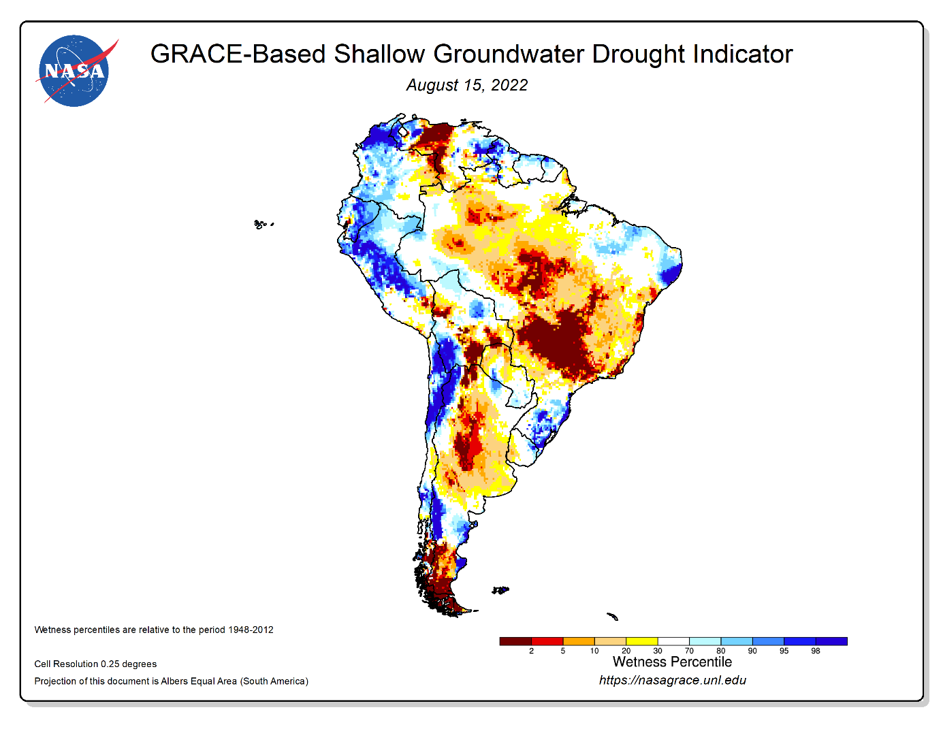
Figure 1: Current state of the groundwater resources in South America, based on terrestrial water storage observations derived from GRACE-FO satellite data and integrated with other observations (source: https://nasagrace.unl.edu/). The drought indicators describe current wet or dry conditions, expressed as a percentile showing the probability of occurrence for that particular location and time of year.

Water related impacts are often, in parallel, reinforced by political decisions and water and land (mis-)management. These are daunting challenges, but they also present a unique opportunity for communities to cooperate, learn, and adapt together.
The Paris Agreement set an ambitious global objective to combat climate change and adapt to its effects. In 2020, the Agreement entered into force, with one focus on ensuring that global pledges adequately consider adaptation and mitigation measures, which will be implemented and updated in the Nationally Determined Contributions (NDC). The NDCs thus comprise the actions countries intend to take to achieve the long-terms goals of the Paris Agreement.

The NDC bottom-up approach allowed countries to define their respective priorities and strategies for addressing climate change, based on their own capabilities and vulnerabilities, while anchoring the Paris Agreement at the national level.
Almost all the NDCs identify water as a central component of their adaptation work and some also link water to the provision of sustainable energy, food security and forest restoration. While the key role of water in strengthening resilience to climate change cannot be overstated, the explicit recognition of water as an essential enabling factor -in that resilient and robust water management is required for climate mitigation and adaptation- is not widely mentioned and may be an important source of concern for effective implementation.
The Bolivian National Determined Contributions (NDCs) cover adaptation mainly in the water, energy and forest, agriculture and livestock sector. However, the current NDC does not provide guidance on how to operationalize adaptation goals neither has specific indicators to report under the transparency mechanisms of the Paris Agreement, e.g. in the prioritized sectors, or about investments needs and benefits and the metric of climate change (adaptation and mitigation). Bolivia is currently embarked on the process of updating its NDCs and developing the implementation and investment plans (route map) into the future. However, to date Bolivia has a lack of a comprehensive analyses projecting climate risks helpful for cost-benefit and cost efficiency analysis to generate a profound information basis for NDC implementation and investment planning. To address this prevalent bottleneck for updating, operationalizing and implementing NDC (1) projections of climate and weather impacts for economy and society and (2) prioritization of adaptation investments to cope with climate and weather risks e.g. via cost-benefit-analysis are needed in all sectors and specially in the water sector.

Objectives

As support for the national authorities and contribution to the country climate risk profile, which synthesizes key findings on the climate change risks in the water sector of Bolivia, this study’s main objectives will be (1) a climate risk analysis generating estimates for projected climate and weather risks of the water sector and (2) assessing costs and benefits of selected adaptation investment strategies/options vs. non-action/ BAU (Business As Usual) including the following two dimensions:
  - Impact-dimension: define the climate risk exposure looking at biophysical, social, financial and economic resilience as well as the associated socioeconomic implications across multiple scenarios.
  - Action-dimension: Development of selected adaptation investment scenarios and options/strategies including costing underlying different scenarios (adaptation investment vs. non-action) and building on the impact dimension in the water sector.
The subject of investigation will be the respective water sector of the NDC adaptation content and the corresponding development of NDC updating, implementation (NDC route map) and investment plans. The case studies will focus on the water sector, but will also consider interlinkages between different sectors, especially incorporating WEF nexus and the ecosystem-based approach (e.g. natural infrastructure, ecosystem-based adaptation, nature based solutions, etc). The level of analysis and research scope will be focused on the national scale. The risk and action estimates will form the base for sector-specific investment planning, considering different eco-regions/strategic river basins/ ecosystem specificities/climate zones within the country. Accordingly, the case study elaboration should be aligned to on-going NDC updating and implementation/investment planning or other relevant policy and investment planning processes in the country to ensure application of the generated data (e.g. National Development Plan -PDES-, National Sectorial Plan -PSDI of the MMAyA-, National Adaptation Plan -PPCC-, National Watershed Plan -PNC-, and subnational territorial plans -PTDI-, etc.).

Structure of the report and related documents

Climate risk profile

Part 0: Methods and data
This chapter described the general methodology of how to get from global climate models to regional consequences for the water balance and hydrological processes, describes recent developments in global and regional climate change and adaptation research, briefly introduces the eco-hydrological model and finally describes the climate and geographical characteristics of the focus areas investigated in this study.

Part 1: Climate change in Bolivia and in the case study regions
This chapter identifies changes in future climatic conditions in Bolivia using the latest generation of climate change scenarios and several widely used indicators. The projected changes in climate indicators were examined for three high-priority scenarios covered in the Sixth Assessment report (AR6) by the Intergovernmental Panel on Climate Change (IPCC). Projected climate data was analyzed to show the range of possible future climatic conditions in the near-future (the 2030s; 2015-2045), mid-century (2050s; 2035-2065), and far-future (2080s; 2065-2095) relative to a reference period (2000s, 1985-2015).

Part 2: Impacts on hydrology and selected adaptation measures
The ecohydrological model SWIM has been implemented to translate the changes in climate described in Part 2 into changes in hydrological processes, available water resources and selected crop yields. Based on that, possible adaptation measures and their effects are described for the Bolivian regions of Santa Cruz and Tarija.

Methods factsheet
Brochure

Methods and data

From climate models to regional consequences for the water balance and hydrological processes

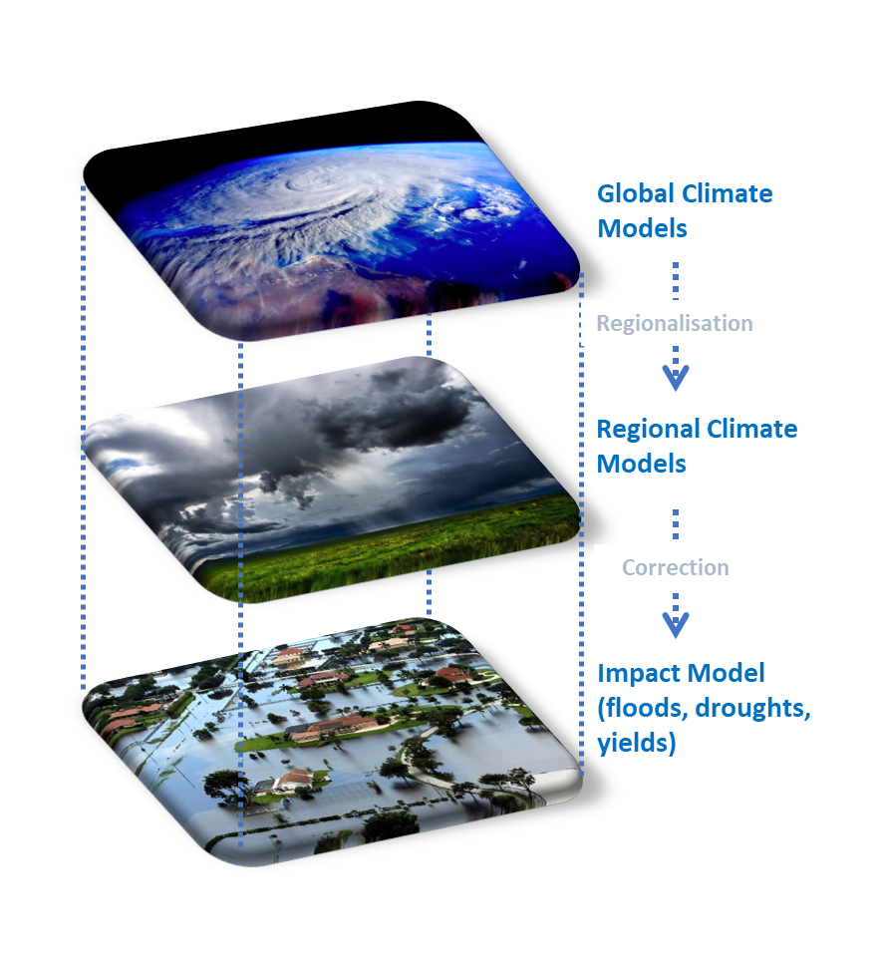

Figure 2: Chain of models for simulating climate impacts on the water cycle.

A chain of models from global climate models to regional climate models to (eco-)hydrological catchment models is usually applied to determine the impacts of global climate change on regional water resources and hydrological extremes. The first model layer is the global climate model, which simulates the global climate and the consequences of an assumed greenhouse gas increase (emission scenario). Its results form the input for dynamic or statistical regional climate models that describe the regional climate on scales of up to a few kilometers. The meteorological fields generated, e.g. of precipitation, temperature, but also radiation, humidity and wind, are then the input to drive hydrological model systems of varying complexity, which now simulate the individual processes of the hydrological cycle on scales of up to a few tens to hundreds of meters resolution. Such a model chain is shown in Figure 2. However, the regional climate data often have to be corrected before they can be fed into the hydrological models. This step is called bias correction.
A global climate model (GCM) is a complex mathematical representation of the major climate system components (atmosphere, land surface, ocean, and sea ice) and divides the global atmosphere into a three-dimensional grid of cells, where the fluxes of heat, water, and momentum are calculated. Its grid size is dependent upon the power of the computer that is available to solve these equations. This limits the spatial resolution and is the reason why a further downscaling of the climate data provided by GCMs is necessary, for example to represent a potentially very heterogeneous landscape (from very mountainous counterparts to flat coastal plains) with its very different potential for heavy precipitation, droughts or other extreme events.
In contrast, regional climate models (RCM) and empirical statistical downscaling (ESD) applied over a limited area and driven by GCM data can provide information at much smaller scales that support more detailed impact assessment and adaptation planning, which is critical in many vulnerable regions of the world. RCMs apply basically the methodology as done in GCMs, but at a much finer resolution. As a result, they need comparable computer resources. For the latest generation of global climate model scenarios (CMIP6), RCM output is not available yet. The only cost-effective way of producing high resolution climate projections for GCMs is via statistical downscaling (ESD). Statistical downscaling in turn requires high resolution observational data, so it can learn the statistical relationships between of the historical climate data at different scales and then use those relationships to enhance the spatial resolution of climate projections.
The last model type in the chain are the so-called impacts models, in our case the hydrological model. The latter reproduces the landscape pattern of a watershed by considering the landscape characteristics of catchments, such as soil properties, land use and relief. Such a model is the eco-hydrological model applied in this study and further described in Chapter 2.1.2.

The climate change scenarios: Recent developments in global and regional climate change and adaptation research

A new set of climate scenarios has been developed with respect to the sixth IPCC report (IPCC AR6), the "Shared Socioeconomic Pathways" (SSPs). The new scenarios represent narratives for different socio-economic pathways resulting in different increases of atmospheric greenhouse gas concentrations and leading to different levels of global warming.
Five basic SSP scenarios were defined (Figure 3):
- SSP1: The sustainable and “green” pathway describes an increasingly sustainable world. Global commons are being preserved, the limits of nature are being respected. The focus is more on human well-being than on economic growth. Income inequalities between states and within states are being reduced. Consumption is oriented towards minimizing material resource and energy usage.
- SSP2: The “Middle of the road” or medium pathway extrapolates the past and current global development into the future. Income trends in different countries are diverging significantly. There is a certain cooperation between states, but it is barely expanded. Global population growth is moderate, leveling off in the second half of the century. Environmental systems are facing a certain degradation.
- SSP3: Regional rivalry. A revival of nationalism and regional conflicts pushes global issues into the background. Policies increasingly focus on questions of national and regional security. Investments in education and technological development are decreasing. Inequality is rising. Some regions suffer drastic environmental damage.
- SSP4: Inequality. The chasm between globally cooperating developed societies and those stalling at a lower developmental stage with low income and a low level of education is widening. Environmental policies are successful in tackling local problems in some regions, but not in others.
- SSP5: Fossil-fueled Development. Global markets are increasingly integrated, leading to innovations and technological progress. The social and economic development, however, is based on an intensified exploitation of fossil fuel resources with a high percentage of coal and an energy-intensive lifestyle worldwide. The world economy is growing and local environmental problems such as air pollution are being tackled successfully.
In General, global warming increases from SSP1 to SSP5.

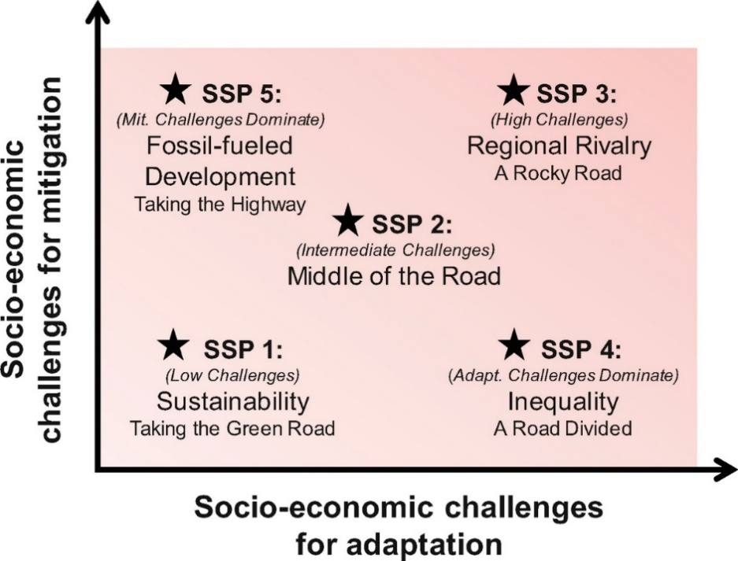
Figure 3: The SSPs of the IPCC guided scenario set (O’Neill et al., 2016).

The SSPs roughly correspond to the RCP (Representative Concentration Pathways) scenarios RCP2.6, RCP4.5, RCP6.0 and RCP8.5 of the previous IPPC report (AR5). The use of comparable developments of greenhouse gas emissions and radiative forcing allows for a direct comparison of CMIP5 and CMIP6 simulations. In contrast to RCP scenarios, the new SSP-based scenarios provide economic and social reasons for the assumed emission pathways and changes in land use.
In our study, we applied the scenarios SSP1-2.6, SSP3-7.0 and SSP5-8.5.

The eco-hydrological model SWIM

The SWIM (Soil and Water Integrated Model) eco-hydrological model was developed to investigate the impacts of climate and land use change at the regional scale, i.e. the scale where the impacts of climate change manifest themselves and adaptation measures are planned and implemented (Figure 4, Krysanova et al 2015, Hattermann et al 2005).

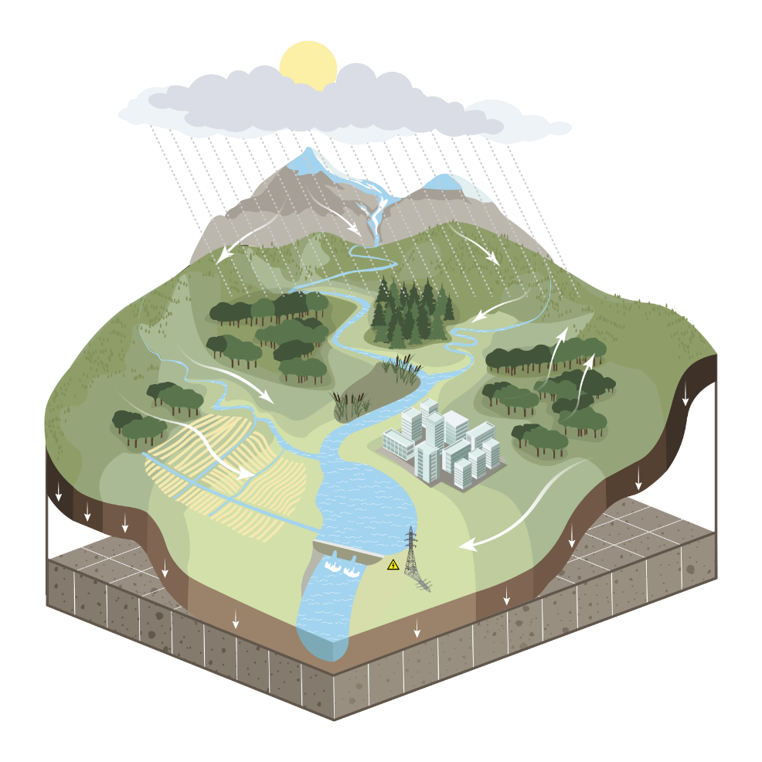
Figure 4: The eco-hydrological model SWIM with the main landscape characteristics and water and matter flows considered.

The model integrates all the relevant and interconnected hydrological, plant and management processes at the mesoscale, such as runoff generation, plant growth, nutrient and carbon cycling and erosion. Added to this are water management and agricultural cropping patterns and yields. The approach thus allows the simulation of all interrelated processes in a single model framework and with daily time steps using regionally available data (climate, land use and soil) and considering feedbacks (Figure 4). Wetlands are considered, among other things, through flooding and higher water availability for plants.
The water management model allows the simulation of reservoirs for flood protection, water supply and low water control. Irrigation and transmission lines are also possible. The agricultural module includes the simulation of cropping sequences, fertilisation and harvesting and the associated nutrient cycles. The vegetation module simulates the dynamic growth of different forest types as well as grassland and shrubland.
SWIM is a spatially semi-distributed model (it uses a three-level disaggregation scheme from catchment to sub-catchment to hydrotope) that generally operates in a daily time step. Model setup and post-processing are supported by a GIS interface. Results are presented as time series and maps for a range of variables.
The SWIM model has been implemented and applied in various projects worldwide to investigate the consequences of climate and land use change on the water-energy-food nexus and on hydroclimatic extremes (see e.g. in Hattermann et al. 2011, 2014, and for an overview Krysanova et al. 2015), and has in addition participated in various model intercomparison studies (see e.g. Hattermann et al. 2017 and 2018).
SWIM is maintained and further developed by the regional hydrological modelling group of PIK's Research Division II (https://www.pik-potsdam.de/en/institute/departments/climate-resilience/models/swim).

Present climatic conditions and development in Bolivia

The basis for the evaluation of the current climate is the observation-based climate dataset W5E5 version 2.0 (WFDE5 over land merged with ERA5 over the ocean, Lange et al. 2021). The W5E5 dataset is available for the entire globe at 0.5° horizontal (approximately 50km x 50km at the equator) and daily temporal resolution from 1979 to 2019. See Annex A for a comparison of bias-adjusted CMIP6 climate models and observation-based data (W5E5 and GMET, including data from SENAMHI).
Bolivia has complex hydroclimatic conditions owing to its different climatic zones and the Andes cordillera, which acts as a topographic barrier for the warm and moist flux from the Amazonian region and leads to strong local and regional differences in climate. The country has three clearly distinct regions: the lowlands with elevations up to 500 m asl (about 60% of the country); the Altiplano and the Andean mountains with elevations above 3500 m asl (around 16% of Bolivia); and the valleys and the slopes of the Andean mountains which encompasses the remaining 24% of the Bolivian territory (Abadi et al., 2020). The climate varies from tropical in the northeast, semiarid in the southeast, mountainous tropical forests along the eastern slopes of the Andes, and arid highlands to the west (Velpuri et al., 2016). The mean annual precipitation (temperature) is about 1285 mm (22 °C) in Bolivia, 1300 mm (25 °C) in the Santa Cruz region, and 745 mm (19 °C) in Tarija region Figure 5.
The spatial patterns of mean annual temperature and total annual precipitation are shown in Figure 5. The temperature pattern is strongly influenced by surface elevation (and also by topography, altitude and gradient). The highest temperatures occur in the lowlands and the lowest at the Altiplano and surrounding mountain chains. Furthermore, the northern regions are warmer compared to their southern counterparts. The spatial pattern of precipitation is characterized by a strong east-west gradient (Figure 5). Higher amounts of precipitation occur over the northern part of the lowlands than in the southern part. The highest precipitation (an amount of about 5000 mm/year) amounts are recorded at the eastern side of the Cordillera Oriental. The Altiplano receives the lowest amounts of precipitation within Bolivian (ranging from 250 to 750 mm/year). The annual precipitation regime in Bolivia is unimodal. The wet season is relatively short over the Andes as in the Guadalquivir watershed and longer over lowlands as in the Amazonian San Martín and Paraguá watersheds (Figure 5). Hence, the short rainy season lasting from November to March in Andean catchments largely determines the agricultural season.
In Bolivia, the large spatial variability of precipitation is modulated by the interplay among large-scale (e.g., latitudinal migration of Atlantic Intertropical Convergence Zone, South American Monsoon Systems, Bolivian High) and local circulation patterns (e.g., upslope and downslope moisture transport) and the complex Andean orography (Espinoza et al., 2020; Garreaud, 2009; Segura et al., 2020). Furthermore, El Niño-Southern Oscillation (ENSO) is a major modulator of hydro-climatology at interannual timescales along the Andes (Poveda et al. 2020). Less precipitation generally occurs during the warm ENSO phase in the Bolivian Andes (Canedo-Rosso et al., 2019; Seiler et al., 2013a), whereas higher amounts of precipitation and a larger number of extreme events occur during both (cold and warm) phases of ENSO in the lowlands (Seiler et al., 2013a).
Mean annual air temperature has increased by 0.1°C per decade since the mid-20th century in Bolivia (Seiler et al., 2013a), with higher trends in the Andes (Altiplano) where warming has reached 0.15 to 0.25 °C per decade in annual and warm-season maximum temperatures (López-Moreno et al., 2016). Precipitation has increased (2.5 mm per year) during the period 1981-2018 in the Altiplano region (Segura et al., 2020; Torres-Batlló and Martí-Cardona, 2020). The largest precipitation increase has been detected in the north-western part of this Altiplano during the rainy season. Furthermore, a negative trend of rainy season duration at a rate of −0.4 days per year was reported (Torres-Batlló and Martí-Cardona, 2020). Therefore, the past climatic changes (rising temperature and reduction of the rainy season duration) could lead to severe implications for water resources at the Andean ecosystems. So far, no changes in precipitation have been reported over the Bolivian Amazon basin; however, as a result of increasing air temperatures, increases in evapotranspiration and decreasing water yield have been observed (Heerspink et al., 2020).

Location map and surface elevation  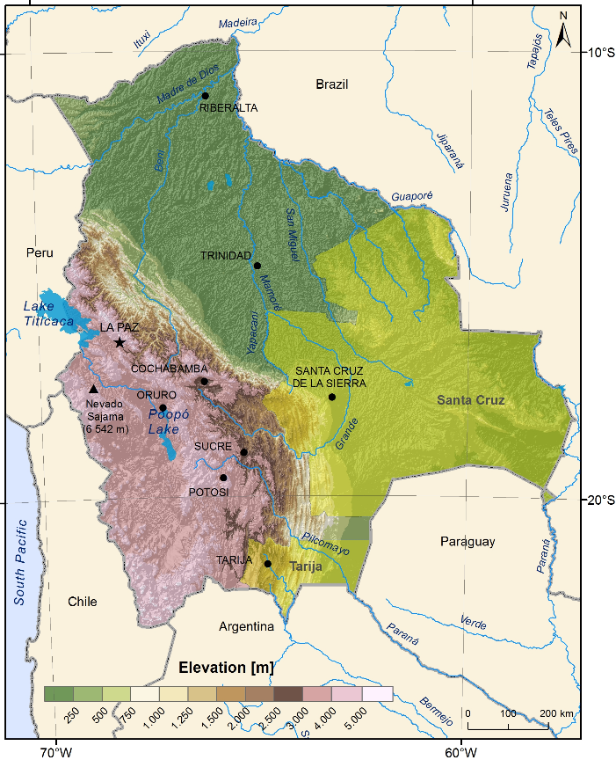 | Precipitation and temperature regimes (1985-2015)
Spatial patterns (1985-2015 average)

Figure 5: Study area and precipitation and temperature regimes for 1985 - 2015.

Focus areas

ITENEZ BASIN IN SANTA CRUZ REGION

The Itenez basin occupies around 50% of the total surface of Bolivia and is mainly located in the tropical lowlands (Figure 6 ). As can be seen on the upper map, the central landuse is the forest evergreen closed, which covers ~45 % (272419 km²) of the basin and occupies most of the tropical lowland territory, including the San Martín and Paraguá sub-basins. The grass savannah occupies the southwestern area, located in the eastern mountains' slopes, as well as the eastern border and northwestern area, around Ginebra Lake, covering ~13 % (78055 km²) of the basin territory. East of the city of Santa Cruz, within the lowlands, is the region mainly covered by agricultural areas, taking up 2 % (11355km²) of the basin area. There are also small patches of grass savannah alongside the evergreen forest. Finally, the basin's southern part is covered by deciduous forest, occupying 1.7 % (11500 km²) of the territory, respectively.

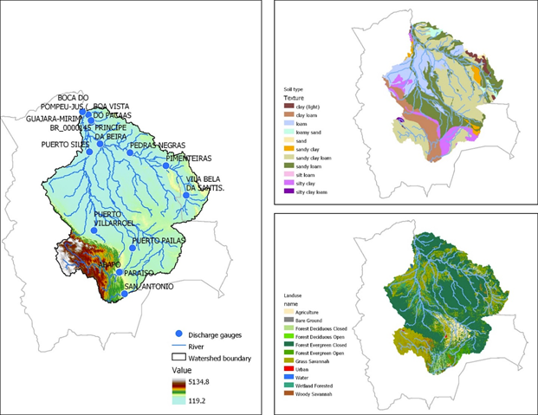
Figure 6: The location of the Itenez basin, the river system and the soil and land use types located in the basin.

In terms of soil textures, the most predominant is sandy clay loam (35 % - 213068 km²), which is found in the eastern mountain slope zone and in most of the lowlands, particularly in the San Martín and Paraguá sub-basins (Figure 6). Along the foothills, clay loam and silty clay soils type are found, representing the 9.8 % (59676 km²) and 7 % (533 km²) of the area, respectively. Along the central region of the basin, loam soil types are found toward the north and sandy loam toward the south, taking up 14.5 % (88754 km²) and 26.9 % (163806 km²) of the area, respectively. In the area around the Paragua and San Martin rivers, a sandy loam soil type is also found together some patches of clay (light), sandy clay and loamy sand, around 32.5 % of the total area (197638 km²). In terms of soil types, large parts of the lowlands are covered by Oxisols/ Ferralsols, best known for their occurrence in tropical rain forests, and defined as soils containing at all depths no more than ten percent weatherable minerals, and low cation exchange capacity. They are sandy-loamy soils being the result of millions of years of weathering, humification and pedoturbation due to animals.

Areas affected by forest fire
The area burned annually in Bolivia was approximately 100 thousand hectares per year until before 1999. Since then, between 2001 and 2020, burned areas have reached an annual average of 3.7 million hectares. The Chiquitano Dry Forest is one of the ecosystems most affected by fires (1.3 million hectares burned in 2019).

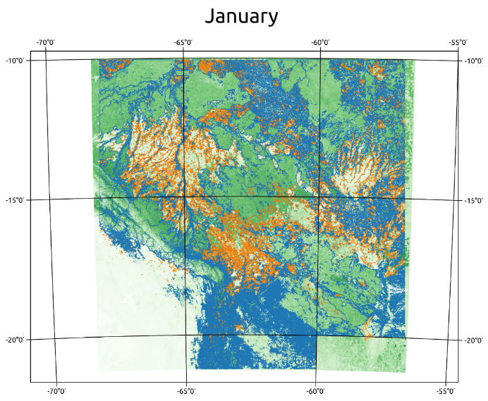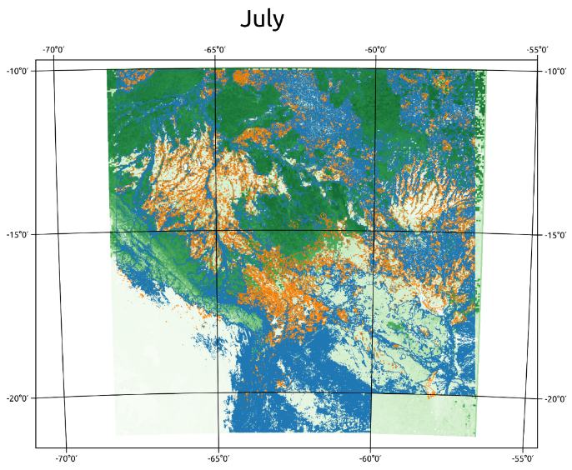
Figure 7: Impact of forest fires. In orange encircled the burned areas since 2011, in green their average vegetation cover (leaf area index LAI) in January and July. Origin of the data: MODIS satellite data.

The fires find a significant synergy with the development of droughts in this region, resulting in reduced volumes in the main sources of water – rivers, streams, wells, among others. In 2019 alone, 2,497 communities were served due to water deficit, both for human consumption and for animal consumption, and by 2020 62 % of the department was under drought conditions. According to the Recovery Plan for Areas Affected by Fires and the Santa Cruz Forest Restoration Strategy (ERFSC), ecosystem restoration is proposed as a measure to recover environmental functions and land suitable for productive development, as well as to mitigate the impact of future fires caused by natural causes, human intervention and aggravated by climate change. Restoration actions include natural forest regeneration ("passive restoration") and the implementation of sustainable land use practices ("active restoration").
After an ecosystem is affected by a fire, two phases must be considered for its recovery. A first in the short term, called rehabilitation, which must be executed as soon as possible after the accident, and a second, in the medium and long term, called restoration.
However, satellite observations show that restoration did not take place in most areas affected by forest fire in the Santa Cruz region: The extent of burned areas since 2011 is shown in Figure 7, together with the long-term impact on vegetation cover given as the Leaf Area Index (LAI), derived from MODIS earth observation data. The maps illustrate that in most areas affected by forest fire, the former vegetation (in most cases forest) did not reestablish and the vegetation cover is lower (max LAI between 2 and 3) than under the original surrounding forest (max LAI between 5 and 7). The possible consequences for the hydrological flows and water resources is investigated in Chapter 4.1.2.2.

BERMEJO BASIN IN TARIJA REGION
The Bermejo basin is located in southern Bolivia on the geographic region known as the eastern mountains' slopes. The more predominant units of land use in the basin are mixed forest and broadleaved forest, which covered 22.6 % (2703 km²) and 21.5 % (2563 km²) of the area, respectively. They are found mainly on the eastern side of the region, and in lesser proportion in the highest part of the basin. The area next to the Tarija settlement in the Guadalquivir basin is covered by croplands and this land use coverage is extended along some rivers toward north, southwest, and east of the city. The cropland occupies 6.2 % (736 km²) of the total area of the Bermejo Basin. East of the cropland coverage, in the west side of the basin, is covered by grass/ bushland taking up 24.6 % (2931 km²) of the total area.
Regarding the soils properties, the Bermejo basin is almost homogeneous considering that around 95% of the area has the same soil types but with differences in the predominance. Sandy clay loam and clay loam soils type are found in the basin, but in the western side, in the highest part of the basin where the Guadalquivir sub-basin is located, the first one is the predominant, meanwhile in the remaining area, the second one is. There is a small patch around the Bermejo settlement where loam and sandy loam soil type is found. The main land use pattern and soil distribution are presented in Figure 8.

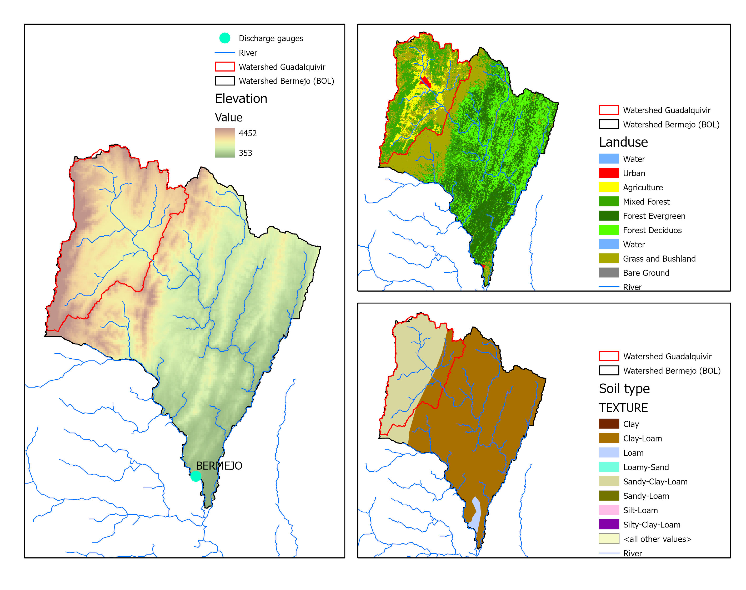
Figure 8: The Tarija region, the San Jacinto reservoir, the river system and the soil and land use types located in the basin.

The San Jacinto Reservoir
The San Jacinto Reservoir is located a few km southwest of Tarija. Its extension in the southwest-northeast direction is about 3 km, the width on average about 400 to 800 m. The lake is fed by several small rivers that originate primarily in the Cordillera de Sama. Drainage is in a southeasterly, then easterly direction into the Río Nuevo Guadalquivir. To the south of the watercourse is the catchment area of the Río Camacho, which joins the Guadalquivir about 10 km further southeast.
The reservoir has a maximum capacity of 63.0 million m³, a dead storage of 17.8 million m³ and a maximum water fall height of 54.15 m for hydropower production.
Built in 1984, the San Jacinto Dam had three objectives: energy generation through the hydroelectric power plant, tourism and irrigation, but for a long time, most of the dam's water was destined for hydropower (80 percent). Over the years, due to the deteriorating water situation in Bolivia, hydropower has taken a back seat and irrigation has gained priority. The water of the lake represents an important freshwater reservoir for the provinces of Cercado and Avilés. Although it is considered to be relatively heavily contaminated, it is used to irrigate agricultural land, as fire-fighting water for forest fires and, to some extent, for the drinking water supply of local residents.

Methodological innovation and value added

The climate risk study provides a scientific and standardized analysis combining several innovative elements:
● Modelling the impact chain: The study delivers a detailed quantitative analysis of climate risks in the water sector under different future scenarios, as established by the Intergovernmental Panel on Climate Change (IPCC). The analysis is taken up in a comprehensive, model-based adaptation assessment, to select suitable and effective adaptation strategies under future climate change projections.
● “State of the art” climate modelling: The climate risk analysis is based on “state of the art” climate models from the latest Coupled Model Intercomparison Project Phase 6 (CMIP6). The climate projections generated in CMIP6 form the basis for the IPCC Sixth Assessment Report (AR6). In this study, data from the Inter-Sectoral Impact Model Intercomparison Project (ISIMIP) is used, which provides bias-adjusted climate data from 10 CMIP6 climate models for different shared socioeconomic pathways. In this way, modelling uncertainty is reduced while considering different socioeconomic development pathways including a worst-case scenario (SSP5-RCP8.5), middle of the road scenario (SSP3-RCP7.0) and an optimistic scenario which is in accordance with the Paris Agreement (SSP1-RCP2.6).
● Quantification of climate change impacts on the water sector: An important component of the risk analysis is the projection of changes in future water availability, which may affect agricultural yield, dam operations and watershed management in general. Climate predictions up to 2100 will be delivered, complementing other climate impact projections done in Bolivia for shorter time frames (e.g. up to 2050).
● Combination of science and local expert criteria: While the climate risk analysis is mainly model-based, input from relevant Bolivian institutions is collected and integrated into the study at several important stages, especially with regard to the definition of the study focus regions, data sharing, the selection and assessment of adaptation strategies and the interpretation of results. The inclusion of national expert criteria in the study process also helps to ensure local ownership of the results and to facilitate the transfer of the findings into policy processes.

Participating institutions
- Ministry of Environment and Water
- Plurinational Authority of Mother Earth
- State Government of Santa Cruz
- State Government of Tarija
- National Institute of Meteorology and Hydrology
- Trinational Office of the Pilcomayo and Bermejo Basins
- Academia and specialized civil society organizations

● Based on Bolivia’s national and subnational priorities: The starting point for selecting the adaptation strategies are relevant national and local policy documents, such as the Patriotic Agenda 2025, the NDC, the sectoral and territorial development plans and the Watershed Management Plan of the Guadalquivir River basin, among others, to ensure political coherence.
● Concrete recommendations for action and investment: Based on the climate risk study, specific recommendations for adaptation action and investments to become more resilient under future climate conditions will be provided and can inform the implementation of national climate strategies, territorial/sectorial plans and watershed management plans, among other initiatives.
● Adding value to previous climate risk analyses: In this study, we use an ensemble of bias-adjusted simulated climate projections of the latest generation of climate models (CMIP6) considering future development pathways. The use of the process-based hydrological model Soil and Water Integrated Model (SWIM) adds an additional hydrological model to the portfolio of tools applied in Bolivia. SWIM has an integrated module for reservoir management with which different management operations and its effect on downstream streamflow can be evaluated (e.g. maximizing hydropower generation, meeting environmental flow requirements, flood/drought control). The spatially semi-distributed character allows investigating hydrological processes from the watershed to the plot (hydrotope) scale. This modelling approach allows to cover large areas (e.g. the Bolivian part of the Amazon basin) while using a finer spatial discretization in the focus watersheds. The combination of climate impact and action dimension will provide a good basis for making robust decisions on climate resilient investments.

PART I – CLIMATE CHANGE IMPACTS IN BOLIVIA AND IN THE FOCUS REGIONS

This Chapter identifies changes in future climatic conditions in Bolivia using the latest generation of climate change scenarios and several widely used indicators. The projected changes in climate indicators were examined for three high-priority scenarios covered in the Sixth Assessment report (AR6) by the Intergovernmental Panel on Climate Change (IPCC). Projected climate data was analyzed to show the range of possible future climatic conditions by the near-future (the 2030s; 2015-2045), mid-century (2050s; 2035-2065), and far-future (2080s; 2065-2095) relative to a reference period (2000s, 1985-2015).
For the analysis of climate change projections, historical and future climate data simulated by climate models participating in the latest Coupled Model Intercomparison Project Phase 6 (CMIP6) were used in this study. CMIP6 historical simulations cover the years 1850-2014 and future projections cover the years 2015-2100. The CMIP6 climate data was bias-adjusted and downscaled to the W5E5 data as part of the latest Inter-Sectoral Impact Model Intercomparison Project round (ISIMIP3b) (Lange and Büchner, 2022, 2021). The bias adjustment and statistical downscaling approach are detailed in Lange (2019). We used daily bias-adjusted records of precipitation, mean temperature, maximum temperature, and minimum temperature from 10 climate models (CANESM5, CNRM-CM6-1, CNRM-ESM2-1, EC-EARTH3, GFDL-ESM4, IPSL-CM6A-LR, MIROC6, MPI-ESM1-2-HR, MRI-ESM2-0, and UKESM1-0-LL). The bias-adjusted records of CMIP6 climate models agree well with the observation-based dataset W5E5. Details are found in Appendix A.
A set of three global warming scenarios of the Shared Socioeconomic Pathways (SSPs) is used to explore climate change over the 21st century. Specifically, the SSP1-2.6, SSP3-7.0, and SSP5-8.5 scenarios, which span a wide range of radiative forcing levels (ranging from 2.6 to 8.5 W/m²) in 2100. The SSP1-2.6 is close to the Paris Agreement goal, where global warming is limited to 2 °C above pre-industrial levels. Moreover, the implementation of the Nationally Determined Contributions of countries presented at COP26 result in a global temperature increase of 2.4 °C until the end of the century (reference). The scenario is characterized by declining greenhouse gas (GHG) emissions to net zero until 2050, followed by varying levels of net negative CO₂ emissions (IPCC, 2021). The SSP3-7.0 scenario is a medium-high and the SSP5-8.5 a high global warming scenario with continuing high fossil fuel development throughout the 21st century and consequently strong increases in GHG emissions. For a detailed description of SSPs scenarios, readers are advised to read the Appendix section (Appendix B) of the Chapter and the Sixth Assessment report by IPCC (2021).
The simulated climate data of the ten bias-adjusted and statistically downscaled climate models are used to analyze the effect of the three different global warming scenarios. The median of the ensemble provides a conservative estimate of possible climatic changes and the spread of the ensemble an estimate of the uncertainty. Climate change projection analyses are based on 31-year averages, meaning that the mean annual temperature in 2030, for instance, is calculated as an average over the mean temperature between 2015 and 2045. The current climate used as the reference period refers to the climate in 2000 (1985-2015). The projected climate changes were evaluated for the periods 2030 (2015-2045), 2050 (2035-2065), and 2080 (2065-2095), thereby providing information for the near-future, mid-century, and far-future.
The climate indicators analyzed are:
- annual mean air temperature
- number of very hot days per year (maximum temperature above 35 °C)
- number of tropical nights per year (minimum temperature above 20 °C)
- frost days (minimum temperature below 0°C)
- total annual precipitation
- frequency and intensity of heavy precipitation events
- frequency of extreme drought events

The indicator for heavy precipitation intensity is the maximum daily precipitation of a year. The indicator for heavy precipitation frequency is the number of days exceeding a threshold. The threshold is defined as the 95th percentile of days with precipitation (defined by days with more than 0.1 mm precipitation) during the baseline period 1985 - 2015 for each grid cell.
The standardized precipitation evapotranspiration index (SPEI, Vicente-Serrano et al. 2010) was used as a measure of meteorological droughts. Extreme drought events were considered when the SPEI value is less than or equal to -2 (SPEI <= -2) (Shekhar and Shapiro, 2019). The SPEI represents the climatic water balance (the monthly difference between precipitation and potential evapotranspiration) (Thornthwaite, 1948) that is calculated at different time scales. Mathematically, the SPEI is similar to the standardized precipitation index (SPI), but it includes the role of temperature and thereby is appropriate to evaluate the effects of climate change on drought in the context of global warming. In this study, SPEI was calculated at a timescale of 6 months (SPEI-6), which is often used as an indicator for reduced streamflow and reservoir storage.

Entire Bolivia

Air temperature
Air temperature projections show a clear increase in annual mean temperature under the three SSP scenarios over the 21st century compared to the reference period (Figure 9a). Following the global warming scenario, the climate projections start to diverge after the 2030s. The SSP3-7.0 and SSP5-8.5 scenarios exhibit a steady increase in air temperature during the 21st century, whereas the warming trend of the SSP1-2.6 scenario stabilizes after the 2050s.
Compared to the reference period, projected far-future (2065-2095) changes show that annual mean temperature is very likely to be higher by 2°C-3.4°C in SSP1-2.6, 3.8°C-6.9°C in SSP3-7.0, and 4.4°C-8.2°C in SSP5-8.5. On average, the temperature in Bolivia is projected to increase under the different scenarios by +2.5°C (SSP1-2.6), +4.7°C (SSP3-7.0), and +5.8°C (SSP5-8.5) for the far future (2065-2095) according to the multimodel median. Similar results have also been seen in the future warming projections (ranging from +2.5°C to +5.9°C) based on the CMIP5 simulations (Seiler et al., 2013b). Air temperature increases across all seasons, with the largest increase occurring during September-November in Bolivia (Figure 10). Spatially, the largest increase in air temperature is projected for the southern Altiplano and northern lowlands (Figure 11).
Projections of warming trends will contribute to more very hot days (Figure 9b) and tropical nights (Figure 9c), while fewer frost days are expected (Figure 9d) under all scenarios in the future. Spatially, more very hot days are projected over the eastern slopes of the Andes and the lowlands, with much more pronounced changes over the tropical climate zone in the northern lowlands under the SSP3-7.0 and SSP5-8.5 scenarios and for mid-century and far-future periods (Figure 12). Similarly, tropical nights are also projected to increase over the eastern slopes of the Andes and the lowlands. Changes in tropical nights are most pronounced over the southern lowlands and the eastern slopes of the Andes (Figure 13). A strong decrease in the number of frost days is projected over the Altiplano region (Figure 14).

a)  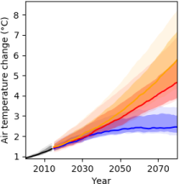 | b)  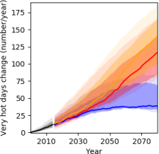 | c)  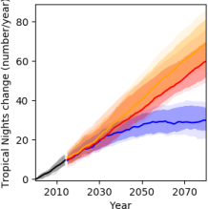
d)  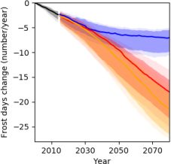 | 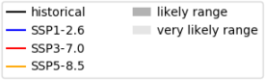  Lines and shaded areas show multimodel percentiles of 31-year running mean values under SSP1-2.6 (blue), SSP3-7.0 (red), and SSP5-8.5 (orange).  Lines represent the best estimate defined by the median of the ensemble of ten climate models and shaded areas the uncertainty bands of the projected changes defined by the confidence intervals of 66% (likely range) and 90% (very likely range).
Figure 9: Projected changes compared to the 1985-2015 average in annual mean air temperature (a), very hot days (b), tropical nights (c), and frost days (d) over the 21st century differentiated by the SSP scenario pathway for Bolivia.

December – February  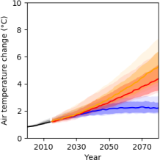 | March - May  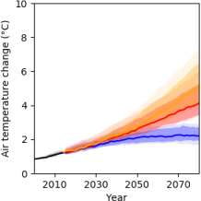 | June - August  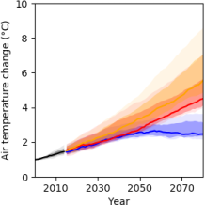
September – November
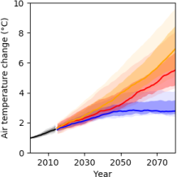
Figure 10: Projected changes compared to the 1985-2015 average in seasonal mean temperature for Bolivia for different climate warming scenarios. Shown are the multimodel median and confidence intervals of 66% (likely range) and 90% (very likely range).

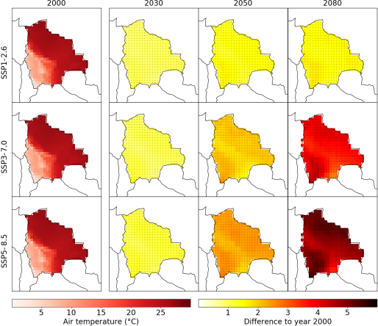
Figure 11: Projected changes in mean annual temperature in the near-future (the 2030s; 2015-2045), mid-century (2050s; 2035-2065), and far-future (2080s; 2065-2095) relative to the reference period (2000s; 1985-2015) for the three different SSP scenarios.

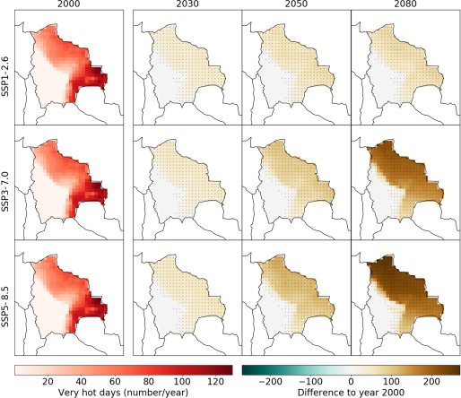
Figure 12: Projected changes in very hot days (daily maximum temperature above 35 °C) in the near-future (the 2030s; 2015-2045), mid-century (2050s; 2035-2065), and far-future (2080s; 2065-2095) relative to the reference period (the 2000s; 1985-2015) for the three different SSP scenarios.

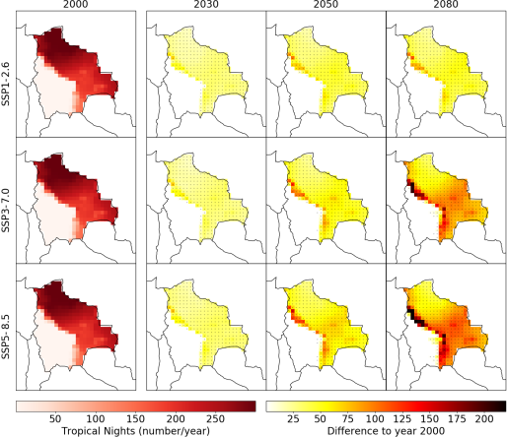
Figure 13: Projected changes in tropical nights (daily minimum air temperature above 20 °C) in the near-future (the 2030s; 2015-2045), mid-century (2050s; 2035-2065), and far-future (2080s; 2065-2095) relative to the reference period (2000s; 1985-2015) for the three different SSP scenarios.

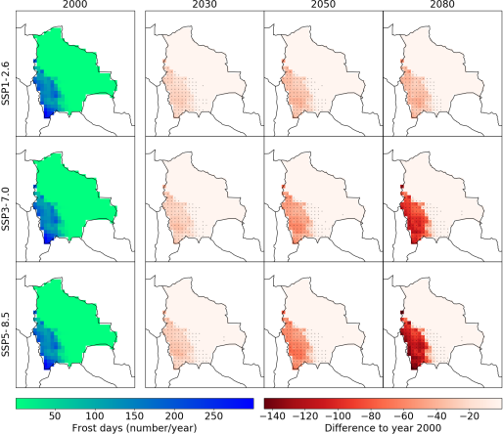
Figure 14: Projected changes in frost days (daily minimum temperature below 0°C) in the near-future (the 2030s; 2015-2045), mid-century (2050s; 2035-2065), and far-future (2080s; 2065-2095) relative to the reference period (2000s; 1985-2015) for the three different SSP scenarios.

Precipitation
The multi-model median indicates a negative trend in projected precipitation amounts under the different scenarios with an average decrease of 30 mm (SSP1-2.6), 68 mm (SSP3-7.0), and 67 mm (SSP5-8.5) for the far future (2065-2095) relative to the reference period (Figure 15a). The large ensemble spread suggests high uncertainties in precipitation projections across the model ensemble. Precipitation is projected to decrease during wetter months, especially during September through November under SSP3-7.0 and SSP5-8.5 scenarios (Figure 16). During December to February, precipitation tends to decrease in the second half of the century for all scenarios. During the remainder of the year (March-August), precipitation remains largely unchanged, with a tendency towards increasing precipitation for the scenarios SSP3-7.0 and SSP5-8.5 in the period March-May.
Projected changes in precipitation differ across regions (Figure 17). We focus on areas with high confidence (more than 75 % of CMIP6 models agree on the sign of the change, see dots in Figure 17) in precipitation projection, especially under the higher emission scenarios. Less precipitation is projected in the northern lowlands, where concurrently the largest increase in temperature is projected. These projections could have negative implications on the tropical forest ecosystem and water resources. More precipitation is projected for the northern part of the Bolivian Altiplano and the Andes' south-eastern slopes where the Tarija department is located.
Changes in the frequency of heavy precipitation days (Figure 15b) and heavy precipitation intensity (Figure 15c) present high uncertainties (wider ensemble spread) when averaged over Bolivia. However, the spatial distribution of the projected changes reveals that the CMIP6 models agree on projecting more heavy precipitation days and heavy precipitation intensities over the Bolivian Andes for the end of the 21st century under SSP3-7.0 and SSP5-8.5 scenarios (Figure 18 and Figure 19).

a)  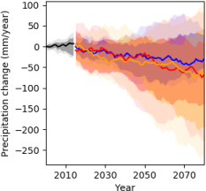 | b)  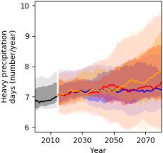 | c)  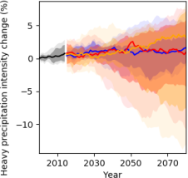
Figure 15: Projected changes compared to the 1985-2015 average in mean annual precipitation (a), frequency of heavy precipitation days (b), and heavy precipitation intensity (c) over the 21st century differentiated by the SSP scenario pathway for Bolivia. Shown are the multimodel median and confidence intervals of 66% (likely range) and 90% (very likely range).

December – February  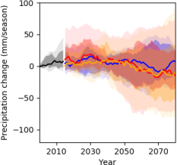 | March - May  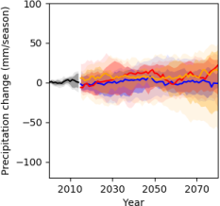 | June - August  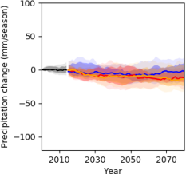
September – November
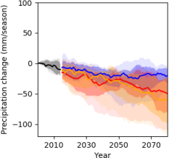
Figure 16: Projected changes compared to the 1985-2015 average in seasonal mean precipitation (DJF, MAM, JJA, and SON) for Bolivia for different climate warming scenarios. Shown are the multimodel median and confidence intervals of 66% (likely range) and 90% (very likely range).

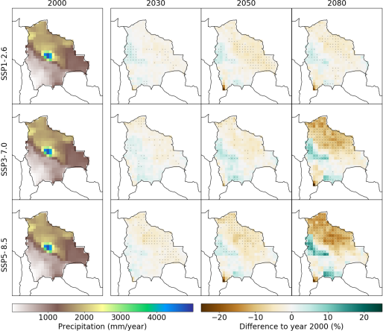
Figure 17: Projected changes in mean annual precipitation in the near-future (the 2030s; 2015-2045), mid-century (2050s; 2035-2065), and far-future (2080s; 2065-2095) relative to the reference period (2000s; 1985-2015) for the three different SSP scenarios.

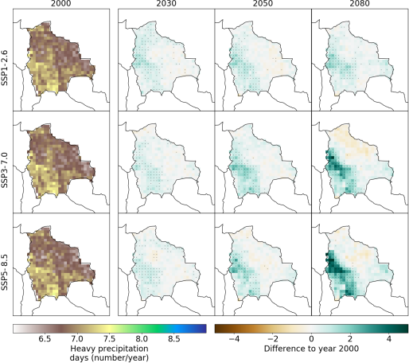

Figure 18: Projected changes in the frequency of heavy precipitation days for the 2030s (2015-2045), 2050 (2035-2065), and 2080s (2065-2095) relative to the 2000s (1985-2015) for the three different SSP scenarios.

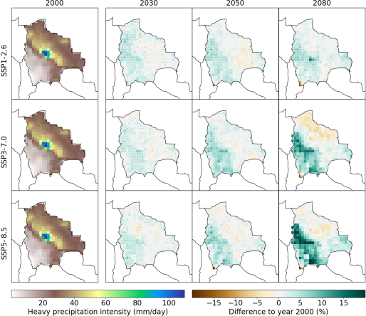
Figure 19: Projected changes in heavy precipitation intensity for the 2030s (2015-2045), 2050 (2035-2065), and 2080s (2065-2095) relative to the reference period (2000s; 1985-2015) for the three different SSP scenarios.

Drought
Extreme drought frequency, here represented by the Standardized Precipitation‐Evapotranspiration Index (SPEI), is likely to increase over Bolivia in the future. The increase occurs more rapidly after the 2030s under SSP3-7.0 and SSP5-8.5 scenarios, whereas under the SSP1-2.6 scenario a slight decrease is projected after the 2050s (Figure 20). For the far-future (the 2080s), extreme drought frequency is likely to increase by 2 months/year (SSP1-2.6), 7 months/year (SSP3-7.0), and 8 months/year (SSP5-8.5), compared to the reference period. The patterns are characterized by increased extreme drought events across Bolivia, with much more pronounced changes over the eastern slopes of the Andes, lowlands, and south-western part of the Altiplano region (Figure 21).
In summary, results show a clear increase in extreme drought frequency throughout the 21st century under all global warming scenarios considered. These results suggest that Bolivia will face unprecedented increases in extreme drought events by the end of the 21st century, particularly under SSP3-7.0 and SSP5-8.5 scenarios.

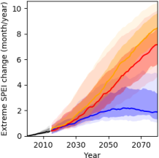
Figure 20: Projected changes compared to the 1985-2015 average in the frequency of extreme drought events (standardized precipitation evapotranspiration index [SPEI] <= -2) over the 21st century differentiated by the SSP scenario pathway for Bolivia. Shown are the multimodel median and confidence intervals of 66% (likely range) and 90% (very likely range).

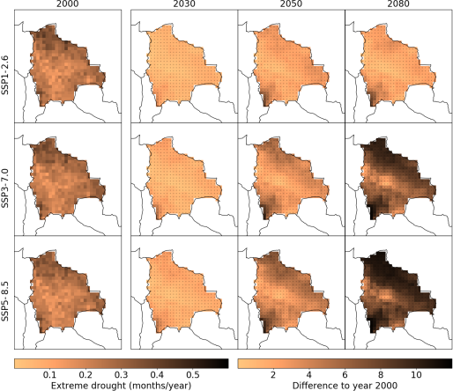
Figure 21: Projected changes in the frequency of extreme drought events (standardized precipitation evapotranspiration index [SPEI] <= -2) in the near-future (the 2030s; 2015-2045), mid-century (2050s; 2035-2065), and far-future (2080s; 2065-2095) relative to reference period (2000s; 1985-2015) for the three different SSP scenarios.

Santa Cruz department

Air temperature
Climate projections show a clear increase in annual mean temperature under all SSP scenarios assessed over the 21st century (Figure 22a) in the Santa Cruz department. For the near-future (the 2030s; 2015-2045), the average change in annual mean temperature is +1.9°C, +1.9°C, and +2.1°C under SSP1-2.6, SSP3-7.0, and SSP5-8.5, respectively. Likewise, temperature changes for the mid-future (the 2050s; 2035-2065) and far-future (2080s; 2065-2095) are +2.4°C and +2.4°C under SSP1-2.6, +2.9°C and +4.6°C under SSP3-7.0, and +3.3°C and +5.6°C under SSP5-8.5. Overall, the projected changes in temperature are greater in Santa Cruz than in Tarija. Temperature increases across all seasons, with the largest increase occurring during September-November (Figure 23).
Increasing air temperature also leads to more very hot days (Figure 22b) and tropical nights (Figure 22c) in the future. For instance, an increase in very hot days by 57, 151, and 181 is projected under SSP1-2.6, SSP3-7.0, and SSP5-8.5, respectively, by the far-future relative to the reference period. Likewise, tropical nights are projected to increase by 50, 89, and 103 under SSP1-2.6, SSP3-7.0, and SSP5-8.5, respectively.

a)  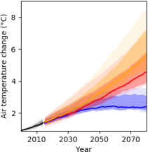 | b)  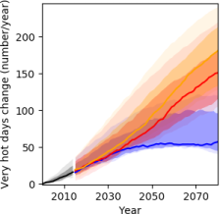 | c)  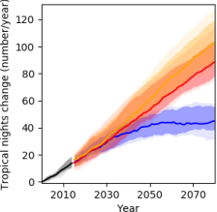
Figure 22: Projected changes compared to the 1985-2015 average in annual mean temperature (a), very hot days (b), and tropical nights (c) over the 21st century differentiated by the SSP scenario pathway for Santa Cruz. Shown are the multimodel median and confidence intervals of 66% (likely range) and 90% (very likely range).

December – February  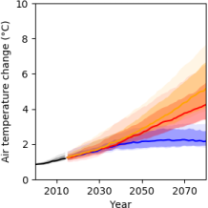 | March – May  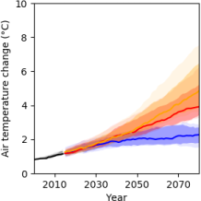 | June – August  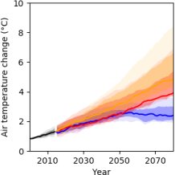
September – November
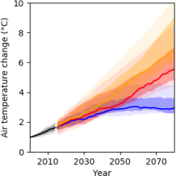
Figure 23: Projected changes compared to the 1985-2015 average in seasonal mean temperature (DJF, MAM, JJA, and SON) for Santa Cruz for different climate warming scenarios. Shown are the multimodel median and confidence intervals of 66% (likely range) and 90% (very likely range).

Precipitation
The multimodel median indicates an overall negative trend in projected precipitation under all scenarios assessed, although the trend is stabilized after the 2050s under the SSP1-2.6 scenario (Figure 24a). Under the SSP1-2.6 scenario, the projected precipitation anomalies are -26.6 mm, -40.9 mm, and -33.5 mm in the 2030s, 2050s, and 2080s, respectively, in comparison to the reference. Similarly, projected average anomalies under SSP3-7.0 and SSP5-8.5 are -24 mm and -24.9 mm in the 2030s, -29.7 mm and -34 mm in the 2050s, and -56.8 mm and -87.7 mm in the 2080s. Precipitation projections show a robust decrease during wetter months, especially during September through November under SSP3-7.0 and SSP5-8.5 scenarios despite large variability across the model ensemble (Figure 25). During December to February, precipitation tends to decrease in the second half of the century under SSP3-7.0 and SSP5-8.5 scenarios mainly. During the remainder of the year (March-August), precipitation remains largely unchanged, with a tendency towards increasing precipitation for the scenarios SSP3-7.0 and SSP5-8.5 in the period March-May.
The multimodel median indicates no considerable changes in the frequency of heavy precipitation days (Figure 24b) and heavy precipitation intensity (Figure 24c) under all scenarios in the future.

a)  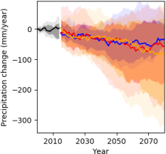 | b)  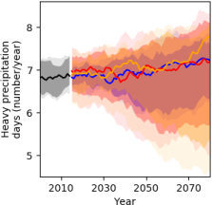 | c)  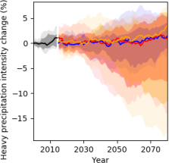
Figure 24: Projected changes compared to the 1985-2015 average in mean annual precipitation (a), frequency of heavy precipitation days (b), and heavy precipitation intensity (c) over the 21st century differentiated by the SSP scenario pathway for Santa Cruz. Shown are the multimodel median and confidence intervals of 66% (likely range) and 90% (very likely range).

December – February  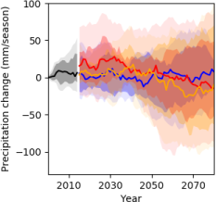 | March – May  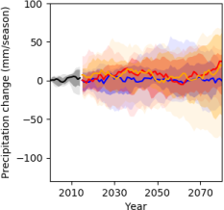 | June – August  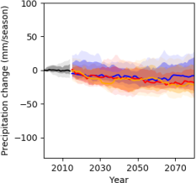
September – November
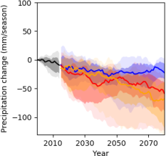
Figure 25: Projected changes compared to the 1985-2015 average in seasonal mean precipitation (DJF, MAM, JJA, and SON) for Santa Cruz for different climate warming scenarios. Shown are the multimodel median and confidence intervals of 66% (likely range) and 90% (very likely range).

Drought
Overall, a positive trend is projected in extreme drought frequency in Santa Cruz under SSP3-7.0 and SSP5-8.5. Similarly, under the SSP1-2.6 scenario, extreme drought frequency shows a positive trend until the 2050s, and afterward, a slight decrease is projected (Figure 26). For the end of the 21st century (the 2080s), extreme drought frequency is likely to increase by 1.5 months/year under SSP1-2.6, 7 months/year under SSP3-7.0, and 9 months/year under SSP5-8.5, compared to the reference period. These increases, particularly under medium-high emissions scenarios (SSP3-7.0 and SSP5-8.5), are critical and suggest drought mitigation and adaptation mechanisms.

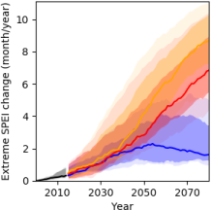
Figure 26: Projected changes compared to the 1985-2015 average in the frequency of extreme drought events (standardized precipitation evapotranspiration index [SPEI] <= -2) over the 21st century differentiated by the SSP scenario pathway for Santa Cruz. Shown are the multimodel median and confidence intervals of 66% (likely range) and 90% (very likely range).

Tarija department

Air temperature
Projections show a clear increase in annual mean temperature under the three SSP scenarios over the 21st century (Figure 27a) in the Tarija department. For the near-future (the 2030s; 2015-2045), the average change in annual mean temperature is +1.7°C, +1.9°C, and +1.9°C under SSP1-2.6, SSP3-7.0, and SSP5-8.5, respectively, relative to the reference. Likewise, temperature changes for the mid-future (the 2050s; 2035-2065) and far-future (2080s; 2065-2095) are +2.1°C and +2.3°C under SSP1-2.6, +2.6°C and +4.0°C under SSP3-7.0, and +2.8°C and +4.9°C under SSP5-8.5. Temperature increases across all seasons, with the largest increase occurring during September-February (Figure 28).
Projections of warming trends under all scenarios will result in increasing numbers of very hot days (Figure 27b) and tropical nights (Figure 27c) in the future, while fewer frost days are projected (Figure 27d). For instance, an increase in very hot days by 39, 109, and 136 days per year under SSP1-2.6, SSP3-7.0, and SSP5-8.5, respectively, is projected for the far-future relative to the reference. Likewise, tropical nights are projected to increase by 37, 87, and 105 nights per year under SSP1-2.6, SSP3-7.0, and SSP5-8.5, respectively. On the contrary, frost days are expected to decrease slightly by 2, 7, and 8 days per year for the far future under SSP1-2.6, SSP3-7.0, and SSP5-8.5, respectively.

a)  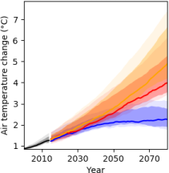 | b)  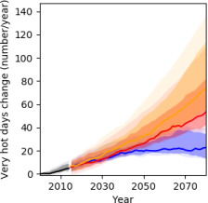 | c)  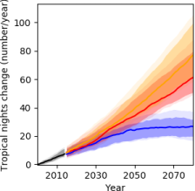
d)
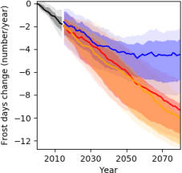
Figure 27: Projected changes compared to the 1985-2015 average in annual mean air temperature (a), very hot days (b), tropical nights (c), and frost days (d) over the 21st century differentiated by the SSP scenario pathway for Tarija. Shown are the multimodel median and confidence intervals of 66% (likely range) and 90% (very likely range).

December – February  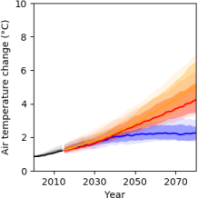 | March – May  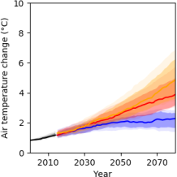 | June – August  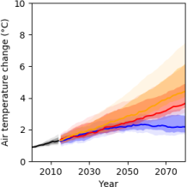
September – November
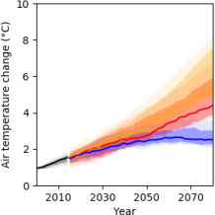
Figure 28: Projected changes compared to the 1985-2015 average in seasonal mean temperature for Tarija for different climate warming scenarios. Shown are the multimodel median and confidence intervals of 66% (likely range) and 90% (very likely range).

Precipitation
The multimodel median indicates no trend in projected precipitation under the SSP1-2.6 scenario as the anomalies in the 2030s (-1.7 mm/year), 2050s (+13.6 mm/year), and 2080s (-1.3 mm/year) relative to the reference are almost close to zero (Figure 29a). Precipitation is projected to increase under the SSP3-7.0 and SSP5-8.5 scenarios in the second half of the century. In the far future, precipitation increase relative to the reference amounts to +49 mm (SSP3-7.0) and +66 mm (SSP5-8.5). The largest increase in precipitation occurs during the rainy season from September to May under SSP3-7.0 and SSP5-8.5 (Figure 30).
The temporal pattern of changes in the frequency of heavy precipitation days (Figure 29b) and heavy precipitation intensity (c) is similar to that of mean annual precipitation. Thus, more heavy precipitation days (on average, 9 days/year) are expected under SSP3-7.0 and SSP5-8.5 in the 2080s, relative to the 2000s (7 days/year). Similarly, an increase in heavy precipitation intensity is projected by 7.4 % (SSP3-7.0) and 11.9 % (SSP5-8.5) in the 2080s.

a)  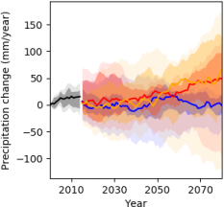 | b)  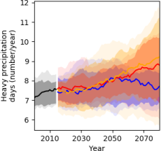 | c)  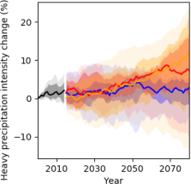
Figure 29: Projected changes compared to the 1985-2015 average in mean annual precipitation (a), frequency of heavy precipitation days (b), and heavy precipitation intensity (c) over the 21st century differentiated by the SSP scenario pathway for Tarija. Shown are the multimodel median and confidence intervals of 66% (likely range) and 90% (very likely range).

December – February  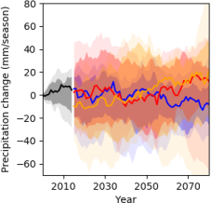 | March – May  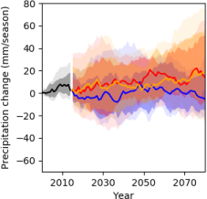 | June – August  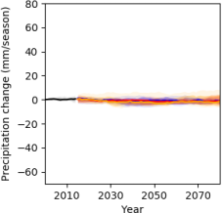
September – November
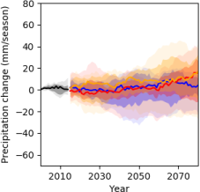
Figure 30: Projected changes compared to the 1985-2015 average in seasonal mean precipitation (DJF, MAM, JJA, and SON) for Tarija for different climate warming scenarios. Shown are the multimodel median and confidence intervals of 66% (likely range) and 90% (very likely range).

Drought
A positive trend in extreme drought frequency is projected in Tarija under all scenarios (Figure 31). Under the SSP1-2.6 scenario, the trend is projected to stabilize after the 2050s. For the far future (the 2080s), extreme drought frequency is likely to increase by 2 months/year under SSP1-2.6, 5 months/year under SSP3-7.0, and 7 months/year under SSP5-8.5, compared to the reference period

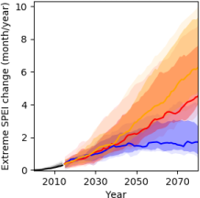
Figure 31: Projected changes compared to the 1985-2015 average in the frequency of extreme drought events (standardized precipitation evapotranspiration index [SPEI] <= -2) over the 21st century differentiated by the SSP scenario pathway for Tarija. Shown are the multimodel median and confidence intervals of 66% (likely range) and 90% (very likely range).

PART II – Impacts on hydrology and selected adaptation measures

The results in Chapter 3 illustrate that climate change manifests differently in the two regions of Tarija and Santa Cruz, with a possible increase in precipitation in Tarija and a possible decrease in Santa Cruz, albeit both trends associated with large uncertainty. As a result, impacts on water resources and vegetation differ and also the planned adaptation measures have to apply to the climate development. The ecohydrological model SWIM, described in Chapter 2.1.3, has been implemented to translate the changes in climate into changes in hydrological processes, available water resources and crop yields. The following chapters will illustrate the possible impacts of climate change on water resources, hydrological extremes and crop yields. Based on that, possible adaptation measures and their effects will be described.

Santa Cruz

Climate change impacts in the San Martín and Paraguá basins

In contrast to the Tarija region, precipitation is likely to decrease in the Amazon lowlands of Bolivia under scenario conditions, where the river basins of the San Martín and Paraguá are located, (see Chapter 3.1.1). As a result, negative trends in river discharge and water availability are a major concern in the San Martín and Paraguá basins.
The ecohydrological model SWIM has been implemented to translate the changes in climate into changes in hydrological processes and available water resources considering 1000 subbasins and using the soil and land use data described in Chapter 2.3.2 to parametrize the vertical and lateral hydrological processes and vegetation growth.
Projections show a clear increase in annual mean temperature under the three SSP scenarios over the 21st century (Figure 32a) in the Tarija department. For the near-future (the 2030s; 2015-2045), the average change in annual mean temperature is +1.7°C, +1.9°C, and +1.9°C under SSP1-2.6, SSP3-7.0, and SSP5-8.5, respectively, relative to the reference. Likewise, temperature changes for the mid-future (the 2050s; 2035-2065) and far-future (2080s; 2065-2095) are +2.1°C and +2.3°C under SSP1-2.6, +2.6°C and +4.0°C under SSP3-7.0, and +2.8°C and +4.9°C under SSP5-8.5. Temperature increases across all seasons, with the largest increase occurring during September-February (Figure 21).

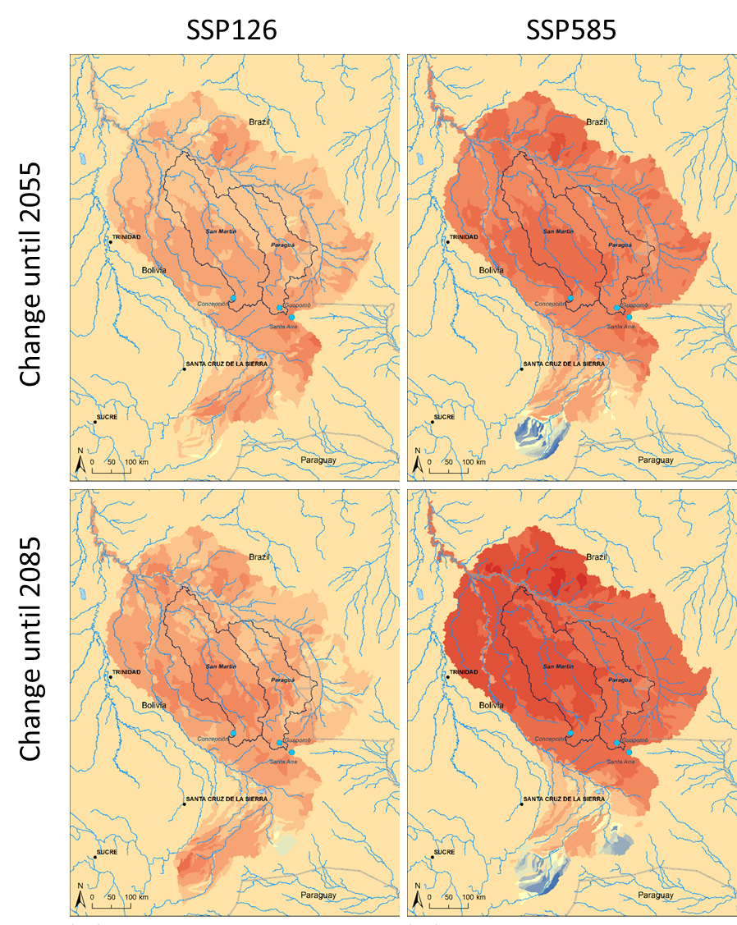
Figure 32: Change in discharge under climate change until mid of the century (top) and end of the century (bottom) and for the low end scenario (left) and the high end scenario (right).

The maps in Figure 32 illustrate the spatial distribution of decreases in river flow in the Iténez basin with the basins of the rivers San Martin and Paraguá within. Under the conditions of the moderate climate scenario SSP1-2.6 with low increase in temperature, there are nearly only decreases in discharge visible in the two basins with down to -15 % until around 2055 and down to 25 % until end of the century. The impacts are more extreme under SSP5-8.5 scenario conditions and the higher temperature increase, with some increases in river discharge in the upstream parts of the Iténez basin, but uniformly strong decreases in the San Martin and Paraguá basins down to around 25 % until mid of the century and down to 40 % until end of the century. The results illustrate that the drying trend in the lowland parts of the Iténez basin, which is also visible in satellite observations (see Figure 1), will most probably go on under further global warming and gets stronger the more the temperature increase is. This provides a major threat to the local societies and environment, not only because the Iténez drains major parts of eastern Bolivia but also is a main tributary and source of the Amazon.
However, the annual values, simulated by SWIM and forced by the 10 bias-adjusted CMIP6 models and three different SSPs, give a large annual fluctuation, shown in Figure 33 for the discharge at the stations Pedras Negras, Principe da Beira and Guajara-Mirim, located in the Iténez and Mamore basins with the latter being the last station at the border to Brazil. The top row shows the annual development of discharge, the bottom row the statistical summary in form of boxplots for the three futures from near to far. The results illustrate that there is a continuous decrease of annual flows, starting in the near future and proceeding or even accelerating until end of this century. The strongest decrease is with the strongest global and regional temperature increase under SSP5-8.5. While the decrease is on average below 10 % in the near future for all stations and scenarios, it drops down to on average around -30 % (Principe da Beira), -40 % (Perdras Negras) and -20 % (Guajara Mirim) until the end of century and under high temperature (SSP5-8.5) scenario conditions. The reason for the lower decrease in the entire Mamore river basin (gauge Guajara Mirim) and the larger decrease in the Itínez basin is that the Mamore river receives more discharge under climate change from the upstream parts, as shown in Figure 32. While the range of changes includes also cases, where the scenario run gives a positive trend, the majority of runs indicates often strong decreases of river discharge and thus water availability, with the extreme drops down to from -50 % to -60 % (Figure 33 bottom). This is a strong indication that climate change will have severe impacts on hydrology and water resources in the Santa Cruz region, and as a result also on water related sectors and on ecology.
The results of SWIM also illustrate how relevant and important mitigation of global climate change is: the impacts on water resources are possibly already severe under the moderate climate scenario (SSP1-2.6), but are massive under high global temperature increase.

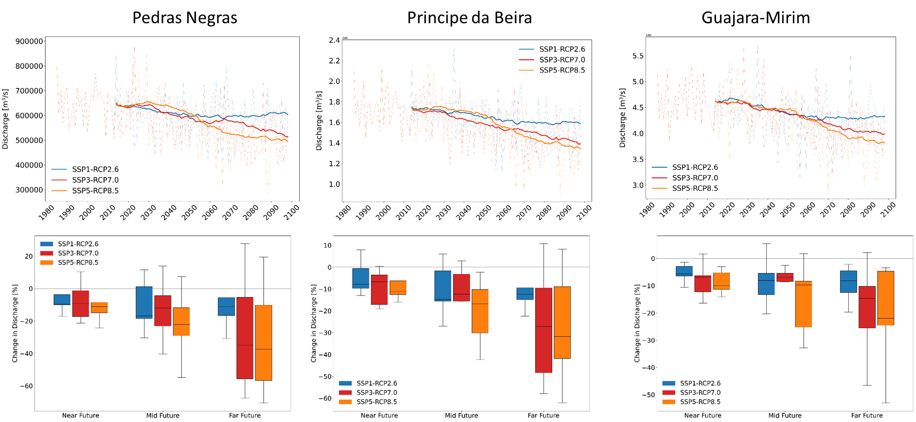

Figure 33: Change of annual discharge at the locations of the stations Pedras Negras, Principe da Beira and Guajara-Mirim, located in the Itenez basin with the latter being the last station at the border to Brazil, simulated by SWIM forced by 10 bias-adjusted CMIP6 models and three different SSPs. Top: Annual development of the discharges under the three scenario conditions: Bottom: boxplots of the changes for the three future time slices from near to far future.

The changes in average monthly discharges at the gauges Pedras Negras, Principe da Beira, and Guajara-Mirim as simulated by SWIM are shown in Figure 34, forced by the 10 bias-adjusted CMIP6 models and for the three different SSPs and three future time slices. The pattern of changes is similar in the three basins, with the strongest impacts for the high-end scenario SSP5-8.5 and the far future. In general, development of discharge is on average negative in most month of the year in the near future and on average negative in all months in the far future. The results give the strongest negative trends with up to 60 % less in November and December, and with up to 30 % less in January and with no or small changes from April to August. Overall, the lowest impacts until end of the century are given under SSP1-2.6 scenario conditions, again stressing the relevance of climate mitigation.

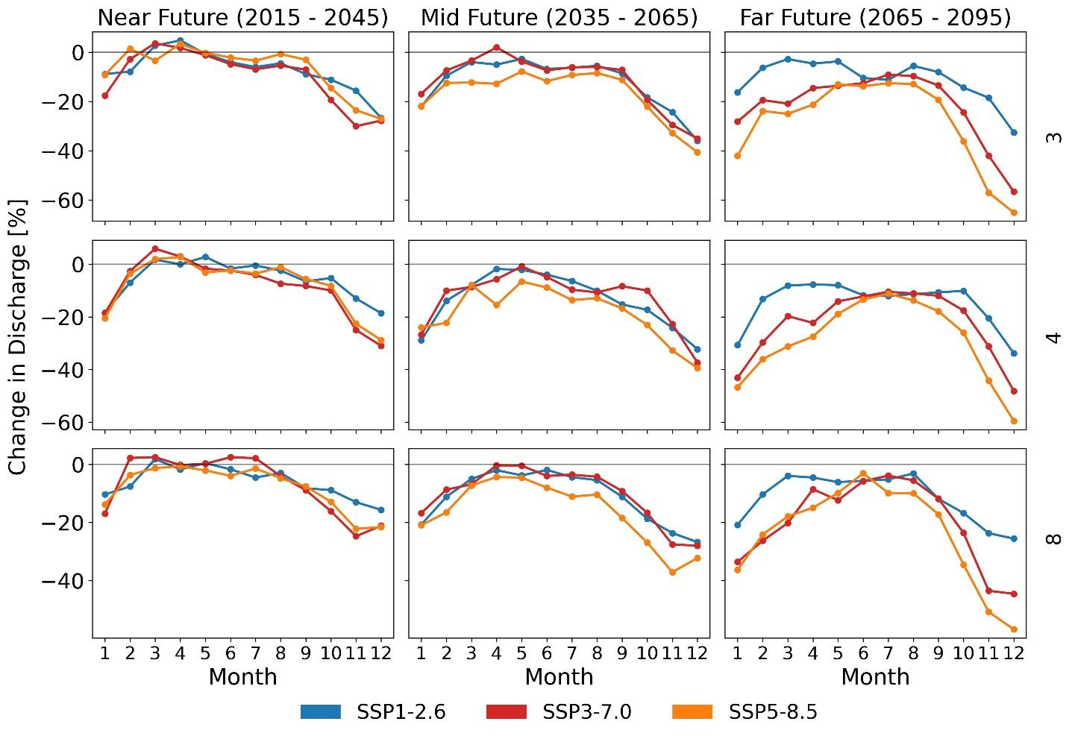
Figure 34: Changes in average montly discharge at Pedras Negras (3), Principe da Beira (4), and Guajara-Mirim (8) gauging stations simulated by SWIM forced by 10 bias-adjusted CMIP6 models and three different SSPs.

With the overall decrease of river discharge, also low flow conditions increase in number and intensity (Figure 35 with the example of Principe da Beira gauging station, which includes the river basins of the San Martin and the Paraguá). All low flow indicators (Q90, Q95 and Q99 with 90 % 95 % and 99 % of the daily values are above) show strong decreases in discharge, the strongest in the far future and for the high-end scenario SSP5-8.5 with up to 50 % less discharge for Q95 and Q99. The lowest impacts are visible under the moderate scenario SSP1-2.6.
In contrast to the Tarija region, the moderate high flow indicators (Q10 and Q590 with 10 % and 5 % of the daily values are above) show no changes or even decreases in the Santa Cruz basins, the strongest decreases for the scenarios SSP3-7.0 and SSP5-8.5. Only the strongest high flow indicator (Q99 with 1 % of the flows above) gives an increase up the middle future and for scenarios SSP1-2.6 and SSP3-7.0.

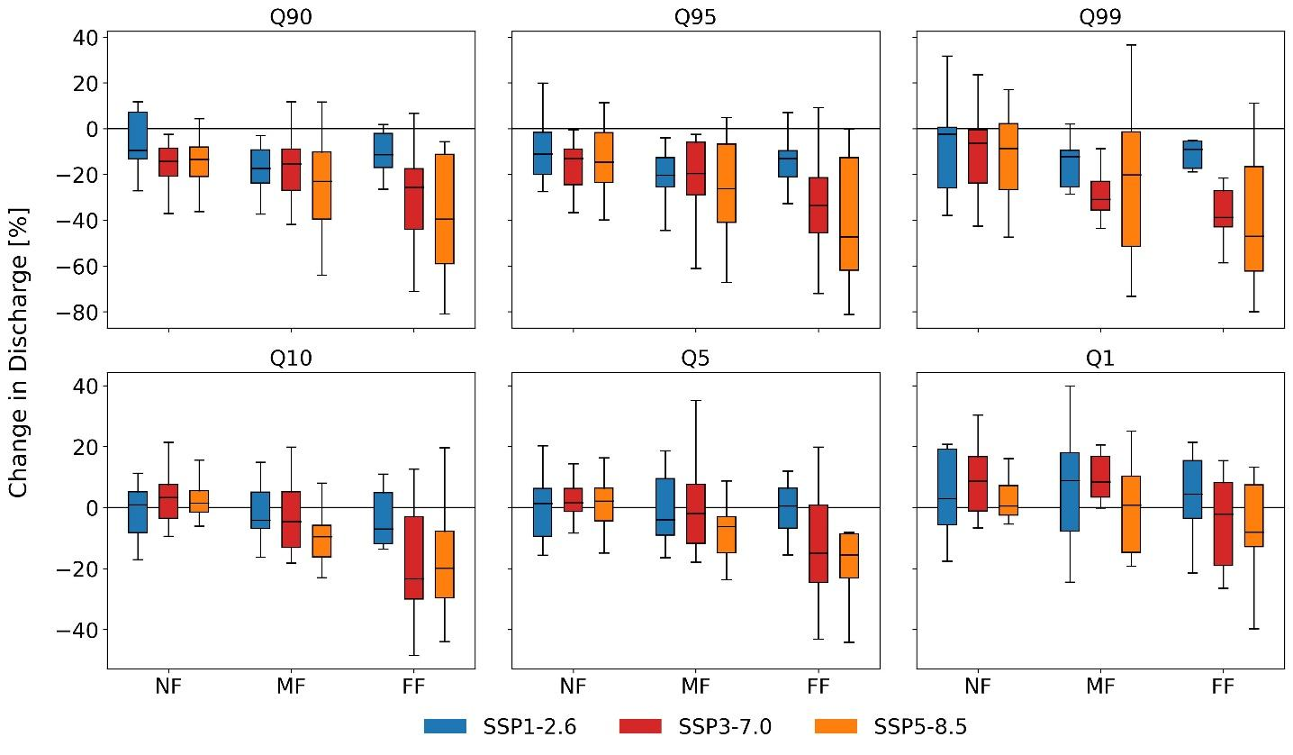
Figure 35: Change in low flow (Q90, Q95, Q99) and high flow (Q10, Q5, Q1) indicators at Principe da Beira gauging station. SWIM simulations forced by 10 bias-adjusted CMIP6 models and three different SSPs.

The average impacts of climate change on water inflow in selected reservoirs in the basin (Guapomó and Conceptión) are listed Table 1. According to the model results, they would sum up to -29 % in the far future and the high end scenario SSP5-8.5 for Concepción and -22 % for Guapomó. Also at these locations, the impacts increase with increasing global and regional temperature.

Table 1: Average changes of water inflow in selected reservoirs.
Reservoir | SSP1-2.6  mid future | SSP1-2.6  far future | SSP5-8.5  mid future | SSP5-8.5  far future
Concepción | -11 % | -14 % | -21 % | -29 %
Guapomó | -14 % | -12 % | -18 % | -22 %

Finally, Figure 36 illustrates the impact of climate change on crop yields (soybean as example) and fodder production (pasture) as an average over the Santa Cruz region.
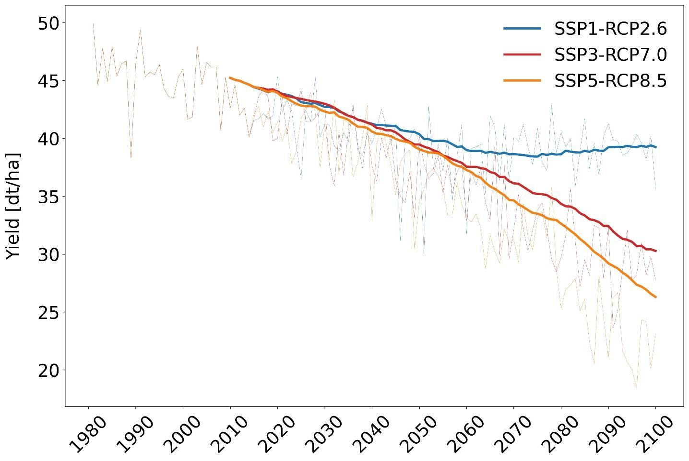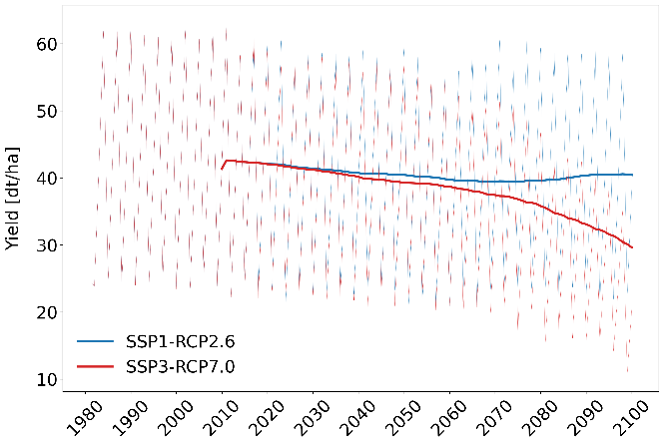

Figure 36: Crop yields soybeans (during austral summer, wet season) and pasture (two harvest/ grazing periods) in the Santa Cruz region.

Adaptation measures

Adaptation scenario fodder for livestock

The climate change impact assessment shows a decreasing water availability, especially during the rainy season, accompanied with increasing drought and fire risk, and negative impacts on crop yields is expected.
Although livestock occupies a small portion of the watersheds (13% of their area), its importance for community livelihoods, the possibilities to improve welfare and sustainability, the possibility of future expansion of human settlements and investments by Bolivian and foreign producers are the reason why an evaluation of land use changes and changes in the current livestock practices has been selected as adaptation measure.
As part of the cost benefit analysis, relevant are the growth and yields of alternative fodder crops under climate change conditions and their impact on the water balance. Selected as an example for fodder production was sorghum (sorghum vulgare). Figure 37 shows the development of the sorghum biomass simulated by SWIM under different climate scenario conditions. The optimal growth temperature of sorghum is from 26.7˚C to 29.4˚C and thus higher than the one of wheat and soybean. Temperatures above 38˚C are harmful, despite the fact that this plant tolerates heat and drought better than, for example, corn (Baradas 1994). Sorghum adapts to different humidity conditions, and rainwater is sufficient to complete its vegetative cycle, especially in the humid to sub-humid tropics, where rainfall ranged between 700 and 1600 mm per year, and therefore also in the Santa Cruz region. The results illustrate that sorghum, other than for example wheat, may benefit from the temperature increase in the area, while as a relatively drought tolerant species still being able to cope with the decrease in precipitation.

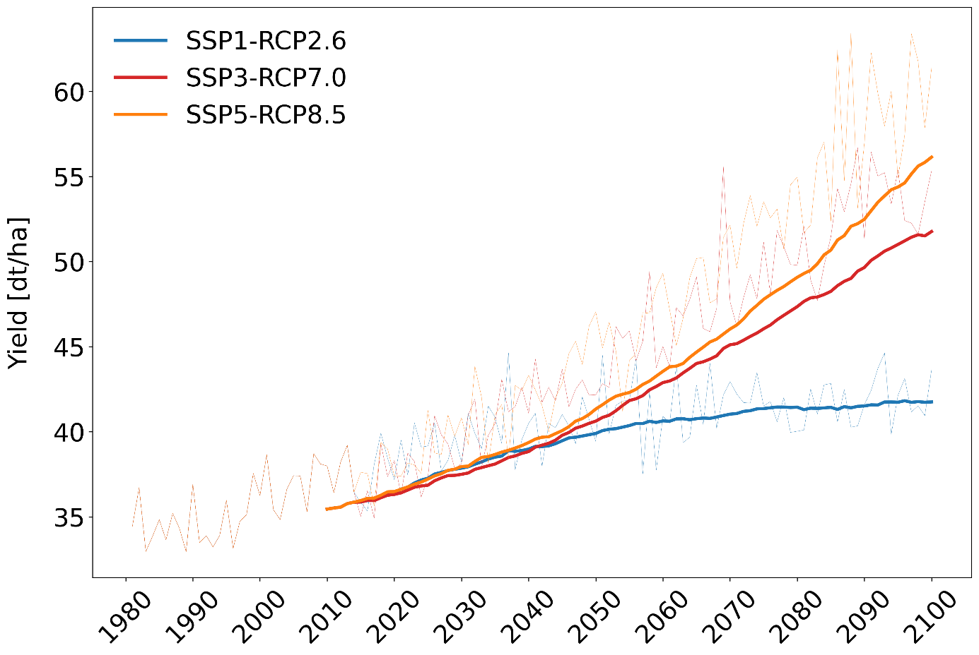
Figure 37: Possible yields of sorghum fodder in San Martin and Paragua watersheds (during austral summer, wet season).

Because of the low share of land for cattle and fodder, no remarkable impacts on water flows are simulated by SWIM when switching from previous fodder plants to sorghum.
SWIM outputs provided for the economical evaluation are the yields of pasture and sorghum und current and climate change conditions.

Adaptation scenario restoration of areas affected by forest fire

The area burned each year until 1999 in Bolivia was approximately 100 thousand hectares. Since then, burned areas have reached an annual average of 3.7 million hectares. The Chiquitano Dry Forest is one of the ecosystems most affected by fires (1.3 million hectares burned in 2019). The fires find a significant synergy with the development of droughts in this region (see Figure 1), resulting in reduced volumes in the main sources of water – rivers, streams, shortcuts, among others. In 2019 alone, 2,497 communities were served due to water deficit, both for human consumption and for animal consumption, and by 2020 62% of the department was under drought conditions. According to the Recovery Plan for Areas Affected by Fires and the Santa Cruz Forest Restoration Strategy (ERFSC), ecosystem restoration is proposed as a measure to recover environmental functions and land suitable for productive development, as well as to mitigate the impact of future fires caused by natural causes, human intervention and aggravated by climate change. Restoration actions include natural forest regeneration ("passive restoration") and the implementation of sustainable land use practices ("active restoration").
For the water cycle and hydrological processes, it is very important how the vegetation recovers, how it develops in the long run or, on the other hand, is managed by humans after the fire happened. Important for the flow processes are also the soil conditions. The physical impacts of fire on soil include breakdown of the soil structure, reduced moisture retention and capacity, and development of water repellency, all of which increase susceptibility to surface runoff and erosion (USDA Forest Service), leading to less water availability for plants, possibly lower groundwater recharge and higher flood risk.
The extent of burned areas since 2011 is shown in Figure 7, together with the long-term impact on vegetation cover given as the Leaf Area Index (LAI). The maps illustrate that in most areas affected by forest fire, the former vegetation did not recover and the vegetation density is still lower than under the original forest.

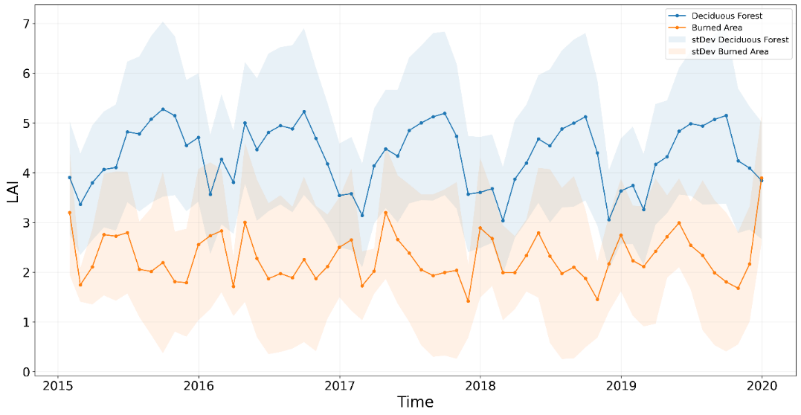
Figure 38: Development of Leaf Area Index (LAI) as an average over the natural vegetation and the burned areas.

The monthly development of the vegetation cover as an average over the burned areas and the surrounding original vegetation is shown in Figure 38. Also here it is obvious that the vegetation cover in formally burned areas is much lower (LAI on average 1.5-3) than the one in the original vegetation (LAI on average 3.5-5.5). While the original vegetation shows in most years one peak of the LAI, two peaks are visible in the formerly burned areas, a possible indication that the latter are under human management with grazing and/ or harvest.

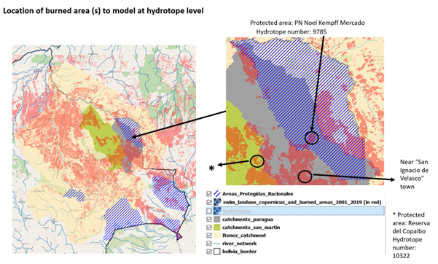
Figure 39: The three selected locations within the Santa Cruz basin to investigate impacts of forest fire on water flows and resources: Noel Kempff Mercado, Bajo Paragua de San Ignacio de Velasco and Reserva del Copaibo.

The possible impacts of forest fire on the hydrological cycle and water resources have been parametrized and modelled by SWIM for three selected locations within the Santa Cruz basin (see Figure 39): Noel Kempff Mercado, Bajo Paragua de San Ignacio de Velasco and Reserva del Copaibo.
The main soil type of the selected locations is a Haplic Ferralsol, a typical soil of the ever-humid tropics, deeply weathered with a loamy-sandy texture and extreme nutrient depletion. The vegetation cover of the formerly burned areas has been parametrized in SWIM as a mixture of pasture and shrub.
The simulated water flows and the development of LAI are shown in Figure 40, taking the location of Bajo Paragua de San Ignacio de Velasco as example, and all results are summarized in Table 2.

Figure 40: Mean annual development of the most important hydrological components and vegetation (LAI) under natural vegetation and in a formerly burned area (location: Bajo Paragua de San Ignacio de Velasco).

Table 2: Impact of forest fire on main components of the water cycle.
Hydrotope | Land use type | Surface runoff [mm] | Groundwater recharge [mm] | Soil moisture  [mm]
1 | Natural forest | 90 | 313 | 118
PN Noel Kempff Mercado | Burned area | 331 | 138 | 115
2 | Natural forest | 129 | 290 | 109
Reserva del Copaibo | Burned area | 402 | 93 | 106
3 | Natural forest | 36 | 79 | 88
Bajo Paragua de San Ignacio de Velasco | Burned area | 165 | 12 | 85

The result is that under the described environmental conditions, natural forests generate more groundwater recharge (up to three times more), mostly so because the formerly burned areas generate a much higher amount of surface runoff (up to four times more). As a consequence, there is a larger groundwater buffer (for example in case of droughts) available under natural conditions, while there is a higher risk for floods and erosion in formerly burned areas. Although Ferralsols in general have a high water holding capacity, soil moisture is lower in formerly burned areas especially in the dry period of the year.
Model results provided by SWIM for the economical evaluation are the changes in groundwater recharge and surface runoff in areas affected by forest fire.

Tarija

Climate change impacts in the Bermejo basin

The climate projections for the region of Tarija show a clear increase in annual mean temperature under the three SSP scenarios over the 21st century (see Chapter 3.1.2). For precipitation, the multimodel median indicates no trend in projected precipitation under the SSP1-2.6 scenario, while precipitation is projected to increase under the SSP3-7.0 and SSP5-8.5 scenarios in the second half of the century. The largest increase in precipitation occurs during the rainy season from September to May under SSP3-7.0 and SSP5-8.5.
The ecohydrological model SWIM has been implemented to translate the changes in climate into changes in hydrological processes and available water resources considering 73 subbasins and using the soil and land use data described in Chapter 2.3.2 to parametrize the vertical and lateral hydrological processes and vegetation growth. The management of the San Jacinto Dam has been parametrized for the SWIM reservoir module using the report “Represa de San Jacinto Tarija-Bolivia”. The modeled and observed water monthly water levels and volumes of the reservoir are given in Figure 41.
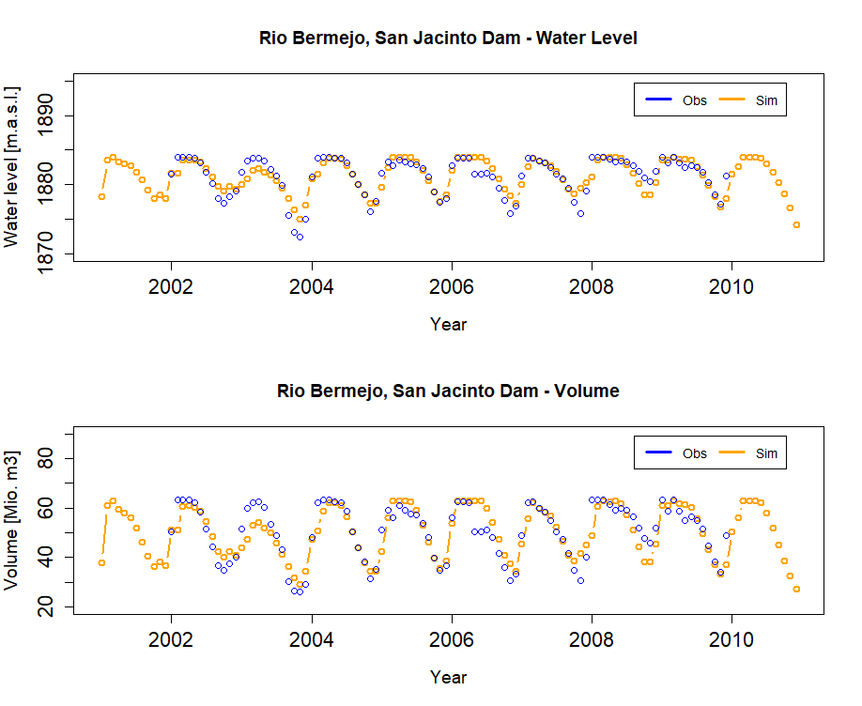
Figure 41: Observed and modeled water level and volume of the San Jacinto Dam, simulated by SWIM.

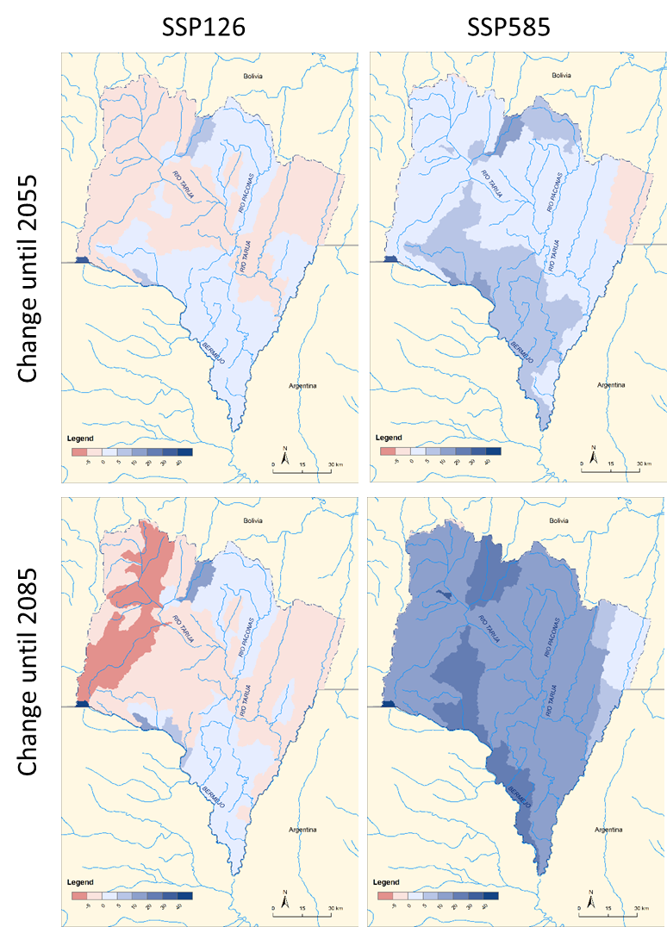
Figure 42: Change in discharge under climate change until mid of the century (top) and end of the century (bottom) and for the low warming scenario (left) and the high warming scenario (right).

The maps in Figure 42 illustrate the spatial distribution of increases and decreases in river discharge and hence water availability in the Bermejo basin. Under the conditions of the moderate climate scenario SSP1-2.6 and until the mid of the century, with low increase in temperature, there are only slight decreases and increases in discharge visible in the headwaters of the basin, mostly with values between -5 % and +10 %. The changes increase with values between -10 % and +20 % in some subbasins until end of the century and moderate climate warming. In contrast, the changes are in almost all cases positive under the warmer scenario SSP5-8.5, up until +20 % until mid of this century and until 40 % until end of the century.

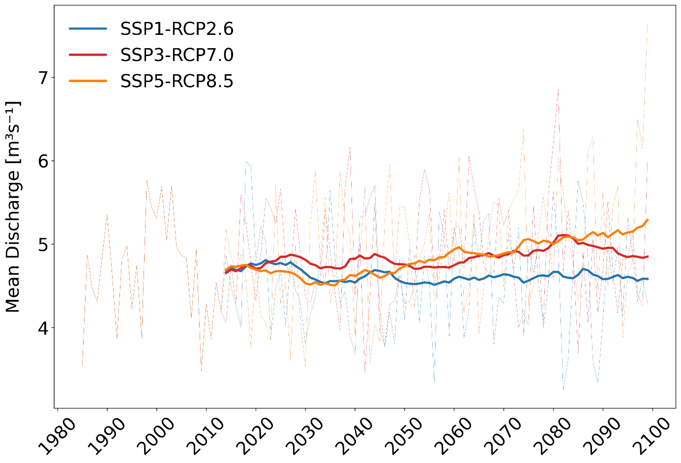
Figure 43: Total annual discharge at San Jacinto dam simulated by SWIM forced by 10 bias-adjusted CMIP6 models and three different SSPs.

However, the annual values, simulated by SWIM and forced by the 10 bias-adjusted CMIP6 models and three different SSPs, give a large annual fluctuation, shown in Figure 43. The results illustrate that there might be an overall increase in discharge and water availability with increasing temperature, possibly associated with more floods, while still also the number of droughts may increase. The highest increase is again in the scenario SSP5-8.5. This is further analyzed in Figure 44.
While there are only weak trends in overall discharge, variability in daily flows increases with temperature increase, most pronounced in the high-end scenario SSP5-8.5 and until end of the century (Figure 44). The figure gives the results for the low flow indicators Q90, Q95 and Q99 (90 % 95 % and 99 % of the daily values are above) and the high flow indicators Q10, Q5 and Q1 (10 %, 5 % and 1 % of the daily values are above). Especially low flow indicators show substantial changes to lower values, the high flows have the strongest increase for the extreme indicator (Q1), the far future and in the strongest warming scenario (SSP5-8.5).

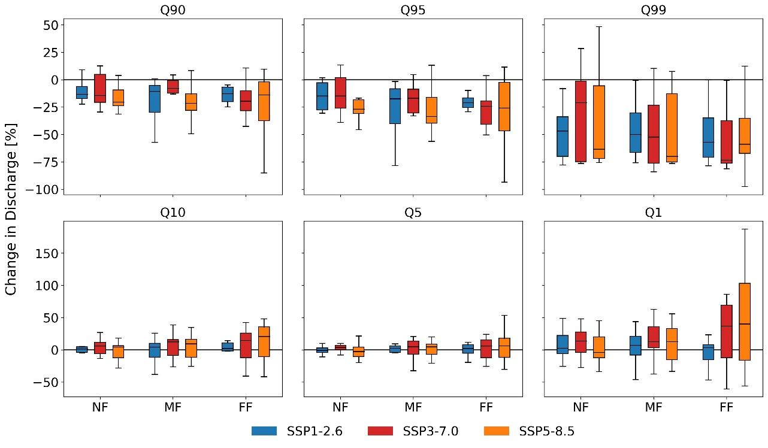
Figure 44: Low (Q90, Q95, Q99) and high flow (Q10, Q5, Q1) indicators at San Jacinto. SWIM simulations forced by 10 bias-adjusted CMIP6 models and three different SSPs.

Adaptation measures

Crop switching adaptation scenarios

The climatic modelling carried out shows a tendency to increase water availability in the Guadalquivir/ Bermejo basins, especially during the rainy season (increased risk of flooding, while no negative impact on crop yields is expected).
Approximately 50 % of the cultivated area in the department of Tarija is dedicated to corn. Corn is sold directly to the local market, while the processing and industrialization of the product is minimal and the profits for producers are low. In order to increase the income and welfare of the local farmers, the government of Tarija has decided to promote the production of "high value crops", such as grapes and strawberries.

Adaptation scenario switching to grapes

In this scenario, the farmer switches from corn to grape. The Crops are not irrigated. It is the hope of the government that the success of this measure will promote greater production in the future, which is why an evaluation of the cost-benefit is presented here in light of future climatic and hydrological changes in the Guadalquivir basin.
The following scenario assumptions have been implemented:
The Baseline is that Corn production is rainfed under current climatic conditions and does not include changes attributable to climate change.

- Adaptation scenario (the measure of adaptation is modeled with climate change impacts)
Change from corn to grape crop in the future - at a rate of 700 Ha every 5 years - under climate change. As the climatic conditions do not suggest additional water stress, the farmer wants to increase his income and progressively switches his crop from corn to grape. The profitability of the crop change under future climate change conditions will be assessed. Market gains and production costs will be extrapolated to 2050 to assess crop yield in the global warming scenarios of 2.6°C and 8.5°C.
- No adaptation scenario (no adaptation measure is modeled, only the impacts of climate change)
Corn production rainfed under the effects of climate change. The farmer does not experience a reduction or increase in corn yield and lacks the means to invest in a new crops, so the area grown with corn does not change. Market gains and production costs will be extrapolated to 2050 to assess crop yield in the global warming scenarios of 2.6°C and 8.5°C.
- No regrets" scenario (the measure of adaptation without climate change impacts is modeled)
In this scenario, there are no positive or negative impacts of climate change, as we assume that current conditions will continue.
The simulated crop yields for corn and for grapes are shown in Figure 45. The future climate projections are displayed for the near-future (NF, 2015-2045), mid-future (2035-2065, MF), and far-future (2065-2095, FF) based on 10 bias-adjusted CMIP6 climate models and three SSPs (SSP1-2.6, SSP3-7.0, SSP5-8.5). Displayed are the mean crop yields over the time period, median over the model ensemble, error bars show the variability induced by the model ensemble. The baseline and the noregret scenarios are simulated using the historical climate conditions.

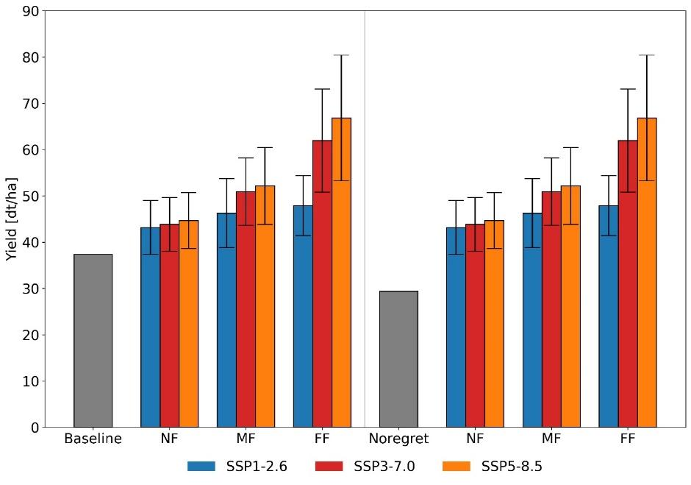
Figure 45: Simulated crop yields for corn (left side baseline (observation-based climate conditions) and no adaptation scenarios) and for grapes (right side noregret (observation-based climate conditions) and adaptation scenarios). The future climate projections are displayed for the near-future (NF, 2015-2045), mid-future (2035-2065, MF), and far-future (2065-2095, FF) based on 10 bias-adjusted CMIP6 climate models and three SSPs (SSP1-2.6, SSP3-7.0, SSP5-8.5). Displayed are the mean crops yields over the time period.

Visible is that both, corn and grapes, may profit from the warming in the Tarija area and the slight increase in precipitation under SSP3-7.0 and SSP5-8.5 conditions.
The SWIM results provided for the economical evaluation are the yields of corn and grape displayed in Figure 45.

Adaptation scenario irrigation of strawberries

Since 2008, the production of strawberries and raspberries has increased in the central valley of Tarija and represents a much better economic and labor intense alternative in comparison to production of potatoes, onions and other agricultural products. In the year 2021, the "Pilot project for food security and economic reactivation post COVID19" has been implemented by the Departmental Autonomous Government of Tarija (GADT), through the Departmental Service of Integral Water Management (SEDEGIA) and financed by PROCUENCA/GIZ. The project is located in the four municipalities of the Guadalquivir River Basin in the Department of Tarija, (San Lorenzo, Cercado, Uriondo and Padcaya).
Based on the results of this experience, there are expectations of continuing to promote strawberry cultivation in the basin. However, to make production more efficient and cope with drought, investments in technical irrigation will be needed.
The following scenario assumptions have been considered:
The Baseline is the production of 15.6 ha of strawberry with seasonal flood irrigation under current climatic conditions. The adaptation measures are:
- Adaptation (the adaptation measure is modeled with climate change impacts): Expansion of strawberry crops (80 m²/year) and drip irrigation during the dry season under climate change conditions. This is possible as the availability of water in the dams is sufficient under climate change conditions with the increase in discharge (see Figure 43). Revenues and production costs will be extrapolated to 2050 assuming the impacts of climate change on crop yields, under the global warming scenarios of 2,6°C and 8,5°C.
- No adaptation (no adaptation measure is modeled, only the impacts of climate change): Expansion of strawberry cultivation only 30 m²/year. The farmer does not have an irrigation system and applies flood irrigation, so he does not take advantage of the availability of water in the dams, yields do not improve over time and his economic income does not increase. Revenues and production costs will be extrapolated to 2050 assuming the impacts of climate change on crop yields, under the global warming scenarios of 2,6°C and 8,5°C.
- "No regrets" (the adaptation measure is modeled without climate change impacts): Expansion of strawberry crops (80 m2/year) and drip irrigation during the dry season under current climatic conditions; there are no positive or negative impacts of climate change. The farmer begins to irrigate his crops (and yields increase) considering the water resources available in the basin, the reduction of the rainfall period and rainfall with greater intensity (Tarija Departmental Plan for Risk Management and Adaptation to Climate Change (2014-2018). Weather conditions will not change, but revenues and costs are extrapolated to 2050.
In the SWIM simulations, more area is irrigation in the adaptation scenario but with better technique (drip irrigation versus flood irrigation). The dam/reservoir operation rules were not adjusted, they are based on the data we had available for calibration/validation of the model. All irrigation water is abstracted from the reservoir, as the irrigation takes place downstream (in the valley, basically in floodplain areas). The total area to be irrigated under the baseline and noadaptation scenarios is < 15.6 ha and under the noregret and adaptaion scenarios < 2098 ha. Three harvest per year are considered in SWIM. The parameterization of strawberries is the same for all scenarios, but the type of irrigation differs with flood irrigation in the baseline and noadaptation scenarios versus drip irrigation in the noregret and adaptation scenarios. The scenario results modelled by SWIM are given in Figure 46.

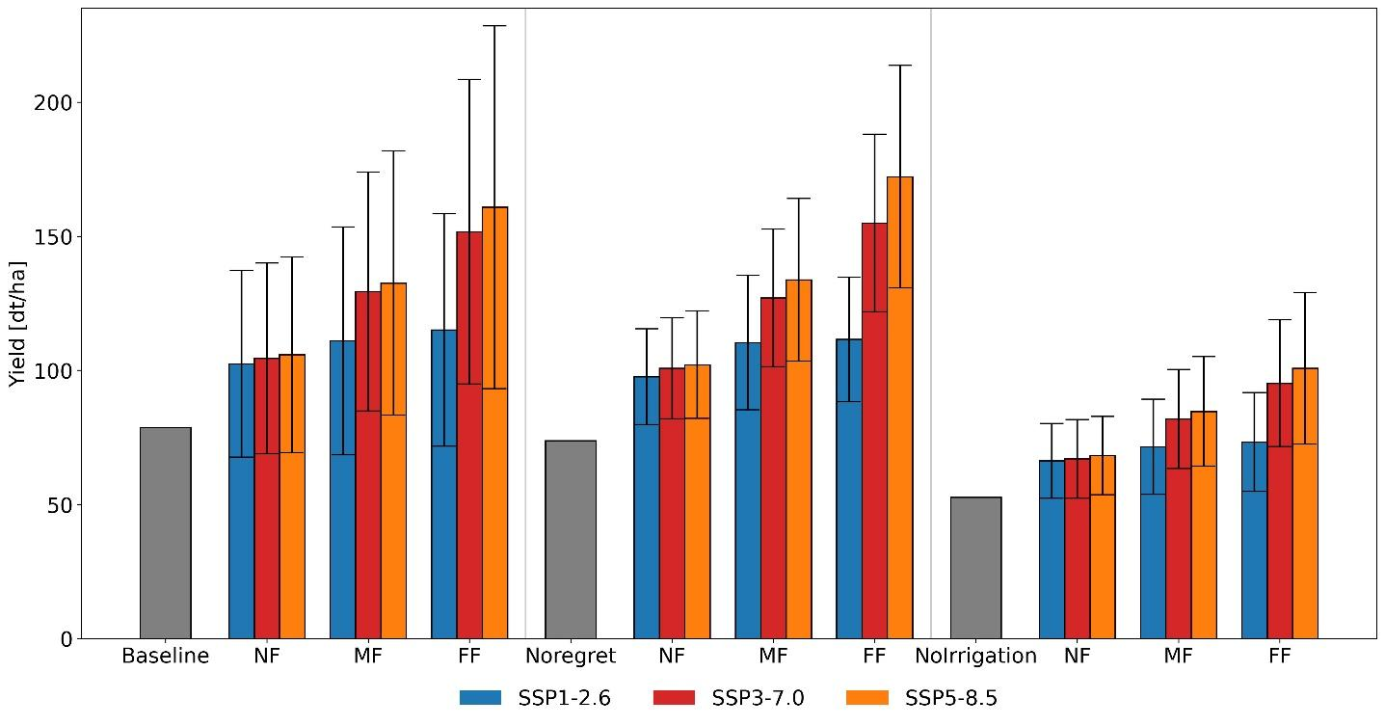
Figure 46: Strawberry yields for “baseline” and “noadaptation” (baseline forced by climate change scenarios). Future climate projections are shown for the near-future (NF; 2015-2045), mid-future (MF; 2035-2065), and far-future (FF; 2065-2095). The “baseline”, “Noregret”, and “Noirrigation” are presented for the period 1985-2015.

As enough water is available in the raining season, irrigation happens only in the dry period. Two harvests are considered in the wet season and an additional one is possible with irrigation in the dry season. The results per ha are shown in Figure 46. One result is that strawberry yields may increase under climate change conditions: favorable is the overall increase in precipitation and temperature. The increasing temperatures lead to more water demand and transpiration by the plants, but is compensated by the increase in precipitation, and the increase in actual transpiration is accompanied by increases in biomass and yields.
Provided for the economical analysis are the yields shown in Figure 46 and the irrigation water demand.

To do/plan:
- Re-run irrigation scenarios with dam operation 2 (priority on irrigation water supply, second aim is hydropower generation (peak generation in the rainy season) [, no flood protection])
- Run scenarios of irrigation area increasing from 2000 up to 7000 ha (increase by 1000 ha) and comparing results based for flood and drip irrigation (currently there is the mix of changes in area and irrigation type which make the interpretation difficult)

Adaptation scenario improved dam operation

An essential function of reservoirs is to balance periods of high and low water by storing water during periods of surplus and releasing it during periods of drought. In the following, a scenario will be described in which, on the one hand, more than 2000 ha of strawberries are irrigated, but on the other hand, flood protection, generation of electricity and the actual irrigation are prioritized differently.
The dam operation scenario is parameterized in the SWIM model as the irrigation “noregret/adaptation” scenario (strawberry cultivation, drip irrigation of 2098 ha). Differences exist based on the operation of the dam:
- Baseline: Priority (first aim of operation) on hydropower generation with peak generation in the rainy season, second aim is irrigation water supply. Flood protection plays a minor role.
- No regret: Priority on irrigation water supply, second aim is hydropower generation (peak generation in the rainy season). Flood protection plays a minor role.
- Dam Electricity: Priority is constant hydropower generation, the dam is operated so that daily about 1.3 MW is generated. Second aim is irrigation water supply. Flood protection plays a minor role.
- Flood protection: Priority is flood protection (max. outflow 60 m3/s), second aim is hydropower generation (peak generation in the rainy season), third aim is irrigation water supply.
The impact of the dam management scenarios on the flow downstream of the dam is given in Figure 47. The largest differences in mean monthly outflow of the San Jacinto dam are in the dry period of the year (June to November), with a constant outflow of the dam of ca. 3 m³/s, while the other three scenarios show a quite similar outflow of the dam.
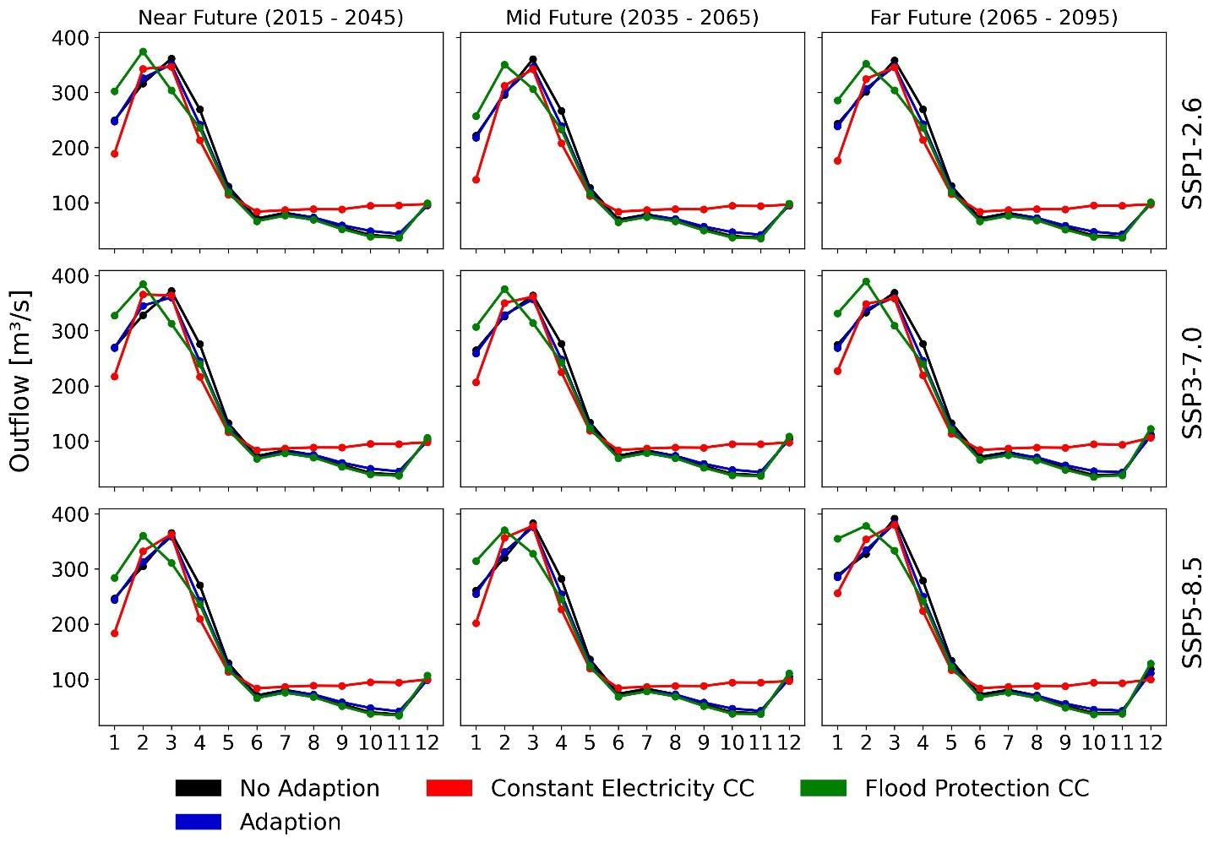
Figure 47: Mean monthly outflow of the San Jacinto dam based on the different scenarios (see scenario description above). Simulations are based on SWIM forced by 10 bias-adjusted CMIP6 climate models (ensemble median) for three different SSPs (SSP1-2.6, SSP3-7.0, SSP5-8.5).

The differences in the amounts of water stored in the reservoir in the respective scenarios show stronger deviations than the outflow (Figure 48). The greatest difference is between scenario “Dam Electricity”, where as much water as possible is stored in the reservoir in and after the rainy season in order to then release it in as large an amount as possible in the dry season, and scenario “Flood protection”, in which as little water as possible is stored in the reservoir in the wet season in order to keep the free storage space as a buffer for possible flood extremes. With no remarkable changes in inflow into the reservoir under scenario conditions, the management scenarios have larger impact than the climate scenarios in the near, middle and far future.
The amount of outflow of the dam is directly linked to electricity production shown in Figure 49 for the different management and climate scenarios and the three time slices. Not surprisingly, the highest electricity production especially in the dry season is under “Dam electricity” scenario conditions, while the lowest especially in the wet season is under “Flood protection” scenario conditions.

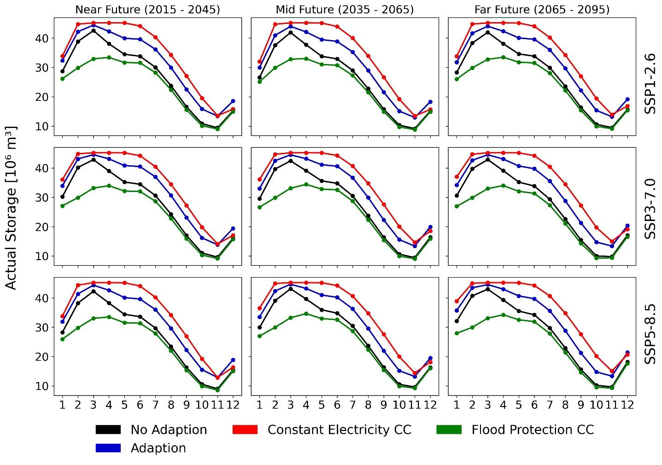
Figure 48: Storage in the San Jacinto dam based on the different scenarios (see scenario description above). Simulations are based on SWIM forced by 10 bias-adjusted CMIP6 climate models (ensemble median) for three different SSPs (SSP1-2.6, SSP3-7.0).

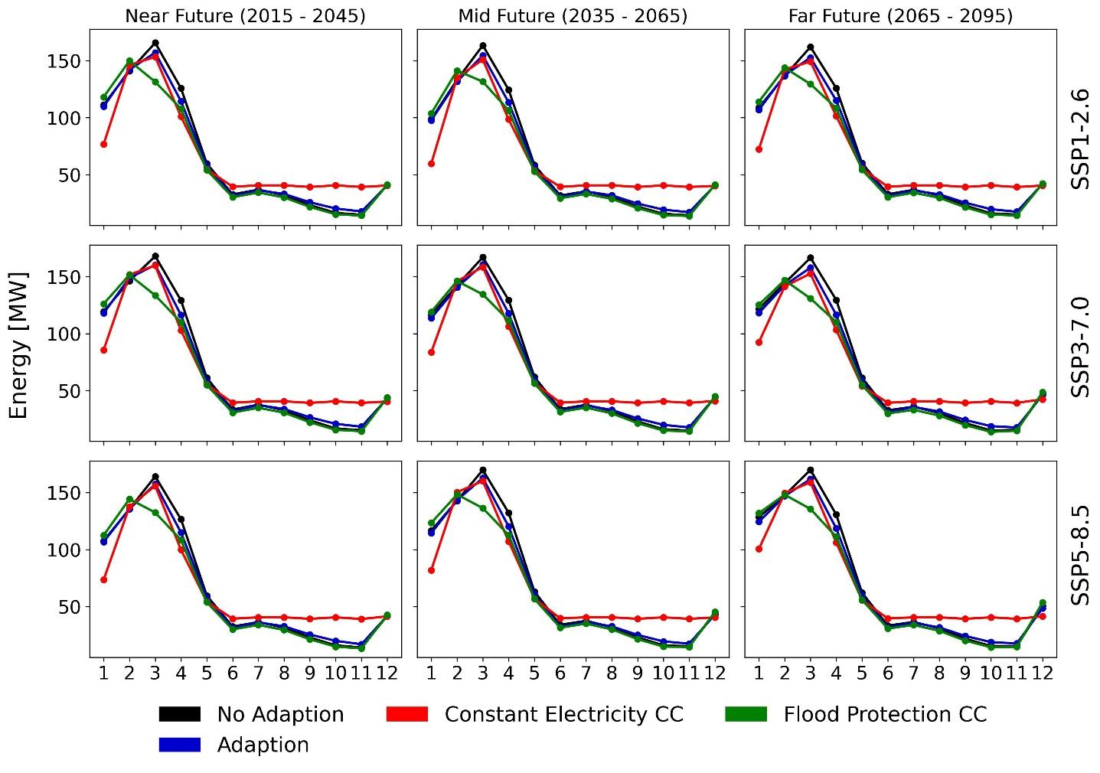
Figure 49: Total energy production of San Jacinto turbines based on the different scenarios (see scenario description above). Simulations are based on SWIM forced by 10 bias-adjusted CMIP6 climate models (ensemble median) for three different SSPs (SSP1-2.6, SSP3-7.0).

SWIM outputs provided for the economical evaluation of the dam scenario data to be modelled in SWIM are the irrigation demand and electricity generation with and without optimized management of the dam.

Sensitivity study “increase of irrigated area” from 3000 ha to 7000 ha

In order to estimate the possible irrigation from the reservoir, we applied SWIM to stepwise increase the amount of irrigated areas in the Bermejo basin from 3000 ha to 7000 ha, with the water taken from the reservoir. The figures §§ and §§ illustrate the impact on the water volume in the reservoir with irrigation as flood irrigation and drip irrigation considered.
Hallo Anne, hier brächte ich Hilfe …

3000 ha
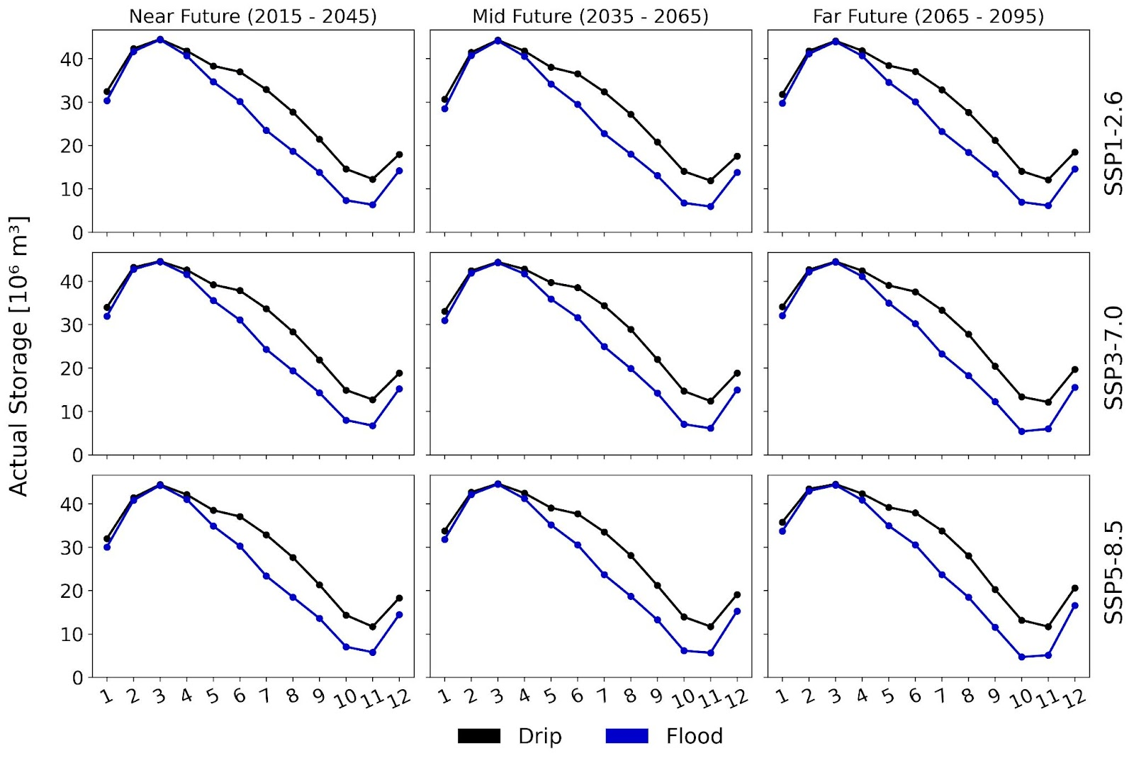

7000 ha
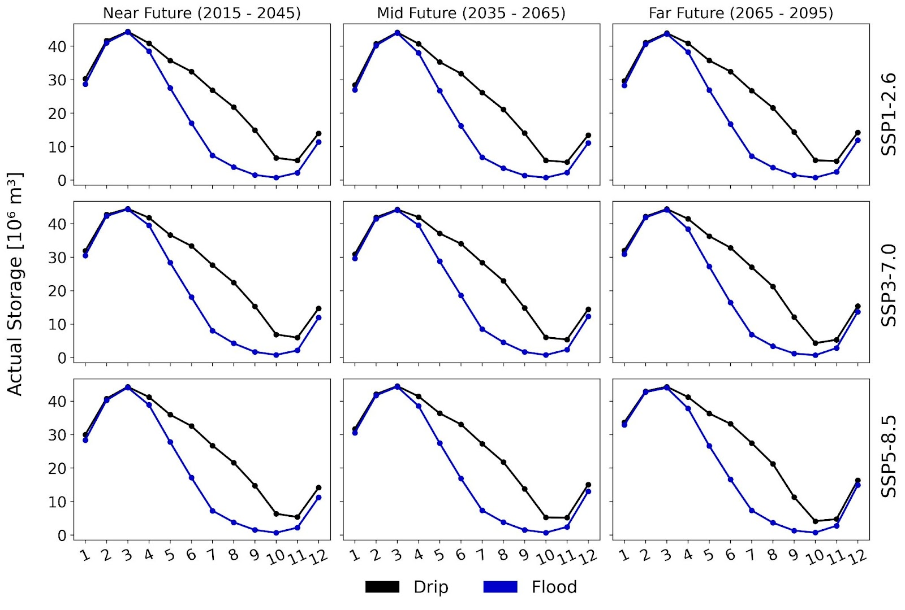

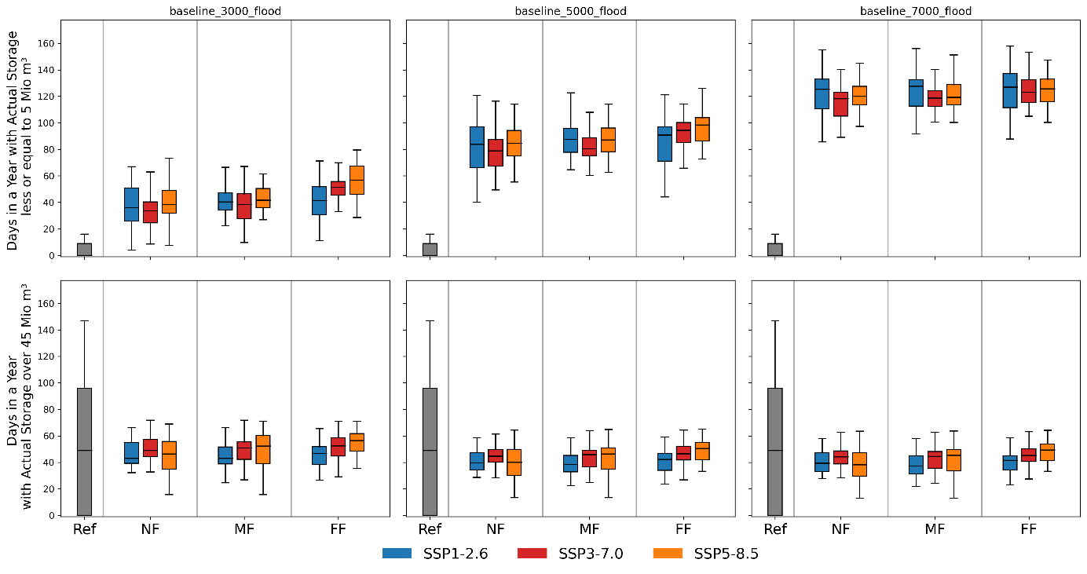
Flood
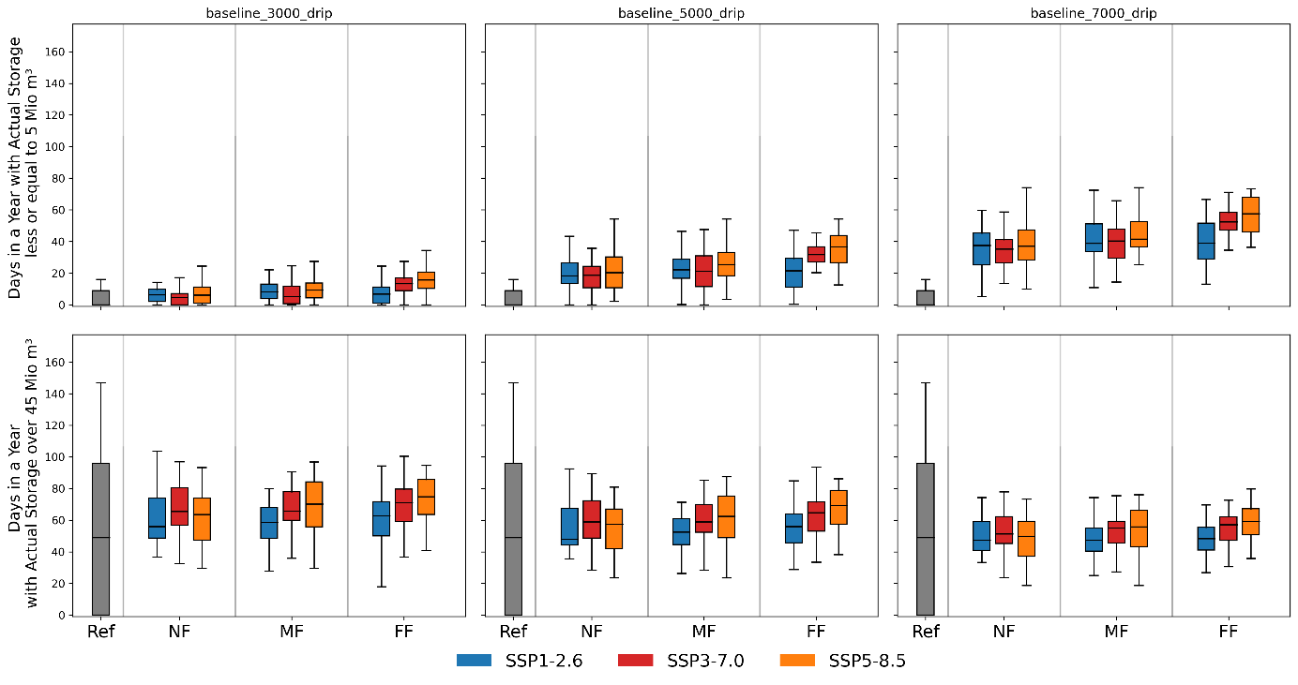
Drip

Discussion

The climate in Bolivia shows a clear trend to increasing air temperature (warming rate of 0.1°C per decade) since the mid-20th century. The largest increase in air temperature was observed in the Altiplano region (0.15 to 0.25 °C per decade) (López-Moreno et al., 2016; Seiler et al., 2013a). Concurrently, the Altiplano region has experienced a tendency to decreasing precipitation since the 1980s (2.5 mm per year) (Segura et al., 2020; Torres-Batlló and Martí-Cardona, 2020).
Future projections mainly show a continuation of the existing trends. With very high certainty mean annual temperatures, hot days, tropical nights, and extreme drought events are increasing in Bolivia, Santa Cruz, and Tarija. Projections of precipitation show a larger overall uncertainty. Annual mean precipitation projections show a tendency to decrease in Bolivia and Santa Cruz, whereas an increase in precipitation is projected in Tarija under the medium and high global warming scenarios. The number of heavy precipitation days and heavy precipitation intensity is projected to increase with high certainty under medium and high global warming scenarios in Bolivia and Tarija, whereas no trend is projected in Santa Cruz.
In summary, the projections related to temperature are robust since the trend is consistent for all models and global warming scenarios, while precipitation projections are more uncertain. This is also reflected in the large spatial variability of change across Bolivia. People might ask why

Summary

Summary of trends: Increasing trend (↑), Decreasing trend (↓) and no trend (−)
Climate indicator | Bolivia | Santa Cruz | Tarija
Annual mean air temperature | ↑ | ↑ | ↑
Hot days | ↑ | ↑ | ↑
Tropical nights | ↑ | ↑ | ↑
Frost days | ↓ | Not analyzed | ↓
Annual mean precipitation | ↓ | ↓ | SSP3-7.0 and SSP5-8.5: ↑
Frequency of heavy precipitation days | SSP5-8.5: ↑ | − | SSP3-7.0 and SSP5-8.5: ↑
Heavy precipitation intensity | SSP5-8.5: ↑ | − | SSP3-7.0 and SSP5-8.5: ↑
Frequency of extreme drought events | ↑ | ↑ | ↑

Certainty: percentage of models agreeing on the trend
Low (<= 50%) | Medium (>= 50%) | High (>= 80%) | Very high (>= 90%)

Summary of trends: Increasing trend (↑), Decreasing trend (↓) and no trend (−)
Climate indicator | Bolivia | Santa Cruz | Tarija
Annual mean air temperature | ↑ | ↑ | ↑
Hot days | ↑ | ↑ | ↑
Tropical nights | ↑ | ↑ | ↑
Frost days | ↓ | Not analyzed | ↓
Annual mean precipitation | ↓ | ↓ | SSP3-7.0 and SSP5-8.5: ↑
Frequency of heavy precipitation days | SSP5-8.5: ↑ | − | SSP3-7.0 and SSP5-8.5: ↑
Heavy precipitation intensity | SSP5-8.5: ↑ | − | SSP3-7.0 and SSP5-8.5: ↑
Frequency of extreme drought events | ↑ | ↑ | ↑

Certainty: percentage of models agreeing on the trend
Low (<= 50%) | Medium (>= 50%) | High (>= 80%) | Very high (>= 90%)

References
Abadi, A.M., Rowe, C.M., Andrade, M., 2020. Climate regionalization in Bolivia: A combination of non-hierarchical and consensus clustering analyses based on precipitation and temperature. Int. J. Climatol. 40, 4408–4421. https://doi.org/10.1002/JOC.6464
Beck, H.E., Zimmermann, N.E., McVicar, T.R., Vergopolan, N., Berg, A., Wood, E.F., 2018. Present and future Köppen-Geiger climate classification maps at 1-km resolution. Sci. Data 2018 51 5, 1–12. https://doi.org/10.1038/sdata.2018.214
Canedo-Rosso, C., Uvo, C.B., Berndtsson, R., 2019. Precipitation variability and its relation to climate anomalies in the Bolivian Altiplano. Int. J. Climatol. 39, 2096–2107. https://doi.org/10.1002/JOC.5937
Espinoza, J.C., Garreaud, R., Poveda, G., Arias, P.A., Molina-Carpio, J., Masiokas, M., Viale, M., Scaff, L., 2020. Hydroclimate of the Andes Part I: Main Climatic Features. Front. Earth Sci. https://doi.org/10.3389/feart.2020.00064
Eyring, V., Bony, S., Meehl, G.A., Senior, C.A., Stevens, B., Stouffer, R.J., Taylor, K.E., 2016. Overview of the Coupled Model Intercomparison Project Phase 6 (CMIP6) experimental design and organization. Geosci. Model Dev. 9, 1937–1958. https://doi.org/10.5194/GMD-9-1937-2016
Garreaud, R.D., 2009. The Andes climate and weather. Adv. Geosci. 22, 3–11. https://doi.org/10.5194/ADGEO-22-3-2009
Hausfather, Z., 2018. Explainer: How ‘Shared Socioeconomic Pathways’ explore future climate change - Carbon Brief [WWW Document]. URL https://www.carbonbrief.org/explainer-how-shared-socioeconomic-pathways-explore-future-climate-change (accessed 10.31.21).
Heerspink, B.P., Kendall, A.D., Coe, M.T., Hyndman, D.W., 2020. Trends in streamflow, evapotranspiration, and groundwater storage across the Amazon Basin linked to changing precipitation and land cover. J. Hydrol. Reg. Stud. 32, 100755. https://doi.org/10.1016/J.EJRH.2020.100755
IPCC, 2021. Climate Change 2021: The Physical Science Basis. Contribution of Working Group I to the Sixth Assessment Report of the Intergovernmental Panel on Climate Change [Masson-Delmotte, V., P. Zhai, A. Pirani, S.L. Connors, C. Péan, S. Berger, N. Caud, Y. Chen, . Cambridge University Press. In Press.
Lange, S., 2019. Trend-preserving bias adjustment and statistical downscaling with ISIMIP3BASD (v1.0). Geosci. Model Dev. 12, 3055–3070. https://doi.org/10.5194/gmd-12-3055-2019
Lange, S., Büchner, M., 2022. Secondary ISIMIP3b bias-adjusted atmospheric climate input data. https://doi.org/10.48364/ISIMIP.581124
Lange, S., Büchner, M., 2021. ISIMIP3b bias-adjusted atmospheric climate input data. https://doi.org/10.48364/ISIMIP.842396.1
Lange, S., Menz, C., Gleixner, S., Cucchi, M., Weedon, G.P., Amici, A., Bellouin, N., Schmied, H.M., Hersbach, H., Buontempo, C., Cagnazzo, C., 2021. WFDE5 over land merged with ERA5 over the ocean (W5E5 v2.0). https://doi.org/10.48364/ISIMIP.342217
López-Moreno, J.I., Morán-Tejeda, E., Vicente-Serrano, S.M., Bazo, J., Azorin-Molina, C., Revuelto, J., Sánchez-Lorenzo, A., Navarro-Serrano, F., Aguilar, E., Chura, O., 2016. Recent temperature variability and change in the Altiplano of Bolivia and Peru. Int. J. Climatol. 36, 1773–1796. https://doi.org/10.1002/JOC.4459
O’Neill, B.C., Kriegler, E., Ebi, K.L., Kemp-Benedict, E., Riahi, K., Rothman, D.S., van Ruijven, B.J., van Vuuren, D.P., Birkmann, J., Kok, K., Levy, M., Solecki, W., 2017. The roads ahead: Narratives for shared socioeconomic pathways describing world futures in the 21st century. Glob. Environ. Chang. 42, 169–180. https://doi.org/10.1016/J.GLOENVCHA.2015.01.004
O’Neill, B.C., Tebaldi, C., Van Vuuren, D.P., Eyring, V., Friedlingstein, P., Hurtt, G., Knutti, R., Kriegler, E., Lamarque, J.F., Lowe, J., Meehl, G.A., Moss, R., Riahi, K., Sanderson, B.M., 2016. The Scenario Model Intercomparison Project (ScenarioMIP) for CMIP6. Geosci. Model Dev. 9, 3461–3482. https://doi.org/10.5194/GMD-9-3461-2016
Riahi, K., van Vuuren, D.P., Kriegler, E., Edmonds, J., O’Neill, B.C., Fujimori, S., Bauer, N., Calvin, K., Dellink, R., Fricko, O., Lutz, W., Popp, A., Cuaresma, J.C., KC, S., Leimbach, M., Jiang, L., Kram, T., Rao, S., Emmerling, J., Ebi, K., Hasegawa, T., Havlik, P., Humpenöder, F., Da Silva, L.A., Smith, S., Stehfest, E., Bosetti, V., Eom, J., Gernaat, D., Masui, T., Rogelj, J., Strefler, J., Drouet, L., Krey, V., Luderer, G., Harmsen, M., Takahashi, K., Baumstark, L., Doelman, J.C., Kainuma, M., Klimont, Z., Marangoni, G., Lotze-Campen, H., Obersteiner, M., Tabeau, A., Tavoni, M., 2017. The Shared Socioeconomic Pathways and their energy, land use, and greenhouse gas emissions implications: An overview. Glob. Environ. Chang. 42, 153–168. https://doi.org/https://doi.org/10.1016/j.gloenvcha.2016.05.009
Segura, H., Espinoza, J.C., Junquas, C., Lebel, T., Vuille, M., Garreaud, R., 2020. Recent changes in the precipitation-driving processes over the southern tropical Andes/western Amazon. Clim. Dyn. 2020 545 54, 2613–2631. https://doi.org/10.1007/S00382-020-05132-6
Seiler, C., Hutjes, R.W.A., Kabat, P., 2013a. Climate Variability and Trends in Bolivia. J. Appl. Meteorol. Climatol. 52, 130–146. https://doi.org/10.1175/JAMC-D-12-0105.1
Seiler, C., Hutjes, R.W.A., Kabat, P., 2013b. Likely Ranges of Climate Change in Bolivia. J. Appl. Meteorol. Climatol. 52, 1303–1317. https://doi.org/10.1175/JAMC-D-12-0224.1
Shekhar, A., Shapiro, C.A., 2019. What do meteorological indices tell us about a long-term tillage study? Soil Tillage Res. 193, 161–170. https://doi.org/10.1016/J.STILL.2019.06.004
Thornthwaite, C.W., 1948. An approach toward a rational classification of climate. Geogr. Rev. 38, 55–94.
Torres-Batlló, J., Martí-Cardona, B., 2020. Precipitation trends over the southern Andean Altiplano from 1981 to 2018. J. Hydrol. 590, 125485. https://doi.org/10.1016/j.jhydrol.2020.125485
van Vuuren, D.P., Edmonds, J., Kainuma, M., Riahi, K., Thomson, A., Hibbard, K., Hurtt, G.C., Kram, T., Krey, V., Lamarque, J.-F., Masui, T., Meinshausen, M., Nakicenovic, N., Smith, S.J., Rose, S.K., 2011. The representative concentration pathways: an overview. Clim. Chang. 2011 1091 109, 5–31. https://doi.org/10.1007/S10584-011-0148-Z
Velpuri, N.M., Pervez, S., Cushing, W.M., 2016. Hydropower assessment of Bolivia—A multisource satellite data and hydrologic modeling approach. U.S. Geol. Surv. Open-File Rep. 2016–1156. https://doi.org/10.3133/OFR20161156
Vicente-Serrano, S.M., Beguería, S., López-Moreno, J.I., 2010. A multiscalar drought index sensitive to global warming: The standardized precipitation evapotranspiration index. J. Clim. 23, 1696–1718. https://doi.org/10.1175/2009JCLI2909.1
Wayne, G.P., 2013. The Beginner’s Guide to Representative Concentration Pathways.
Wickel, A., Ghajarnia, N., Yates, D., Newman, A., Escobar, M., Purkey, D., Lima, N., Escalera, A.C., Kaenel, M. von, 2019. Developing a gridded high-resolution gauge based precipitation product for Bolivia. Geophys. Res. Abstr. 21.

Appendix
A. Comparison of bias-adjusted CMIP6 climate models and observation-based data (W5E5 and GMET)
This section shows the intra-annual comparison of bias-adjusted air temperature and precipitation records obtained fromCMIP6 climate models and observation-based data W5E5 and local GMET Gridded climate data (Wickel et al., 2019) for the period 1985-2015. GMET is based on observed climate data from Servicio Nacional de Meteorología e Hidrología (SENAMHI). The comparison shows that the model ensemble of CMIP6 captures the seasonal patterns of precipitation and mean air temperature for the spatial average of Bolivia and the spatial average of the two departments of Santa Cruz and Tarija very well. This suggests that the bias-adjustment method applied to CMIP6 climate model outputs is highly effective. Moreover, W5E5 depicts well the seasonal patterns of precipitation and mean air temperature when compared to GMET, although slight overestimation of precipitation is observed over Santa Cruz region during the rainy season. Overall, comparison results show the adequacy of bias-adjusted records of CMIP6 climate models and W5E5 for climate impact studies in Bolivia.
Figure A1: Annual cycle of precipitation and mean air temperature for historical period 1985-2015 using CMIP6 ensemble (10 models) and observation-based data (W5E5 and GMET) for Bolivia (upper panel), Santa Cruz (middle panel) and Tarija (Bottom panel).
B. Shared Socioeconomic Pathways (SSPs) and Representative Concentration Pathways (RCPs)
The standard set of future scenarios, which were used in the 6th Assessment Report of the IPCC (AR6) released in 2021 (IPCC, 2021), is based on a new set of emissions and land-use scenarios: pathways of societal development, the shared socioeconomic pathways (O’Neill et al., 2017), linked with forcing levels of the representative concentration pathways (Eyring et al., 2016; O’Neill et al., 2016).

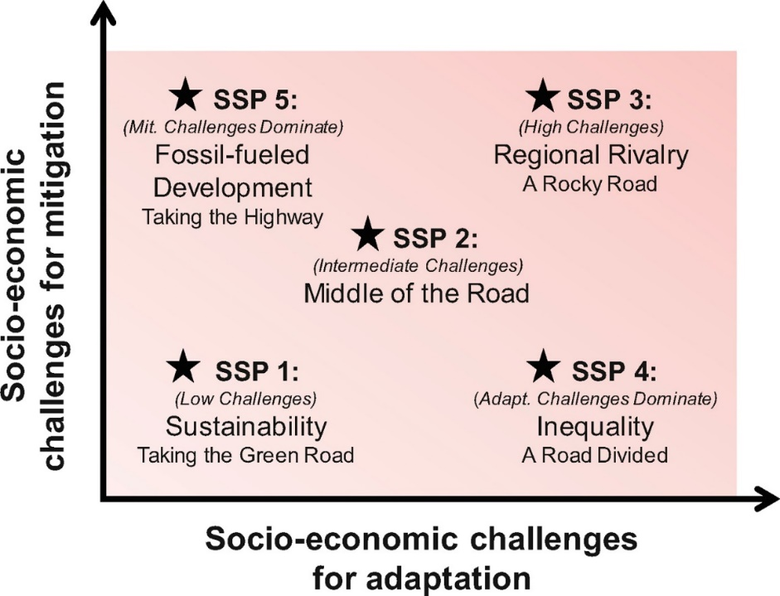
Figure B1: The SSPs of the IPCC guided scenario set (O’Neill et al., 2016)

The SSPs comprise five alternative narratives that describe socioeconomic trends that shape future society. They include quantitative descriptions for key elements like population, economic growth and urbanization (O’Neill et al., 2016). SSP1 envisions an optimistic trend for human development with substantial investments in health, education, well-functioning institutions, and economic growth and, at the same time, a shift towards sustainable practices. SSP3, on the contrary, shows a pessimistic development trend with increasing inequalities and prioritization of regional security (O’Neill et al., 2016). To translate the socioeconomic conditions of the SSPs into possible greenhouse gas emissions trajectories, different integrated assessment models (IAMs) were employed (Hausfather, 2018). The IAMs project different emissions pathways for individual SSPs. These different emissions pathways are grouped and represented by the seven representative concentration pathways (RCPs), which are defining a radiative forcing achieved in 2100. The RCPs are labelled after the additional radiative forcing level reached in the year 2100 relative to pre-industrial times (+1.9, +2.6, +3.4, +4.5, +6.0, +7.0 and +8.5 W/m², respectively) (van Vuuren et al., 2011; Wayne, 2013).

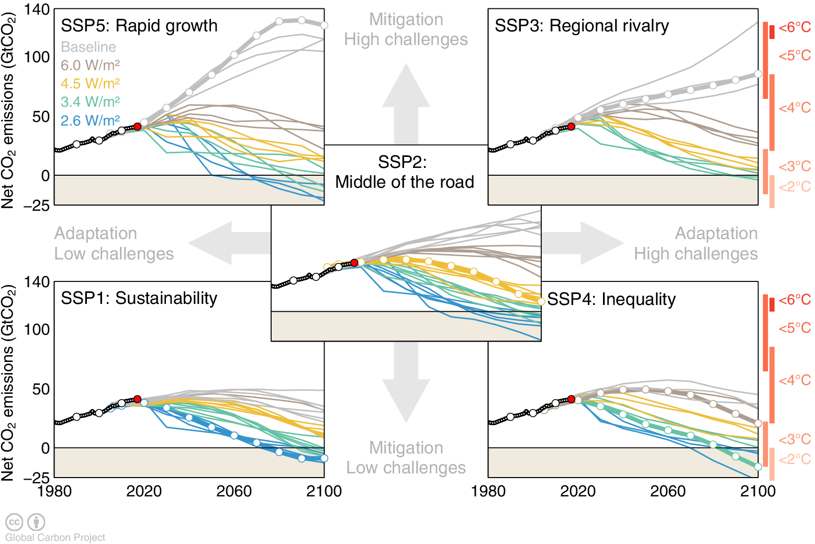
Figure B2: Global CO2 emissions (GrCO2) for all IAM runs in the SSP database. Chart produced by Global Carbon Project.

Below is described the Shared Socioeconomic Pathways (SSPs) used in this study based on (Riahi et al., 2017).

SSP1: Sustainability – Taking the Green Road (Low challenges to mitigation and adaptation)
The world shifts gradually, but pervasively, toward a more sustainable path, emphasizing more inclusive development that respects perceived environmental boundaries. Management of the global commons slowly improves, educational and health investments accelerate the demographic transition, and the emphasis on economic growth shifts toward a broader emphasis on human well-being. Driven by an increasing commitment to achieving development goals, inequality is reduced both across and within countries. Consumption is oriented toward low material growth and lower resource and energy intensity.

SSP3: Regional Rivalry – A Rocky Road (High challenges to mitigation and adaptation)
A resurgent nationalism, concerns about competitiveness and security, and regional conflicts push countries to increasingly focus on domestic or, at most, regional issues. Policies shift over time to become increasingly oriented toward national and regional security issues. Countries focus on achieving energy and food security goals within their own regions at the expense of broader-based development. Investments in education and technological development decline. Economic development is slow, consumption is material-intensive, and inequalities persist or worsen over time. Population growth is low in industrialized and high in developing countries. A low international priority for addressing environmental concerns leads to strong environmental degradation in some regions.

SSP5: Fossil-fueled Development – Taking the Highway (High challenges to mitigation, low challenges to adaptation)
This world places increasing faith in competitive markets, innovation and participatory societies to produce rapid technological progress and development of human capital as the path to sustainable development. Global markets are increasingly integrated. There are also strong investments in health, education, and institutions to enhance human and social capital. At the same time, the push for economic and social development is coupled with the exploitation of abundant fossil fuel resources and the adoption of resource and energy intensive lifestyles around the world. All these factors lead to rapid growth of the global economy, while global population peaks and declines in the 21st century. Local environmental problems like air pollution are successfully managed. There is faith in the ability to effectively manage social and ecological systems, including by geo-engineering if necessary.

W5E5 data is available at https://doi.org/10.48364/ISIMIP.342217
https://doku.pub/download/represa-de-san-jacinto-tarija-bolivia-el9vg8m24kqy
For practical reasons, the climate models included in ISIMIP are not described here. For more information, please check the ISIMIP website: https://www.isimip.org/gettingstarted/input-data-bias-correction/. The bias-adjusted atmospheric climate data are available at https://doi.org/10.48364/ISIMIP.842396.1 and https://doi.org/10.48364/ISIMIP.581124
Climate variables (such as temperature and precipitation) show high annual variability. In order to analyze long-term climatic changes instead of annual variabilities, means of climate variables over 20-40 years are compared with one another.
Colors show multi-model medians of 31-year mean values under SSP1-2.6 (top panel), SSP3-7.0 (middle panel) and SSP5-8.5 (bottom panel) for different 31-year periods (central year indicated above each column). Colors in the leftmost column show these values for a reference period (color bar on the left). Colors in the other columns show differences relative to this reference period (color bar on the right). The presence (absence) of a dot in the other columns indicates that at least (less than) 75 % of all models agree on the sign of the difference.
Colors show multi-model medians of 31-year mean values under SSP1-2.6 (top panel), SSP3-7.0 (middle panel) and SSP5-8.5 (bottom panel) for different 31-year periods (central year indicated above each column). Colors in the leftmost column show these values for a reference period (color bar on the left). Colors in the other columns show differences relative to this reference period (color bar on the right). The presence (absence) of a dot in the other columns indicates that at least (less than) 75 % of all models agree on the sign of the difference.
https://doku.pub/download/represa-de-san-jacinto-tarija-bolivia-el9vg8m24kqy

